SAL INSTITUTE OF TECHNOLOGY AND ENGINEERING RESEARCH
Opp. Science city, Sola-Bhadaj Road, Ahmedabad, Gujarat 380060
Ph: 079 67129000 | Website: www.sal.edu.in

Student's Weekly Report of Internship
Student Name: | Jainil Gupta
Enrollment Number: | 220670132018
Week Duration: | February 19, 2026 - February 25, 2026 (Week 8)
Name Of Organization: | Microsoft Elevate Program (via Edunet Foundation & FICE Education)
External Guide Name: | Adarsh Gupta
External Guide Contact: | 0124-4080107
Internal Faculty Guide: | Chintan Rana

Work done in last Week with description:

1. Week 8 Module: GitHub Co-pilot and AI-Powered Coding

Description:
Attended comprehensive session on "Co-pilot" on March 13, 2026. This session covered AI-powered coding assistants, their role in modern software development, and practical applications. Learned how tools like GitHub Copilot, ChatGPT for coding, and other AI assistants are revolutionizing the development workflow.

Key Topics Covered:
- Introduction to AI coding assistants ecosystem (GitHub Copilot, Tabnine, Amazon CodeWhisperer)
- How Copilot works: OpenAI Codex model trained on billions of lines of code
- Intelligent code completion and multi-line suggestions
- Converting natural language comments to functional code
- Context-aware suggestions based on current file and project
- Generating entire functions from descriptive names
- Code explanation and documentation (docstrings, comments)
- Automated unit test generation with pytest and unittest
- Refactoring suggestions and code improvement
- Debugging assistance and error explanation
- Best practices for prompt engineering with coding AI
- Limitations and ethical considerations (code licensing, accuracy verification)

Hands-on Practice:
Installed GitHub Copilot extension in VS Code. Practiced generating Python functions by writing descriptive comments. Generated data preprocessing code for image handling. Created unit tests for sample functions using AI suggestions. Experimented with code refactoring suggestions. Generated boilerplate code for Flask API endpoints. Practiced debugging by asking AI to explain error messages and suggest fixes.
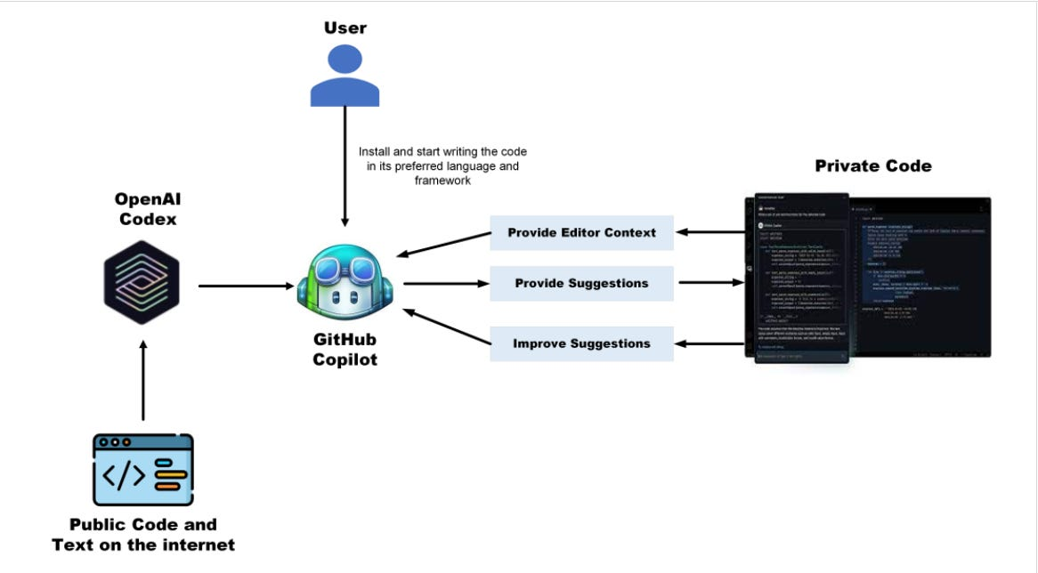
Figure 1: AI-powered coding assistant workflow where natural language prompts generate code suggestions using machine learning models.

Assignment Completed:
Built a complete Python module using 80% AI-generated code with human review and modification. Created data validation functions, file I/O operations, and error handling using Copilot suggestions. Generated comprehensive docstrings and type hints for all functions. Submitted code along with reflection on AI tool effectiveness and limitations.

2. Week 8 Module: Cloud Computing Fundamentals

Description:
Participated in comprehensive "Cloud Computing Fundamentals" session on March 16, 2026. This session provided deep understanding of cloud computing architecture, service models, deployment strategies, and major cloud platforms. Essential foundation for Week 8-9 Azure modules.

Key Topics Covered:
- Evolution of computing: Mainframe → Client-Server → Cloud
- Cloud computing definition: On-demand network access to shared computing resources
- 5 Essential characteristics: On-demand self-service, broad network access, resource pooling, rapid elasticity, measured service
- Service Models - IaaS, PaaS, SaaS with real-world examples
- IaaS (Infrastructure as a Service): Virtual machines, storage, networks (AWS EC2, Azure VMs)
- PaaS (Platform as a Service): Development platforms, databases (Heroku, Azure App Service)
- SaaS (Software as a Service): Ready-to-use applications (Office 365, Salesforce, Gmail)
- Deployment Models: Public, Private, Hybrid, Community clouds
- Public cloud providers: Azure (Microsoft), AWS (Amazon), GCP (Google), IBM Cloud
- Cloud benefits: Cost savings (CAPEX to OPEX), scalability, reliability, global reach
- Elasticity vs Scalability: Automatic scaling vs planned capacity
- Cloud storage types: Object, Block, File storage
- Compute services: VMs, Containers, Serverless functions
- Serverless computing: Function-as-a-Service (FaaS), event-driven architecture
- Cloud pricing models: Pay-per-use, reserved instances, spot instances
- Cloud security: Shared responsibility model, encryption, IAM
- Latency and regions: Choosing data center locations

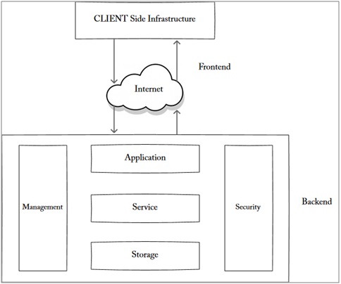
Figure 2: Cloud computing architecture showing front-end user interface connected to back-end infrastructure including servers, storage, and virtualization.

Case Studies Discussed:
Netflix migration to AWS for global streaming infrastructure. Spotify using Google Cloud for music recommendation engine. Comparison of AWS vs Azure vs GCP: pricing, services, and market share. Discussion on when to use cloud vs on-premises infrastructure. Real-world disaster recovery scenarios using cloud backup.

Hands-on Exercise:
Calculated cost comparison between on-premises server and cloud VM for hypothetical workload. Designed cloud architecture for e-commerce application using IaaS + PaaS services. Identified appropriate service models (IaaS/PaaS/SaaS) for different business scenarios. Discussed which cloud deployment model (public/private/hybrid) fits different organization needs.

Understanding Gained:
Understood why cloud is ideal for AI/ML projects: elastic compute for training, pay only for GPU hours used, global data center availability. Recognized Azure Functions (serverless) is perfect for event-driven detection pipeline. Learned how object storage (Blob) handles large video files cost-effectively. Prepared solid foundation for diving into Azure-specific services.
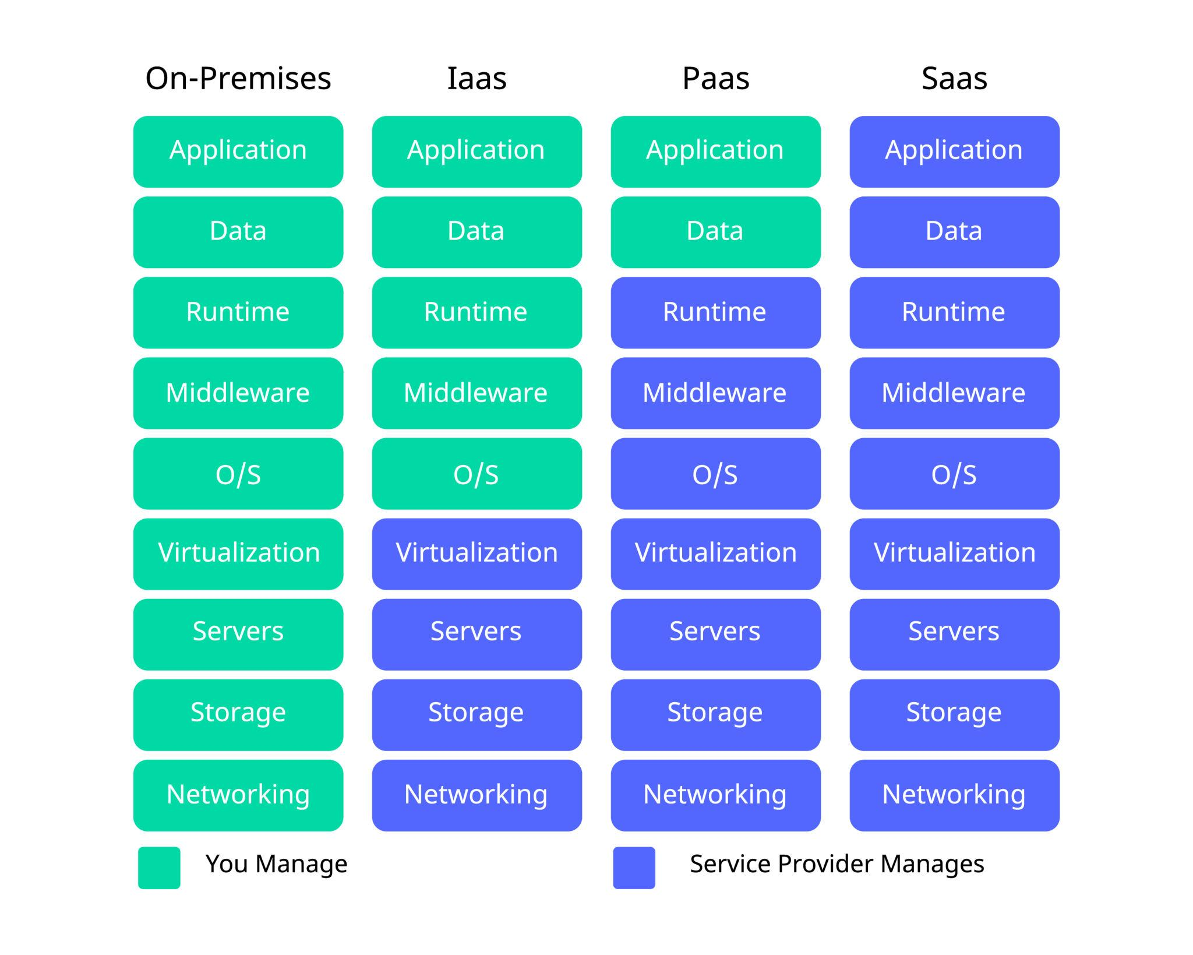
Figure 3: Cloud service models showing Infrastructure as a Service (IaaS), Platform as a Service (PaaS), and Software as a Service (SaaS).

3. Week 8 Module: Microsoft Azure Introduction

Description:
Attended comprehensive "Azure Introduction" session on March 18, 2026. This session provided in-depth tour of Microsoft Azure platform, core services architecture, pricing models, and hands-on portal navigation. This is the primary cloud platform we'll use for project deployment in upcoming weeks.

Key Topics Covered:
- Azure platform overview: 60+ regions, 200+ services, trusted by 95% Fortune 500
- Azure global infrastructure: regions, availability zones, data centers
- Azure Portal navigation: dashboard, resource management, search functionality
- Resource Groups: logical containers for organizing Azure resources
- Subscriptions and management hierarchy
- Azure Compute Services: Virtual Machines, App Service, Container Instances, Kubernetes Service
- Azure Storage Services: Blob Storage (object), File Storage, Queue, Table
- Azure Blob Storage deep dive: containers, access tiers (Hot/Cool/Archive), security
- Azure Functions: serverless compute, event-driven architecture, supported languages
- Azure Cosmos DB: globally distributed NoSQL database, multi-model support
- Azure Cognitive Services: Computer Vision, Face API, Custom Vision for AI applications
- Azure Networking: Virtual Networks, Load Balancers, Application Gateway
- Azure AI/ML Services: Machine Learning Studio, AI Builder
- Azure pricing models: Pay-as-you-go, Reserved Instances, Spot VMs
- Azure Cost Management: budgets, cost analysis, recommendations
- Azure for Students: ₹15,600 free credits, free services tier
- Azure Security: Role-Based Access Control (RBAC), Key Vault, Security Center
- Azure DevOps: Pipelines, Repos, Boards for CI/CD

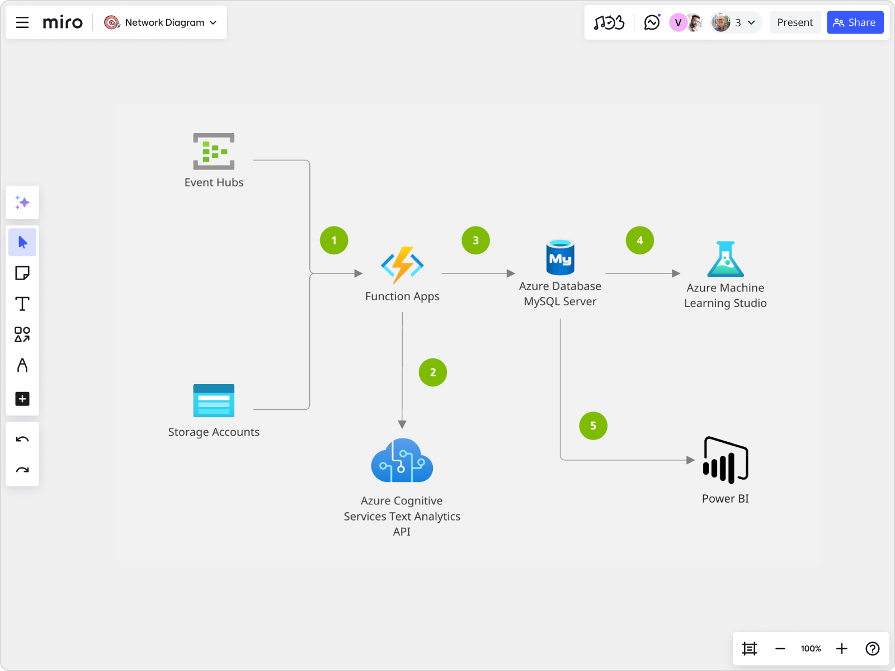
Figure 4: Microsoft Azure architecture showing major service categories including compute, storage, networking, and AI services.

Hands-on Portal Navigation:
Explored Azure Portal interface and navigation menu. Created sample Resource Group for organizing project resources. Browsed available services categorized by Compute, Storage, Networking, Databases, AI+ML. Reviewed Azure Marketplace for third-party solutions. Explored Cost Management dashboard to understand billing. Checked Azure for Students benefits and credit balance. Practiced using Azure Cloud Shell (bash and PowerShell).

Service Comparison Exercise:
Compared Azure Blob Storage vs File Storage vs Table Storage for different use cases. Analyzed when to use Azure Functions vs App Service vs Virtual Machines. Evaluated Azure Cosmos DB vs SQL Database for different data models. Calculated estimated monthly costs for sample AI/ML workload using Azure Pricing Calculator.

Project Relevance:
Identified exact Azure services needed for surveillance project: Blob Storage for video files, Azure Functions for serverless detection processing, Cosmos DB for storing alert logs and metadata, Azure Monitor for tracking system performance. Understood how these services integrate to create scalable, cost-effective AI pipeline. Prepared mental architecture map for Week 9-10 implementation.

Assignment:
Designed Azure architecture diagram for e-commerce application including: App Service for web frontend, Azure SQL for transactions, Blob Storage for product images, Azure CDN for content delivery. Calculated estimated monthly cost using Azure Pricing Calculator. Submitted architecture diagram with justification for service choices.
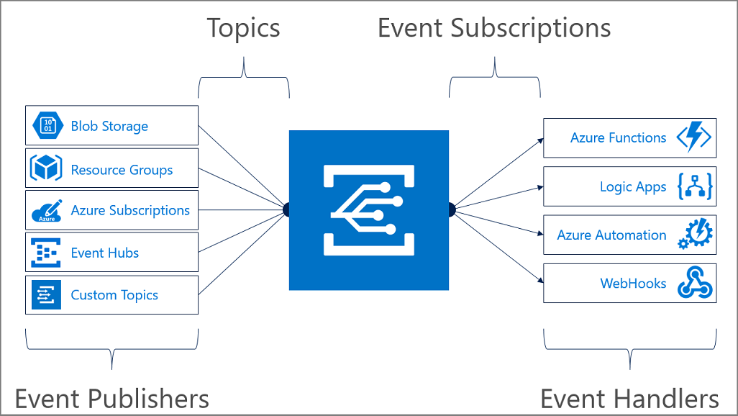
Figure 5: Example Azure serverless architecture using Blob Storage, Azure Functions, and Cosmos DB for scalable data processing.

4. GTU Project - Azure Account Setup and Dataset Organization

Description:
Applied learning from Azure Introduction session to setup Azure for Students account for project deployment. Organized previously prepared dataset files into proper directory structure for future annotation work.

Work Completed:
- Registered Azure for Students account with SAL Institute email
- Verified ₹15,600 free credits available
- Explored Azure Portal and available free-tier services
- Organized 850 surveillance frames into categorized folders
- Created train/validation split directory structure
- Documented dataset characteristics for annotation tool selection

Next Steps:
Will begin dataset annotation in Week 9 using Roboflow or LabelImg tool. Will create Azure Storage Account and Blob containers after completing Azure Experiments modules. Focus this week remained on completing training modules to build strong cloud computing foundation.
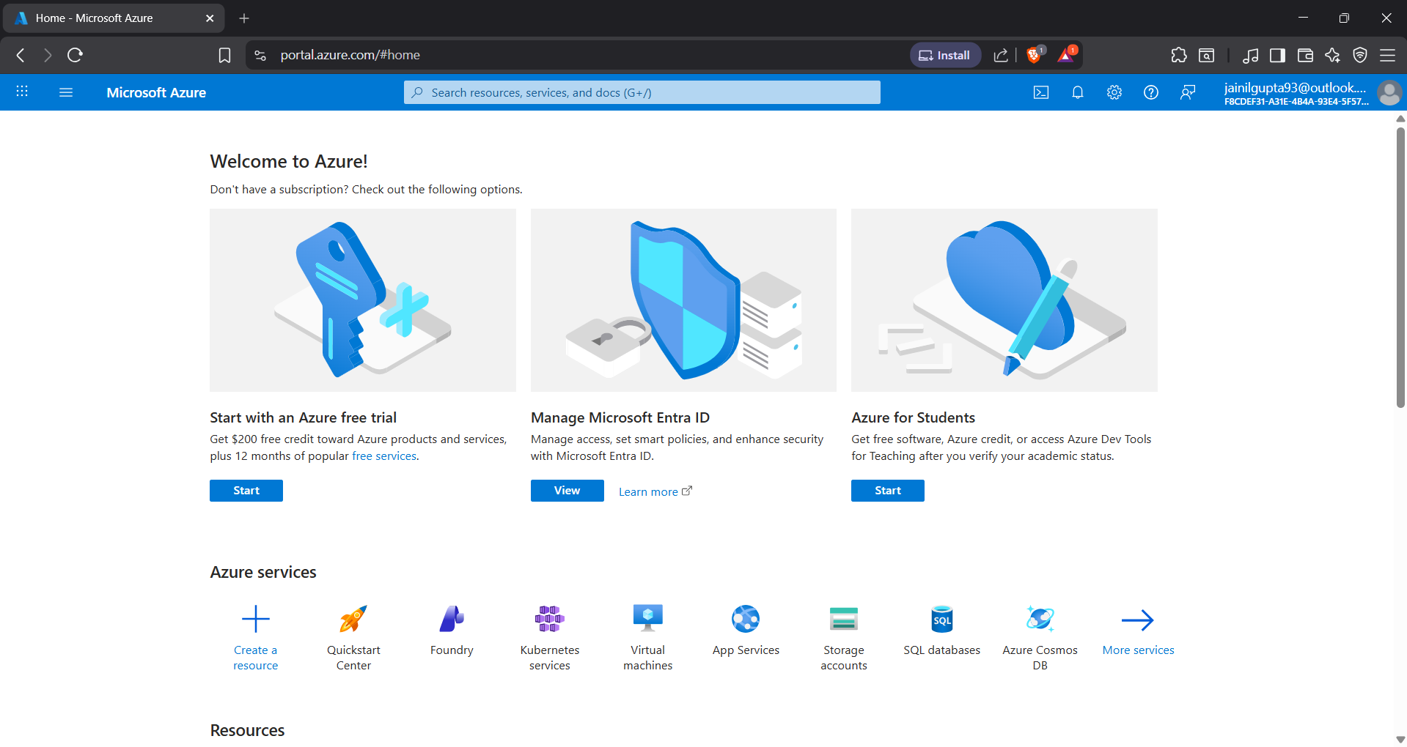

5. Week 8 Assignments Completion

Description:
Completed three assignments for Week 8 modules covering AI coding tools, cloud computing concepts, and Azure services architecture.

Assignment 1: AI Coding Assistant Project
Built complete Python data processing module using GitHub Copilot with 70-80% AI-generated code. Created functions for CSV file handling, data validation, statistical analysis, and visualization. Generated unit tests, type hints, and comprehensive docstrings. Documented experience and reflection on AI tool effectiveness, limitations, and when human oversight is essential.

Assignment 2: Cloud Computing Architecture Design
Designed cloud architecture for online education platform using IaaS and PaaS services. Selected appropriate service models for: video streaming (CDN + Blob Storage), user authentication (PaaS identity service), course database (managed SQL), assignment grading (serverless functions). Created cost estimate comparing on-premises vs cloud deployment. Justified each architectural decision with technical and business rationale.

Assignment 3: Azure Services Mapping
Created detailed comparison matrix of Azure services vs AWS equivalents (Blob Storage vs S3, Functions vs Lambda, Cosmos DB vs DynamoDB). Designed Azure architecture for real-time IoT data pipeline using IoT Hub, Stream Analytics, and Time Series Insights. Used Azure Pricing Calculator to estimate monthly costs for hypothetical workload. All assignments submitted to MS Elevate portal.

6. Study Group Discussion and Doubt Clearing

Description:
Participated in peer study sessions to discuss cloud computing concepts, Azure services selection, and project architecture planning. Engaged in MS Elevate discussion forum to clarify doubts and help fellow interns.

Discussion Topics:
- Clarified differences between Azure Blob Storage access tiers (Hot/Cool/Archive)
- Discussed when to use Azure Functions vs App Service vs Container Instances
- Compared Azure Cosmos DB vs Azure SQL Database for different scenarios
- Shared tips on optimizing Azure costs and using free tier effectively
- Discussed project deployment strategies and timeline planning

Plans for next week:

1. Complete Week 9 Microsoft Elevate Modules
- Attend three "Azure Experiments" sessions (Mar 20, 23, 27)
- Learn hands-on Azure Blob Storage operations
- Practice Azure Functions development and deployment
- Work with Azure Cosmos DB for NoSQL data storage
- Complete Azure hands-on labs and assignments

2. Azure Practical Exercises
- Deploy sample web application on Azure App Service
- Create and trigger Azure Functions with HTTP/Timer triggers
- Upload and manage files in Azure Blob Storage
- Practice Azure CLI and PowerShell commands
- Monitor Azure resources using Azure Monitor

3. Begin Dataset Annotation for Project
- Setup Roboflow or LabelImg annotation tool
- Start annotating surveillance frames with bounding boxes
- Define object classes (person, vehicle, suspicious_object)
- Complete annotation for at least 200-300 training frames

4. Azure Integration Planning
- Design Azure architecture for project deployment
- Map project components to Azure services
- Create Azure resource group for project
- Estimate Azure costs for project infrastructure

5. Project Documentation Update
- Update GitHub repository with progress
- Document Azure services selection rationale
- Create system architecture diagram with Azure components
- Prepare mid-term project progress report

Total Working Hours: 34 hours
Signature of Student: _____________________
The above entries are correct, and the grading of work done by Trainee is:
Excellent | Very Good | Good | Fair | Below Average | Poor
☐ | ☐ | ☐ | ☐ | ☐ | ☐

Signature of External Guide with Company Seal: _____________________
Date: ___________
Signature of Internal Guide: _____________________
Date: ___________

