AI-POWERED BORDER SURVEILLANCE SYSTEM
WITH REAL-TIME ANOMALY DETECTION

A PROJECT REPORT
Submitted by

JAINIL RAMKUMAR GUPTA
220670132018
In partial fulfilment for the award of the degree of

BACHELOR OF ENGINEERING
in
Information And Communication Technology


SAL INSTITUTE OF TECHNOLOGY & ENGINEERING RESEARCH

Gujarat Technological University, Ahmedabad
May, 2026



Sal Institute of Technology & Engineering Research

Opp. Science City, Ahmedabad, Gujarat – 380060

CERTIFICATE
This is to certify that the project report submitted along with the project entitled AI-POWERED BORDER SURVEILLANCE SYSTEM WITH REAL-TIME ANOMALY DETECTION has been carried out by JAINIL RAMKUMAR GUPTA under my guidance in partial fulfilment for the degree of Bachelor of Engineering in Information and Communication Technology, 8th Semester of Gujarat Technological University, Ahmedabad during the academic year 2025-26.

Mr. Chintan Rana Prof. Nimisha Patel
Internal Guide Head of CE/CSE/ICT Department
SALITER

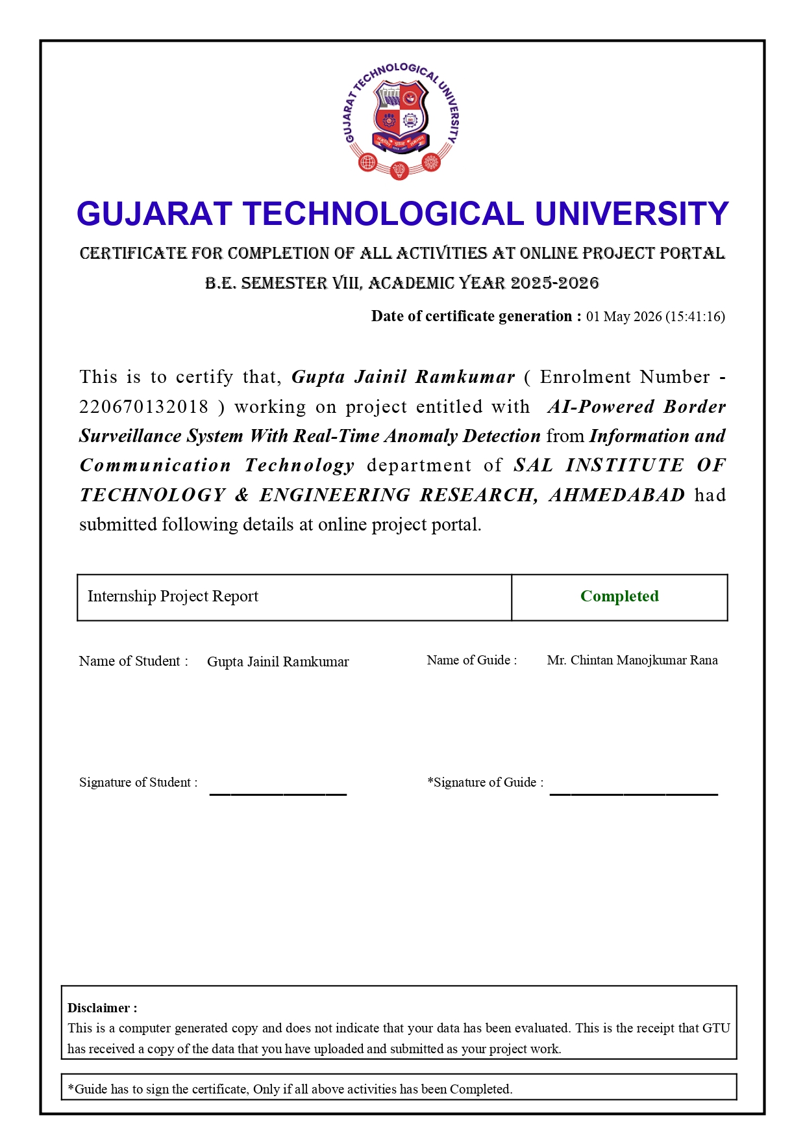




Sal Institute of Technology & Engineering Research

Opp. Science City, Ahmedabad, Gujarat – 380060

DECLARATION
I hereby declare that the Internship report submitted along with the project entitled "AI-Powered Border Surveillance System with Real-Time Anomaly Detection" submitted in partial fulfilment for the degree of Bachelor of Engineering in Information and Communication Technology to Gujarat Technological University, Ahmedabad, is a Bonafide record of original project work carried out by me at Microsoft Elevate Internship Program (via Edunet Foundation and FICE Education) under the supervision of Mr. Chintan Rana (Internal Guide) and Mr. Adarsh Gupta (External Guide), and that no part of this report has been directly copied from any students' reports or taken from any other source without providing due reference.
I further declare that all information, figures, results, and data presented in this report are accurate and true to the best of my knowledge, and all external sources have been duly acknowledged.

Name of the student Sign of Student
JAINIL R. GUPTA ____________

