2025 Summer Term Direct Reading Report
Kilsar Project for Weapon Detection of Surveillance Videos

By
Xinran Wang

Table of Contents

Executive Summary
The System Design
The Model Training
The Preprocessor
The Postprocessor
Results
Appendix

Executive Summary

Weapon detection of surveillance videos has practical use for cases including public security, police investigation, and so on. The challenge is that the surveillance videos are many times recorded under tough and dynamic environments such as low light, dense crowd, blurriness and so on, which makes the weapon detection difficult, resulting in low accuracy rate even with object detection model specifically trained to detect weapon via Supervised Fine Tuned (SFT) training. In Kilsar project, we take an innovative approach of object re-identification by using people as ‘anchor object’ and weapon as ‘target object’ to be associated with anchor object, where the current state-of-the-art object detection model has high accuracy to detect this anchor object and by association under reasonable assumption, for example, in a consecutive 5 second period of time, a conclusion can be draw that the weapon should be with this anchor even though the model does not detect it in certain video frames within the time period. Two key aspects of this system design are 1) a fine-tuned object detection model for weapon detection, and 2) a tracking algorithm to track the anchor object and associated target object. The fine-tuned model is to let model detect weapon with higher accuracy than a base model, and the tracking algorithm is to use model to identify both anchor and target objects, associate them together across consecutive video frames and build a video for each track. Overall, the whole system is a pipeline includes a preprocessor taking video as input and create temporal image frames from the input video, an object detection module to detect target object, and a post processor taking image frames from preprocessor and building the track of video frames containing anchor and associated target object.

The System Design

The whole system consists of preprocessor, the model prediction module, and postprocessor, where the preprocessor is to digest the input video, chunk the video into image frames, search the best image from the neighbors of each frame and extract them, and filter out static video frames; the output of this preprocessor is a list of image frames.

These frames are fed into the object detection model to detect ‘target object’, the model a fine-tuned Yolo model specifically trained for weapons. The output of this module is a list of image frames associated with bounding box for each detected weapon.

The postprocessor takes these images with bounding boxes, conducts the ‘anchor object’ detection (people holding guns, for example), calculate the distance between ‘target object’ and ‘anchor object’ to build association – once the association is identified, the postprocessor will track both anchor object and target object for the consecutive image frames to create a ‘track’, which contains the information such as ‘one person holding a gun till this person disappears’.

Figure 1. System Design

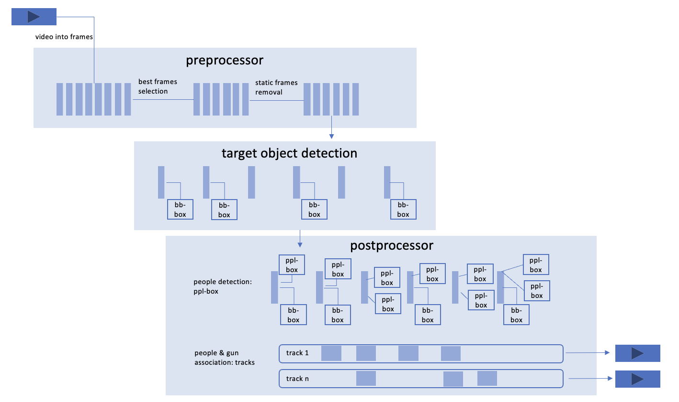

The Model Training

The system is based on Yolo model, a SOTA object detection model. Recent years of Yolo development has expanded its capabilities and now Yolo can detect and track objects, the latter is what we use to track the ‘anchor object’.

The pre-trained Yolo model has little capability of detect weapons, and thus it’s important for us to fine-tune the model for weapon detection. To do so, one of the most important aspects is dataset preparation so that we can have enough data to train the model. We make efforts in data augmentation due to reasons that:
1. our dataset is limited from Kilsar team.
2. we need to consider the surveillance videos under various harsh environments, for example low light, low-resolution etc.

Data augmentation includes a combination of the follow methods:

Augmentation | Purpose | Method
Crop | To reduce ‘noise’ of the image so that model can focus on weapon | Using the bounding box of the weapon as ‘center’, expand the size (keep the original aspect ratio) to certain percentage of the original image (e.g. 50%)
Low-light | To train the model to detect weapon under low-light situation | Using ‘albumentations’ library to adjust brightness & contrast of the image
Low-resolution | To train the model to detect weapon with low quality video | To save the image to low-quality image
Shear | To train the model to detect weapon using different angle/viewpoint | Using ‘albumentations’ library to adjust image shear

A few other augmentations are experimented with, including rotation, flip, and grayscale. In the end the Crop, Low-light, Low-resolution, and Shear are selected that cover most of the scenarios without increasing too much of the dataset. A combination of these 4 methods is used and the final dataset is expanded about 5x to around 500,000 image frames.

The training is conducted on GPU003 server that has 4 A30 GPUs for 300 epochs, and even with early stopping set, the training is still improving for each epoch so the model is trained with the full 300 epochs.

Training results on the validation dataset.

Figure 2. Training Losses

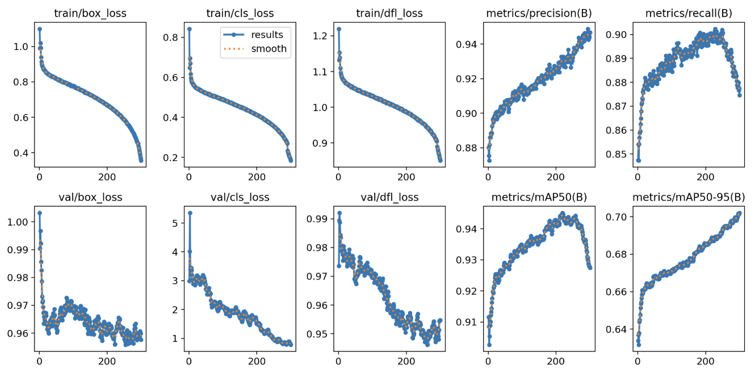
Figure 3. Confusion Matrix
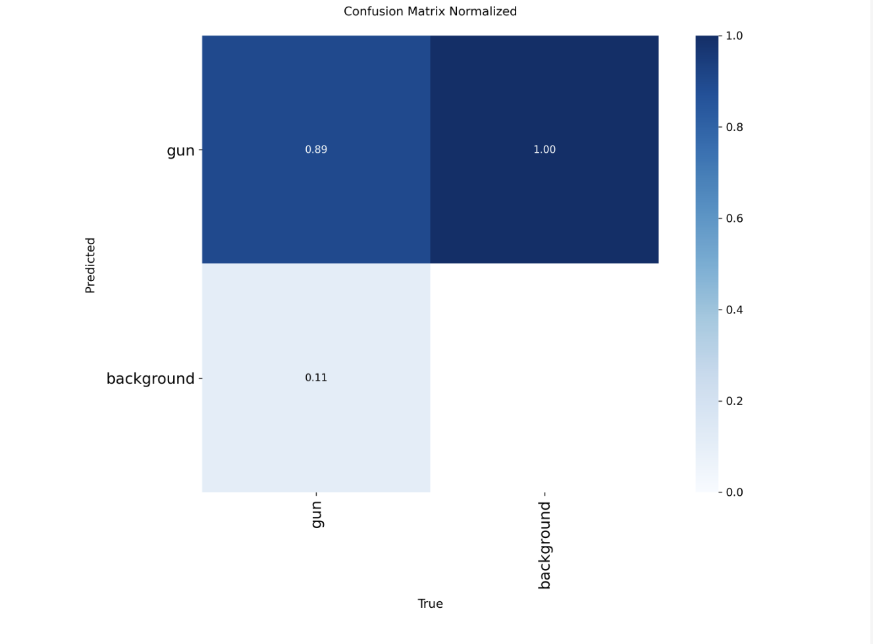
Figure 4. F-1 Score
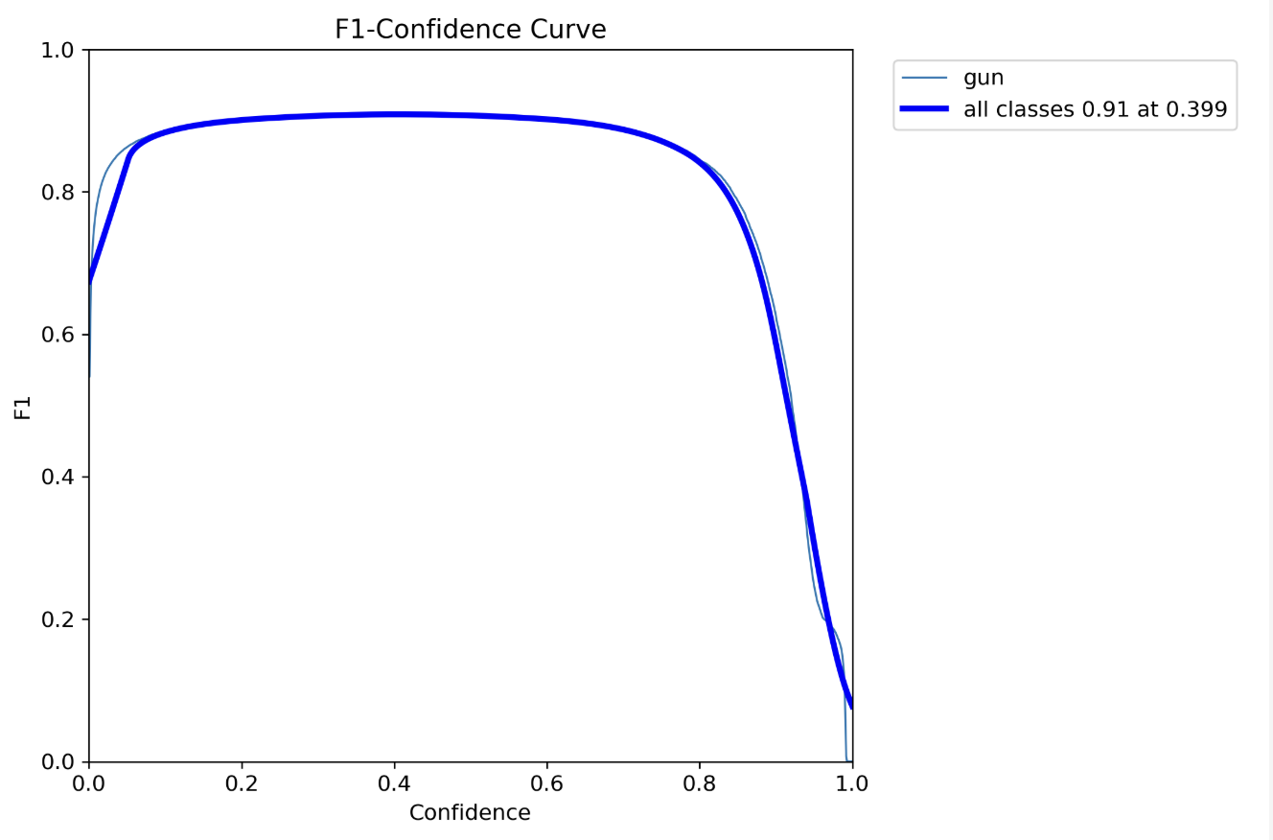

Figure 5. Precision Curve
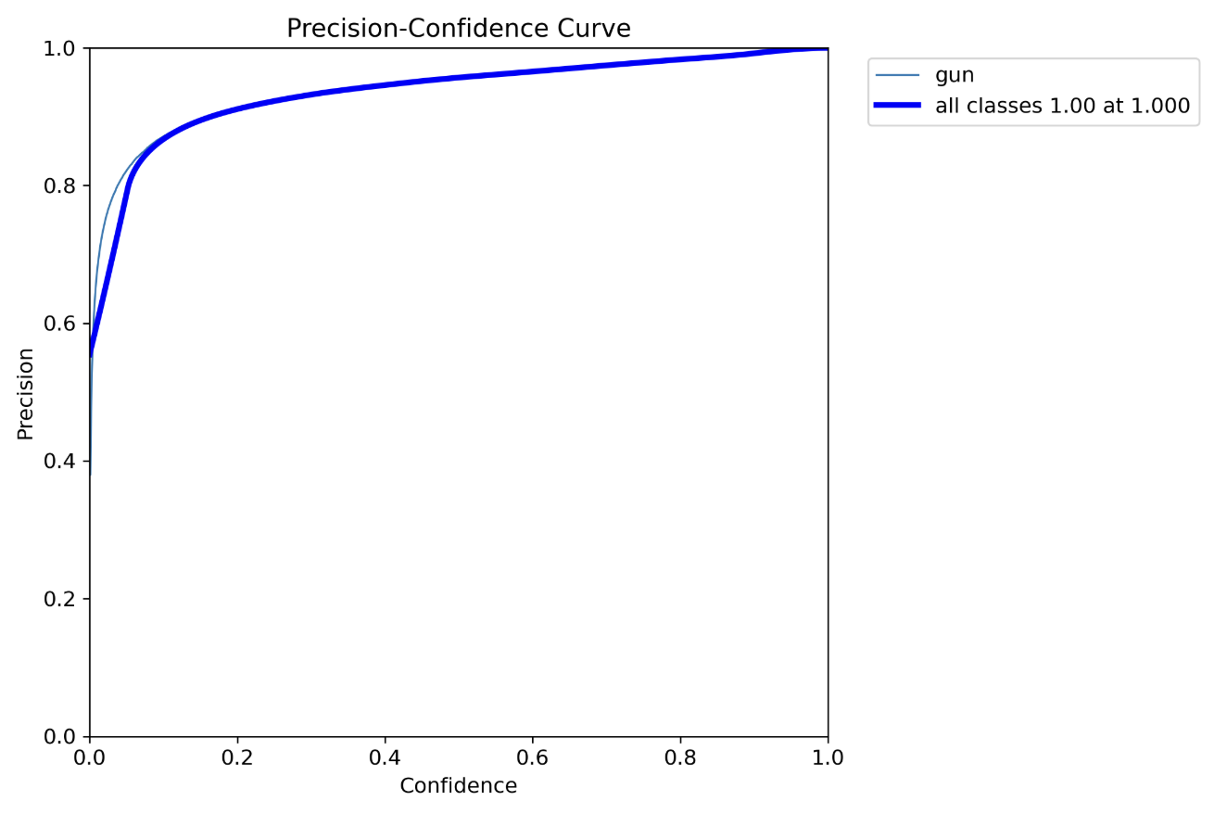

Figure 6. Recall Curve
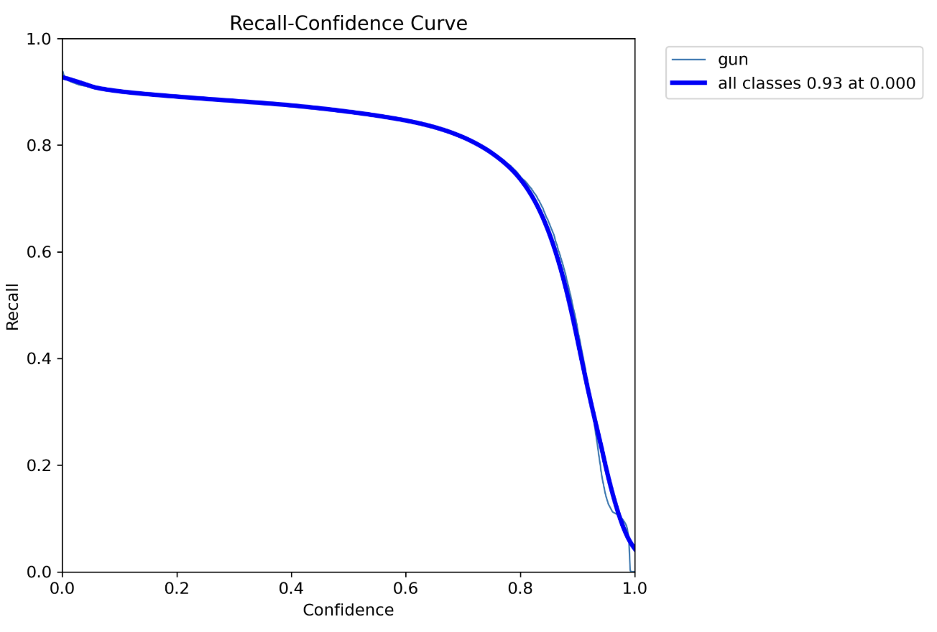

Although the training result is promising, our experience is that our previous model performs badly on certain videos manually stitched together. To select the best model checkpoint for the system, two comparisons are made against the video: one is to extract from the video 42 image frames and run object (gun) detection, and the other is run the validation against the dataset manually annotated of the whole video. Checkpoint epoch15.pt is the baseline that was previously trained.

Table 1. Gun detection of 42 images.

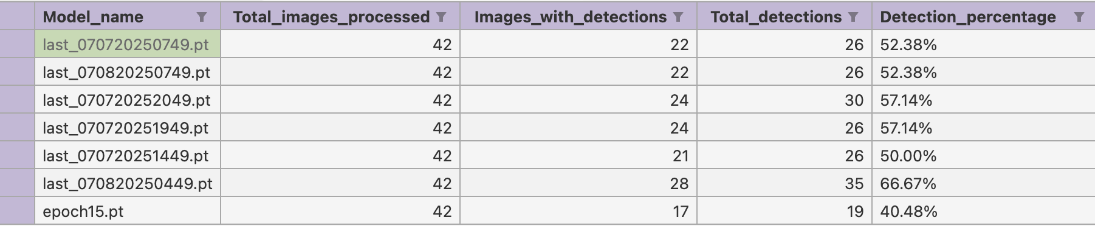

Table 2. Validation against dataset (sorted by mAP50)

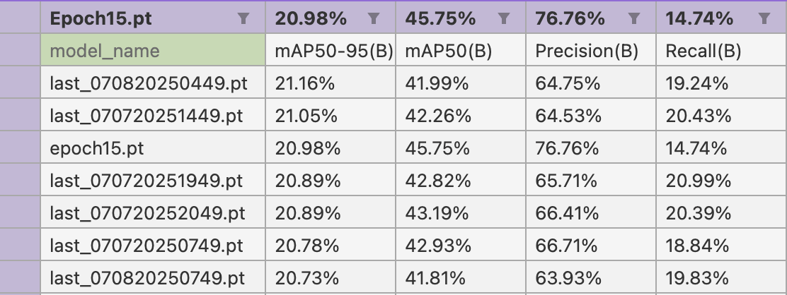
The selection criteria is having higher detection rate (recall rate) with certain tolerance of lower precision rate, and thus we select a balanced checkpoint (070820250449.pt) as our best model for the system.

The Preprocessor

The purpose of the preprocessor is to extract relevant, best-quality image frames from the video input. It consists of two main modules, motion detection module and best-sharpness frame selection module, to achieve this goal.

The best sharpness frame selection module is to select the frame containing the moving object that has the sharpest edge among a range of image frames (in a window). The process logic: for the current image frame, it is compared with its previous frame in the window by finding the moving object of between them, and applying Laplacian operator (using CV2 library) - the higher variance of Laplacian output corresponds to a sharper image, shown in the psudo-code:

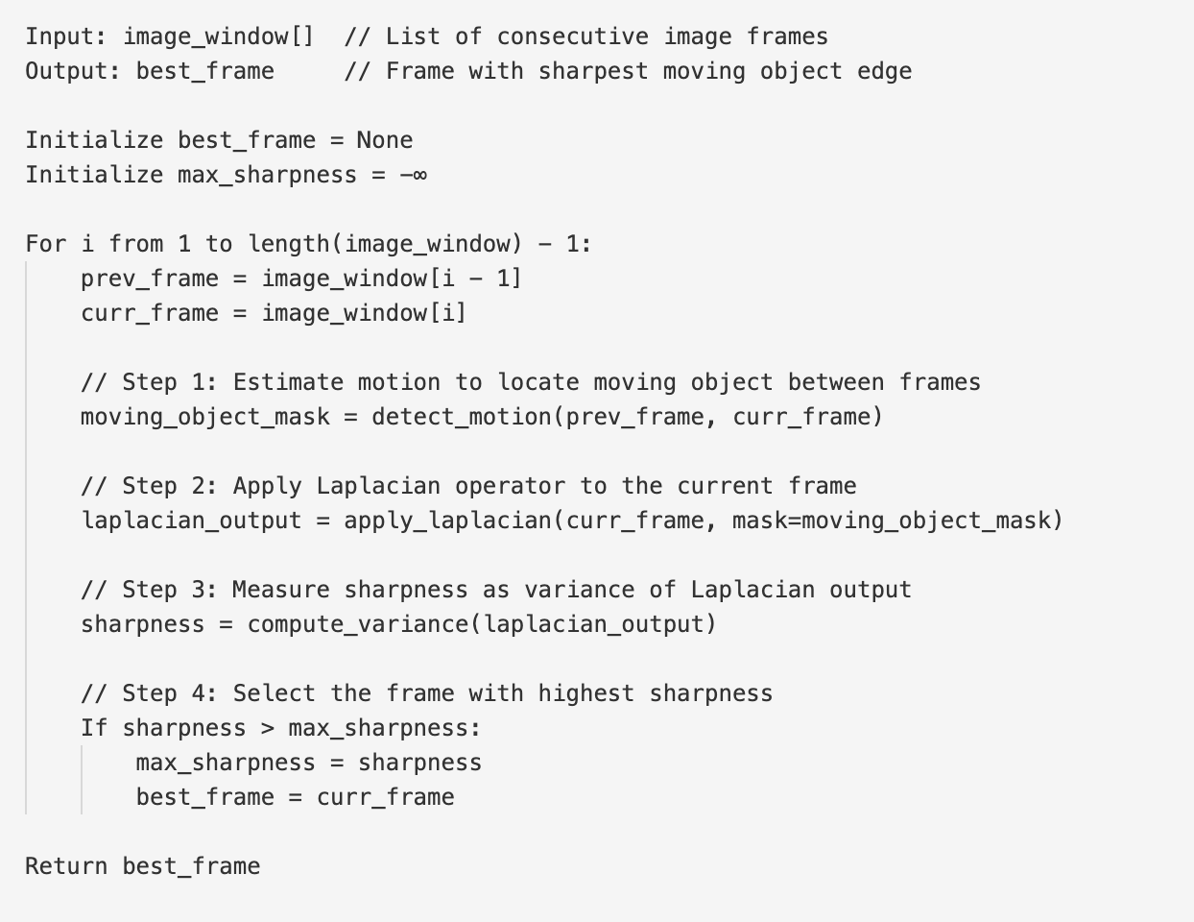

The motion detection module is to select scene-change frames by filtering out the still/static image frames that do not provide value to the system. Key is to iteratively analyze the consecutive image frames for motion detection, if the detected motion change is greater than threshold, then the image frame is saved, otherwise continue to analyze the next image frame.

Three methods are evaluated for scene change: compare histograms, compare motion, and compare features:

Compare histograms: compare histograms of two consecutive image frames, and if the difference is greater than threshold, then there are enough scene changes for these two images.

Compare motion: compare motion change by calculating percentage of changed pixels, and if the percentage is greater than threshold, then there are enough scene changes.

Compare features: apply ORB (Oriented FAST and Rotated BRIEF) algorithm to detect multi-view scene features, and if feature changes between two image frames is greater than threshold, then there are enough scene changes.

The experiment results show that histogram detecting change requires large movements of the people in surveillance video frames, unless the threshold is set very low. The ORB algorithm treats almost all frames having the same features due to the surveillance nature that large static backgrounds, resulting in very few frames selected. The motion comparison results in a good selection of frames that can easily be tuned by the threshold. In the end, the motion comparison method is used for the preprocessor.

The Postprocessor

Although the fine-tuned Yolo has fair detection rate on validation during training (about % recall rate and % precision rate), but in the test video given to us, the detection rate is very low (about 20% of recall). The video is manually created and the whole scene is very difficult to detect weapons, even with human eyes. For example, when a gun is waved around when the person holding it passes by, some video frames will not show, or only partially show the gun held, or the gun could be blocked by the crowd. A couple of the images are shown below:

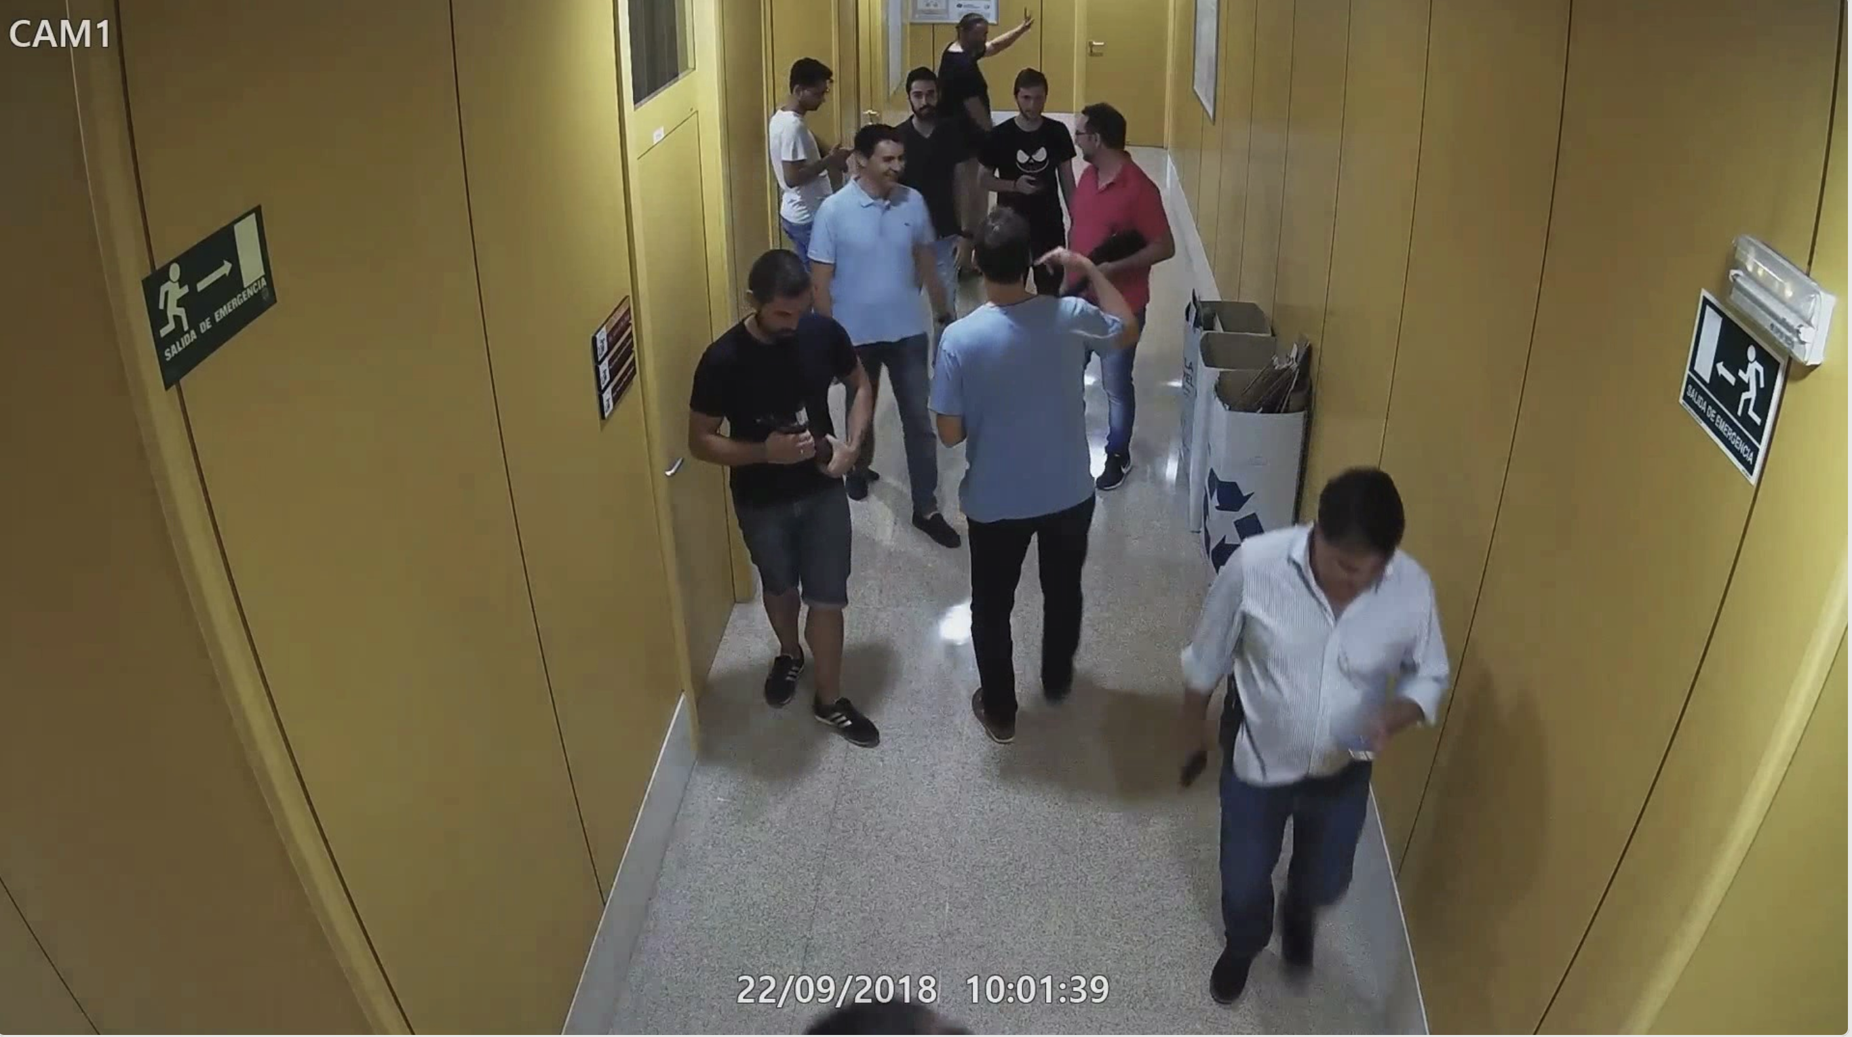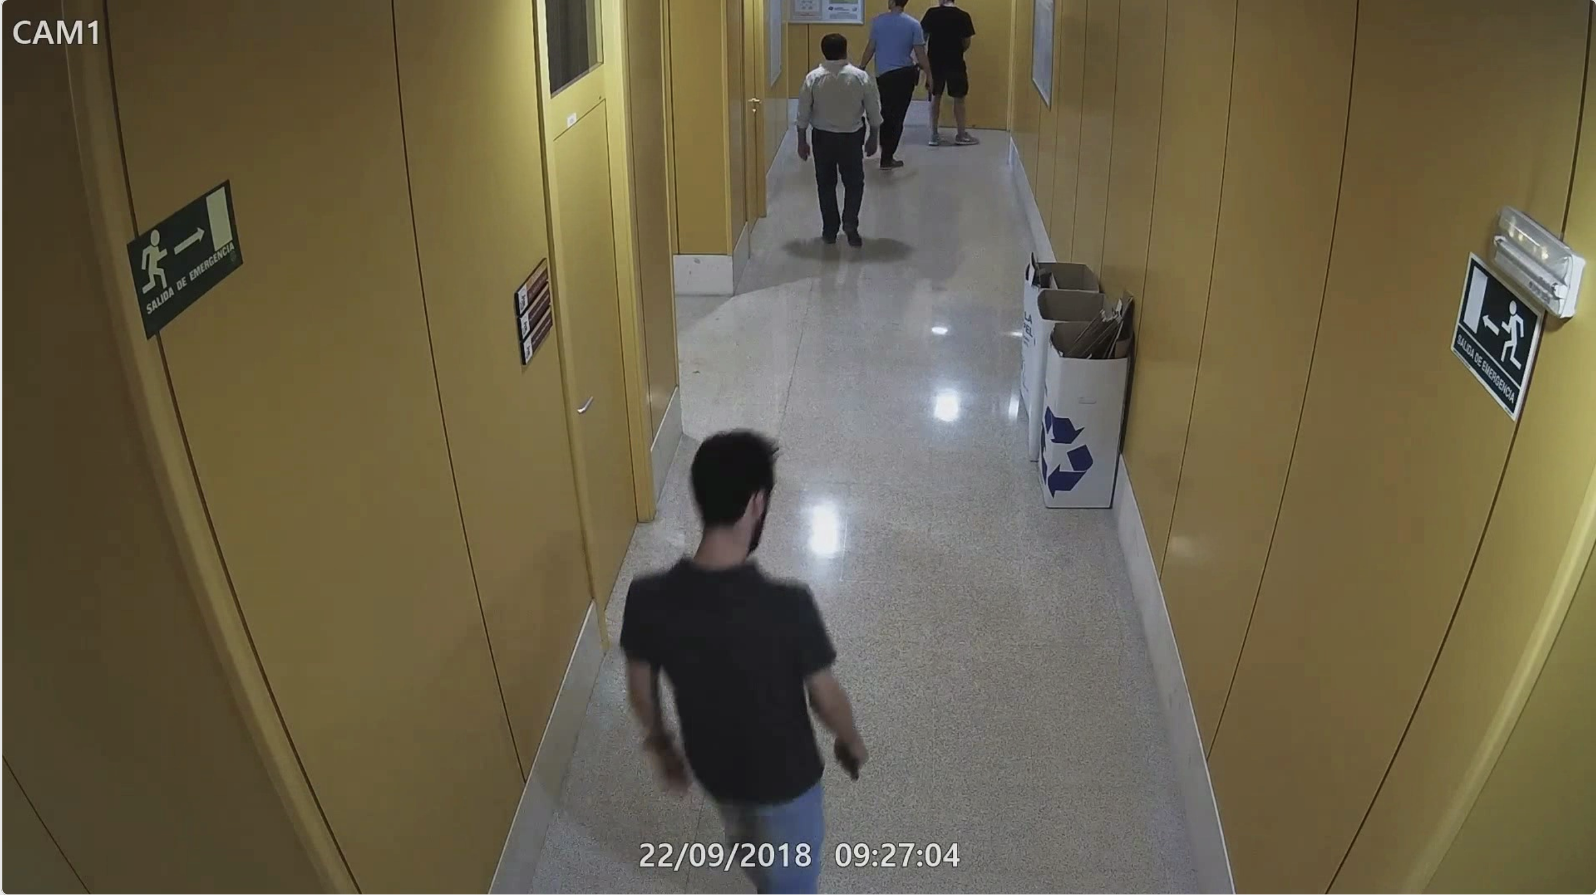

The further training of model detection has diminishing returns and can only slightly improve the detection rate for these test videos. We build the postprocessor to enhance the overall detectability of these videos.

The core idea of postprocessor is to build the spatio-temporal relationship between an anchor object (person holding the gun) and the target object (the gun), where the Yolo model has way better detection rate to detect and track human (the anchor), and thus we can create a video track for this human and associate the gun held by this person to this track. With reasonable time window assumption for the track, we conclude the gun is detected for the whole track, even if the gun detection is lost for some image frames in the track.

The postprocessor consists of track-building module and weapon-association module.

Track-building module is to track each person (anchor object in our system) throughout the video frames. We use Yolo tracking feature to conduct the tracking, whose algorithm detects person and keeps track of this person in the subsequent image frames over time. The output of tracking module is a list of image frame lists that each image list has a unique track ID identifying the person in this image frame list.

Yolo tracking takes customizable parameters to adjust the tracking, for example, we can set ‘track_buffer’, which is “Buffer used to indicate the number of frames lost tracks should be kept alive before getting removed. Higher value means more tolerance for occlusion”. Below is the configuration for Yolo tracking:

“
appearance_thresh: 0.8
fuse_score: true
gmc_method: sparseOptFlow
match_thresh: 0.8
model: auto
new_track_thresh: 0.25
proximity_thresh: 0.5
track_buffer: 25.0
track_high_thresh: 0.25
track_low_thresh: 0.1
tracker_type: botsort
with_reid: false
”

Weapon association module is to associate detected gun to the person in a track. The association algorithm is to calculate distances between centroids of bounding boxes of gun and people in an image frame, and the gun is associated with one person object that has minimal distance among all distances.

[Formula]

The association algorithm is sufficient for simple scenarios where a lone person is holding a gun or the person is in not crowded background. However, in a crowded situation (below image as an example), two people’s bounding boxes could be close and the calculated minimal distance causes the gun to be assigned to the wrong person.
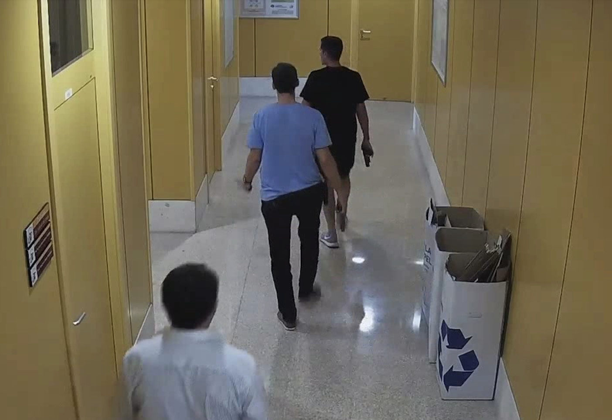

Our current implementation does not implement a remedy for this type of scenario, because although this type of mis-association reduces the precision/recall rate, from the track’s point of view, a few other image frames with solid correct associations make the gun association with whole track correct.

However, we propose a ‘look-back’ algorithm to alleviate this type of error, where in one frame differences between distances of gun from other people are less than threshold, we look back in time of preceding image frames in this track to see if a gun has already been associated with the person of this track (recall that a track is tracking this one person in a crowd). If a gun has been associated with this person before, then we will assign the gun to this person in the current frame.

The Result

We test the whole system on the Cam1 video manually stitched together, the whole result is listed in Appendix II. The highlight of the statistics is explained in the following:

--- Global Statistics ---
Total frames processed: 370
Frames with raw detections: 146
Pre-tracking detection rate: 39.46%
Frames in tracks with detections (post-processing): 312
Post-tracking effective rate: 84.32%
Total tracks generated: 60
Number of tracks with at least one detection: 38
Track detection ratio (tracks with gun detections / total tracks): 63.33%

The whole video is about 5-minute long and after the preprocessor extracts 370 frames (motion + best sharpness). The fine-tuned Yolo model detects guns in 146 frames, about 39% of detection rate. After postprocessing, 38 tracks in total 60 tracks built are detected with guns, about 63%.

--- Overall Track Statistics ---

- Per-Track Analysis (all tracks):
- True Positives (TP): 24
- False Positives (FP): 14
- True Negatives (TN): 16
- False Negatives (FN): 6
- Precision: 0.632
- Recall: 0.800
- F1-Score: 0.706

For these 38 detections of all 60 tracks, 24 are True Positive, 14 are False Positive. Overall, we achieve 63% precision rate and 80% of recall rate. Without the postprocessing, our raw recall rate for the gun detection is about 22% - the system shows much improvement on the gun detection.

Appendix I. Datasets for System Training

Datasets -
1https://deepknowledge-us.github.io/US-Real-time-gun-detection-in-CCTV-An-open-problem-dataset/

The dataset utilized in this work was sourced from the publicly available repository provided by Deep Knowledge US, accessible at https://deepknowledge-us.github.io/US-Real-time-gun-detection-in-CCTV-An-open-problem-dataset/. This repository comprises annotated frames captured from CCTV footage specifically for the task of real-time gun detection.
We downloaded the frames from this dataset at a frame rate of 2 frames per second (FPS), accompanied by detailed annotations specifying the bounding box locations of firearms within each frame. To facilitate more realistic and practical testing scenarios, we converted these frames into continuous video sequences. This conversion was critical for developing and validating our post-processing methods, particularly enabling us to leverage temporal tracking information rather than relying solely on isolated frame-based detections.
By constructing videos from the annotated frames, we were able to apply and evaluate tracking algorithms that follow the movement of detected firearms across sequential frames. This approach provided a richer and more reliable detection mechanism, improving both detection continuity and reducing false positives, thus enhancing the practical applicability of our method in real-world surveillance scenarios.
2) https://www.sciencedirect.com/science/article/pii/S2352340924000040

The dataset utilized for this research was the “Firearm-related action recognition and object detection dataset for video surveillance systems,” which consists of 398 videos featuring individuals performing distinct actions relevant to firearm surveillance scenarios. Each video was carefully annotated by experts in COCO-standard JSON format, providing precise bounding boxes around detected objects. The dataset contains three key categories: “Handgun,” “Machine_Gun,” and “No_Gun,” designed to facilitate targeted object detection and classification.

This dataset was crucial for training two different algorithms in our research:
- Classification Algorithm: A classifier based on a small ResNet architecture was trained specifically to distinguish between handguns and machine guns. This step was critical in further classifying detected firearms into these two categories.
- YOLO Object Detection: The dataset was also extensively employed for training YOLO (You Only Look Once) models. However, it is important to note that the dataset included several images with significant motion blur, which could not be entirely removed. Consequently, these blurred images were inadvertently included in YOLO training, potentially influencing the accuracy of firearm detection.

The dataset is structured clearly with separate folders for each firearm category, and each video folder contains the corresponding .mp4 video files along with the annotation files (.json).

We extend our sincere gratitude to the annotators for their meticulous effort in manually labeling this comprehensive dataset. Their contributions significantly enhanced the quality and utility of the data, directly impacting the reliability and effectiveness of the algorithms trained. Their diligent annotations have made it possible to advance research and applications in firearm detection and security surveillance systems.

- https://www.imfdb.org/wiki/Main_Page
We constructed a large-scale, diverse gun detection dataset by leveraging web crawling techniques and manual annotation workflows. Specifically, we developed a web crawler using Selenium to systematically extract approximately 1,000,000 high-resolution images containing firearms from the Internet Movie Firearms Database (IMFDB) (https://www.imfdb.org/wiki/Main_Page). Selenium enabled efficient automation by programmatically navigating through the website, interacting with dynamic content, and downloading images systematically, ensuring comprehensive coverage and dataset richness.
The collected images featured excellent visual clarity but initially lacked structured annotations necessary for training object detection algorithms. To address this, we utilized Roboflow, a robust annotation platform, to manually label the images. Given the massive scale of the collected dataset, we segmented it into manageable subsets, each containing 10,000 images. This approach streamlined the annotation process, facilitating thorough and precise labeling.

Roboflow significantly accelerated our annotation efforts through its semi-automated annotation tools. As manual labeling progressed, Roboflow’s built-in assistive models learned incrementally, continuously improving annotation speed and accuracy by suggesting bounding boxes and labels. This interactive and iterative annotation method allowed us to efficiently scale up our labeling operations without sacrificing annotation quality.

The finalized annotated subsets were subsequently employed to train YOLO (You Only Look Once), a state-of-the-art object detection algorithm, achieving reliable firearm detection. A key strength of this dataset was its diversity, encompassing a broad spectrum of firearm types and configurations drawn from cinematic contexts, making it uniquely comprehensive and suitable for training highly generalized gun detection models.

Other datasets that were used in the training -

🎯 YouTube‑GDD (YouTube Gun Detection Dataset)
- Path: e.g. .../YouTube‑GDD/train/images
- Details: Created from 343 HD YouTube videos, comprising 5,000 annotated frames with 16,064 gun instancesand 9,046 person instances .
- Citation: Yongxiang Gu et al., YouTube‑GDD: A challenging gun detection dataset with rich contextual information, arXiv, March 8 2022 .

🛡️ Threat Detection / Gun Detection Datasets (Roboflow Universe)
- Paths:
  - .../Threat Detection Done 2/train/images
  - .../Threat Detection‑2/train/images
  - .../gun‑2/train/images
  - .../guns‑2/train/images
  - .../nosrep_nug/train/images etc.
- Details: These include multiple related Roboflow projects:
  - “threat-detection” dataset (~9.6 k weapon‑related images, multiple classes, real‑world conditions) .
  - A smaller “gun‑dataset” (~115 images) created by the same group (~Threat Detection) .

🧰 Weapon Detection / Multi‑weapon datasets (Roboflow Universe)
- Paths:
  - .../Weapon detection‑2/train/images
  - .../WeaponD/train/images
  - .../proj3/train/images
  - .../weapon_detection/train/images
- Details: These refer to the “weapon‑detection” project (9.7 k open‑source weapon images, multi‑class including guns, knives, etc.) authored by user yolov7test on Roboflow .

Appendix II. Statistics of Detection for Cam1 Video
--- Global Statistics ---
Total frames processed: 370
Frames with raw detections: 146
Pre-tracking detection rate: 39.46%
Frames in tracks with detections (post-processing): 312
Post-tracking effective rate: 84.32%
Total tracks generated: 60
Number of tracks with at least one detection: 38
Track detection ratio (tracks with gun detections / total tracks): 63.33%

--- Per-Track Statistics ---

Track ID: 2_split0
- Time Duration: 11.50 seconds.
- Total frames in track: 23
- Frames with detections: 2
- Frames of detections accepted by IOU: 2
- Best confidence of detections: 0.58
- Average confidence of detections: 0.54
- Best IOU of detections: 0.74
- Average IOU of detections: 0.74

- Per-Frame Analysis (within track ID 2_split0):
- True Positives (TP): 2
- False Positives (FP): 0
- True Negatives (TN): 10
- False Negatives (FN): 11
- Precision: 1.000
- Recall: 0.154
- F1-Score: 0.267

Track ID: 5_split0
- Time Duration: 11.00 seconds.
- Total frames in track: 22
- Frames with detections: 4
- Frames of detections accepted by IOU: 2
- Best confidence of detections: 0.58
- Average confidence of detections: 0.45
- Best IOU of detections: 0.55
- Average IOU of detections: 0.40

- Per-Frame Analysis (within track ID 5_split0):
- True Positives (TP): 3
- False Positives (FP): 1
- True Negatives (TN): 10
- False Negatives (FN): 8
- Precision: 0.750
- Recall: 0.273
- F1-Score: 0.400

Track ID: 8_split0
- Time Duration: 8.00 seconds.
- Total frames in track: 16
- Frames with detections: 0
- Frames of detections accepted by IOU: 0
- Best confidence of detections: 0.00
- Average confidence of detections: 0.00
- Best IOU of detections: 0.00
- Average IOU of detections: 0.00

- Per-Frame Analysis (within track ID 8_split0):
- True Positives (TP): 0
- False Positives (FP): 0
- True Negatives (TN): 16
- False Negatives (FN): 0
- Precision: 0.000
- Recall: 0.000
- F1-Score: 0.000

Track ID: 14_split0
- Time Duration: 6.00 seconds.
- Total frames in track: 13
- Frames with detections: 7
- Frames of detections accepted by IOU: 7
- Best confidence of detections: 0.68
- Average confidence of detections: 0.56
- Best IOU of detections: 0.97
- Average IOU of detections: 0.82

- Per-Frame Analysis (within track ID 14_split0):
- True Positives (TP): 7
- False Positives (FP): 0
- True Negatives (TN): 0
- False Negatives (FN): 6
- Precision: 1.000
- Recall: 0.538
- F1-Score: 0.700

Track ID: 17_split0
- Time Duration: 7.50 seconds.
- Total frames in track: 14
- Frames with detections: 5
- Frames of detections accepted by IOU: 5
- Best confidence of detections: 0.65
- Average confidence of detections: 0.60
- Best IOU of detections: 0.89
- Average IOU of detections: 0.77

- Per-Frame Analysis (within track ID 17_split0):
- True Positives (TP): 5
- False Positives (FP): 0
- True Negatives (TN): 0
- False Negatives (FN): 9
- Precision: 1.000
- Recall: 0.357
- F1-Score: 0.526

Track ID: 22_split0
- Time Duration: 5.50 seconds.
- Total frames in track: 9
- Frames with detections: 7
- Frames of detections accepted by IOU: 7
- Best confidence of detections: 0.71
- Average confidence of detections: 0.63
- Best IOU of detections: 0.90
- Average IOU of detections: 0.79

- Per-Frame Analysis (within track ID 22_split0):
- True Positives (TP): 7
- False Positives (FP): 0
- True Negatives (TN): 0
- False Negatives (FN): 2
- Precision: 1.000
- Recall: 0.778
- F1-Score: 0.875

Track ID: 26_split0
- Time Duration: 7.00 seconds.
- Total frames in track: 15
- Frames with detections: 3
- Frames of detections accepted by IOU: 3
- Best confidence of detections: 0.70
- Average confidence of detections: 0.69
- Best IOU of detections: 0.85
- Average IOU of detections: 0.78

- Per-Frame Analysis (within track ID 26_split0):
- True Positives (TP): 3
- False Positives (FP): 0
- True Negatives (TN): 4
- False Negatives (FN): 8
- Precision: 1.000
- Recall: 0.273
- F1-Score: 0.429

Track ID: 29_split0
- Time Duration: 6.50 seconds.
- Total frames in track: 14
- Frames with detections: 7
- Frames of detections accepted by IOU: 0
- Best confidence of detections: 0.67
- Average confidence of detections: 0.55
- Best IOU of detections: 0.00
- Average IOU of detections: 0.00

- Per-Frame Analysis (within track ID 29_split0):
- True Positives (TP): 0
- False Positives (FP): 7
- True Negatives (TN): 5
- False Negatives (FN): 2
- Precision: 0.000
- Recall: 0.000
- F1-Score: 0.000

Track ID: 32_split0
- Time Duration: 4.50 seconds.
- Total frames in track: 9
- Frames with detections: 8
- Frames of detections accepted by IOU: 6
- Best confidence of detections: 0.73
- Average confidence of detections: 0.57
- Best IOU of detections: 0.79
- Average IOU of detections: 0.51

- Per-Frame Analysis (within track ID 32_split0):
- True Positives (TP): 7
- False Positives (FP): 1
- True Negatives (TN): 1
- False Negatives (FN): 0
- Precision: 0.875
- Recall: 1.000
- F1-Score: 0.933

Track ID: 38_split0
- Time Duration: 9.50 seconds.
- Total frames in track: 19
- Frames with detections: 6
- Frames of detections accepted by IOU: 5
- Best confidence of detections: 0.69
- Average confidence of detections: 0.58
- Best IOU of detections: 0.81
- Average IOU of detections: 0.62

- Per-Frame Analysis (within track ID 38_split0):
- True Positives (TP): 6
- False Positives (FP): 0
- True Negatives (TN): 0
- False Negatives (FN): 13
- Precision: 1.000
- Recall: 0.316
- F1-Score: 0.480

Track ID: 42_split0
- Time Duration: 5.50 seconds.
- Total frames in track: 10
- Frames with detections: 8
- Frames of detections accepted by IOU: 8
- Best confidence of detections: 0.68
- Average confidence of detections: 0.57
- Best IOU of detections: 0.88
- Average IOU of detections: 0.74

- Per-Frame Analysis (within track ID 42_split0):
- True Positives (TP): 8
- False Positives (FP): 0
- True Negatives (TN): 0
- False Negatives (FN): 2
- Precision: 1.000
- Recall: 0.800
- F1-Score: 0.889

Track ID: 43_split0
- Time Duration: 5.00 seconds.
- Total frames in track: 11
- Frames with detections: 4
- Frames of detections accepted by IOU: 2
- Best confidence of detections: 0.64
- Average confidence of detections: 0.52
- Best IOU of detections: 0.69
- Average IOU of detections: 0.62

- Per-Frame Analysis (within track ID 43_split0):
- True Positives (TP): 2
- False Positives (FP): 2
- True Negatives (TN): 3
- False Negatives (FN): 4
- Precision: 0.500
- Recall: 0.333
- F1-Score: 0.400

Track ID: 44_split0
- Time Duration: 7.00 seconds.
- Total frames in track: 15
- Frames with detections: 1
- Frames of detections accepted by IOU: 1
- Best confidence of detections: 0.35
- Average confidence of detections: 0.35
- Best IOU of detections: 0.82
- Average IOU of detections: 0.82

- Per-Frame Analysis (within track ID 44_split0):
- True Positives (TP): 1
- False Positives (FP): 0
- True Negatives (TN): 14
- False Negatives (FN): 0
- Precision: 1.000
- Recall: 1.000
- F1-Score: 1.000

Track ID: 52_split0
- Time Duration: 3.00 seconds.
- Total frames in track: 7
- Frames with detections: 2
- Frames of detections accepted by IOU: 0
- Best confidence of detections: 0.43
- Average confidence of detections: 0.41
- Best IOU of detections: 0.00
- Average IOU of detections: 0.00

- Per-Frame Analysis (within track ID 52_split0):
- True Positives (TP): 0
- False Positives (FP): 2
- True Negatives (TN): 5
- False Negatives (FN): 0
- Precision: 0.000
- Recall: 0.000
- F1-Score: 0.000

Track ID: 53_split0
- Time Duration: 16.00 seconds.
- Total frames in track: 27
- Frames with detections: 1
- Frames of detections accepted by IOU: 1
- Best confidence of detections: 0.67
- Average confidence of detections: 0.67
- Best IOU of detections: 0.78
- Average IOU of detections: 0.78

- Per-Frame Analysis (within track ID 53_split0):
- True Positives (TP): 1
- False Positives (FP): 0
- True Negatives (TN): 21
- False Negatives (FN): 5
- Precision: 1.000
- Recall: 0.167
- F1-Score: 0.286

Track ID: 62_split0
- Time Duration: 3.00 seconds.
- Total frames in track: 7
- Frames with detections: 0
- Frames of detections accepted by IOU: 0
- Best confidence of detections: 0.00
- Average confidence of detections: 0.00
- Best IOU of detections: 0.00
- Average IOU of detections: 0.00

- Per-Frame Analysis (within track ID 62_split0):
- True Positives (TP): 0
- False Positives (FP): 0
- True Negatives (TN): 5
- False Negatives (FN): 2
- Precision: 0.000
- Recall: 0.000
- F1-Score: 0.000

Track ID: 69_split0
- Time Duration: 2.50 seconds.
- Total frames in track: 6
- Frames with detections: 3
- Frames of detections accepted by IOU: 1
- Best confidence of detections: 0.50
- Average confidence of detections: 0.44
- Best IOU of detections: 0.60
- Average IOU of detections: 0.43

- Per-Frame Analysis (within track ID 69_split0):
- True Positives (TP): 3
- False Positives (FP): 0
- True Negatives (TN): 2
- False Negatives (FN): 1
- Precision: 1.000
- Recall: 0.750
- F1-Score: 0.857

Track ID: 75_split0
- Time Duration: 4.00 seconds.
- Total frames in track: 7
- Frames with detections: 0
- Frames of detections accepted by IOU: 0
- Best confidence of detections: 0.00
- Average confidence of detections: 0.00
- Best IOU of detections: 0.00
- Average IOU of detections: 0.00

- Per-Frame Analysis (within track ID 75_split0):
- True Positives (TP): 0
- False Positives (FP): 0
- True Negatives (TN): 6
- False Negatives (FN): 1
- Precision: 0.000
- Recall: 0.000
- F1-Score: 0.000

Track ID: 91_split0
- Time Duration: 6.50 seconds.
- Total frames in track: 13
- Frames with detections: 0
- Frames of detections accepted by IOU: 0
- Best confidence of detections: 0.00
- Average confidence of detections: 0.00
- Best IOU of detections: 0.00
- Average IOU of detections: 0.00

- Per-Frame Analysis (within track ID 91_split0):
- True Positives (TP): 0
- False Positives (FP): 0
- True Negatives (TN): 9
- False Negatives (FN): 4
- Precision: 0.000
- Recall: 0.000
- F1-Score: 0.000

Track ID: 94_split0
- Time Duration: 4.00 seconds.
- Total frames in track: 8
- Frames with detections: 1
- Frames of detections accepted by IOU: 1
- Best confidence of detections: 0.65
- Average confidence of detections: 0.65
- Best IOU of detections: 0.64
- Average IOU of detections: 0.64

- Per-Frame Analysis (within track ID 94_split0):
- True Positives (TP): 1
- False Positives (FP): 0
- True Negatives (TN): 6
- False Negatives (FN): 1
- Precision: 1.000
- Recall: 0.500
- F1-Score: 0.667

Track ID: 100_split0
- Time Duration: 3.00 seconds.
- Total frames in track: 6
- Frames with detections: 1
- Frames of detections accepted by IOU: 1
- Best confidence of detections: 0.51
- Average confidence of detections: 0.51
- Best IOU of detections: 0.64
- Average IOU of detections: 0.64

- Per-Frame Analysis (within track ID 100_split0):
- True Positives (TP): 1
- False Positives (FP): 0
- True Negatives (TN): 2
- False Negatives (FN): 3
- Precision: 1.000
- Recall: 0.250
- F1-Score: 0.400

Track ID: 94_split1
- Time Duration: 8.50 seconds.
- Total frames in track: 18
- Frames with detections: 2
- Frames of detections accepted by IOU: 0
- Best confidence of detections: 0.40
- Average confidence of detections: 0.38
- Best IOU of detections: 0.00
- Average IOU of detections: 0.00

- Per-Frame Analysis (within track ID 94_split1):
- True Positives (TP): 0
- False Positives (FP): 2
- True Negatives (TN): 16
- False Negatives (FN): 0
- Precision: 0.000
- Recall: 0.000
- F1-Score: 0.000

Track ID: 103_split0
- Time Duration: 4.50 seconds.
- Total frames in track: 10
- Frames with detections: 0
- Frames of detections accepted by IOU: 0
- Best confidence of detections: 0.00
- Average confidence of detections: 0.00
- Best IOU of detections: 0.00
- Average IOU of detections: 0.00

- Per-Frame Analysis (within track ID 103_split0):
- True Positives (TP): 0
- False Positives (FP): 0
- True Negatives (TN): 10
- False Negatives (FN): 0
- Precision: 0.000
- Recall: 0.000
- F1-Score: 0.000

Track ID: 105_split0
- Time Duration: 8.00 seconds.
- Total frames in track: 17
- Frames with detections: 1
- Frames of detections accepted by IOU: 0
- Best confidence of detections: 0.49
- Average confidence of detections: 0.49
- Best IOU of detections: 0.00
- Average IOU of detections: 0.00

- Per-Frame Analysis (within track ID 105_split0):
- True Positives (TP): 1
- False Positives (FP): 0
- True Negatives (TN): 3
- False Negatives (FN): 13
- Precision: 1.000
- Recall: 0.071
- F1-Score: 0.133

Track ID: -1_split6
- Time Duration: 6.50 seconds.
- Total frames in track: 4
- Frames with detections: 0
- Frames of detections accepted by IOU: 0
- Best confidence of detections: 0.00
- Average confidence of detections: 0.00
- Best IOU of detections: 0.00
- Average IOU of detections: 0.00

- Per-Frame Analysis (within track ID -1_split6):
- True Positives (TP): 0
- False Positives (FP): 0
- True Negatives (TN): 4
- False Negatives (FN): 0
- Precision: 0.000
- Recall: 0.000
- F1-Score: 0.000

Track ID: 113_split0
- Time Duration: 6.00 seconds.
- Total frames in track: 11
- Frames with detections: 2
- Frames of detections accepted by IOU: 0
- Best confidence of detections: 0.60
- Average confidence of detections: 0.52
- Best IOU of detections: 0.00
- Average IOU of detections: 0.00

- Per-Frame Analysis (within track ID 113_split0):
- True Positives (TP): 0
- False Positives (FP): 2
- True Negatives (TN): 9
- False Negatives (FN): 0
- Precision: 0.000
- Recall: 0.000
- F1-Score: 0.000

Track ID: 115_split0
- Time Duration: 4.00 seconds.
- Total frames in track: 7
- Frames with detections: 0
- Frames of detections accepted by IOU: 0
- Best confidence of detections: 0.00
- Average confidence of detections: 0.00
- Best IOU of detections: 0.00
- Average IOU of detections: 0.00

- Per-Frame Analysis (within track ID 115_split0):
- True Positives (TP): 0
- False Positives (FP): 0
- True Negatives (TN): 6
- False Negatives (FN): 1
- Precision: 0.000
- Recall: 0.000
- F1-Score: 0.000

Track ID: 119_split0
- Time Duration: 6.00 seconds.
- Total frames in track: 10
- Frames with detections: 0
- Frames of detections accepted by IOU: 0
- Best confidence of detections: 0.00
- Average confidence of detections: 0.00
- Best IOU of detections: 0.00
- Average IOU of detections: 0.00

- Per-Frame Analysis (within track ID 119_split0):
- True Positives (TP): 0
- False Positives (FP): 0
- True Negatives (TN): 10
- False Negatives (FN): 0
- Precision: 0.000
- Recall: 0.000
- F1-Score: 0.000

Track ID: 125_split0
- Time Duration: 6.00 seconds.
- Total frames in track: 13
- Frames with detections: 1
- Frames of detections accepted by IOU: 0
- Best confidence of detections: 0.38
- Average confidence of detections: 0.38
- Best IOU of detections: 0.00
- Average IOU of detections: 0.00

- Per-Frame Analysis (within track ID 125_split0):
- True Positives (TP): 0
- False Positives (FP): 1
- True Negatives (TN): 12
- False Negatives (FN): 0
- Precision: 0.000
- Recall: 0.000
- F1-Score: 0.000

Track ID: 126_split0
- Time Duration: 6.00 seconds.
- Total frames in track: 13
- Frames with detections: 0
- Frames of detections accepted by IOU: 0
- Best confidence of detections: 0.00
- Average confidence of detections: 0.00
- Best IOU of detections: 0.00
- Average IOU of detections: 0.00

- Per-Frame Analysis (within track ID 126_split0):
- True Positives (TP): 0
- False Positives (FP): 0
- True Negatives (TN): 13
- False Negatives (FN): 0
- Precision: 0.000
- Recall: 0.000
- F1-Score: 0.000

Track ID: 131_split0
- Time Duration: 7.50 seconds.
- Total frames in track: 14
- Frames with detections: 0
- Frames of detections accepted by IOU: 0
- Best confidence of detections: 0.00
- Average confidence of detections: 0.00
- Best IOU of detections: 0.00
- Average IOU of detections: 0.00

- Per-Frame Analysis (within track ID 131_split0):
- True Positives (TP): 0
- False Positives (FP): 0
- True Negatives (TN): 14
- False Negatives (FN): 0
- Precision: 0.000
- Recall: 0.000
- F1-Score: 0.000

Track ID: 134_split0
- Time Duration: 5.83 seconds.
- Total frames in track: 11
- Frames with detections: 0
- Frames of detections accepted by IOU: 0
- Best confidence of detections: 0.00
- Average confidence of detections: 0.00
- Best IOU of detections: 0.00
- Average IOU of detections: 0.00

- Per-Frame Analysis (within track ID 134_split0):
- True Positives (TP): 0
- False Positives (FP): 0
- True Negatives (TN): 11
- False Negatives (FN): 0
- Precision: 0.000
- Recall: 0.000
- F1-Score: 0.000

Track ID: -1_split10
- Time Duration: 5.00 seconds.
- Total frames in track: 5
- Frames with detections: 1
- Frames of detections accepted by IOU: 1
- Best confidence of detections: 0.52
- Average confidence of detections: 0.52
- Best IOU of detections: 0.62
- Average IOU of detections: 0.62

- Per-Frame Analysis (within track ID -1_split10):
- True Positives (TP): 1
- False Positives (FP): 0
- True Negatives (TN): 3
- False Negatives (FN): 1
- Precision: 1.000
- Recall: 0.500
- F1-Score: 0.667

Track ID: 144_split0
- Time Duration: 6.00 seconds.
- Total frames in track: 7
- Frames with detections: 1
- Frames of detections accepted by IOU: 1
- Best confidence of detections: 0.62
- Average confidence of detections: 0.62
- Best IOU of detections: 0.54
- Average IOU of detections: 0.54

- Per-Frame Analysis (within track ID 144_split0):
- True Positives (TP): 1
- False Positives (FP): 0
- True Negatives (TN): 3
- False Negatives (FN): 3
- Precision: 1.000
- Recall: 0.250
- F1-Score: 0.400

Track ID: 146_split0
- Time Duration: 2.50 seconds.
- Total frames in track: 6
- Frames with detections: 6
- Frames of detections accepted by IOU: 5
- Best confidence of detections: 0.73
- Average confidence of detections: 0.58
- Best IOU of detections: 0.90
- Average IOU of detections: 0.70

- Per-Frame Analysis (within track ID 146_split0):
- True Positives (TP): 6
- False Positives (FP): 0
- True Negatives (TN): 0
- False Negatives (FN): 0
- Precision: 1.000
- Recall: 1.000
- F1-Score: 1.000

Track ID: 140_split1
- Time Duration: 2.50 seconds.
- Total frames in track: 6
- Frames with detections: 2
- Frames of detections accepted by IOU: 2
- Best confidence of detections: 0.61
- Average confidence of detections: 0.55
- Best IOU of detections: 0.86
- Average IOU of detections: 0.68

- Per-Frame Analysis (within track ID 140_split1):
- True Positives (TP): 2
- False Positives (FP): 0
- True Negatives (TN): 3
- False Negatives (FN): 1
- Precision: 1.000
- Recall: 0.667
- F1-Score: 0.800

Track ID: 144_split1
- Time Duration: 3.00 seconds.
- Total frames in track: 7
- Frames with detections: 2
- Frames of detections accepted by IOU: 0
- Best confidence of detections: 0.60
- Average confidence of detections: 0.57
- Best IOU of detections: 0.00
- Average IOU of detections: 0.00

- Per-Frame Analysis (within track ID 144_split1):
- True Positives (TP): 0
- False Positives (FP): 2
- True Negatives (TN): 5
- False Negatives (FN): 0
- Precision: 0.000
- Recall: 0.000
- F1-Score: 0.000

Track ID: 151_split0
- Time Duration: 4.50 seconds.
- Total frames in track: 10
- Frames with detections: 1
- Frames of detections accepted by IOU: 0
- Best confidence of detections: 0.47
- Average confidence of detections: 0.47
- Best IOU of detections: 0.00
- Average IOU of detections: 0.00

- Per-Frame Analysis (within track ID 151_split0):
- True Positives (TP): 0
- False Positives (FP): 1
- True Negatives (TN): 9
- False Negatives (FN): 0
- Precision: 0.000
- Recall: 0.000
- F1-Score: 0.000

Track ID: 131_split3
- Time Duration: 2.50 seconds.
- Total frames in track: 6
- Frames with detections: 2
- Frames of detections accepted by IOU: 0
- Best confidence of detections: 0.48
- Average confidence of detections: 0.45
- Best IOU of detections: 0.00
- Average IOU of detections: 0.00

- Per-Frame Analysis (within track ID 131_split3):
- True Positives (TP): 0
- False Positives (FP): 2
- True Negatives (TN): 4
- False Negatives (FN): 0
- Precision: 0.000
- Recall: 0.000
- F1-Score: 0.000

Track ID: 172_split0
- Time Duration: 11.50 seconds.
- Total frames in track: 16
- Frames with detections: 3
- Frames of detections accepted by IOU: 0
- Best confidence of detections: 0.65
- Average confidence of detections: 0.54
- Best IOU of detections: 0.00
- Average IOU of detections: 0.00

- Per-Frame Analysis (within track ID 172_split0):
- True Positives (TP): 0
- False Positives (FP): 3
- True Negatives (TN): 13
- False Negatives (FN): 0
- Precision: 0.000
- Recall: 0.000
- F1-Score: 0.000

Track ID: 166_split2
- Time Duration: 12.00 seconds.
- Total frames in track: 17
- Frames with detections: 3
- Frames of detections accepted by IOU: 0
- Best confidence of detections: 0.50
- Average confidence of detections: 0.46
- Best IOU of detections: 0.00
- Average IOU of detections: 0.00

- Per-Frame Analysis (within track ID 166_split2):
- True Positives (TP): 0
- False Positives (FP): 3
- True Negatives (TN): 14
- False Negatives (FN): 0
- Precision: 0.000
- Recall: 0.000
- F1-Score: 0.000

Track ID: 173_split0
- Time Duration: 49.50 seconds.
- Total frames in track: 74
- Frames with detections: 4
- Frames of detections accepted by IOU: 0
- Best confidence of detections: 0.51
- Average confidence of detections: 0.44
- Best IOU of detections: 0.00
- Average IOU of detections: 0.00

- Per-Frame Analysis (within track ID 173_split0):
- True Positives (TP): 0
- False Positives (FP): 4
- True Negatives (TN): 70
- False Negatives (FN): 0
- Precision: 0.000
- Recall: 0.000
- F1-Score: 0.000

Track ID: 178_split0
- Time Duration: 14.00 seconds.
- Total frames in track: 25
- Frames with detections: 8
- Frames of detections accepted by IOU: 5
- Best confidence of detections: 0.64
- Average confidence of detections: 0.50
- Best IOU of detections: 0.89
- Average IOU of detections: 0.40

- Per-Frame Analysis (within track ID 178_split0):
- True Positives (TP): 8
- False Positives (FP): 0
- True Negatives (TN): 7
- False Negatives (FN): 10
- Precision: 1.000
- Recall: 0.444
- F1-Score: 0.615

Track ID: 179_split0
- Time Duration: 2.50 seconds.
- Total frames in track: 6
- Frames with detections: 3
- Frames of detections accepted by IOU: 1
- Best confidence of detections: 0.60
- Average confidence of detections: 0.46
- Best IOU of detections: 0.52
- Average IOU of detections: 0.20

- Per-Frame Analysis (within track ID 179_split0):
- True Positives (TP): 3
- False Positives (FP): 0
- True Negatives (TN): 1
- False Negatives (FN): 2
- Precision: 1.000
- Recall: 0.600
- F1-Score: 0.750

Track ID: 181_split0
- Time Duration: 40.50 seconds.
- Total frames in track: 73
- Frames with detections: 26
- Frames of detections accepted by IOU: 14
- Best confidence of detections: 0.71
- Average confidence of detections: 0.49
- Best IOU of detections: 0.86
- Average IOU of detections: 0.51

- Per-Frame Analysis (within track ID 181_split0):
- True Positives (TP): 26
- False Positives (FP): 0
- True Negatives (TN): 8
- False Negatives (FN): 39
- Precision: 1.000
- Recall: 0.400
- F1-Score: 0.571

Track ID: 182_split0
- Time Duration: 5.50 seconds.
- Total frames in track: 10
- Frames with detections: 0
- Frames of detections accepted by IOU: 0
- Best confidence of detections: 0.00
- Average confidence of detections: 0.00
- Best IOU of detections: 0.00
- Average IOU of detections: 0.00

- Per-Frame Analysis (within track ID 182_split0):
- True Positives (TP): 0
- False Positives (FP): 0
- True Negatives (TN): 10
- False Negatives (FN): 0
- Precision: 0.000
- Recall: 0.000
- F1-Score: 0.000

Track ID: 193_split0
- Time Duration: 36.00 seconds.
- Total frames in track: 64
- Frames with detections: 2
- Frames of detections accepted by IOU: 0
- Best confidence of detections: 0.42
- Average confidence of detections: 0.41
- Best IOU of detections: 0.00
- Average IOU of detections: 0.00

- Per-Frame Analysis (within track ID 193_split0):
- True Positives (TP): 0
- False Positives (FP): 2
- True Negatives (TN): 43
- False Negatives (FN): 19
- Precision: 0.000
- Recall: 0.000
- F1-Score: 0.000

Track ID: 195_split0
- Time Duration: 7.50 seconds.
- Total frames in track: 13
- Frames with detections: 0
- Frames of detections accepted by IOU: 0
- Best confidence of detections: 0.00
- Average confidence of detections: 0.00
- Best IOU of detections: 0.00
- Average IOU of detections: 0.00

- Per-Frame Analysis (within track ID 195_split0):
- True Positives (TP): 0
- False Positives (FP): 0
- True Negatives (TN): 13
- False Negatives (FN): 0
- Precision: 0.000
- Recall: 0.000
- F1-Score: 0.000

Track ID: 198_split0
- Time Duration: 5.00 seconds.
- Total frames in track: 8
- Frames with detections: 0
- Frames of detections accepted by IOU: 0
- Best confidence of detections: 0.00
- Average confidence of detections: 0.00
- Best IOU of detections: 0.00
- Average IOU of detections: 0.00

- Per-Frame Analysis (within track ID 198_split0):
- True Positives (TP): 0
- False Positives (FP): 0
- True Negatives (TN): 8
- False Negatives (FN): 0
- Precision: 0.000
- Recall: 0.000
- F1-Score: 0.000

Track ID: 199_split0
- Time Duration: 32.50 seconds.
- Total frames in track: 59
- Frames with detections: 6
- Frames of detections accepted by IOU: 1
- Best confidence of detections: 0.52
- Average confidence of detections: 0.45
- Best IOU of detections: 0.68
- Average IOU of detections: 0.49

- Per-Frame Analysis (within track ID 199_split0):
- True Positives (TP): 3
- False Positives (FP): 3
- True Negatives (TN): 48
- False Negatives (FN): 5
- Precision: 0.500
- Recall: 0.375
- F1-Score: 0.429

Track ID: 204_split0
- Time Duration: 4.00 seconds.
- Total frames in track: 5
- Frames with detections: 0
- Frames of detections accepted by IOU: 0
- Best confidence of detections: 0.00
- Average confidence of detections: 0.00
- Best IOU of detections: 0.00
- Average IOU of detections: 0.00

- Per-Frame Analysis (within track ID 204_split0):
- True Positives (TP): 0
- False Positives (FP): 0
- True Negatives (TN): 5
- False Negatives (FN): 0
- Precision: 0.000
- Recall: 0.000
- F1-Score: 0.000

Track ID: 172_split2
- Time Duration: 26.50 seconds.
- Total frames in track: 49
- Frames with detections: 0
- Frames of detections accepted by IOU: 0
- Best confidence of detections: 0.00
- Average confidence of detections: 0.00
- Best IOU of detections: 0.00
- Average IOU of detections: 0.00

- Per-Frame Analysis (within track ID 172_split2):
- True Positives (TP): 0
- False Positives (FP): 0
- True Negatives (TN): 49
- False Negatives (FN): 0
- Precision: 0.000
- Recall: 0.000
- F1-Score: 0.000

Track ID: 205_split0
- Time Duration: 24.00 seconds.
- Total frames in track: 44
- Frames with detections: 0
- Frames of detections accepted by IOU: 0
- Best confidence of detections: 0.00
- Average confidence of detections: 0.00
- Best IOU of detections: 0.00
- Average IOU of detections: 0.00

- Per-Frame Analysis (within track ID 205_split0):
- True Positives (TP): 0
- False Positives (FP): 0
- True Negatives (TN): 29
- False Negatives (FN): 15
- Precision: 0.000
- Recall: 0.000
- F1-Score: 0.000

Track ID: 206_split0
- Time Duration: 3.00 seconds.
- Total frames in track: 7
- Frames with detections: 0
- Frames of detections accepted by IOU: 0
- Best confidence of detections: 0.00
- Average confidence of detections: 0.00
- Best IOU of detections: 0.00
- Average IOU of detections: 0.00

- Per-Frame Analysis (within track ID 206_split0):
- True Positives (TP): 0
- False Positives (FP): 0
- True Negatives (TN): 7
- False Negatives (FN): 0
- Precision: 0.000
- Recall: 0.000
- F1-Score: 0.000

Track ID: 209_split0
- Time Duration: 16.50 seconds.
- Total frames in track: 32
- Frames with detections: 2
- Frames of detections accepted by IOU: 2
- Best confidence of detections: 0.41
- Average confidence of detections: 0.38
- Best IOU of detections: 0.68
- Average IOU of detections: 0.67

- Per-Frame Analysis (within track ID 209_split0):
- True Positives (TP): 2
- False Positives (FP): 0
- True Negatives (TN): 28
- False Negatives (FN): 2
- Precision: 1.000
- Recall: 0.500
- F1-Score: 0.667

Track ID: 217_split0
- Time Duration: 17.50 seconds.
- Total frames in track: 34
- Frames with detections: 0
- Frames of detections accepted by IOU: 0
- Best confidence of detections: 0.00
- Average confidence of detections: 0.00
- Best IOU of detections: 0.00
- Average IOU of detections: 0.00

- Per-Frame Analysis (within track ID 217_split0):
- True Positives (TP): 0
- False Positives (FP): 0
- True Negatives (TN): 19
- False Negatives (FN): 15
- Precision: 0.000
- Recall: 0.000
- F1-Score: 0.000

Track ID: 218_split0
- Time Duration: 7.00 seconds.
- Total frames in track: 15
- Frames with detections: 0
- Frames of detections accepted by IOU: 0
- Best confidence of detections: 0.00
- Average confidence of detections: 0.00
- Best IOU of detections: 0.00
- Average IOU of detections: 0.00

- Per-Frame Analysis (within track ID 218_split0):
- True Positives (TP): 0
- False Positives (FP): 0
- True Negatives (TN): 15
- False Negatives (FN): 0
- Precision: 0.000
- Recall: 0.000
- F1-Score: 0.000

Track ID: 204_split2
- Time Duration: 9.00 seconds.
- Total frames in track: 19
- Frames with detections: 0
- Frames of detections accepted by IOU: 0
- Best confidence of detections: 0.00
- Average confidence of detections: 0.00
- Best IOU of detections: 0.00
- Average IOU of detections: 0.00

- Per-Frame Analysis (within track ID 204_split2):
- True Positives (TP): 0
- False Positives (FP): 0
- True Negatives (TN): 19
- False Negatives (FN): 0
- Precision: 0.000
- Recall: 0.000
- F1-Score: 0.000

Track ID: 227_split0
- Time Duration: 5.50 seconds.
- Total frames in track: 12
- Frames with detections: 0
- Frames of detections accepted by IOU: 0
- Best confidence of detections: 0.00
- Average confidence of detections: 0.00
- Best IOU of detections: 0.00
- Average IOU of detections: 0.00

- Per-Frame Analysis (within track ID 227_split0):
- True Positives (TP): 0
- False Positives (FP): 0
- True Negatives (TN): 12
- False Negatives (FN): 0
- Precision: 0.000
- Recall: 0.000
- F1-Score: 0.000

Track ID: 236_split0
- Time Duration: 4.00 seconds.
- Total frames in track: 9
- Frames with detections: 1
- Frames of detections accepted by IOU: 0
- Best confidence of detections: 0.53
- Average confidence of detections: 0.53
- Best IOU of detections: 0.00
- Average IOU of detections: 0.00

- Per-Frame Analysis (within track ID 236_split0):
- True Positives (TP): 0
- False Positives (FP): 1
- True Negatives (TN): 8
- False Negatives (FN): 0
- Precision: 0.000
- Recall: 0.000
- F1-Score: 0.000

--- Overall Track Statistics ---

- Per-Track Analysis (all tracks):
- True Positives (TP): 24
- False Positives (FP): 14
- True Negatives (TN): 16
- False Negatives (FN): 6
- Precision: 0.632
- Recall: 0.800
- F1-Score: 0.706

