Practical – 2
AIM : i) Implement bubble sort algorithm and perform its best case, average case and worst-case analysis.
Code:
import time
import random
def bubble_sort(arr):
n = len(arr)
for i in range(n - 1):
swapped = False # optimization to stop if already sorted
for j in range(n - i - 1):
if arr[j] > arr[j + 1]:
arr[j], arr[j + 1] = arr[j + 1], arr[j]
swapped = True
if not swapped:
break # stop early if array is already sorted
return arr

# Function to measure execution time
def measure_time(arr):
start = time.time()
bubble_sort(arr.copy()) # use copy so original list stays unchanged
end = time.time()
return end – start

# Number of elements
n = 5000
# Best Case: Already sorted
best_case = list(range(n))
best_time = measure_time(best_case)
print("Best case time:", best_time, "seconds")

# Worst Case: Reverse sorted
worst_case = list(range(n, 0, -1))
worst_time = measure_time(worst_case)
print("Worst case time:", worst_time, "seconds")

# Average Case: Random order
average_case = random.sample(range(n), n)
average_time = measure_time(average_case)
print("Average case time:", average_time, "seconds")

Output :

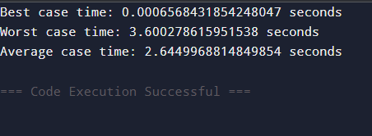

ii) Implement insertion sort algorithm and perform its best case, average case and worst-case analysis.
Code:
import time
import random

def insertion_sort(arr):
n = len(arr)
for i in range(1 j = i - 1
while j >= 0 and arr[j] > key:, n):
key = arr[i]

arr[j + 1] = arr[j]
j -= 1
arr[j + 1] = key
return arr
# Function to measure execution time
def measure_time(arr):
start = time.time()
insertion_sort(arr.copy()) # use copy to avoid modifying original
end = time.time()
return end - start

# Number of elements
n = 5000
# Best Case: Already sorted
best_case = list(range(n))
best_time = measure_time(best_case)
print("Best case time:", best_time, "seconds")

# Worst Case: Reverse sorted
worst_case = list(range(n, 0, -1))
worst_time = measure_time(worst_case)
print("Worst case time:", worst_time, "seconds")

# Average Case: Random order
average_case = random.sample(range(n), n)
average_time = measure_time(average_case)
print("Average case time:", average_time, "seconds")

Output :
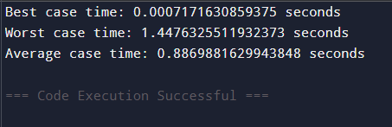
iii) Implement selection sort algorithm and perform its best case , average case and worst case analysis.
Code:
import time
import random

# Selection Sort Function
def selection_sort(arr):
n = len(arr)
for i in range(n - 1):
min_index = i
for j in range(i + 1, n):
if arr[j] < arr[min_index]:
min_index = j

# Swap the found minimum element with first element
arr[i], arr[min_index] = arr[min_index], arr[i]

return arr
# Function to measure execution time
def measure_time(arr):
start = time.time()
selection_sort(arr.copy())
end = time.time()
return end - start

# Number of elements
n = 4000

# Best Case:
best_case = list(range(n))
best_time = measure_time(best_case)
print("Best case time:", best_time, "seconds")

# Worst Case:
worst_case = list(range(n, 0, -1))
worst_time = measure_time(worst_case)
print("Worst case time:", worst_time, "seconds")

# Average Case:
average_case = random.sample(range(n), n)
average_time = measure_time(average_case)
print("Average case time:", average_time, "seconds")

Output :

