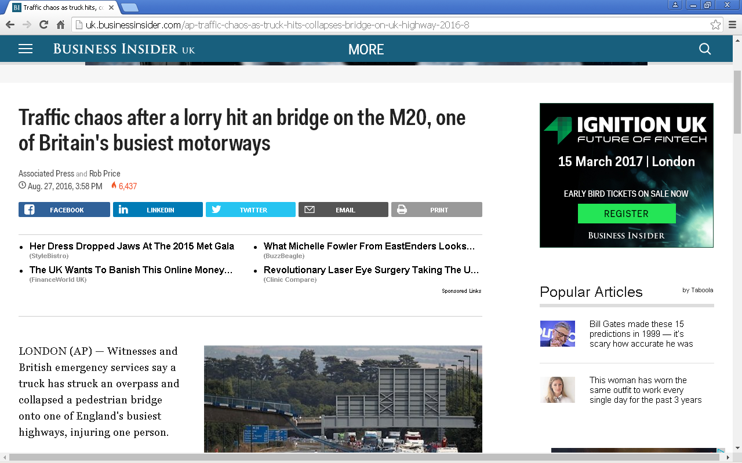

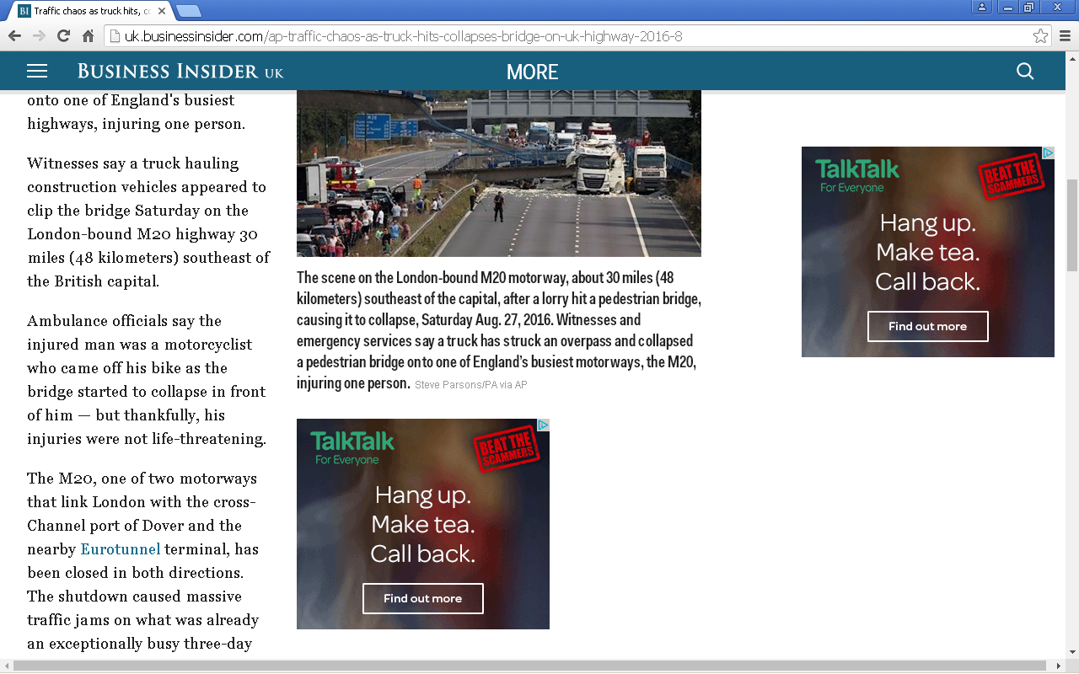
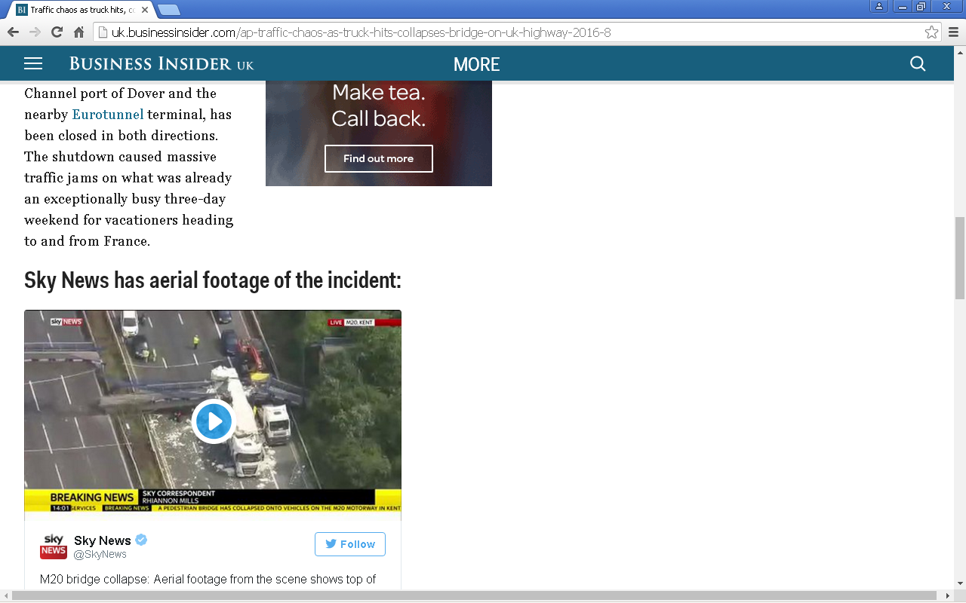

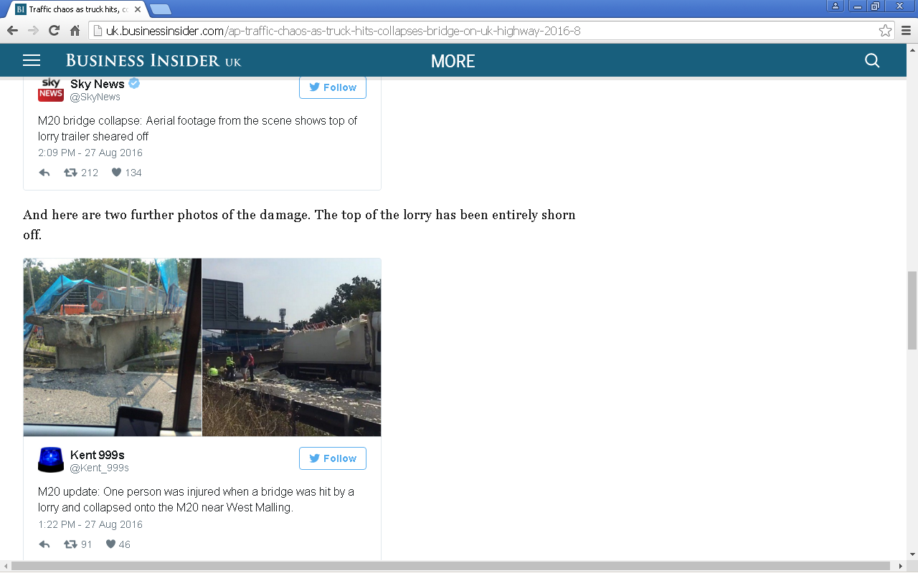

Original source location - website address

http://uk.businessinsider.com/ap-traffic-chaos-as-truck-hits-collapses-bridge-on-uk-highway-2016-8

Accessed on 05/11/2016: Time - 23:02

