**Android Activity Life Cycle**

**https://github.com/udacity/Sunshine/tree/4.01-life-cycle-logging**

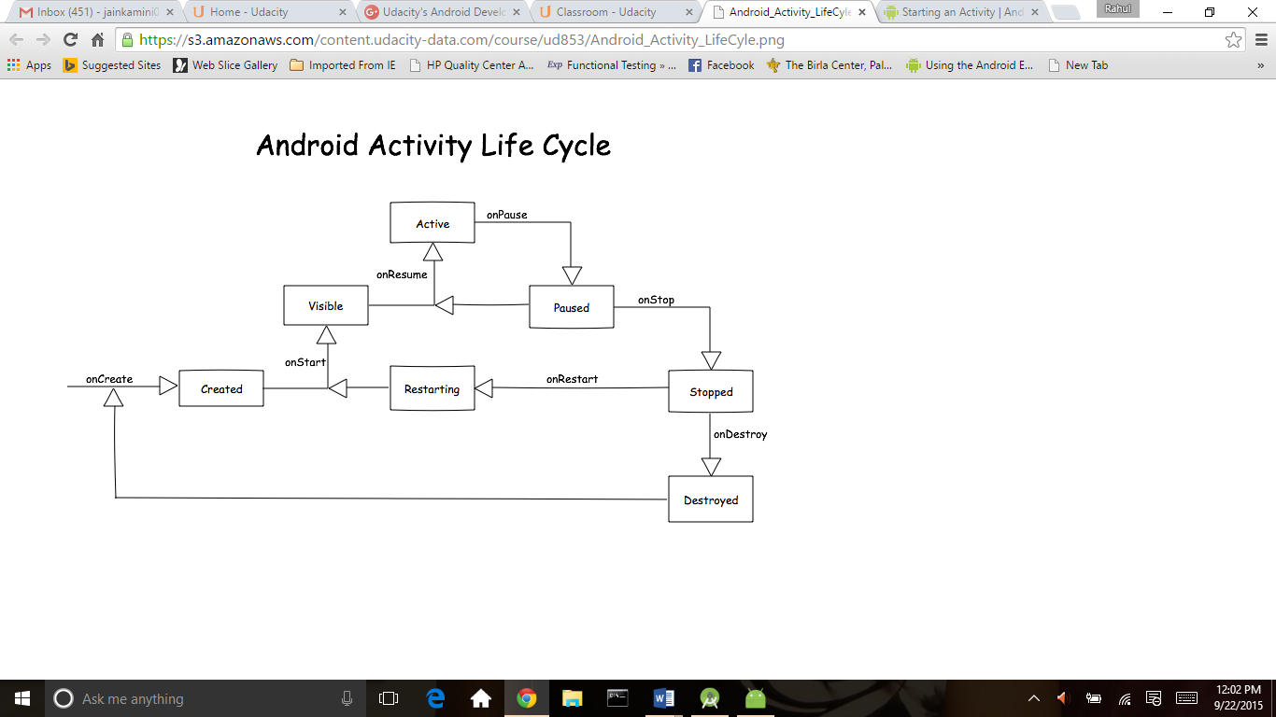

<http://developer.android.com/training/basics/activity-lifecycle/starting.html>

<http://developer.android.com/guide/components/activities.html#ImplementingLifecycleCallbacks>

for fragment and life cycle of fragment

<http://developer.android.com/guide/components/fragments.html>

git hub for life cycle of activity and fragment

https://github.com/xxv/android-lifecycle

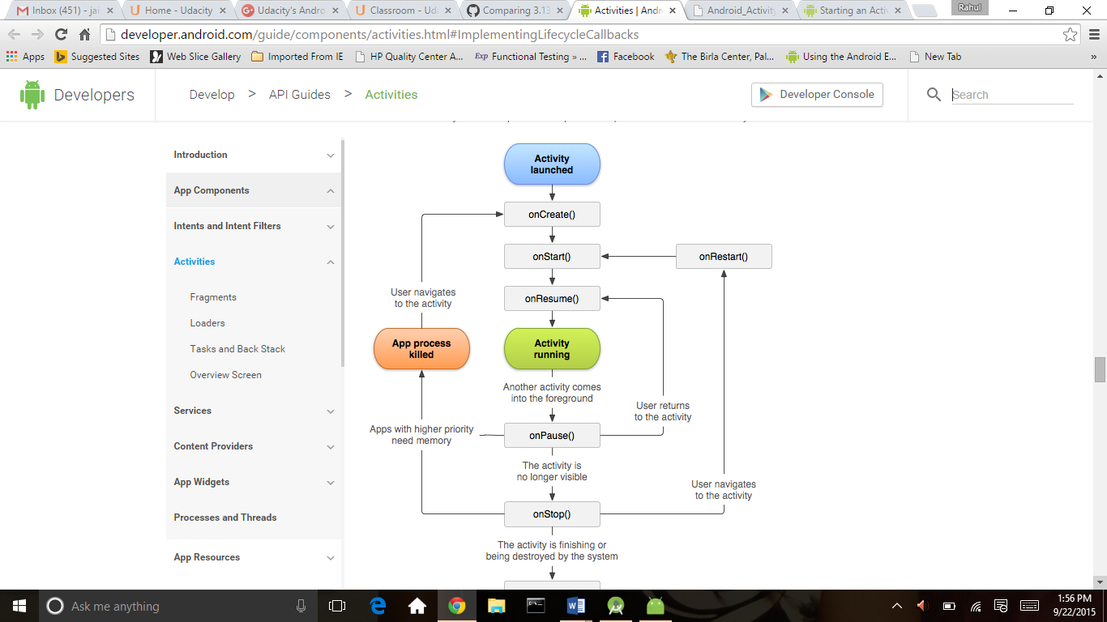

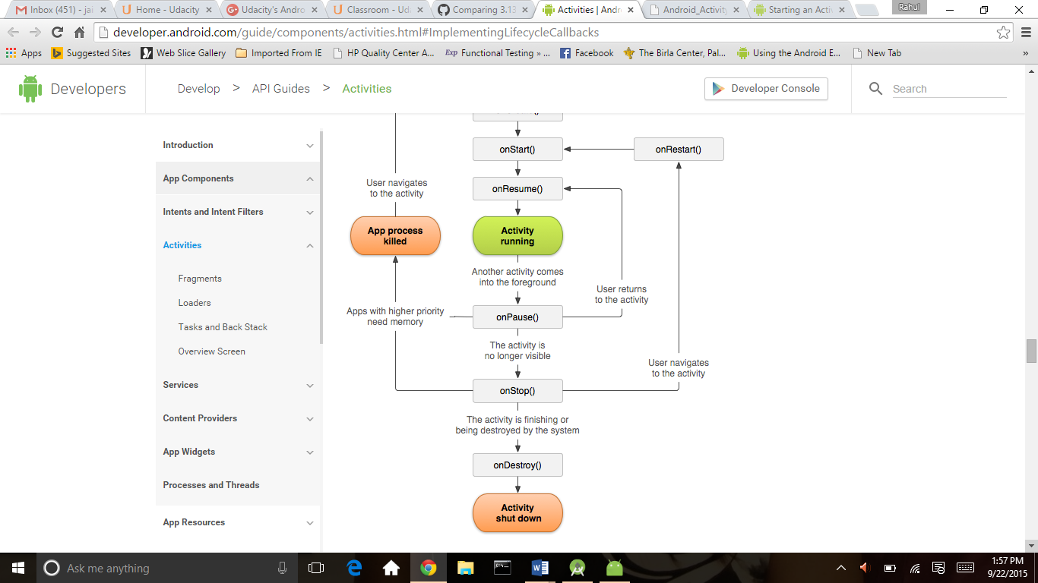

For example of life cycle

<https://github.com/udacity/android-lifecycle/commit/c7f99e13e93d43e61d100b0620f399a0acb4ad5b>