https://developers.google.com/vision/barcodes-overview

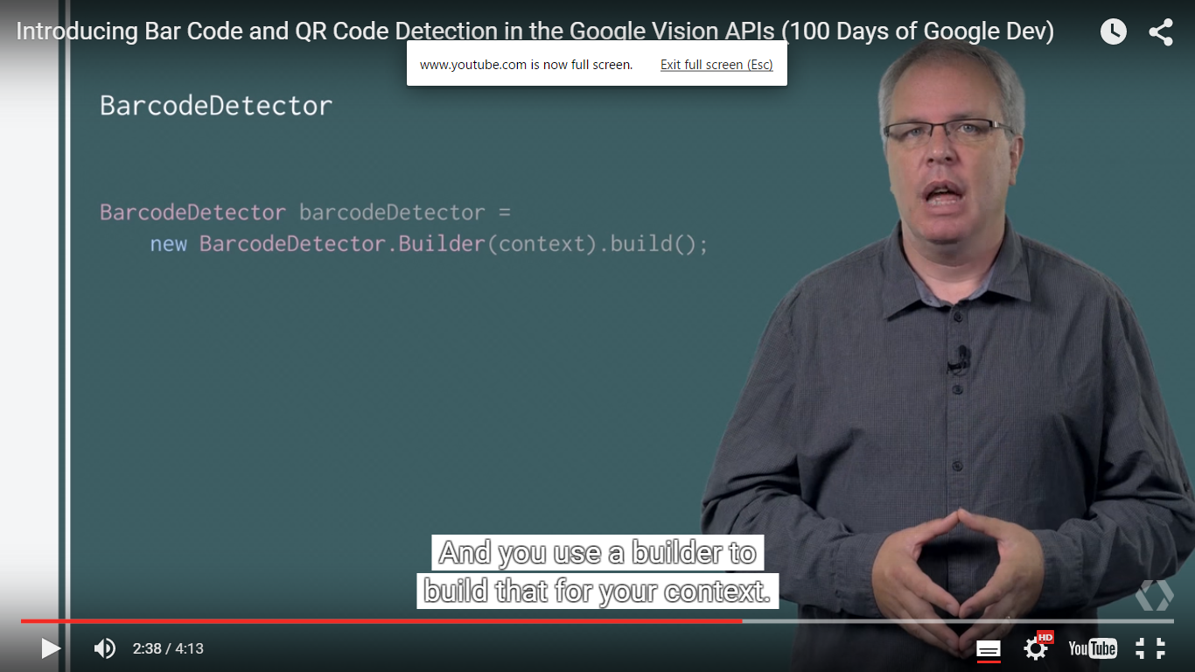

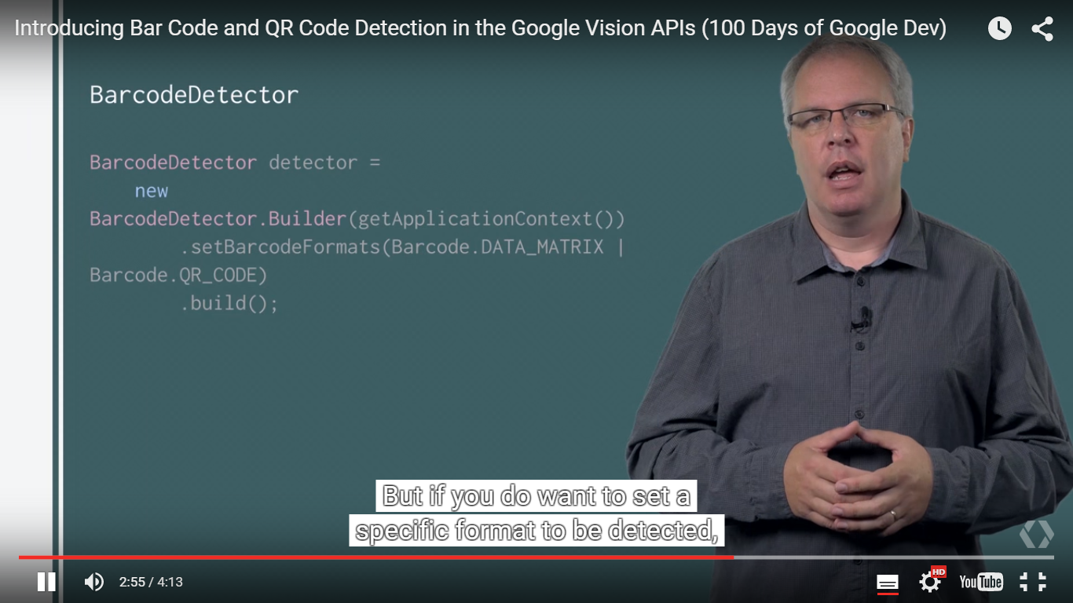

<https://developers.google.com/vision/multi-tracker-tutorial>

Code for bar code

<http://code.tutsplus.com/tutorials/reading-qr-codes-using-the-mobile-vision-api--cms-24680>

stackoverflow

<http://stackoverflow.com/questions/tagged/android-vision>

<http://stackoverflow.com/questions/19804233/android-autofocuscallback-is-not-being-called-or-not-returning>

<http://stackoverflow.com/questions/12273976/camera-tutorial-for-android-using-surfaceview>

http://stackoverflow.com/questions/16832372/surfacecreated-java-lang-nullpointerexception