**Angular Installation**

npm set registry=https://registry.npmjs.org/

**Angular install**

npm install -g @angular/cli

ng new <project name>

cd <project name>

**run the files**

ng serve

**Add bootstrap files**

npm install bootstrap@4.6.0

**Add model class**

ng g class yourclass –type=model –skip-tests

**Add ng lint**

ng add @angular-eslint/schematics

**Add ng pwa**

ng add @angular/pwa@12.0.0

**Add ngrx**

ng add @ngrx/store

**Add ngrx effects**

ng add @ngrx/effects

**Add devtools**

npm install --save-dev @ngrx/store-devtools

**Generate files**

ng g c <Component name>

ng g c -is <Component name> (inline style)

ng g m <Module name> --routing

ng g cl <Class name>

ng g s <service name>

ng g p <pipe name>

ng g d <directive name>

ng g i <interface name>

**Rxjs update**

npm i rxjs@latest

**guard**

ng g guard <guard name>

**React Installation**

**React install**

**For first time install -** npm install -g create-react-app

npx create-react-app my-app

cd my-app

**Add typescript**

npx create-react-app react-ts --template typescript

**run the files**

npm start

**Add router files**

npm set registry=https://registry.npmjs.org/

npm i [react-router-dom](mailto:react-router-dom@5.2.0)

**check react version**

npm view react version

**Add redux**

npm i redux react-redux

**Add redux toolkit**

npm install @reduxjs/toolkit

**Add nextjs**

npx create-next-app

**run files**

npm run dev

**Vue Installation**

**Vue install**

**For first time install -** npm install -g @vue/cli

vue create my-project

cd my-project

**run the files**

npm run serve

**and add extension vue VSCode Snippet**

**Http method**

npm i axios

**Router method**

npm i vue-router

**Installed Vetur, HTML CSS Support and Vue VSCode Snippets extension from marketplace**

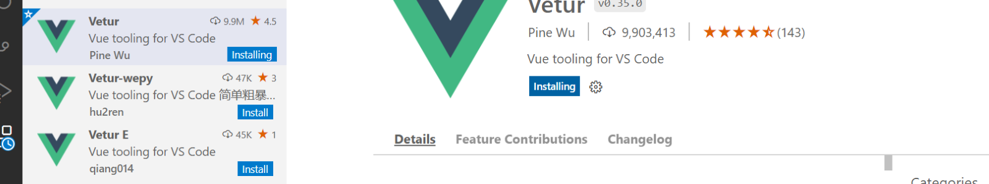

**When showing this error**

**Parsing error: No babel config file detected**

**Vs code will make a .vscode/ folder inside which a settings.jsonfile was created. There add this line:**

"vetur.experimental.templateInterpolationService": false,

    "eslint.options": {

        "configFile": "\\ABSOLUTE\\PATH\\TO\\YOUR\\PROJECT\\VUE_PROJECT\\babel.config.js"

}

**Solution error vetur**

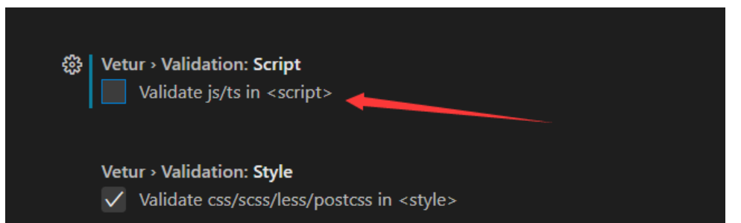

**Package.json**

Search **eslintConfig add rules**

"rules": {

      "vue/multi-word-component-names": 0,

      "vue/comment-directive": 0

    }