**Stencil install**

**Do in command admin**

npm config set strict-ssl false

Set NODE_TLS_REJECT_UNAUTHORIZED=0

npm init stencil (Choose components in this)

  > cd practice

   > npm install

   > npm start

**Component Generator**

npm run generate

**Npm package**

npm set registry=https://registry.npmjs.org/

npm login

npm publish

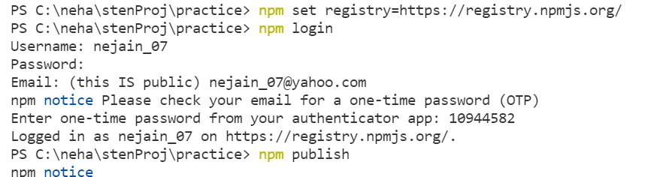

**After successful published**

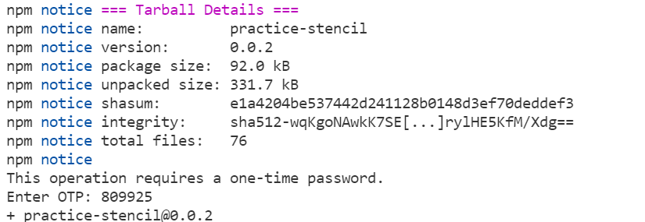

**React deploy**

**Go to the npm package**

npm set registry=https://registry.npmjs.org/

npm i practice-stencil-demo

**Add this in index.js (my-app under react app)**

import { defineCustomElements } from 'practice-stencil-demo/loader';

defineCustomElements(window);

**If more than package then use ALIAS in them**

import { defineCustomElements as creation} from 'practice-stencil-demo-creation/loader';

import { defineCustomElements as button} from 'practice-stencil-example/loader';

creation(window);

button(window);

**Add component in app.js**

<my-card user-name="Stencil learner"></my-card> <search-world search-text="true"></search-world>

**Normal project html deploy**

**After npm run build copy the dist folder in the new project**

**Add html file this script and change according to location**

<script type="module" src="dist/practice/practice.esm.js"></script>

<script nomodule src="dist/esm/practice.js"></script>

Add custom components in html file

<my-component first="Stencil" last="'Don't call me a framework' JS"></my-component>

<my-first-component name="Max Smith"></my-first-component>

<first-generate name="James Smith" age="23"></first-generate>

**Angular Deploy**

**Go to the npm package**

npm i dxp-button-example

**Add this in app.module.ts**

import { NgModule, CUSTOM_ELEMENTS_SCHEMA } from '@angular/core';

schemas: [CUSTOM_ELEMENTS_SCHEMA]

**Add this in main.ts (my-angular-app under angular app)**

import { defineCustomElements } from 'practice-stencil-demo-creation/loader';

defineCustomElements(window);

**If more than package then use ALIAS in them**

import { defineCustomElements as creation} from 'practice-stencil-demo-creation/loader';

import { defineCustomElements as button} from 'practice-stencil-example/loader';

creation(window);

button(window)

**Add component in app.component.html**

<my-card user-name="Stencil learner"></my-card> <search-world search-text="true"></search-world>

**Vue deploy**

**Go to the npm package**

npm set registry=https://registry.npmjs.org/

npm i dxp-button-example

**Add this in main.js**

import { defineCustomElements } from 'practice-stencil-demo/loader';

defineCustomElements(window);

**Add component in app.vue**

<my-card user-name="Stencil learner"></my-card> <search-world search-text="true"></search-world>

**Add @font-face in local (stencil)**

**Assets in fonts folder custom fonts and add global using @font-face**

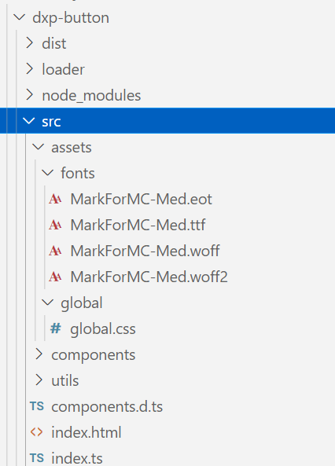

**stencil.config.ts**

{

      type: 'www',

      serviceWorker: null, // disable service workers

      copy: [

        { src: 'assets/fonts', dest: 'fonts' },

      ]

}

**Add assetsDir in component ts file**

@Component({

  tag: 'dxp-button',

  styleUrl: 'dxp-button.css',

  assetsDirs: ['assets'],

  shadow: false

  // shadow: true,

})

**Import in component css file**

@import '../../assets/global/global.css';

**Add Sass compile in Stencil**

**stencil.config.ts**

import { sass } from '@stencil/sass';

plugins: [

    sass()

  ],