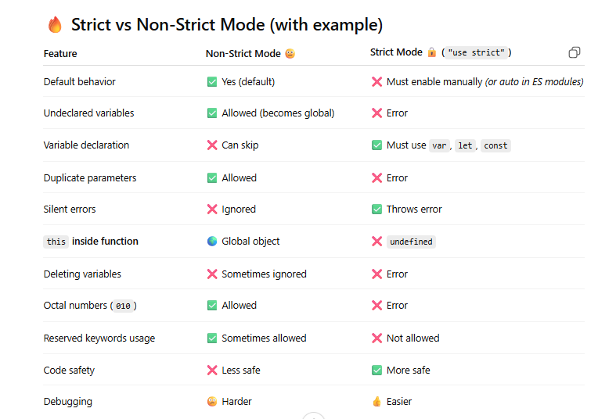

1️⃣ Default Behavior

Non-Strict (default)
function test() {
x = 10;
}
test();
console.log(x); // ✅ 10

Strict
"use strict";
function test() {
x = 10; // ❌ Error
}

2️⃣ Undeclared Variables

Non-Strict
x = 5;
console.log(x); // ✅ 5 (global)

Strict
"use strict";
x = 5; // ❌ ReferenceError

3️⃣ Variable Declaration

Non-Strict
y = 20; // ✅ allowed

Strict
"use strict";
y = 20; // ❌ must declare

4️⃣ Duplicate Parameters

Non-Strict
function sum(a, a) {
return a + a;
}
console.log(sum(2, 3)); // ✅ 6

Strict
"use strict";
function sum(a, a) { } // ❌ Error

5️⃣ Silent Errors

Non-Strict
var obj = {};
Object.defineProperty(obj, "x", { value: 10, writable: false });
obj.x = 20; // ❌ ignored silently
console.log(obj.x); // 10

Strict
"use strict";
obj.x = 20; // ❌ TypeError

6️⃣ this inside function

Non-Strict
function test() {
console.log(this);
}
test(); // 🌍 global object

Strict
"use strict";
function test() {
console.log(this);
}
test(); // ❌ undefined

7️⃣ Deleting Variables

Non-Strict
var a = 10;
delete a; // ❌ fails silently
console.log(a); // 10

Strict
"use strict";
var a = 10;
delete a; // ❌ Error

8️⃣ Octal Numbers

Non-Strict
let num = 010;
console.log(num); // ✅ 8

Strict
"use strict";
let num = 010; // ❌ SyntaxError

9️⃣ Reserved Keywords

Non-Strict
var public = 10; // ⚠️ sometimes allowed

Strict
"use strict";
var public = 10; // ❌ Error

💡 Final One-Line Summary
- Non-strict → allows mistakes, may hide bugs
- Strict → prevents mistakes, throws errors early ✅

Variable Shadowing
If a local variable and a global variable have the same name, the local one is used inside the function/block.
This is called variable shadowing.
var msg = "Good morning"; // global
function greeting() {
var msg = "Good Evening"; // local (shadows global)
console.log(msg);
}
greeting();
console.log(msg);
Good Evening
Good morning
Arrow functions are great, but there are clear cases where you should NOT use them 👇

🚫 When NOT to use Arrow Functions in ES6

1️⃣ When you need your own this
Arrow functions don’t have their own this — they use the outer scope.

❌ Wrong
const user = {
name: "Neha",
greet: () => {
console.log(this.name); // ❌ undefined
}
};
user.greet();

✅ Correct
const user = {
name: "Neha",
greet() {
console.log(this.name); // ✅ Neha
}
};

2️⃣ Inside object methods (generally avoid)
Same reason — this won’t refer to the object.
const obj = {
value: 10,
getValue: () => this.value // ❌ wrong
};

3️⃣ When using constructor (classes)
Arrow functions cannot be used as constructors

❌ Wrong
const Person = (name) => {
this.name = name;
};
new Person("Neha"); // ❌ Error

✅ Correct
function Person(name) {
this.name = name;
}

4️⃣ When you need arguments object
Arrow functions don’t have arguments

❌ Wrong
const sum = () => {
console.log(arguments); // ❌ not defined
};

✅ Correct
function sum() {
console.log(arguments); // ✅ works
}

5️⃣ When you need dynamic this (call, apply, bind)
Arrow functions ignore call, apply, bind

❌ Wrong
const greet = () => console.log(this.name);
greet.call({ name: "Neha" }); // ❌ undefined

✅ Correct
function greet() {
console.log(this.name);
}
greet.call({ name: "Neha" }); // ✅ Neha

6️⃣ Event handlers (sometimes)
If you need this to refer to the element:

❌ Wrong
button.addEventListener("click", () => {
console.log(this); // ❌ not the button
});

✅ Correct
button.addEventListener("click", function () {
console.log(this); // ✅ button
});

🔥 Quick Summary
Situation | Use Arrow?
Need own this | ❌ No
Object methods | ❌ Avoid
Constructor functions | ❌ No
Need arguments | ❌ No
Using call/apply/bind | ❌ No
Simple callbacks | ✅ Yes

💡 One-line rule
👉 Arrow functions = no this, no arguments, no constructor

When to Use Arrow Functions in ES6

1️⃣ Callbacks (array methods, RxJS, promises)
Short, clean, and no need for a new this.
const nums = [1, 2, 3];
const doubled = nums.map(n => n * 2);
console.log(doubled); // [2, 4, 6]
👉 Perfect for map, filter, reduce, etc.

2️⃣ When you want lexical this (inherit from outer scope)
Arrow functions capture this from where they are defined.
function Timer() {
this.count = 0;
setInterval(() => {
this.count++;
console.log(this.count); // ✅ correct
}, 1000);
}
👉 No need for const self = this or .bind(this)

3️⃣ Async operations (Angular / JS)
Very common in APIs and subscriptions.
this.http.get('/api').subscribe(res => {
console.log(this.data); // ✅ component context preserved
});

4️⃣ setTimeout / setInterval
Keeps this intact.
class Test {
name = "Neha";
start() {
setTimeout(() => {
console.log(this.name); // ✅ Neha
}, 1000);
}
}

5️⃣ Functional-style code
Cleaner for small functions.
const add = (a, b) => a + b;

6️⃣ Inline functions (short logic)
const isEven = n => n % 2 === 0;

⚖️ Quick Decision Table
Situation | Use Arrow?
Short callbacks | ✅ Yes
Need outer this | ✅ Yes
RxJS / async code | ✅ Yes
setTimeout / timers | ✅ Yes
Object methods | ❌ No
Constructor / classes | ❌ No
Need dynamic this | ❌ No

💡 One-line rule
👉 Use arrow functions when you want short code + same this as outer scope

⚔️ Arrow Function vs Normal Function
Feature | Arrow Function (=>) | Normal Function (function)
Syntax | Short, concise | Longer
this | ❌ No own this (lexical) | ✅ Has its own this
arguments | ❌ Not available | ✅ Available
Constructor (new) | ❌ Cannot be used | ✅ Can be used
call/apply/bind | ❌ Ignored | ✅ Works
Use as method | ❌ Not recommended | ✅ Recommended
Best use | Callbacks, async | Methods, constructors

🔹 Side-by-side Examples

1️⃣ this behavior
const obj = {
name: "Neha",
normal: function () {
console.log(this.name); // ✅ Neha
},
arrow: () => {
console.log(this.name); // ❌ undefined
}
};
obj.normal();
obj.arrow();

2️⃣ arguments
// Normal
function sum() {
console.log(arguments); // ✅ works
}
sum(1, 2);
// Arrow
const sum2 = () => {
console.log(arguments); // ❌ error
};

3️⃣ Constructor
// Normal
function Person(name) {
this.name = name;
}
const p = new Person("Neha"); // ✅
// Arrow
const Person2 = (name) => {
this.name = name;
};
new Person2("Neha"); // ❌ error

4️⃣ Callback (best use of arrow)
// Normal
setTimeout(function () {
console.log(this); // ❌ wrong this
}, 1000);
// Arrow
setTimeout(() => {
console.log(this); // ✅ correct this
}, 1000);

🧠 Easy Memory Trick
👉 Arrow = no own this
👉 Function = full control (this, arguments, constructor)

✅ When to Use What
- Use arrow → callbacks, RxJS, timers, short functions
- Use normal function → object methods, classes, constructors

