ESP32-S3 A7672S 4G+2G LTE Development Board with Wi-Fi, BLE & USB Networking

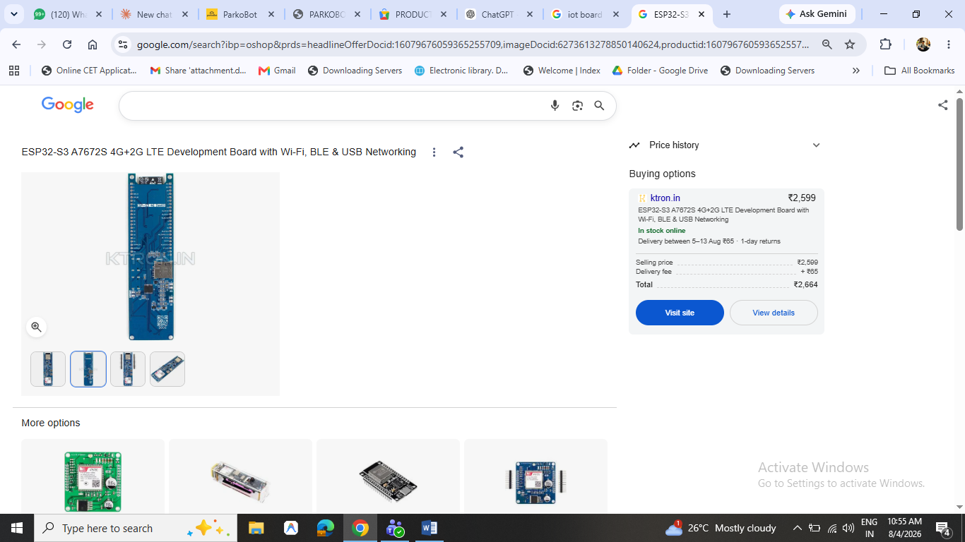 Electronic Spices BMS 18650 Lithium Battery Protection Board (3S, 20A, 12.6V) (3S 20A BMS)
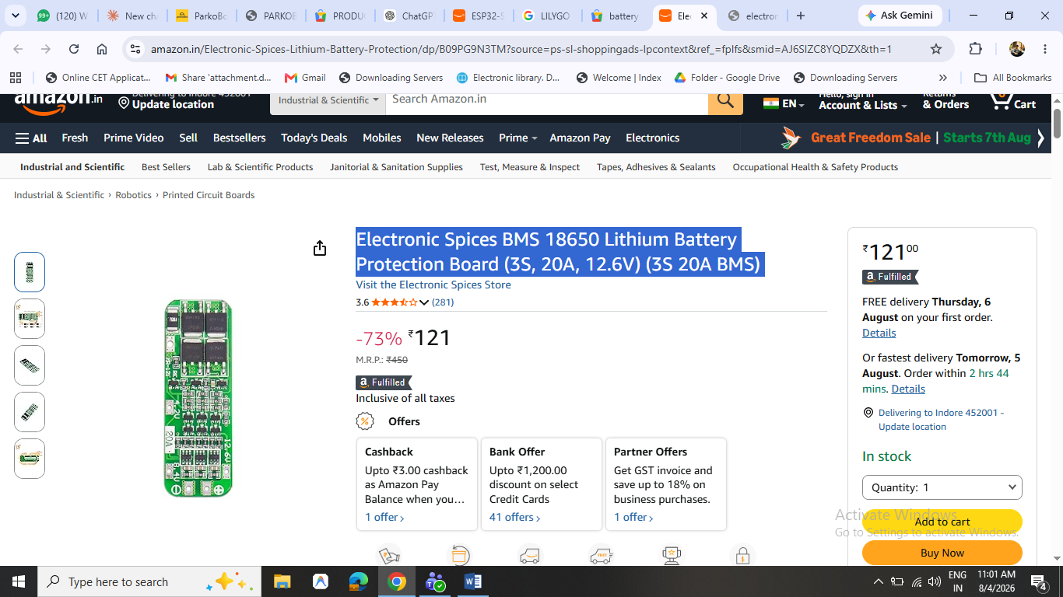 1. Power Distribution
2. Motor Driver System
3. Main Controller (MCU)-3000
4. Position Feedback
5. Battery Management

6. Communication Module
Difference Between Secure+ and Monetize+
Feature | Secure+ | Monetize+
Bluetooth Unlock | ✅ | ✅
Family E-Keys | ✅ | ✅
Private Use | ✅ | ✅
Marketplace Listing | ❌ | ✅
Booking System | ❌ | ✅
Online Payments | ❌ | ✅
Revenue Dashboard | ❌ | ✅
Dynamic Pricing | ❌ | ✅
Revenue Sharing | ❌ | 70% Owner / 30% Platform

JGY370 DC 12V 40RPM 4.5kg-cm Metal Worm Gear Motor PWM Forward Reverse

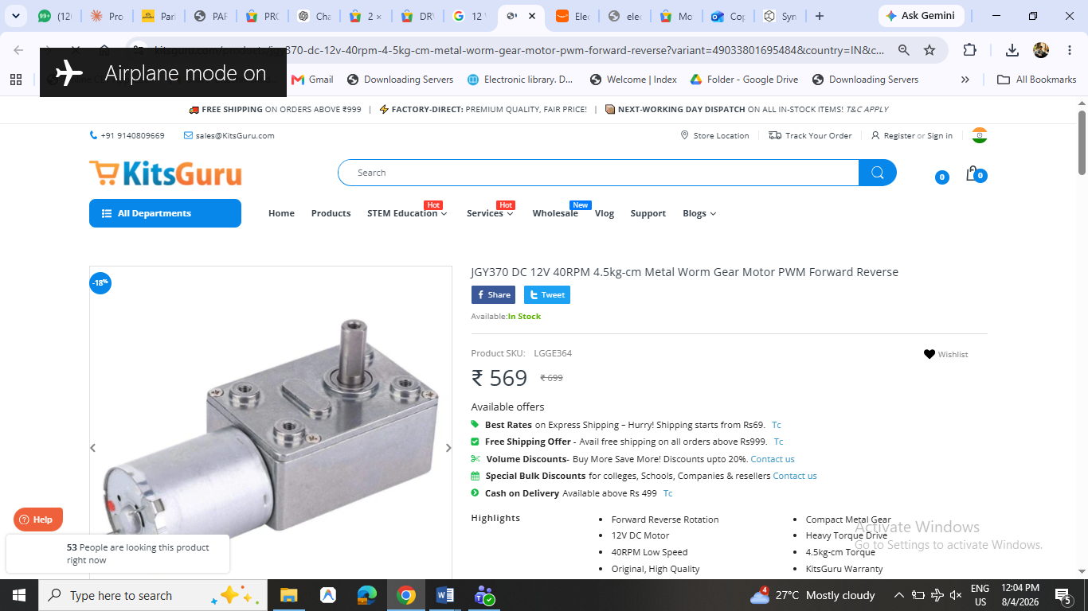 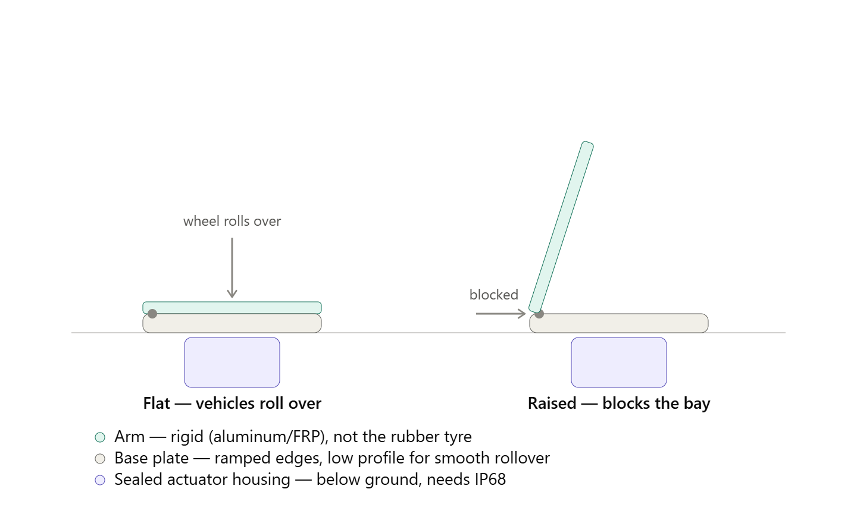.

Component |  | Qty | Approx. Price (₹)
ESP32-S3 + A7672S 4G Development Board |  | 1 | 3,000
JGY370 12V Worm Gear Motor (40 RPM) |  | 1 | 900–1,200
Motor Driver (DRV8876/BTS7960) |  | 1 | 350–600
18650 Cells (Samsung/LG, 8 cells) |  | 8 | 2,000–2,800
Battery Holder / Spot Welding / Nickel Strips |  | 1 | 300
BMS (4S Smart BMS recommended) |  | 1 | 500–1,000
16.8V Li-ion Charger |  | 1 | 400–700
Buck Converter (12V → 3.3V/5V) |  | 2 | 250
Hall Sensors |  | 2 | 100
Magnets |  | 2 | 100
IMU (MPU6050/ICM42688) |  | 1 | 250–700
Waterproof Connectors & Wiring |  | — | 500
RGB LED + Buzzer + Buttons |  | — | 200
PCB (prototype) |  | 1 | 1,000–2,000
Custom Metal Enclosure (laser cut + weld) |  | 1 | 2,000–3,500
Base Plate (MS, powder coated) |  | 1 | 800–1,500
Barrier Arm (Aluminum/Steel) |  | 1 | 600–1,000
Bearings + Shaft + Bushes |  | — | 500–800
Rubber Bumpers / Seals |  | — | 300
Fasteners (SS304) |  | — | 300
Version | Cost
Basic Working Prototype | ₹15,000–18,000
Good Engineering Prototype | ₹18,000–22,000
Near-Commercial Prototype | ₹22,000–28,000

