EMPLOYEE ONBOARDING
MANAGEMENT SYSTEM
USER MANUAL

PART I — EMPLOYEE MANUAL

1. Getting Started
Use the credentials provided by the organization to access the system.
Important: Keep your username and password confidential.

2. Employee Login
- Open the login page.
- Enter your username.
- Enter your password.
- Click Login.
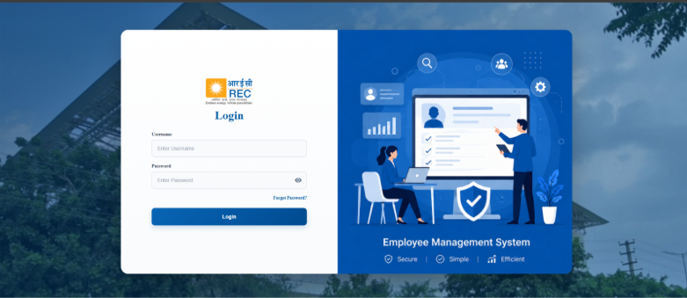

3. First Login and Password Change
If your account requires a first-time password update, follow the password update screen.
- Enter the current/temporary password.
- Enter a new password.
- Confirm the new password.
- Submit the update.
- Log in using the new password when required.
Security: Choose a strong password and never share it.

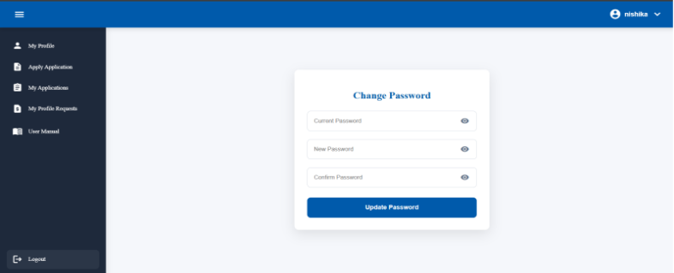

4. Employee Profile
- Personal Information — name, username, email, phone, date of birth, age and gender.
- Work Information — department, designation, joining date and role.
- Address — employee address.
- Previous Service History — organizations, dates, tenure and experience certificates when available.
- Documents — profile photo, Aadhaar, PAN, resume, driving licence, RC and vehicle documents when available.
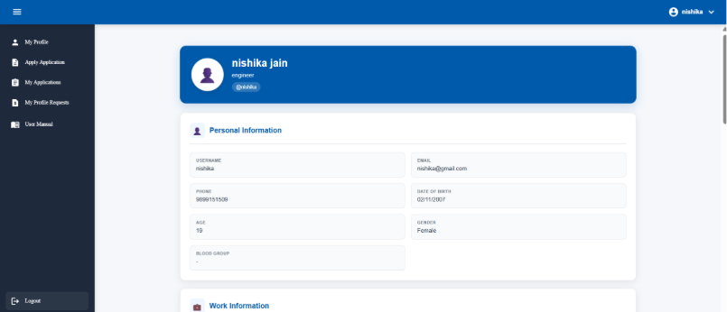

5. Editing Profile Details
- Open My Profile.
- Select Edit Details.
- Update the required information.
- Review the changes.
- Submit the request.
Important: Profile changes may require review by an authorized HR/Admin user.
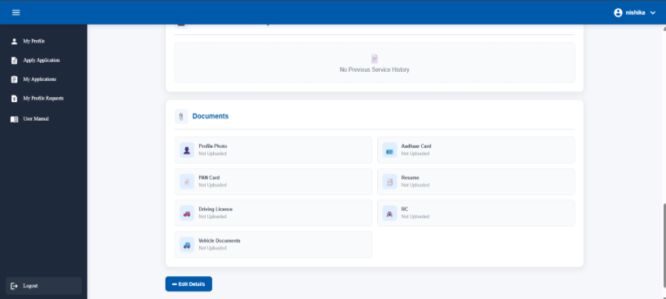
6. Profile Change Requests
- Submit the required changes.
- The request is sent for review.
- HR/Admin can approve or reject it.
- If rejected, read the remarks and correct the information if necessary.
- Use My Profile Requests to track requests.
- Employee records may contain documents like Aadhaar, Pan, Resume & etc.

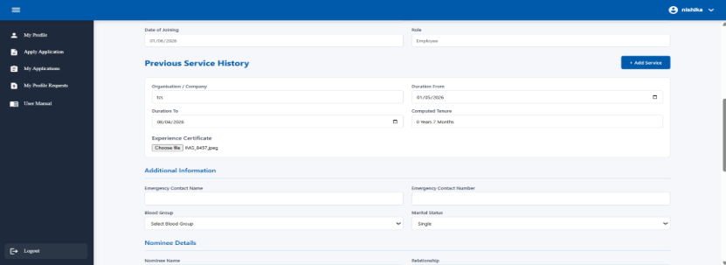
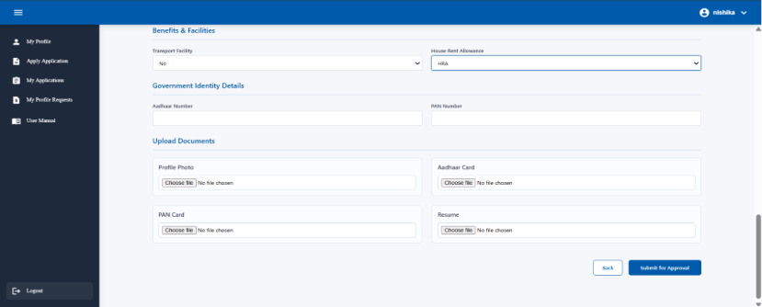

7. Applying for an Application
- Open Apply Application.
- Select the application type.
- Enter the required details.
- Provide the reason/details requested.
- Attach the supporting document when required.
- Submit the application.

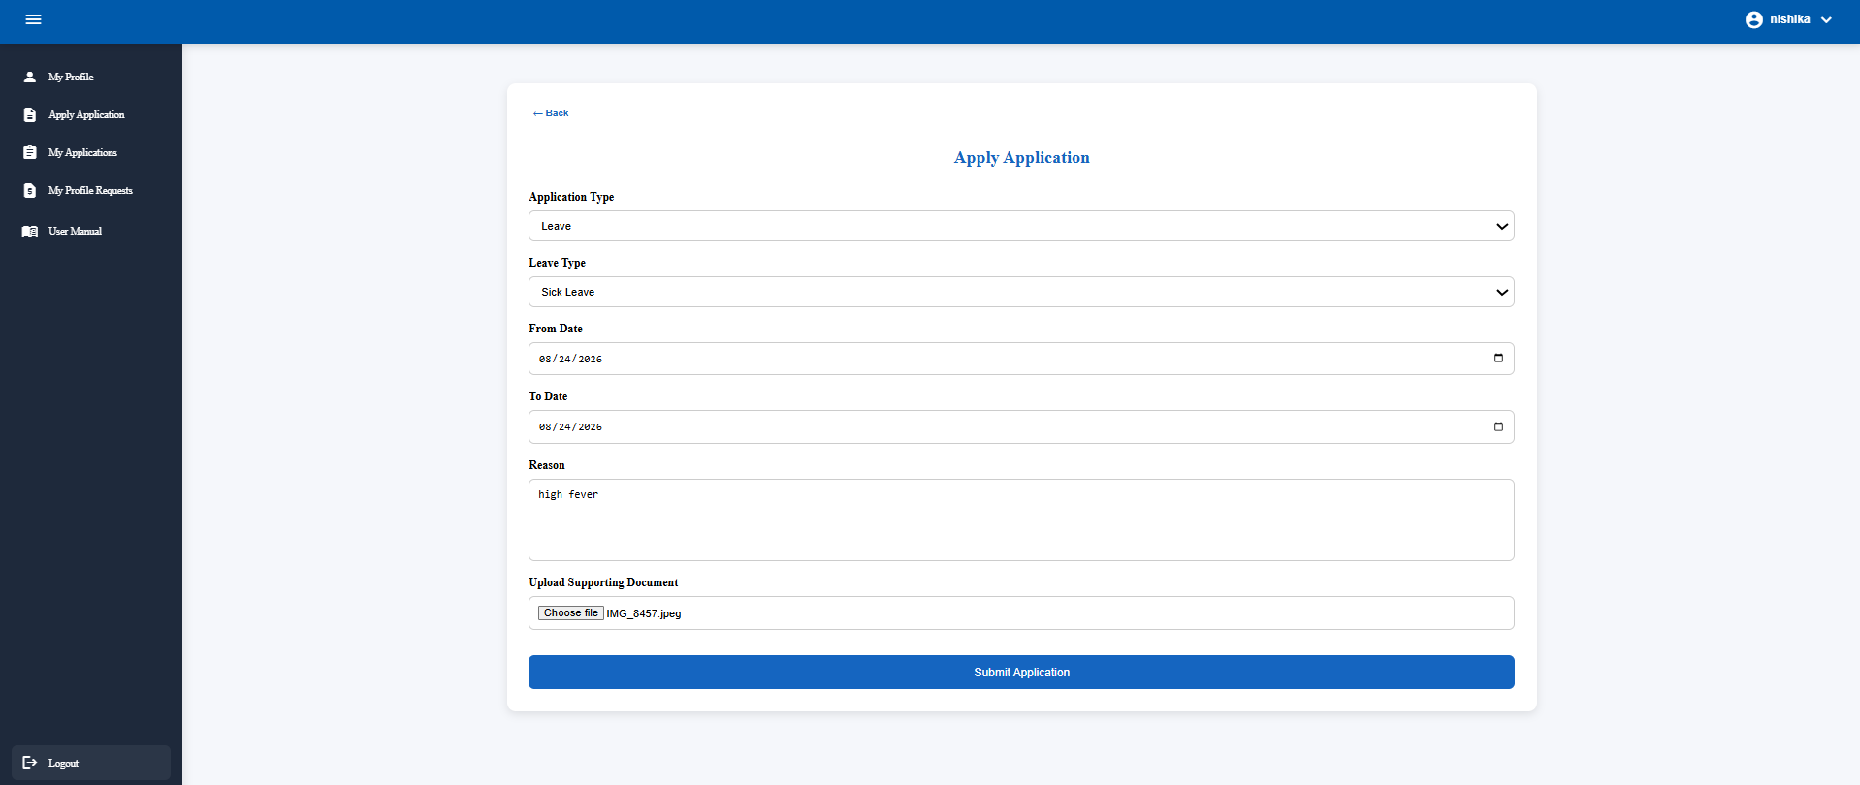

8. Tracking Applications
Open My Applications to see submitted applications, their status and reviewer information.
Status | Meaning | Action
Pending | Waiting for review. | Wait for review.
Approved | Accepted. | Check the result/updated information.
Rejected | Not approved. | Read remarks and resubmit if needed.
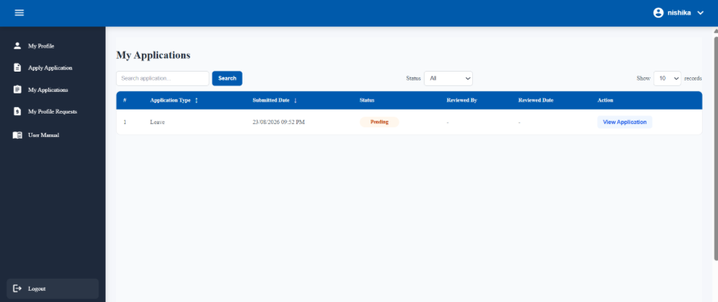

9. Logout and Security
- Use Logout after finishing.
- You can logout either by clicking on your top right profile or from the bottom of sidebar.
- Do not leave the system open on a shared computer.
- 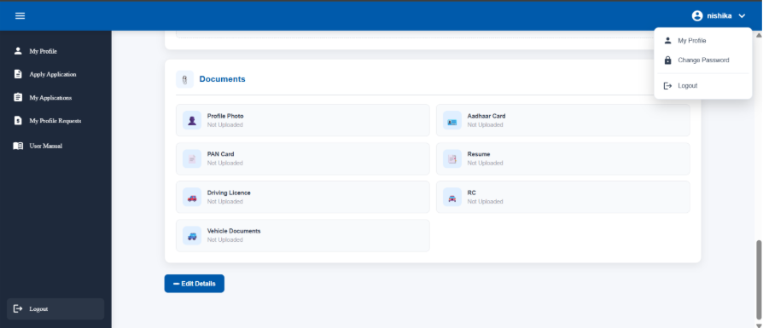

PART II — HR & ADMIN MANUAL
This section covers management functions. Some functions are restricted to Admin users.

1. HR and Admin Login
- Enter the organization-provided username and password.
- Click Login.
- The system identifies the role and displays the appropriate permissions.

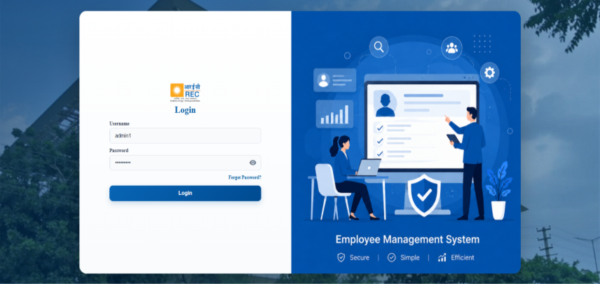

2. Dashboard
- Active employee count.
- Admin/HR information where available.
- Department overview.
- Pending profile requests.
- Pending applications.
- Recent employee information.
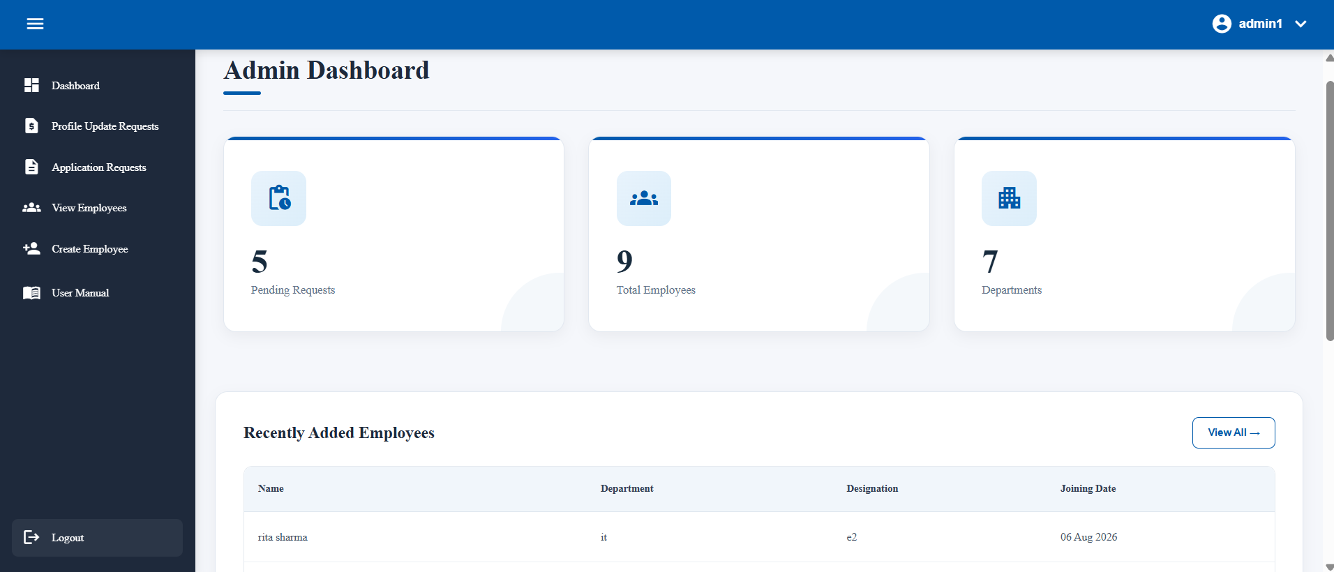

3. Employee Management
- Search employee records.
- Filter by department, role and designation.
- Sort the employee list.
- Change records per page.
- Navigate with pagination.
- View employee details.
- Edit employee information where permitted.
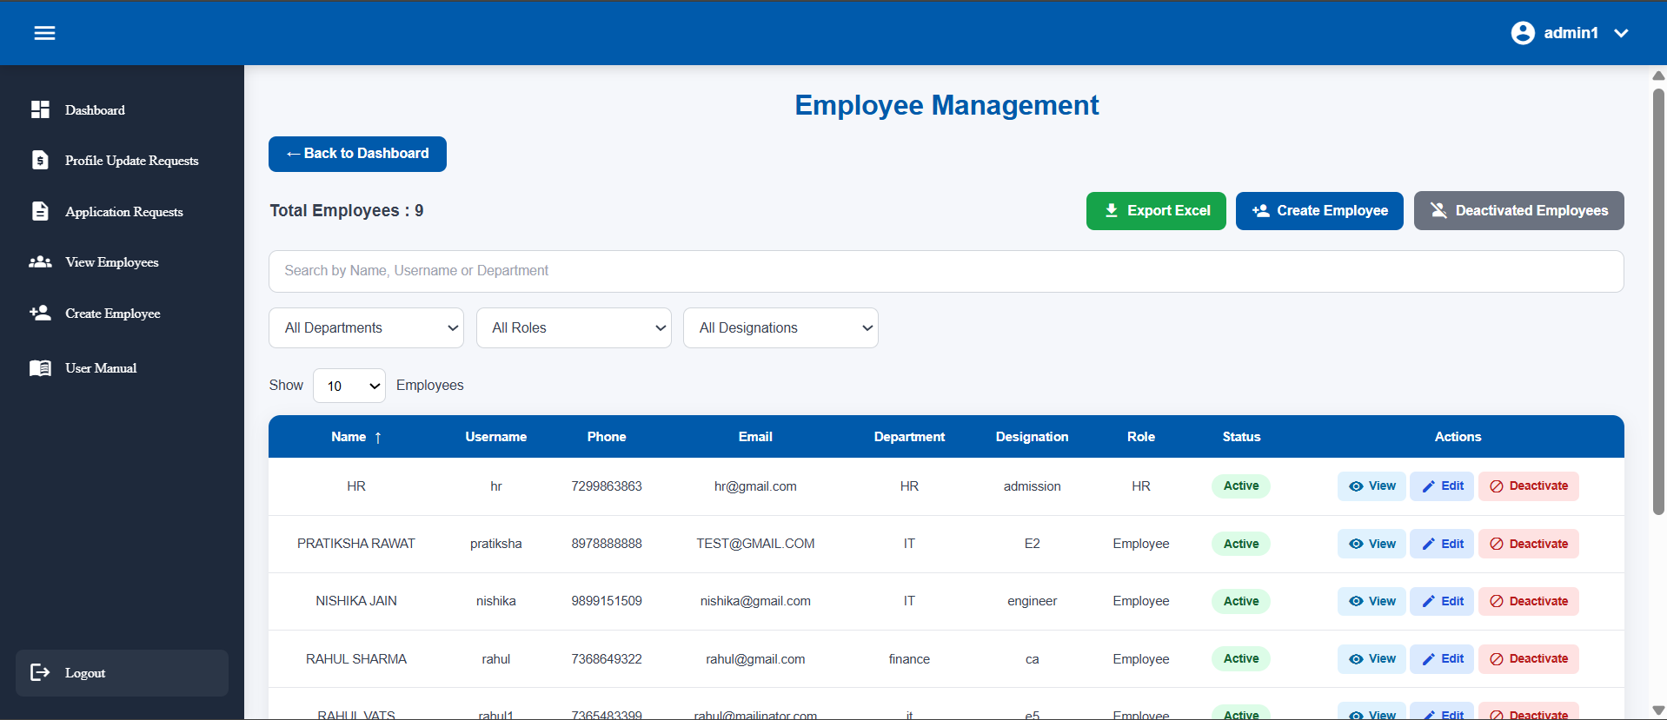

4. Create Employee
- Open Create Employee.
- Enter personal information.
- Enter work information.
- Enter address and role.
- Complete required additional/document information.
- Submit the employee record.
- Automated mail will be sent to new employee sharing username and temporary password.
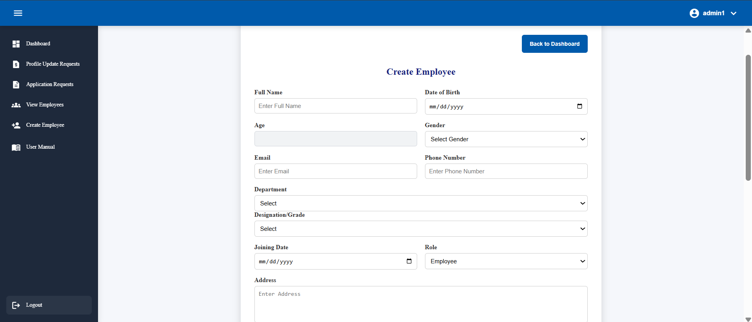

5. Employee Details and Editing
Authorized HR/Admin users can view employee profile and document information and edit permitted fields.
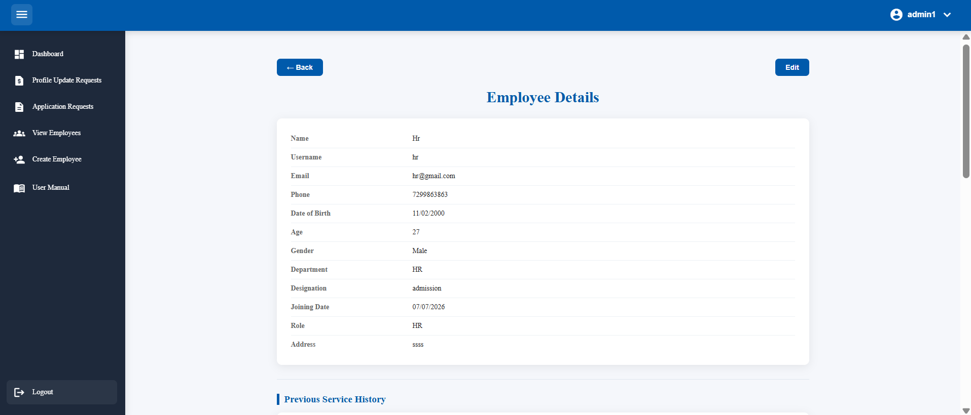
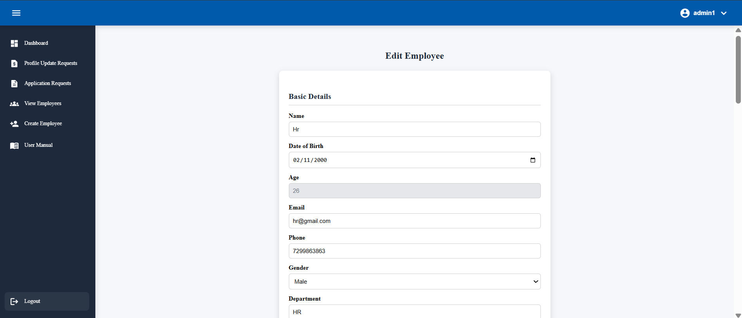

6. Employee Activation and Deactivation (Admin)
Activation/deactivation is an Admin-level function.
- Open View Employees.
- Locate the employee.
- Select Deactivate for an active employee.
- Confirm the action.
- The employee becomes inactive and is removed from the active employee list.
- The inactive employee cannot log in.
- Open Inactive Employees and select Activate when access should be restored.
Access Control: HR should not have activation/deactivation controls.
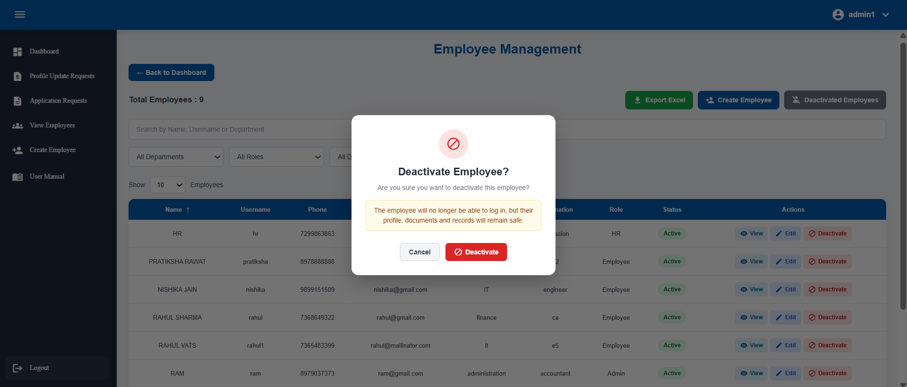

7. Inactive Employees
- View inactive employees.
- Search inactive records.
- Sort records.
- Use pagination.
- Review employee information.
- Activate an employee when authorized (only admin).
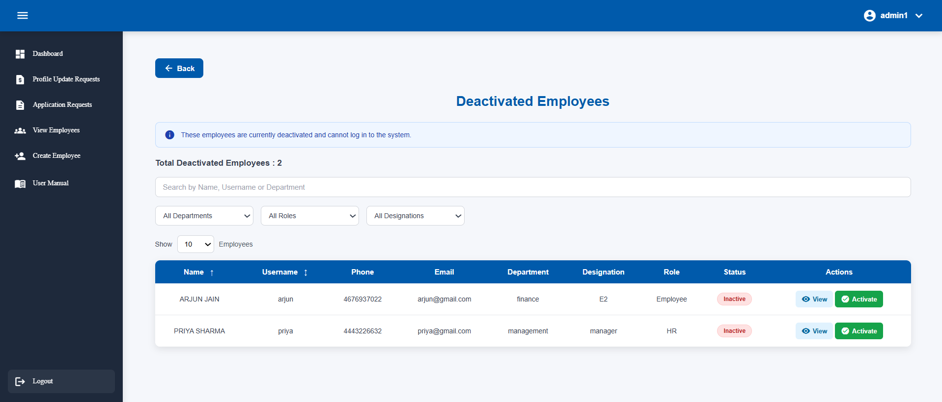

8. Profile Requests
- Open Profile Requests.
- Search/filter requests.
- Open a request using View.
- Review requested changes and supporting information (changes will be highlighted).
- Enter remarks if required.
- Approve or reject.
- The employee can track the result.

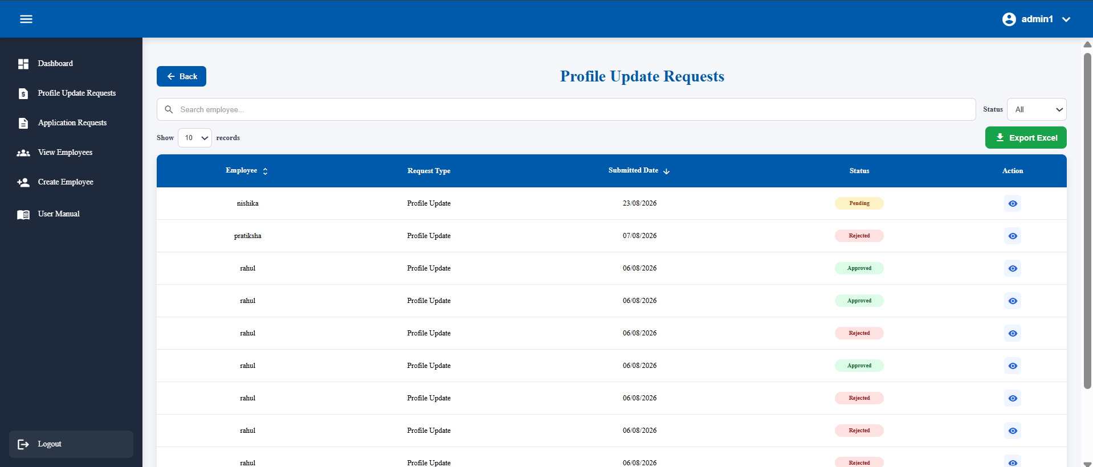
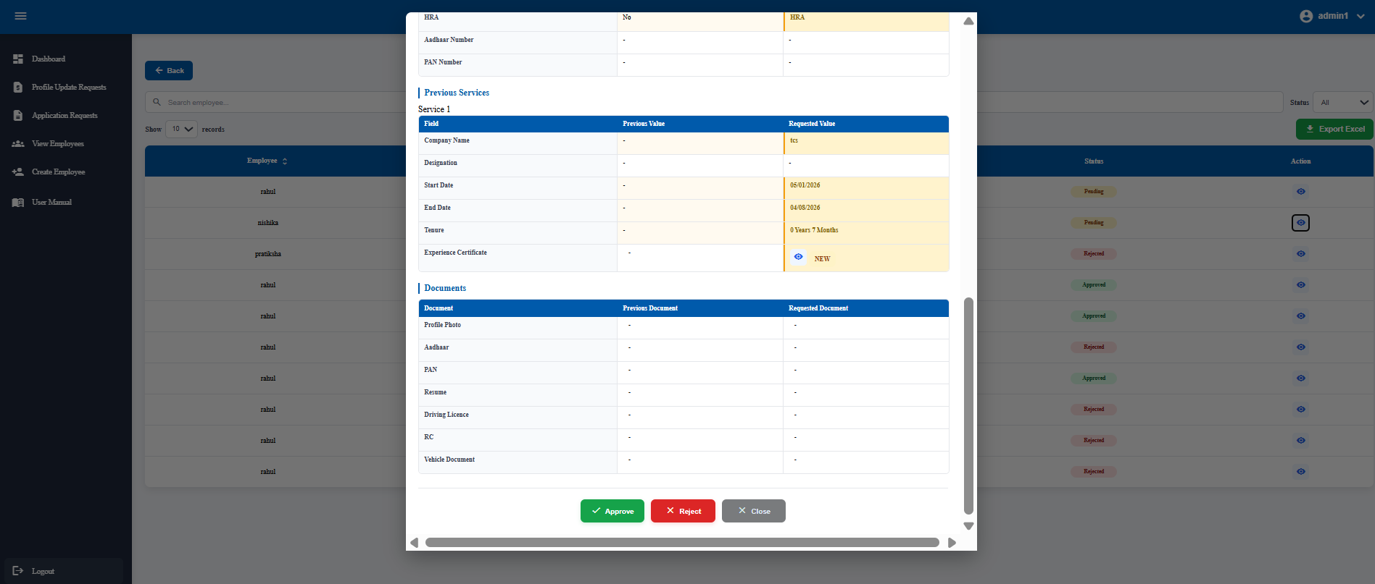

9. Application Requests
- Open Application Requests.
- Search/filter by employee or status.
- You can also export application requests.
- Open an application.
- Review details and supporting documents.
- Enter remarks if required.
- Approve or reject.
- The employee can see the result in My Applications.
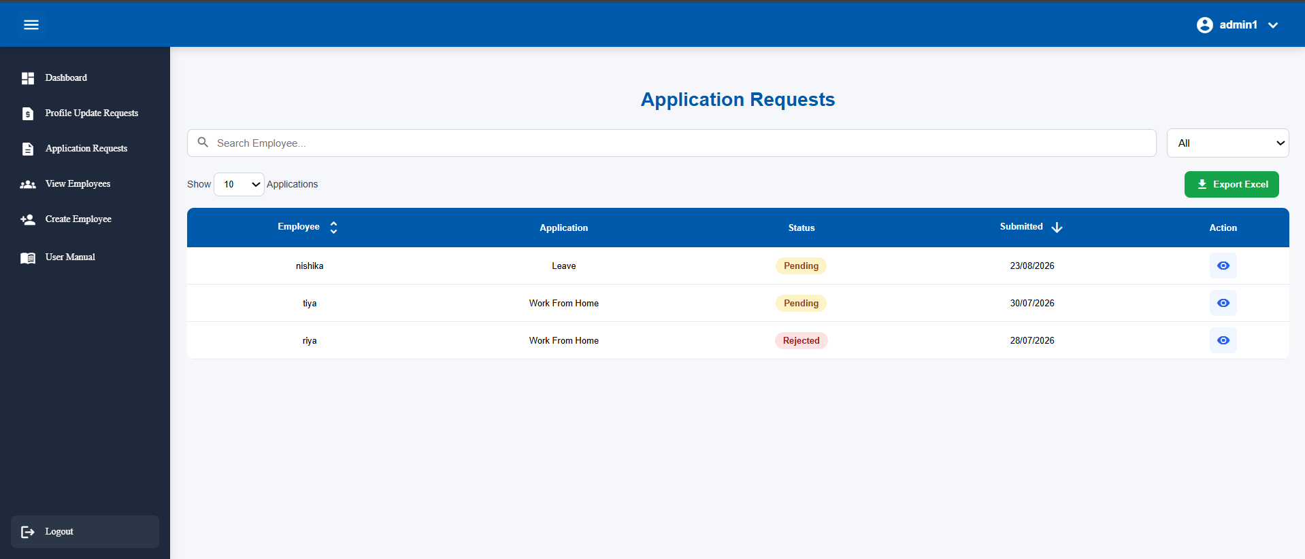
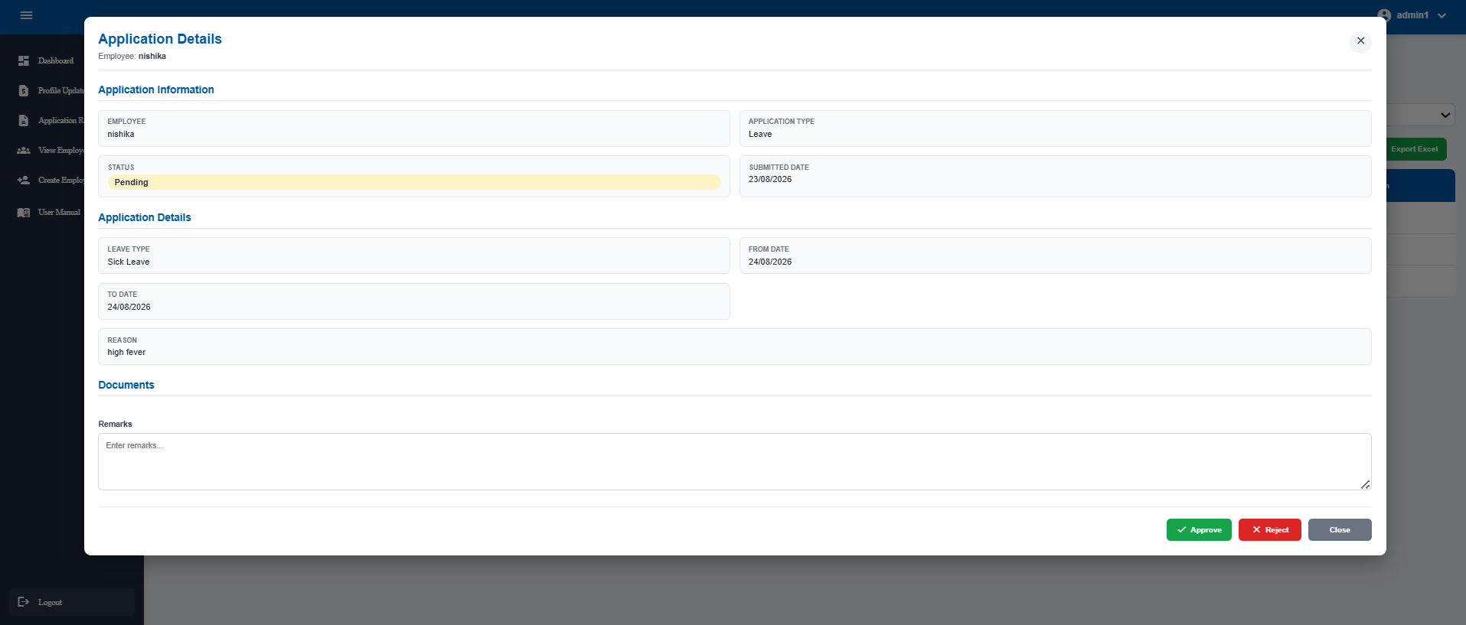

10. Role and Access Differences
Function | Employee | HR | Admin
View own profile | ✓ | — | —
Submit profile requests | ✓ | — | —
Submit applications | ✓ | — | —
Review profile requests | — | ✓ | ✓
Review applications | — | ✓ | ✓
Manage employee records | — | ✓ | ✓
Create employee | — | ✓ | ✓
Activate/deactivate employee | — | — | ✓
Inactive employees | — | — | ✓
Export management/request data | — | ✓ | ✓

Common Issues and Troubleshooting
Invalid Username: Check the username. If the issue continues, contact the authorized administrator.
Invalid Password: Check the password and use the available password recovery process.
Account Deactivated: Contact an Admin. A deactivated account cannot log in until activated.
Server Error: Check the connection and try again. Report persistent issues to the system administrator.
Request Not Visible: Refresh and check filters/status. Contact HR/Admin if it remains missing.
Document Not Opening: Verify that the document exists and is accessible.
Excel Export Has No Data: Check whether filters or search conditions exclude all records.

Quick Reference
Employee: Login → Profile → Edit/Request Changes → Apply → Track Status → Logout
HR: Login → Dashboard → View Employees → Review Requests/Applications → Approve/Reject → Export if required → Logout
Admin: Login → Dashboard → Employee Management → Create/Edit/Activate/Deactivate → Review Requests/Applications → Export if required → Logout
End of User Manual

