1. Throw vs Throws

<https://www.youtube.com/watch?v=nsJvdOrjBRA&t=16s>

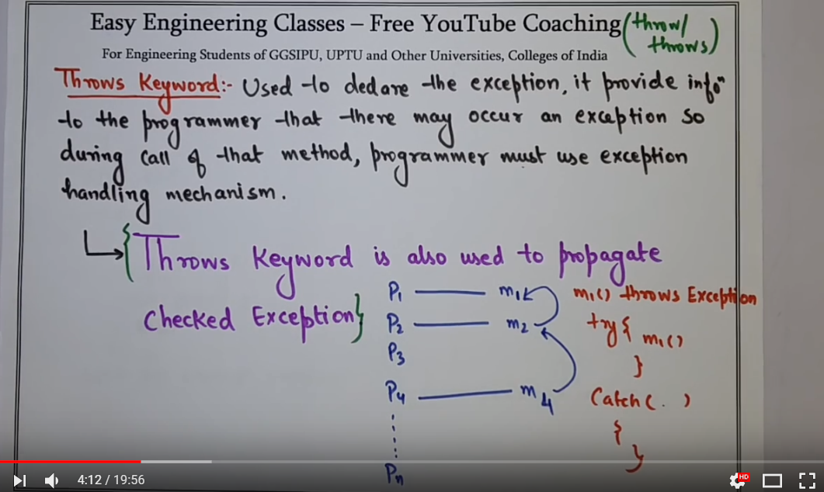

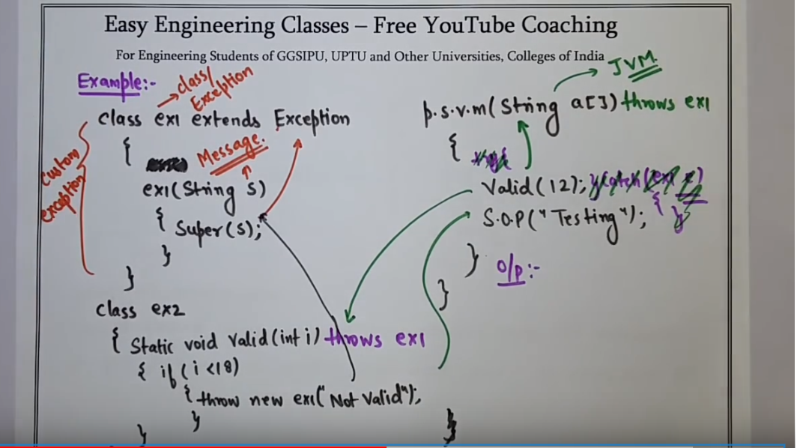

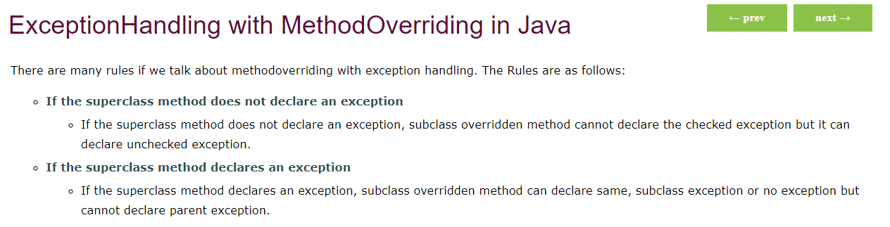

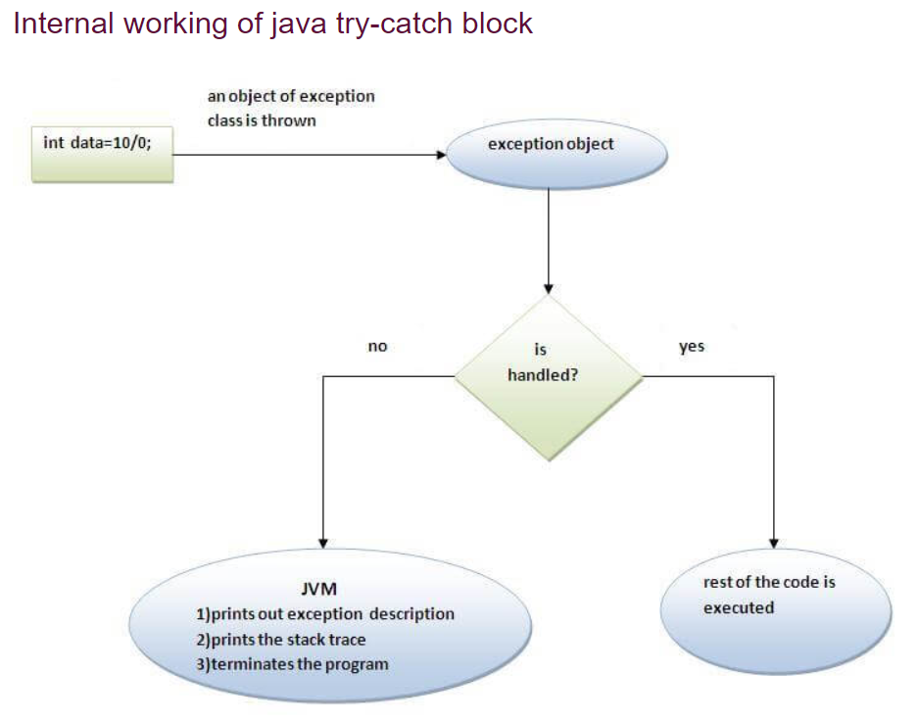

* **Rule: All catch blocks must be ordered from most specific to most general i.e. catch for ArithmeticException must come before catch for Exception .**

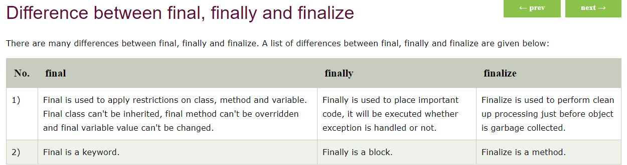

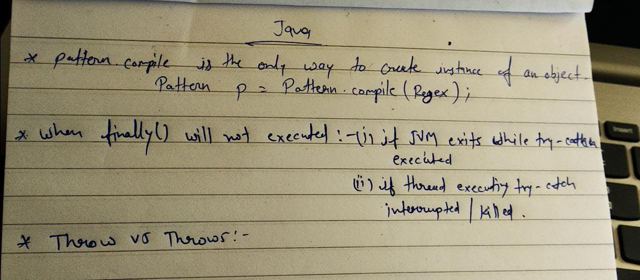

* Sleep method should always be in a try-catch block, as throws was declared in the declaration of this method, so we have to handle that exception using try-catch else it’ll give compile time error.
* **isAlive() & join() :-**

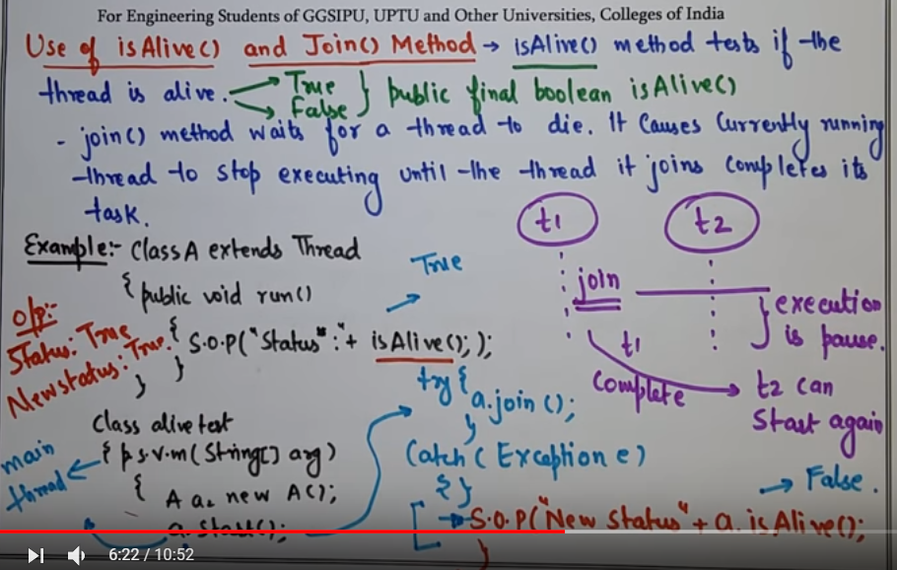

* **Yield() :-**

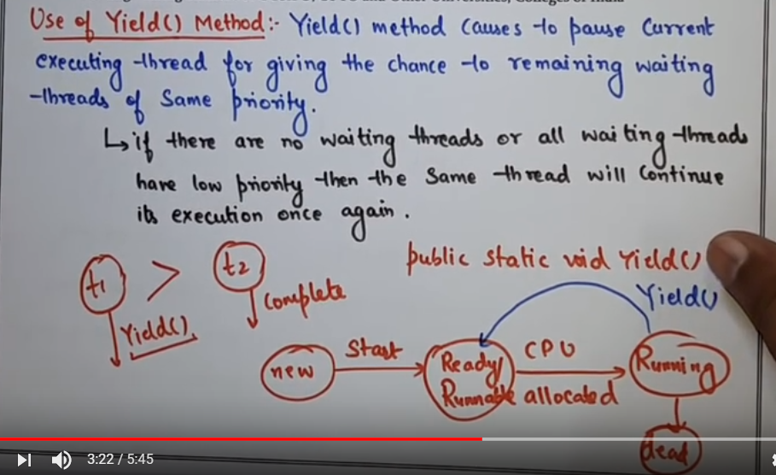

* **Synchronization :-**

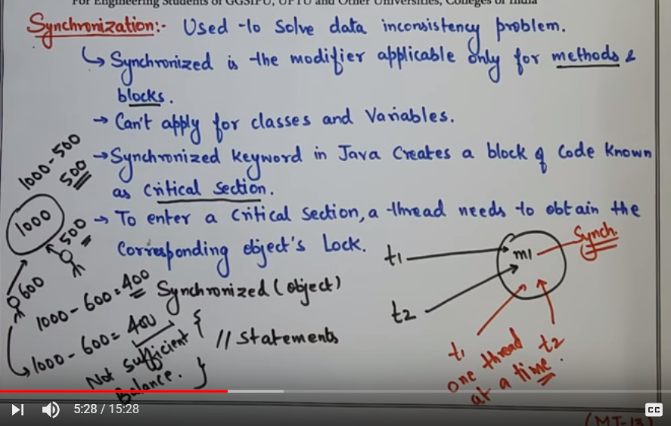

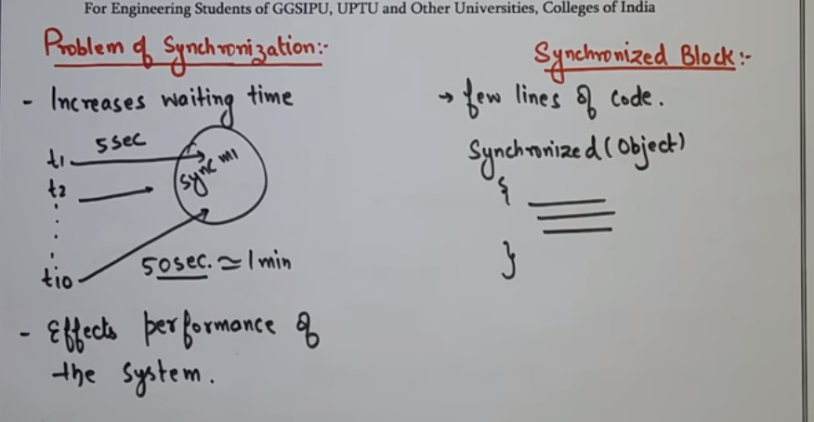

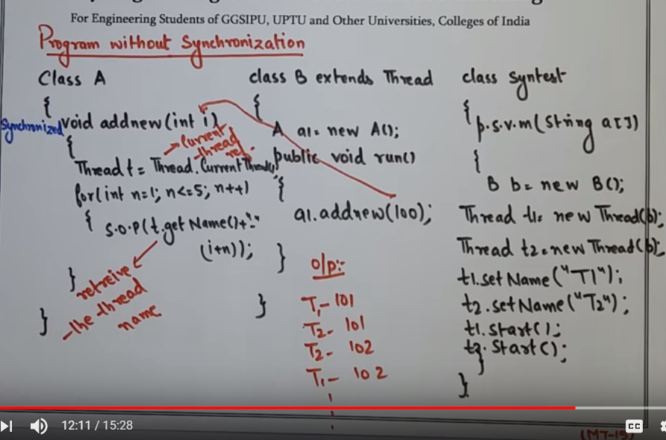

* **Producer – Consumer problem:-**

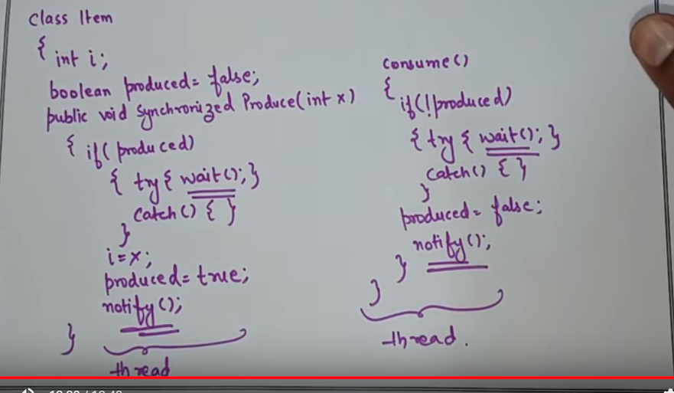

* **What happens if we call the run() method instead of start() method ?**

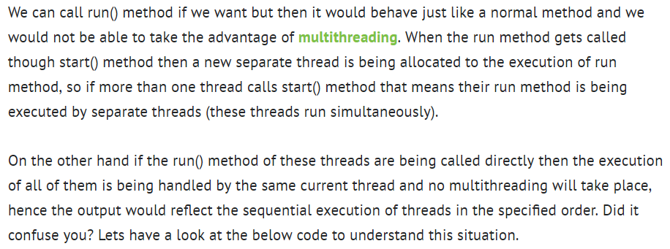

* 

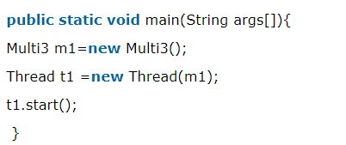

* **Daemon Thread :-**

**Daemon thread in java** is a service provider thread that provides services to the user thread. Its life depend on the mercy of user threads i.e. when all the user threads dies, JVM terminates this thread automatically. There are many java daemon threads running automatically e.g. gc, finalizer etc.

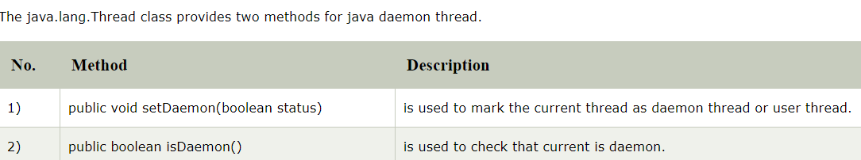

#### Note: If you want to make a user thread as Daemon, it must not be started otherwise it will throw IllegalThreadStateException.

* <https://www.javatpoint.com/java-thread-pool>