Mobile Infrastructure as a Service

High level design

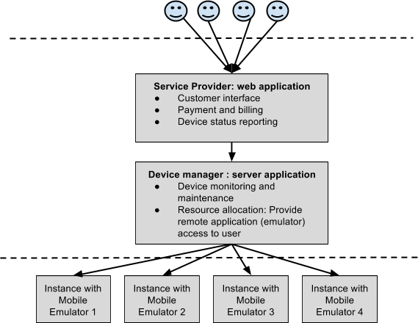

Questions:

1. Device type: Custom types (android, windows etc. ) or user defined?
2. If user defined, should the emulator configuration be handled by the program and then granted access to user, or should the user be directly granted access to emulator to configure?
3. Should the user be granted access to emulator through remote desktop app, like in AWS?
4. After remote access is granted, should the user activity still be monitored or should the machine only be pinged to check the status (dead or alive)?