# Array

1. **Sort array**

Asc => int[] a = {4,7,2,0,1}; Array.Sort(a);

Desc => Array.Sort(a); Array.Reverse(a); / Array.Sort(a, (x, y) => y.CompareTo(x));

Convert to list = List<int> list = new List<int>(a);

1. Size of array => nums.Length

# Dictionary

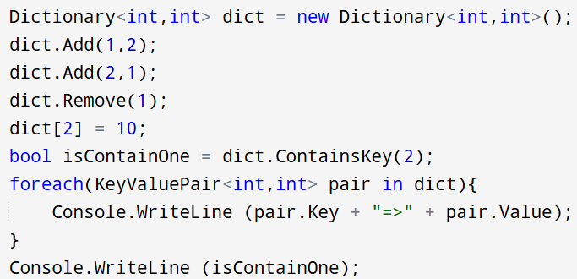

Is Anagram **Input:** s = "anagram", t = "nagaram" true learn how to make use of dict properly

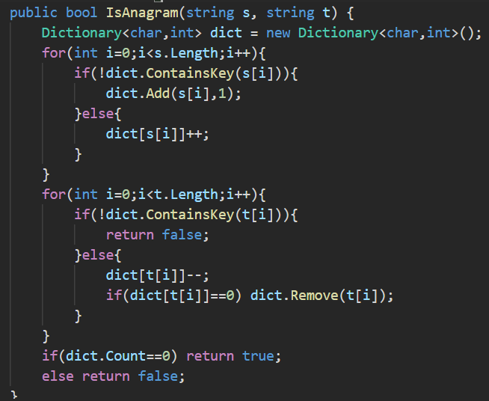

# Stack

# Maths

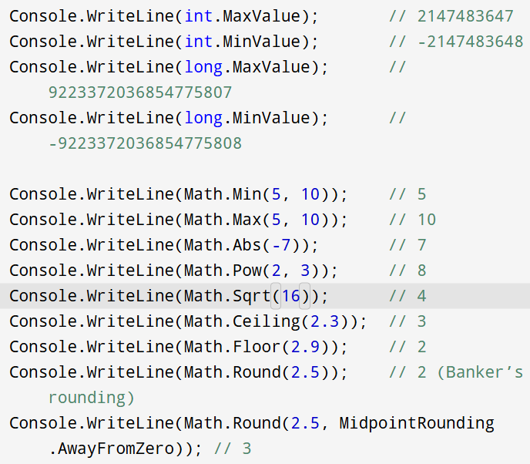

Swap two number

# ASCII

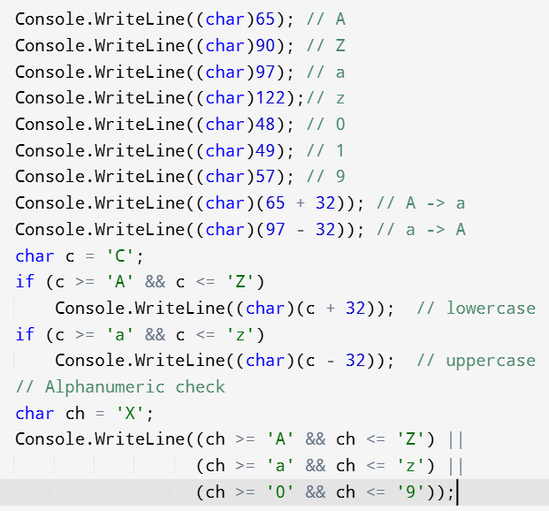

# String

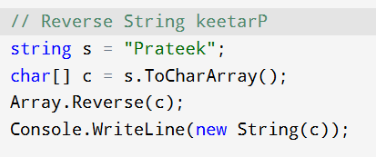

# Set



