Date: February 13, 2026
To: Karen Wasserman, Editorial Production Mgr.
Technical Analysis of Stocks & Commodities, The Traders’ Magazine
Topic: Python code to implement concepts from “A Synthetic Oscillator" by John F Ehlers.
Cc:: editor@Traders.com, kwasserman@traders.com

Hi Karen,

Please find below python code for the April 2026 Trader Tips. Please adjust as you see fit.

Please contact me with any questions, comments or suggestions to improve.

All the Best,

--Rajeev

===
Rajeev Jain
San Diego, CA
jainraje@yahoo.com
858-705-5261

"""
Python code to implement concepts in Technical Analysis of Stocks & Commodiities magazine
April 2026 article "A Synthetic Oscillator" by John F Ehlers. This python code is provided
for TraderTips section of the magazine.

Written By:
Rajeev Jain, Feb 2026
jainraje@yahoo,com

All code available in GitHub:
https://github.com/jainraje/TraderTipArticles/

HELPER FUNCTIONS
Not included in Trader Tip article but included in the associated
Jupyter notebook found in the GitHub repo.

Functions called:
- HannFilter
- SuperSmoother
- HighPassFilter
- UltimateSmoother
- RMS

"""

# import required python libraries
import pandas as pd
import numpy as np
import matplotlib.pyplot as plt
import yfinance as yf
import math
print(yf.__version__)

# MAIN CODE FOR ARTICLE

def synthetic_oscillator(close, params=(15, 25, 4)):
"""
Synthetic Oscillator function (Python version compatible with list-based helper functions)
close : list of closing prices
lower_bound : Lower bound of cycle period
upper_bound : Upper bound of cycle period
length : smoothing length (not directly used here)
returns: list of oscillator values

"""

lower_bound = params[0]
upper_bound = params[1]
length = params[2]

n = len(close)
synth = [0] * n
phase = [0] * n

# Step 1: Price preprocessing with Hann window
price = hann_lowpass(close, length=12)

# Step 2: Real component (bandpass filtered & normalized)
hp = high_pass(price, upper_bound)
lp = super_smoother(hp, lower_bound)
rms_lp = rms(lp, 100)
real = [lp[i] / rms_lp[i] if rms_lp[i] != 0 else 0 for i in range(n)]

# Step 3: Imaginary component (rate of change normalized)
roc = [0] * n
for i in range(1, n):
roc[i] = real[i] - real[i-1]
qrms = rms(roc, 100)
imag = [roc[i] / qrms[i] if qrms[i] != 0 else 0 for i in range(n)]

# Step 4: Dominant cycle period (DC) calculation
dc = [0] * n
for i in range(1, n):
denom = (real[i] - real[i-1]) * imag[i] - (imag[i] - imag[i-1]) * real[i]
if denom != 0:
dc_val = 2 * math.pi * (real[i]**2 + imag[i]**2) / denom
# limit DC to lower and upper bounds
dc[i] = max(lower_bound, min(dc_val, upper_bound))
else:
dc[i] = lower_bound

# Step 5: Midpoint cycle
mid = math.sqrt(lower_bound * upper_bound)

# Step 6: Bandpass filter at average dominant cycle
hp2 = high_pass(close, mid)
bp = ultimate_smoother(hp2, mid)

# Step 7: Phase accumulation
for i in range(1, n):
phase[i] = phase[i-1] + 360 / dc[i]

# Reset phase at BP zero crossings
if bp[i-1] < 0 <= bp[i]:
phase[i] = 180 / dc[i]
elif bp[i-1] > 0 >= bp[i]:
phase[i] = 180 + 180 / dc[i]

# Step 8: Synthetic oscillator = sine of cumulative phase
synth = [math.sin(math.radians(p)) for p in phase]

# Step 9: Remove reset glitch if continuity falls in same quadrant
for i in range(1, n):
if 0 < phase[i] < 90 and synth[i] < synth[i-1]:
synth[i] = synth[i-1]
elif 180 < phase[i] < 270 and synth[i] > synth[i-1]:
synth[i] = synth[i-1]

return synth

def plot_trading_signals(df, params, plot_so_ena=False, plot_roc2_ena=True, plot_buy_sell_ena=True):

fig, (ax1, ax2) = plt.subplots(
2, 1,
figsize=(9, 6),
sharex=True,
constrained_layout=True,
gridspec_kw={'height_ratios': [2, 1]}
)

# --- Price subplot ---
ax1.plot(df.index, df['Close'], label='Close', color='black')
ax1.set_ylabel('Close Price')

if plot_buy_sell_ena:
ax1.set_title(f"Ticker='{symbol}', Close & Buy and Sell Signals")
else:
ax1.set_title(f"Ticker='{symbol}', Close")
ax1.grid(True)

if plot_buy_sell_ena:
# --- Plot Buy/Sell markers only on transitions ---
if 'Signal' in df.columns:
buy_idx = df[(df['Signal'] == 1) & (df['Signal'].shift(1) != 1)]
sell_idx = df[(df['Signal'] == -1) & (df['Signal'].shift(1) != -1)]

ax1.scatter(
buy_idx.index,
buy_idx['Close'],
marker='^',
color='green',
s=100,
label='Buy',
zorder=3
)

ax1.scatter(
sell_idx.index,
sell_idx['Close'],
marker='v',
color='red',
s=100,
label='Sell',
zorder=3
)

ax1.legend(loc='upper left')

# --- Oscillator subplot ---
ax2_left = ax2
ax2_right = ax2.twinx()

title_text = f"params={params}"

if plot_so_ena and 'SO' in df.columns:
ax2_right.plot(df.index, df['SO'], label='Synthetic Oscillator', color='darkblue')
title_text += f", SO_last={df['SO'].iloc[-1]:.2f}"

if plot_roc2_ena and 'ROC2' in df.columns:
ax2_right.plot(df.index, df['ROC2'], label='ROC2', color='darkblue')
title_text += f", ROC2_last={df['ROC2'].iloc[-1]:.2f}"
if 'Signal' in df.columns:
ax2_left.plot(df.index, df['Signal'], label='Signal', color='lightblue')
ax2_left.set_ylabel('Signal')

ax2_right.set_ylabel('Oscillators')
ax2_right.axhline(0, color='black', linewidth=2)
ax2_right.set_title(title_text)
ax2_right.grid(True)

lines_left, labels_left = ax2_left.get_legend_handles_labels()
lines_right, labels_right = ax2_right.get_legend_handles_labels()
ax2_right.legend(lines_left + lines_right, labels_left + labels_right, loc='upper left')

plt.xticks(rotation=45)
plt.show()

# The following function contains all indicator calculations and trading logic.
def calc_trading_strategy(ohlcv, params=None):

if params is None:
params=(17, 23, 8)

length = params[2]

df = ohlcv.copy()
# synthetic oscillator indicator (aka SO)
df['SO'] = synthetic_oscillator(df['Close'], params)

# run SO output through Hann lowpass filter and perform ROC
df['SO2'] = hann_lowpass(df['SO'], params[2])
df['ROC2'] = df['SO2'] - df['SO2'].shift()

# buy logic (ROC2 cross above 0)
cond_buy = (df['ROC2'] > 0) & (df['ROC2'].shift() < 0)
df['Signal'] = np.where(cond_buy, 1, np.nan)

# sell logic (ROC2 cross below 0)
cond_sell = (df['ROC2'] < 0) & (df['ROC2'].shift() > 0)
df['Signal'] = np.where(cond_sell, -1, df['Signal'])
df['Signal'] = df['Signal'].fillna(method='ffill')

# add BUY and SELL alerts to dataframe
df['Alert'] = np.where((df['Signal']==1) & (df['Signal'].shift()== -1), 'BUY', '')
df['Alert'] = np.where((df['Signal']==-1) & (df['Signal'].shift()== 1), 'SELL', df['Alert'])

return df

# EXAMPLE USAGE

# download price data from Yahoo Finance
symbol = '^GSPC'
symbol = 'ES=F'
ohlcv = yf.download(
symbol,
start="2000-01-01",
end="2026-02-12",
group_by="Ticker",
auto_adjust=True,
progress=False,
)
ohlcv = ohlcv[symbol]

# Call trading strategy and plotting functions.
# Use slicing technique to set plot start and end timeframes.
# Set arguments on plotting function to enable or disable
# desired indicator plots

# example usage below shows closing price for instrument in top subplot
# and Synthetic Oscillator in the bottom subplot

# --- Set Indicator Parameters as desired ---
lower_bound = 17
upper_bound = 23
length = 8
params=(lower_bound, upper_bound, length)
df = calc_trading_strategy(ohlcv, params)
plot_trading_signals(df['2010':'2010'], params, plot_so_ena=True, plot_roc2_ena=False, plot_buy_sell_ena=False)

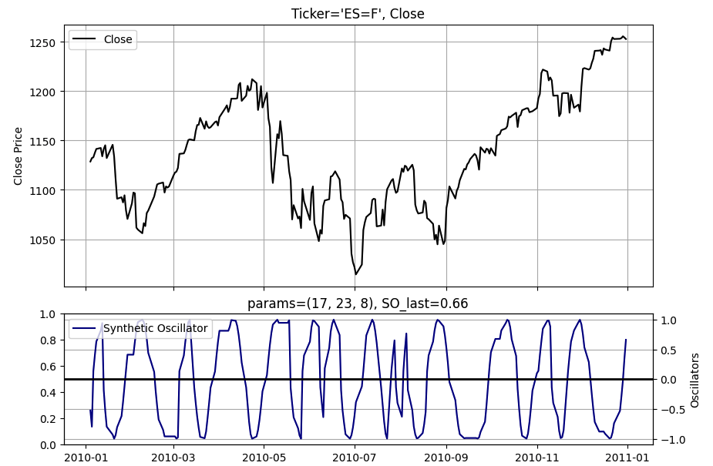

# Call trading strategy and plotting functions.
# Use slicing technique to set plot start and end timeframes.
# Note the Signal line (light blue) generates the buy and sell
# signals as the ROC2 indicator goes above and below zero.
# Inspect plot for buy or sell signal.

# --- Set Indicator Parameters as desired ---
lower_bound = 17
upper_bound = 23
length = 8

params=(lower_bound, upper_bound, length)
df = calc_trading_strategy(ohlcv, params)
plot_trading_signals(df['2010':'2010'], params, plot_so_ena=False, plot_roc2_ena=True, plot_buy_sell_ena=True)
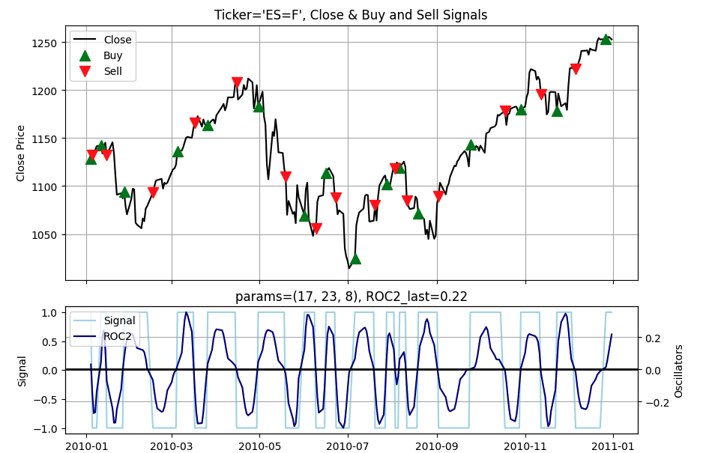

# Inspect resulting dataframe for a BUY or SELL Alert
# example below shows most recent last 12 days
df.tail(12)

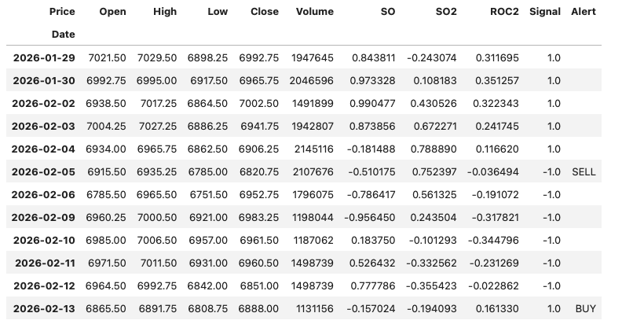

# Filter to inspect all BUY and SELL Alerts
# Use slicing techniques to zero in on specific time frames
cond = df['Alert'] != ''
df[cond]['2025':'2025'].head(10)
