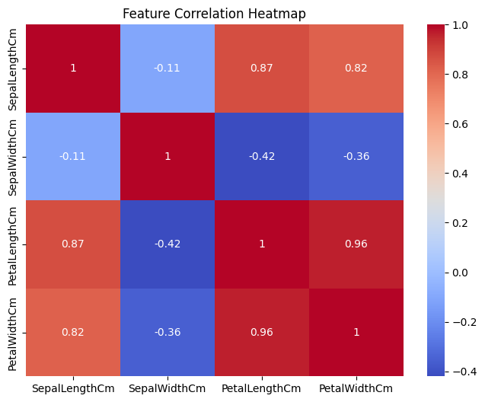

Key Findings

1. Petal Length and Petal Width (0.96)
PetalLengthCm ↔ PetalWidthCm = 0.96
This is the strongest correlation in the dataset.

Interpretation
- Flowers with longer petals almost always have wider petals.
- These two features grow together.
- If you know the petal length, you can estimate the petal width quite accurately.

Biological Meaning
As the flower becomes larger, both petal dimensions increase proportionally.

Machine Learning Insight
Petal features contain most of the information needed to classify flower species.

2. Sepal Length and Petal Length (0.87)
SepalLengthCm ↔ PetalLengthCm = 0.87

Interpretation
- Flowers with longer sepals tend to have longer petals.
- This is a very strong positive relationship.

Insight
Larger flowers generally have larger measurements across different parts of the flower.

3. Sepal Length and Petal Width (0.82)
SepalLengthCm ↔ PetalWidthCm = 0.82

Interpretation
Another strong positive relationship.
As sepal length increases, petal width usually increases as well.

Conclusion
Sepal length is a good indicator of overall flower size.

4. Sepal Width and Petal Length (-0.42)
SepalWidthCm ↔ PetalLengthCm = -0.42

Interpretation
Moderate negative correlation.
When sepal width increases, petal length tends to decrease somewhat.

Why?
This often happens because different species have different growth patterns.
For example:
- Setosa tends to have wider sepals but very short petals.
- Virginica tends to have narrower sepals but much longer petals.
This species difference creates the negative relationship.

5. Sepal Width and Petal Width (-0.36)
SepalWidthCm ↔ PetalWidthCm = -0.36

Interpretation
Weak-to-moderate negative relationship.
Flowers with wider sepals tend to have slightly narrower petals.
Again, this is driven largely by species differences.

6. Sepal Length and Sepal Width (-0.11)
SepalLengthCm ↔ SepalWidthCm = -0.11

Interpretation
Almost no relationship.
Knowing sepal length tells you very little about sepal width.

Conclusion
These two measurements vary independently.

🎯 Feature Importance Analysis
Based on this heatmap:

Most Important Features
- Petal Length
- Petal Width
These features show the strongest relationships and provide the clearest separation between species.

Least Important Feature
- Sepal Width
It has weak or negative correlations with most other variables.

🌿 Species-Level Interpretation
The heatmap indirectly reveals the species structure:

Setosa
- Small petals
- Wider sepals
- Clearly different from the other two species

Versicolor
- Medium-sized petals
- Intermediate measurements

Virginica
- Largest petals
- Longest sepals
Because petal measurements differ so strongly across species, petal features become highly predictive.

