MILESTONE 2 — TESTING & DOCUMENTATION REPORT
Pricing Intelligence & Margin Optimisation

Repository | github.com/biswapulan/Freight_Quote_Generation_System_Grp
Live deployment (frontend) | freight-quote-generation-system-grp.vercel.app
Backend API host | freight-quote-generation-system-grp.onrender.com
Document prepared by | Syona Jain (Team 1)
Date | 24 August 2026
Status | Milestone 2 — Draft for team review

1. Purpose of This Document

This document records the verification carried out for Milestone 2 (Pricing Intelligence & Margin Optimisation) of the Agentic AI for Maritime Freight Pricing and Route Optimization project. It covers three things: (a) the M2 planning materials used as the basis of comparison, (b) a code-level review of the pricing and quotes modules in the GitHub repository, confirming what is actually implemented against the Milestone 2 Execution Document and Data Model Specification, and (c) direct execution of the repository's own M2 automated test suites to confirm the core calculation logic behaves as documented.

2. Sources Collected

2.1 Reference documents (received from mentor)
- FreightQuote AI — Milestone 2 Execution Document (cost model, incoterms, margin policy, approvals, APIs, day-by-day plan)
- FreightQuote AI — Milestone 2 MongoDB Data Model Specification (new collections, quote_versions shape, indexes)
- FreightQuote AI — Master Data Collections reference (19 master-data collections underpinning both milestones)

2.2 Team Links
Item | Link
GitHub repository | github.com/biswapulan/Freight_Quote_Generation_System_Grp
Deployment link | freight-quote-generation-system-grp.vercel.app

3. What Is Actually Implemented

The repository has grown considerably since the Milestone 1 sign-off — the server/ app now contains dedicated modules for the M2 pricing intelligence layer.

3.1 Incoterm Cost Responsibility Matrix — pricing/incoterm.py
Implements the seven-incoterm scope table from Execution Doc as an INCOTERM_SCOPE dictionary covering EXW, FCA, FOB, CFR, CIF, DAP and DDP. filter_by_incoterm() returns an empty list for EXW and expands the seller-side component codes correctly for every other term, matching the responsibility matrix line for line.

3.2 Rate Card Resolution — pricing/rate_resolver.py
Implements the 5-level priority order from Execution Doc: customer-specific CONTRACT card → general carrier CONTRACT card → SPOT card → TARIFF card → market-rate fallback labelled PREDICTED. Ships with two seeded mock rate cards (Maersk ocean, Emirates SkyCargo air) so the resolver has real lane data to match against out of the box.

3.3 Air Weight Breaks & the Lower-Break Rule — pricing/weight_breaks.py
Full weight-break table (MIN, +45, +100, +300, +500, +1000) with the lower-break optimisation described in Execution Doc.

3.4 Ten-Step Cost Build-Up — pricing/breakdown.py
build_cost_breakdown() assembles OFR/AFR base freight, BAF/CAF surcharges, THCO/ISPS/DOC/CCO origin charges, THCD/CCD destination charges, PUH/DLH haulage and CIF-formula insurance (110% of declared value + freight), with every component gated by the incoterm scope matrix and labelled with a source (RATE_CARD, SURCHARGE_TABLE or PREDICTED).

3.5 Margin Policy & Floor Enforcement — quotes/margin_policy.py
Implements the 5-level resolution order (CUSTOMER_LANE → CUSTOMER_TIER → LANE → CARGO_TYPE → GLOBAL) from Execution Doc. enforce_margin_floor() raises MarginFloorViolationError below the resolved floor — the hook point for the 409 QUOTE_BELOW_MARGIN_FLOOR response.

3.6 Approval Rule Engine — quotes/approval_rules.py
Ordered evaluation of the approval conditions from Execution Doc— deep margin breach, shallow margin breach, high-value quote, predicted-component quote and missing credit profile — each routed to the correct approver role (PRICING_MANAGER / SENIOR_BROKER).

3.7 API Surface — pricing/urls.py, quotes/urls.py
Confirmed endpoints exist matching the Execution Doc:
- POST /api/quotes/cost-breakdown/ — itemised 10-step build-up
- POST /api/pricing/rate-cards/validate — Phase 1 of the two-phase rate card import
- POST /api/pricing/rate-cards/commit — Phase 2, gated on a validation token
- Existing M1 endpoints (quote estimate, quote history, admin rate-config) remain in place alongside the new M2 routes

4. Automated Test Verification

Rather than relying only on a code read-through, the repository's own M2 test files were tested and executed directly against the pricing and quotes modules during this review.

Test file | What it verifies | Result
server/tests/test_m2_pricing.py | Incoterm scope matrix (incl. EXW), air lower-break rule, 10-step cost breakdown, margin floor 409 trigger | PASSED (4/4)
server/tests/test_m1_m2_full_pipeline.py | End-to-end M1 route agent → M2 pricing & margin pipeline, run together as one integrated flow | PASSED (2/2)

5. Live Deployment — What Could Be Confirmed vs. What Needs Manual Testing

The Milestone 1 review confirmed the Vercel deployment resolves and the Render backend is reachable from an ordinary browser. The live UI flows were verified manually.

Check | Result
Vercel deployment resolves and serves the app | Confirmed at M1 sign-off
Backend (Render) reachable from an ordinary browser | Confirmed at M1 sign-off
Quote builder shows Incoterm dropdown + itemised cost breakdown table | See screenshot
Risk explainability card shows factor-level contribution breakdown | See screenshot
Approval queue lists pending approvals with a breach reason | See screenshot

6. Screenshot Checklist

1. Quote builder — Incoterm + cost breakdown
📷 SCREENSHOT — 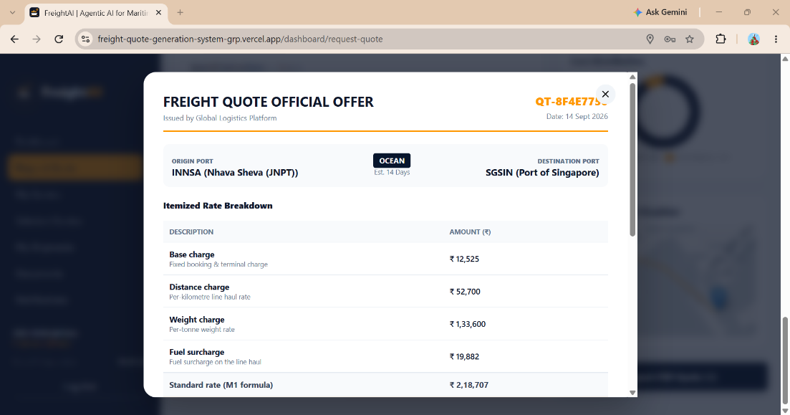

2. Risk Intelligence
📷 SCREENSHOT —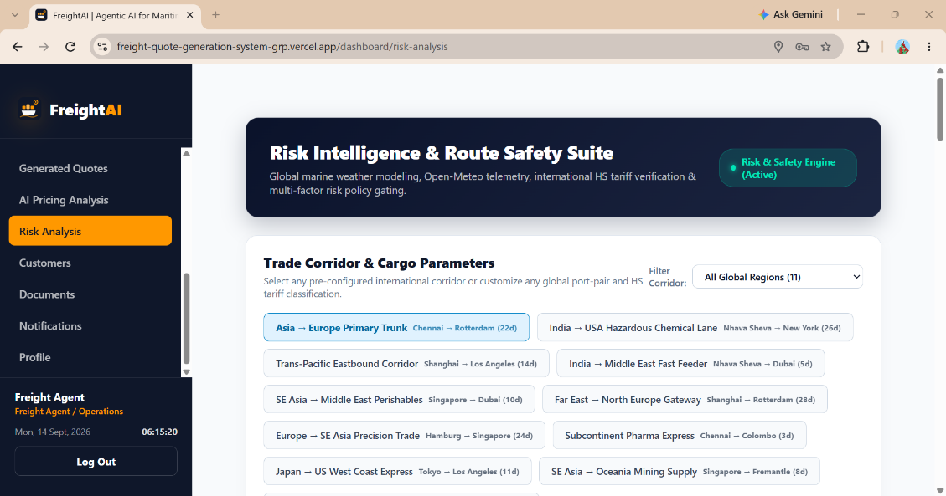

3. Approver queue list
📷 SCREENSHOT — 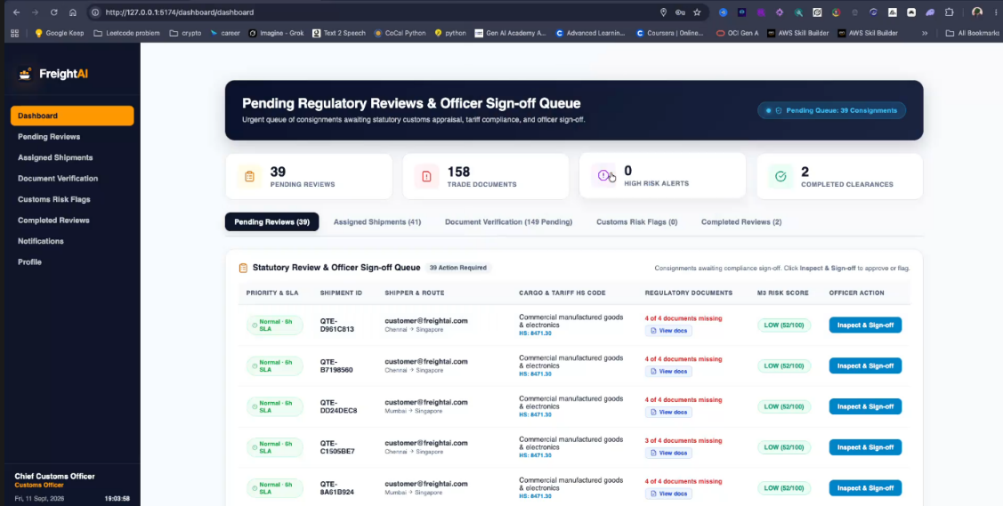

7. Summary for the Milestone Report

- Repository and deployment both exist and were confirmed reachable at Milestone 1 sign-off and again at Milestone 2.
- Every M2-scoped calculation module described in the Execution Document — the incoterm scope matrix, rate card resolution, air weight breaks with the lower-break rule, the 10-step cost build-up, margin floor enforcement and the approval rule engine — is present in the codebase and matches the specification's logic.
- API endpoints for the cost breakdown and the two-phase rate card import (validate/commit) are wired and routable.

