MILESTONE 1 — TESTING & DOCUMENTATION REPORT
Repository review, live deployment verification, and open pull-request audit for Milestone 1 sign-off.

Repository | github.com/biswapulan/Freight_Quote_Generation_System_Grp
Live deployment (frontend) | freight-quote-generation-system-grp.vercel.app
Backend API host | freight-quote-generation-system-grp.onrender.com
Document prepared by | Syona Jain
Date | 4 August 2026
Status | Milestone 1 — Draft for team 1 review

1. Purpose of This Document
This document records the documentation and verification process carried out for Milestone 1 of the freight quotation project. It covers two things: (a) the source materials collected — reference PDFs circulated by mail and the team's deployment/repository links and (b) a code-level review of the GitHub repository to confirm what is actually implemented versus what the planning documents describe.

2. Sources Collected

2.1 Reference documents (received by mail)
The following planning/reference documents were supplied for this milestone and used as the basis of comparison against the actual codebase:
- FreightQuote AI — Milestone 1 Data Model Specification (MongoDB collections, Decimal128 money handling, quote immutability rules)
- FreightQuote AI — Milestone 1 Execution Document (form field spec, calculation methods, day-by-day plan)
- FreightQuote AI — Enterprise Technical Blueprint (full 8-week, 4-milestone architecture: React + Django + FastAPI + PostgreSQL/PostGIS)
- Intelligent Freight Quote Generation System — Project Explanation Document (React + Django + MongoDB + JWT + scikit-learn architecture — this matches the actual repo most closely)
- Project Explanation — Architecture & Process (2-page proposal deck with workflow/architecture/DB-schema diagrams)
- FreightQuote AI — Master Data Collections reference (19 MongoDB master-data collections: countries, ports, tradeLanes, carriers, rateCards, etc.)

2.2 Links provided
GitHub repository | https://github.com/biswapulan/Freight_Quote_Generation_System_Grp
Deployment link | https://freight-quote-generation-system-grp.vercel.app/

3. What Is Actually Implemented (main branch)
The repository is a two-folder monorepo:
client/ — React 18 + Vite frontend (deployed on Vercel), and server/ — Django + Django REST Framework backend (deployed on Render).

3.1 Backend
- Framework: Django 6.0 + DRF, served via Gunicorn on Render's free tier.
- Two different databases are in play: Django's own ORM points at a local SQLite file (db.sqlite3), but the actual application data — user accounts and quotes — is written directly to MongoDB via pymongo (see accounts/mongo.py and pricing/mongo.py), bypassing the Django ORM entirely. This matches the "Intelligent Freight Quote Generation System" doc's architecture.
- Auth: custom JWT (PyJWT) issued by the accounts app, not Django's session auth — DRF is configured with a custom MongoJWTAuthentication class.
- Roles implemented in code: retail, business, agent, admin (4 roles)
- Pricing engine (pricing/engine.py): pure rule-based formula — haversine great-circle distance between origin/destination coordinates, chargeable weight (max of actual vs. volumetric), then price = base_rate × distance × cargo_multiplier × mode_multiplier + fuel_surcharge, using a rate_config record editable by admins. No ML model is present yet — this matches "Stage 1" of the Project Explanation Document.

3.2 Frontend
- React Router SPA with public marketing pages (/, /services, /tracking, /contact, etc.) plus a protected /dashboard shell that changes its sidebar and content entirely based on account role.
- Confirmed wired to the real backend: the /quote page and the retail dashboard's "Generate Quote" section both call POST /api/quotes/estimate/ and render the live response.

3.3 Deployment
Frontend host | Vercel — static SPA build, client/vercel.json rewrites all paths to index.html (correct for a React Router SPA)
Backend host | Render (free tier)
Frontend → backend wiring | client/src/api/client.js hardcodes the Render URL as a fallback if VITE_API_BASE_URL isn't set

4. Live Deployment — What Could Be Confirmed vs. What Needs Manual Testing
The deployment link confirms the site is live and served (title "FreightAI | Intelligent Freight Quote Generation" resolves correctly).
Check | Result
Vercel deployment resolves and serves the app | Confirmed — page loads, correct title returned
Backend (Render) reachable from this environment | Confirmed from an ordinary browser/network.
Signup / login talk to the real backend (not the demo-mode fallback) | See screenshot
Quote generation returns a real priced quote | See screenshot
Admin rate-config change affects the next quote | See screenshot

5. Screenshot Checklist
1. Landing page
📷 SCREENSHOT — Landing page
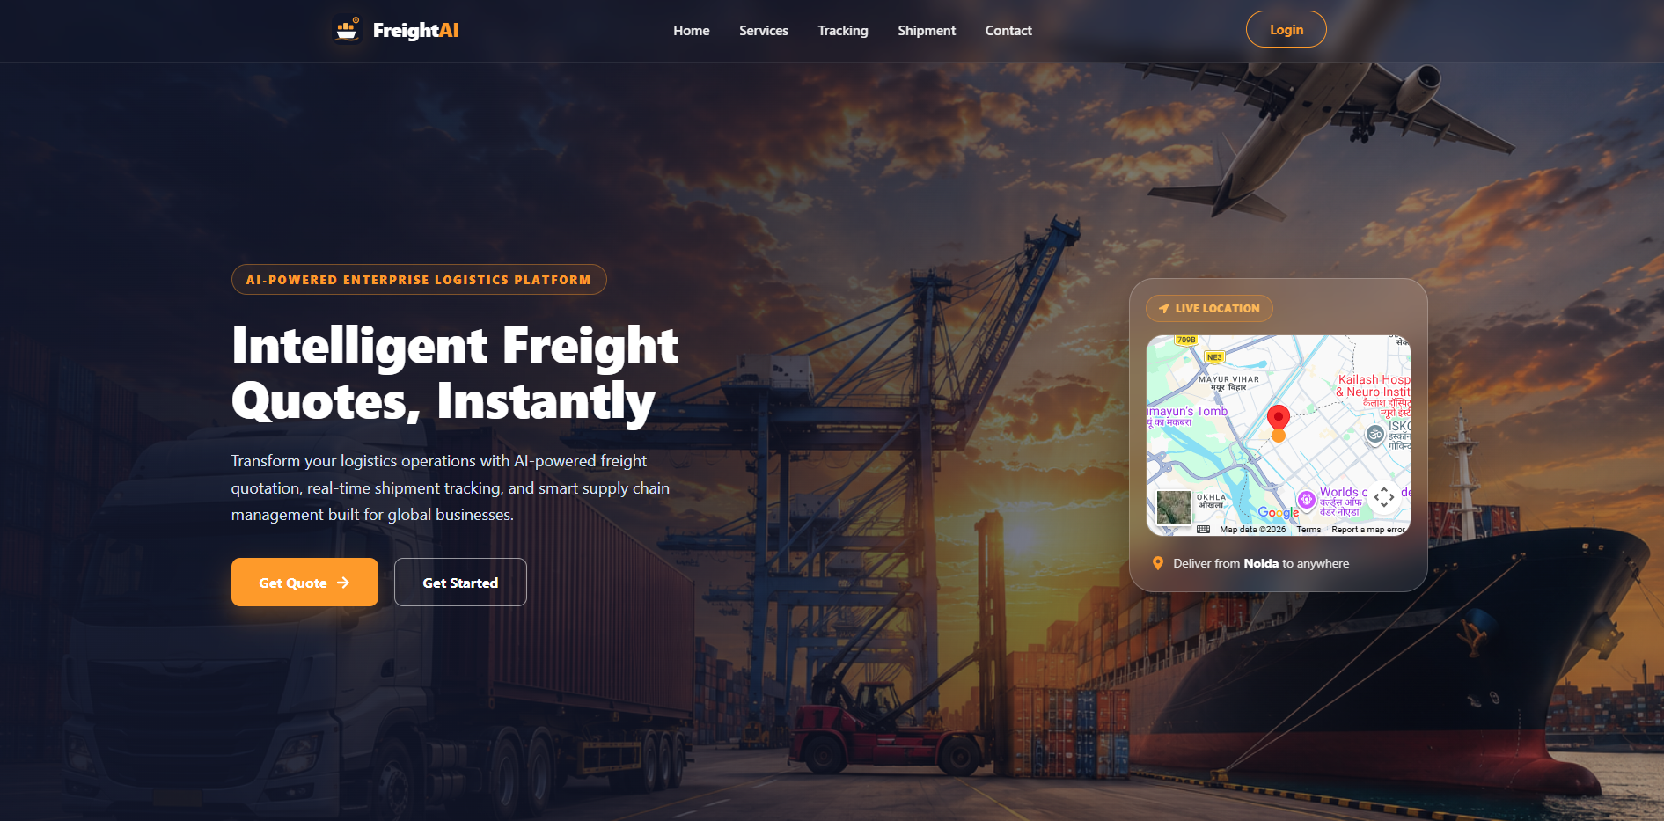
https://freight-quote-generation-system-grp.vercel.app/ fully loaded. Confirms the deployment is live and the marketing/home page renders correctly.
2. Signup
📷 SCREENSHOT — Signup form + result
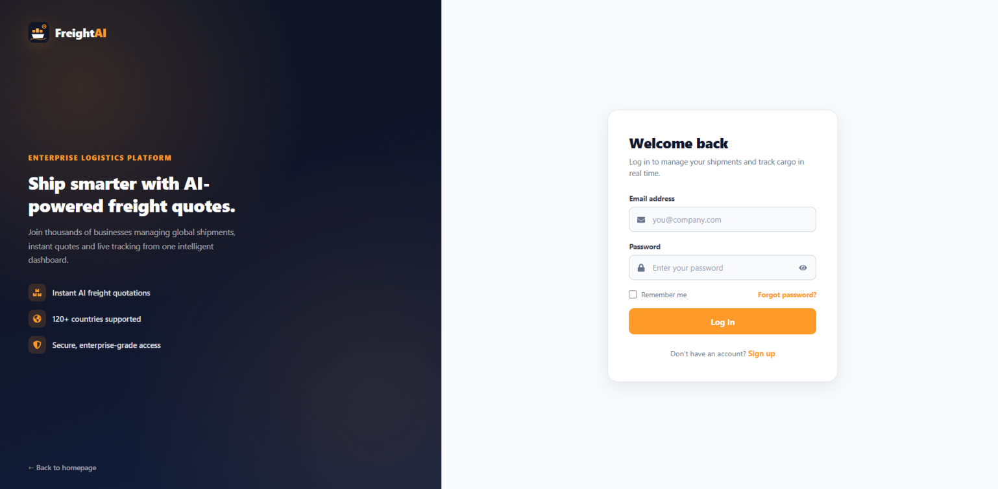
Fill and submit the signup form for a fresh test account (retail role).
3. Customer Dashboard
📷 SCREENSHOT — 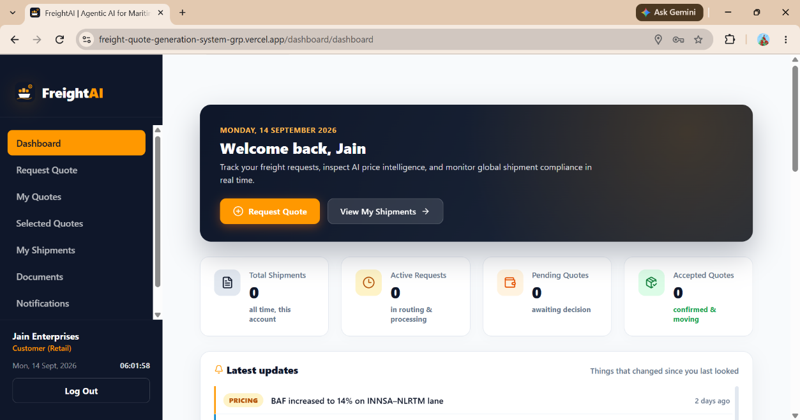
4. Generate a quote (Retail flow)
📷 SCREENSHOT — Quote form + quote result
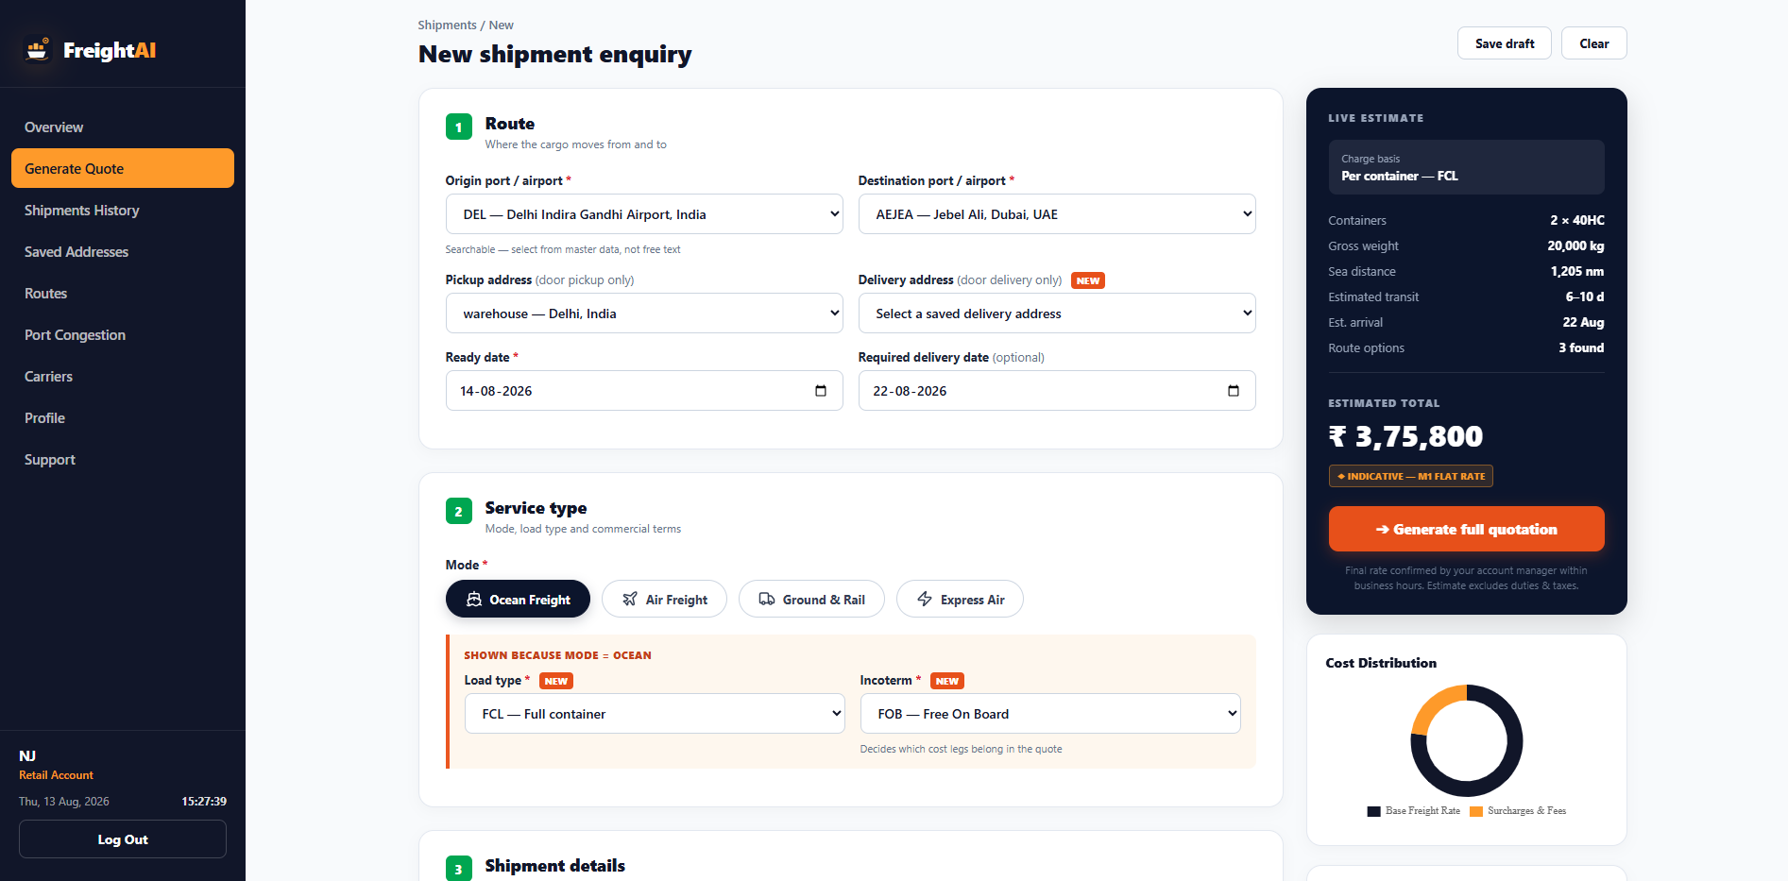

From the dashboard, go to Generate Quote (or /quote), fill in origin, destination, cargo type, mode, weight, volume, and submit.
5. Shipment/ Quote history
📷 SCREENSHOT — Quote history list
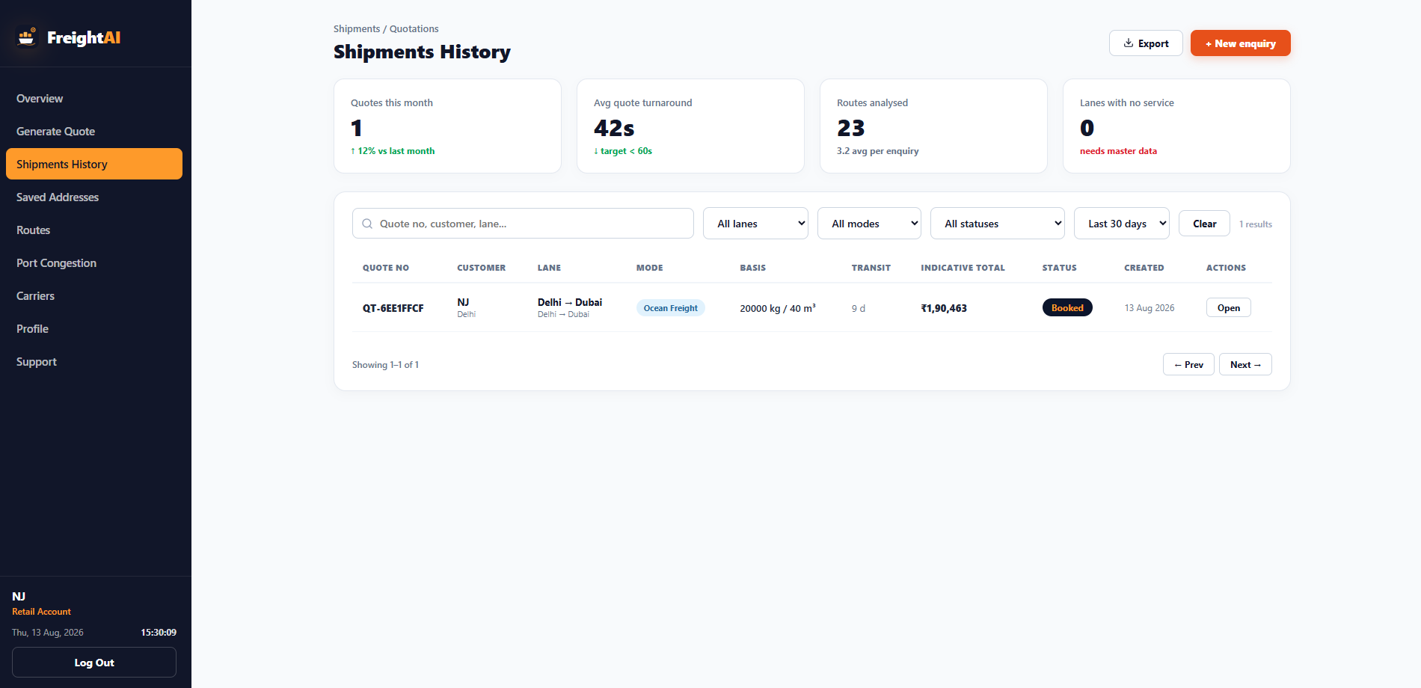
Navigate to Shipments History and see the list showing the quote you just generated, confirming it persisted.
6. Admin rate config
📷 SCREENSHOT — Admin rate-config page
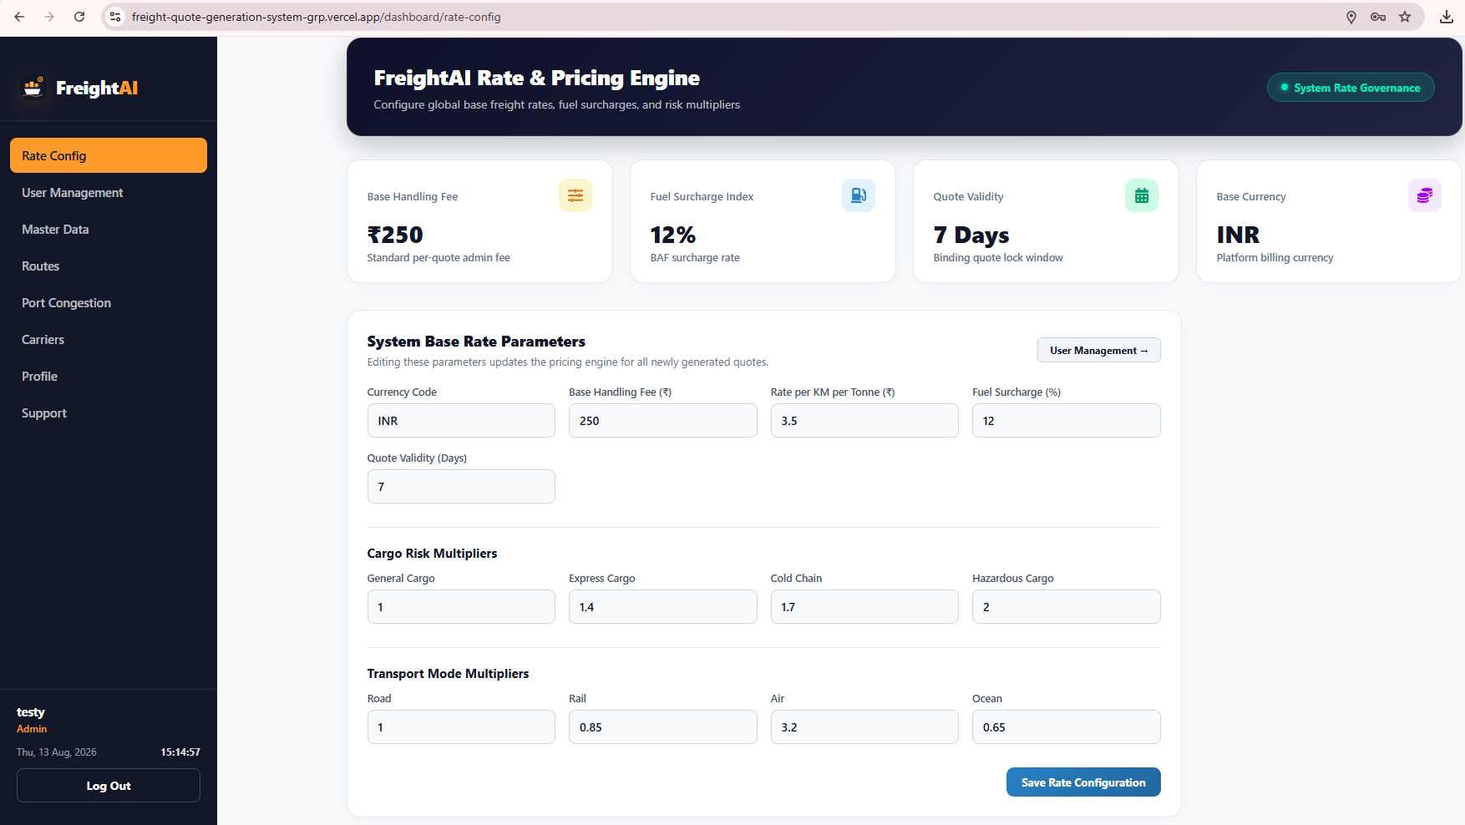
Log in as an admin and open the Rate Config page.
8. Business sign up
📷 SCREENSHOT — Business role — New Quote section
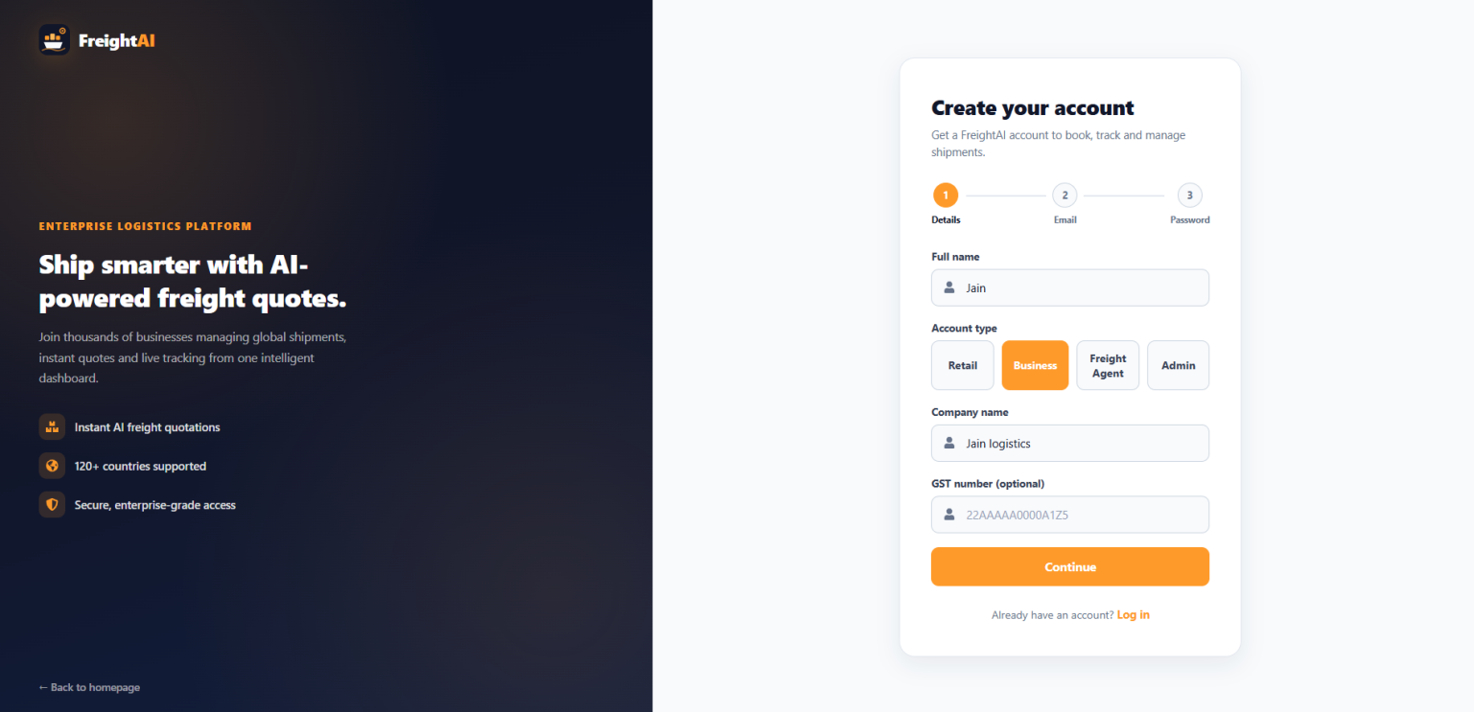
Log in as (or switch to) a business account, open New Quote, and try generating a quote.
9. Admin dashboard
📷 SCREENSHOT — Admin dashboard sections
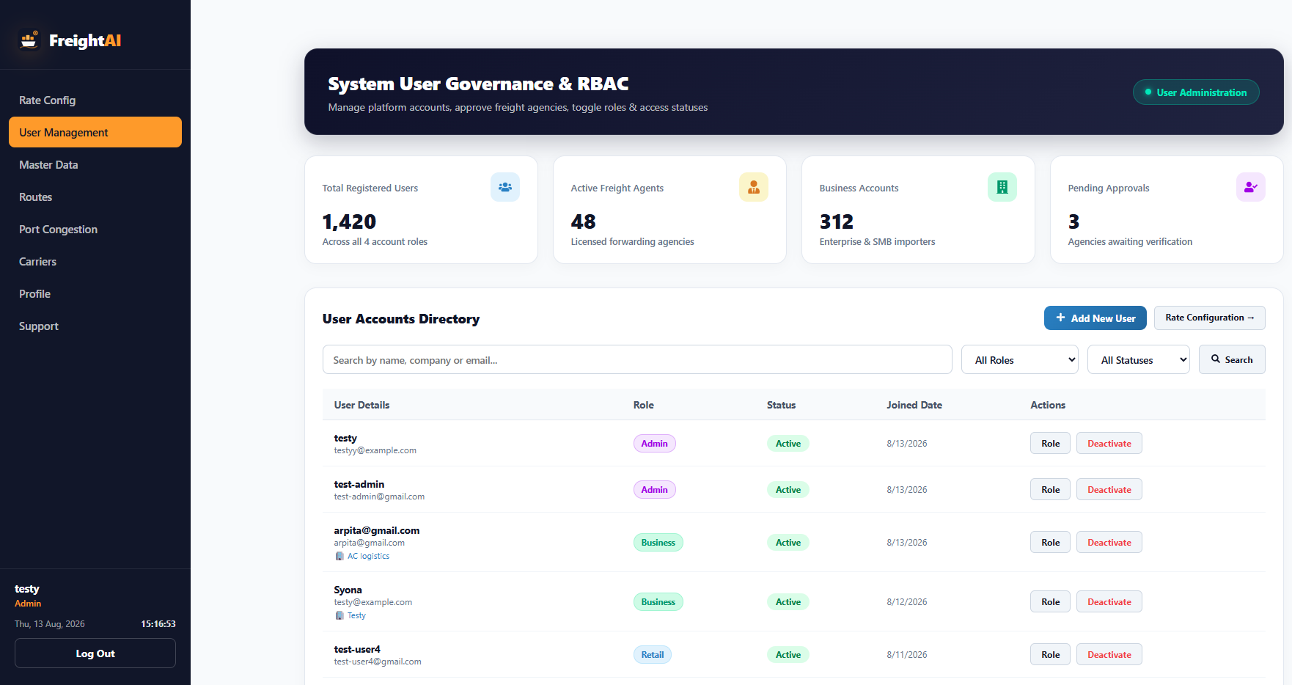

10. Other pages - Support, etc.
📷 SCREENSHOT —
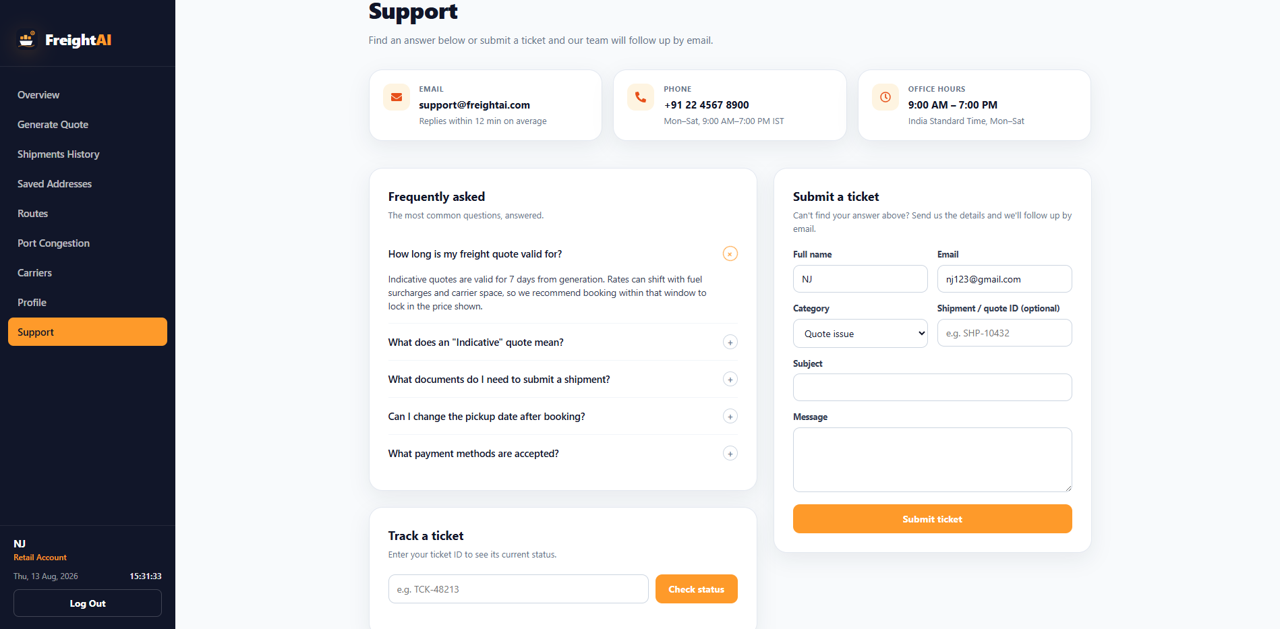

9. Summary for the Milestone Report
- Repo and deployment both exist and are reachable.
- The codebase matches the "rule-based pricing, JWT auth, MongoDB" design from the Project Explanation Document.

