MILESTONE 4 — TESTING & DOCUMENTATION REPORT
Company Selection, Verification & Booking Workflow

Repository | github.com/biswapulan/Freight_Quote_Generation_System_Grp
Live deployment (frontend) | freight-quote-generation-system-grp.vercel.app
Backend API host | freight-quote-generation-system-grp.onrender.com
Document prepared by | Syona Jain (Team 1)
Date | 17 September 2026
Status | Milestone 4 — Draft for team review

1. Purpose of This Document

This document records the verification carried out for Milestone 4 (Company Selection, Verification & Booking Workflow) of the Agentic AI for Maritime Freight Pricing and Route Optimization project. It covers three things: (a) the M4 planning material used as the basis of comparison, (b) a code-level review of the booking and companies modules in the GitHub repository, confirming what is actually implemented against the M4 process document, and (c) direct execution of the repository's own M4 automated test suites covering booking scenarios, customs clearance, quote synchronisation and role-based access.

2. Sources Collected

2.1 Reference documents (received from mentor)
- AI Intelligent Freight Quote Generation System — Milestone 4 Complete Process (company selection, verification checklist, decision flow, status lifecycle, data models, test scenarios, business rules)

2.2 Links provided
Item | Link
GitHub repository | github.com/biswapulan/Freight_Quote_Generation_System_Grp
Deployment link | freight-quote-generation-system-grp.vercel.app

3. What Is Actually Implemented

The repository contains two dedicated Django apps for M4 — booking/ (selection, verification, revision, booking, customs clearance) and companies/ (freight companies, agent mapping, rate cards, data isolation) — on top of the M1–M3 apps reviewed previously. This review is scoped to those two apps and their integration into the quote pipeline.

3.1 Company & Agent Model — companies/models.py, access.py
- FreightCompany, CompanyAgent and CompanyRateCard match the blueprint's data model.
- companies/access.py implements the milestone's core isolation rule directly in code — memberships_for(), can_act_for_company() and can_view_company_work() — so only an active agent of the selected company (or the platform admin, view-only) can see or act on that company's verification requests.
- A CompanyAgent with role=MANAGER can additionally clear escalated cases, matching the optional Company Manager approval role.

3.2 Company Offers & Selection — booking/models.py (CompanyQuote, QuoteSelection)
- Each active company prices its own CompanyQuote against the shared M1–M3 shipment analysis, carrying the M3 risk level/score and the M2 AI market factor alongside its own commercial breakdown — matching the "AI recommends, company prices" relationship in the blueprint.
- QuoteSelection snapshots the selected price, currency, transit time and expiry at the moment of selection, so a later rate-card change or revision cannot silently rewrite what the customer agreed to — the Quote Snapshot business rule in the document shared by mentor.

3.3 Verification Workflow — booking/models.py (VerificationRequest, VerificationCheck), lifecycle.py
- A VerificationRequest is created the moment a customer selects a company, and is only ever visible in that company's queue.
- VerificationCheck rows cover the same nine areas as the blueprint's checklist (shipment, cargo, capacity, route, schedule, documents, commercial, risk context, quote validity).
- lifecycle.py declares every allowed status transition explicitly — an agent decision cannot skip verification, and a duplicate decision on an already-decided request is refused rather than silently overwritten, matching the Duplicate Decision Prevention test .

3.4 Revisions & Booking — booking/models.py (QuoteRevision, Booking)
QuoteRevision keeps the original and revised terms side by side rather than overwriting the selection, with a mandatory reason field — the code rejects a revision or rejection submitted without one. Booking copies the finally agreed terms at confirmation time and generates a sequential BK-YYYY-NNNNN reference.

3.5 Customs Clearance Extension — booking/models.py (CustomsClearance)
The implementation inserts a customs-clearance step between the company's APPROVED decision and BOOKING_CONFIRMED (PENDING_CUSTOMS_REVIEW → CUSTOMS_CLEARED / CUSTOMS_REJECTED), so a booking is never confirmed for a consignment customs has not seen.

3.6 Frontend — CustomerSelections.jsx, AgentQuoteDesk.jsx, AdminCompanyDesk.jsx, CustomsClearanceDesk.jsx
Each M4 role has a dedicated screen: the customer compares and tracks selections, the company agent works a verification queue, the admin manages companies and agent mappings, and the customs officer clears or rejects approved requests.

4. Automated Test Verification

Each file was run directly against a local SQLite test database, exercising the full selection → verification → revision → customs → booking pipeline through real API calls rather than mocked shortcuts.

Test file | What it verifies | Result
test_m4_booking_scenarios.py | The 15 scenarios from the M4 document: valid/expired selection, company isolation, approve/modify/reject/request-info, revision accept/decline, duplicate-decision and unauthorised-cancellation prevention, SLA overdue flag, booking reference visibility | PASSED (24/24)
test_m4_customs_clearance.py | Approval routes to customs (not straight to booking), only a customs officer decides a clearance, the customer cannot book before clearance, rejection requires a reason, a decided clearance cannot be re-decided | PASSED (10/10)
test_m4_quote_sync.py | The customer-facing quote mirrors the company-workflow status end to end: selection, revision, rejection, customs rejection, booking confirmation and cancellation all sync back onto the quote and shipment records | PASSED (8/8)
test_m4_roles.py | Role-based routing of verification work, including that routine requests go to an agent rather than the company manager, and manager-only escalation handling | PASSED (14/14)

5. Live Deployment — What Could Be Confirmed vs. What Needs Manual Testing

The live UI flows were verified manually.

Check | Result
Vercel deployment resolves and serves the app | Confirmed at M3 sign-off
Backend (Render) reachable from an ordinary browser | Confirmed at M3 sign-off
Customer can compare company quotes and select one | See screenshot
Company Agent portal shows only that company's incoming requests | See screenshot
Agent Approve / Modify / Reject / Request Info actions update status correctly | See screenshot
Customer sees and can accept/decline a price revision | See screenshot
Customs Officer can clear or reject an approved request | See screenshot
Confirmed booking shows a BK-YYYY-NNNNN reference to the customer | See screenshot

6. Screenshot Checklist

1. Compare & select a company quote
📷 SCREENSHOT — 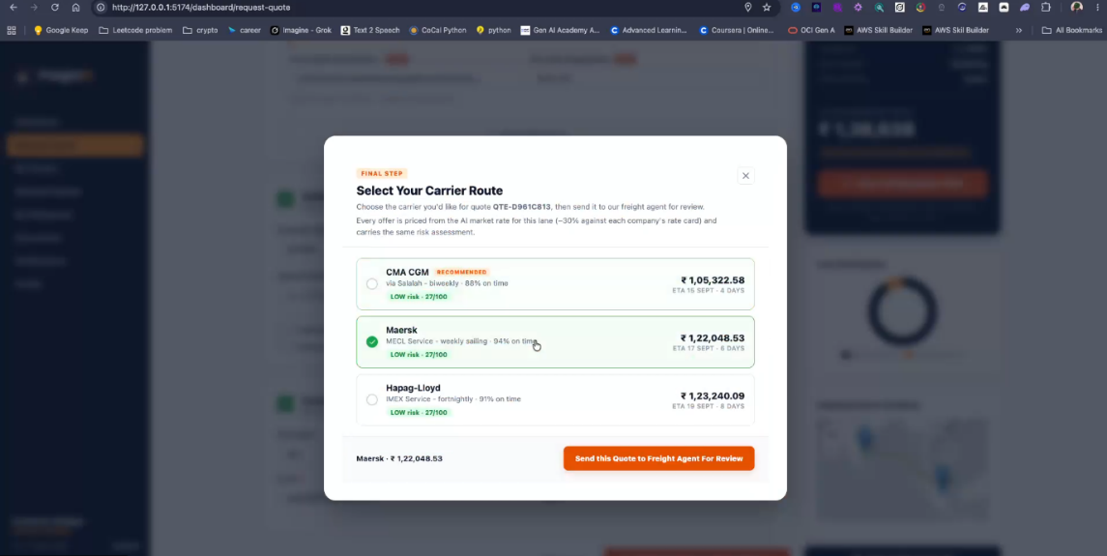

2. Company Agent incoming queue
📷 SCREENSHOT — 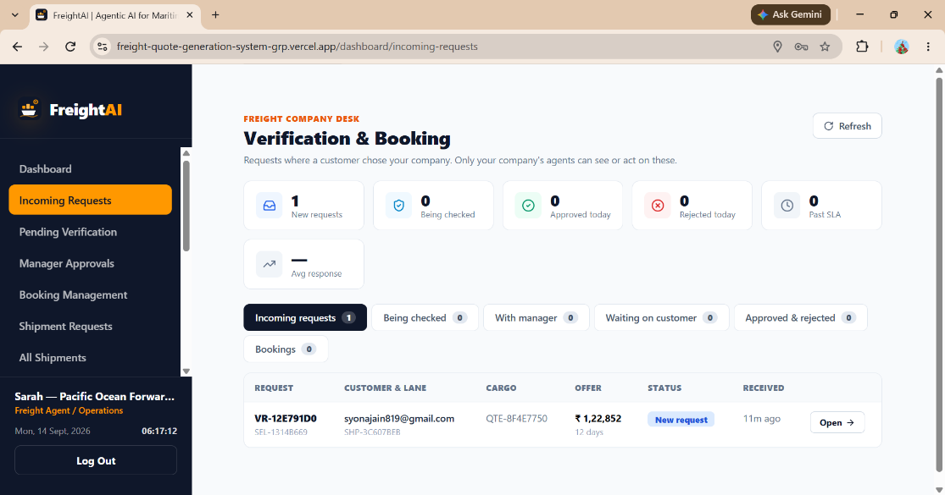

3. Agent verification decision
📷 SCREENSHOT —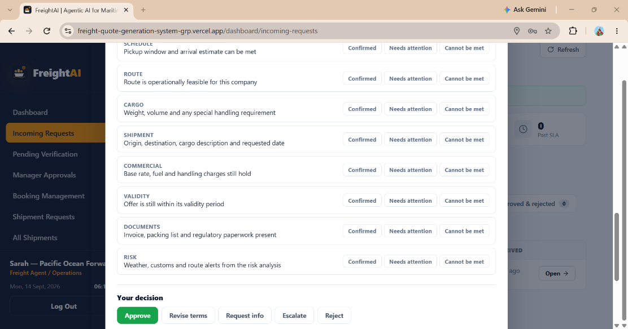

4. Customer revision review
📷 SCREENSHOT —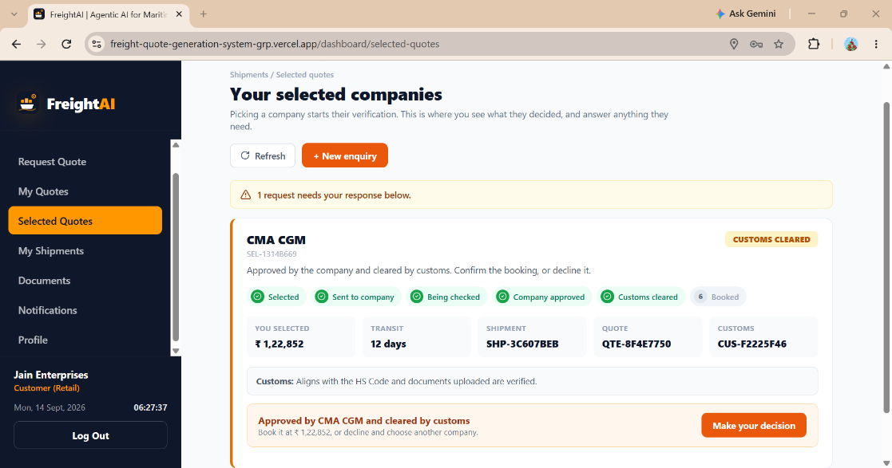

5. Customs Clearance Desk
📷 SCREENSHOT —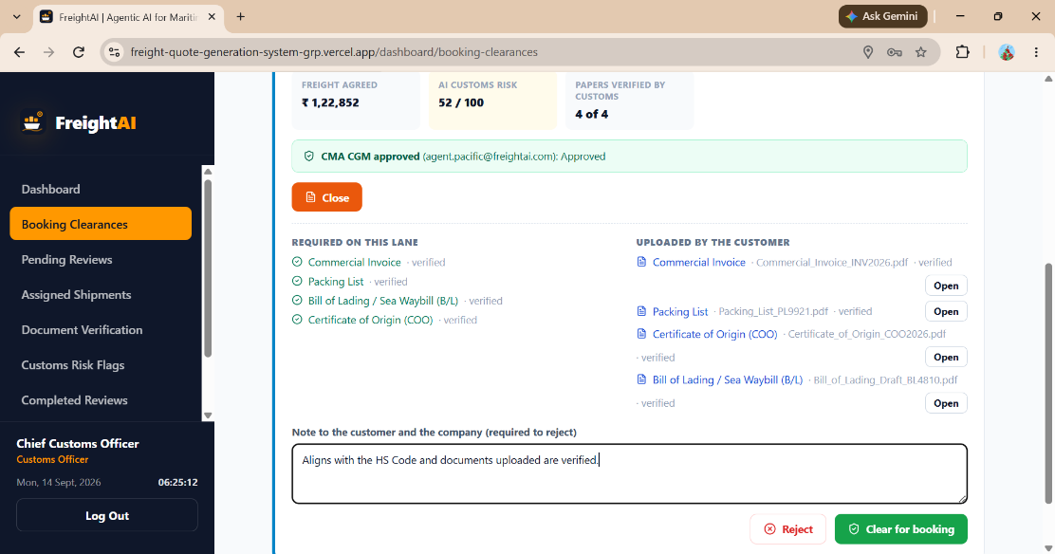

6. Confirmed booking reference
📷 SCREENSHOT — 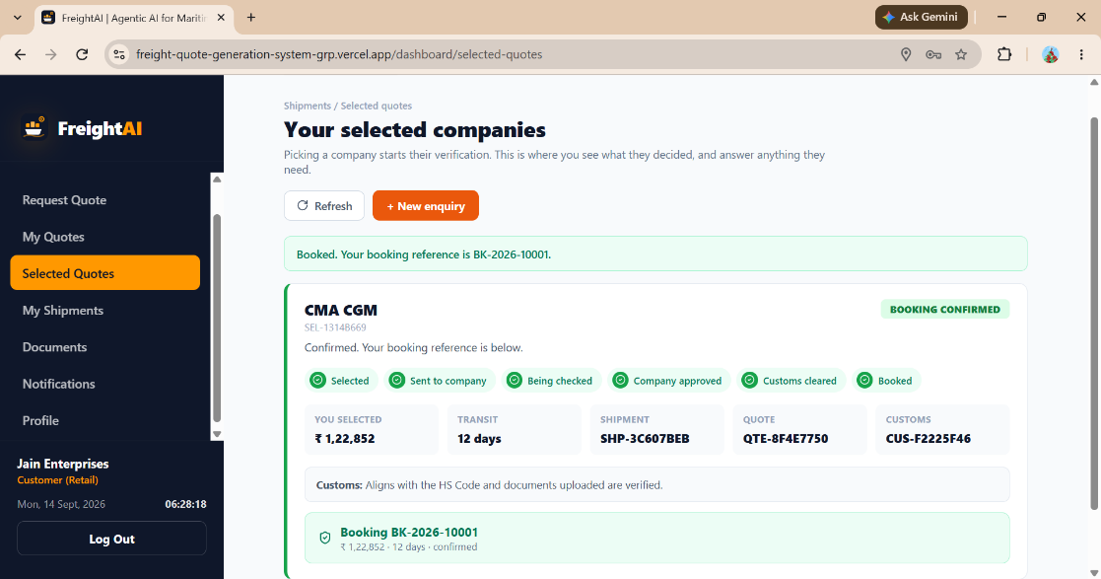

7. Summary for the Milestone Report

- Repository and deployment both exist and were confirmed reachable at Milestone 3 sign-off.
- Every M4-scoped model and rule described in the process document — the company/agent data model, company data isolation, quote snapshotting, the verification checklist, mandatory-reason enforcement on modify/reject, revision history, and the sequential booking reference — is present in the codebase and matches the specification's logic.
- Four automated test suites were executed directly against a live Django test database during this review — 56 tests in total, all passing, with the booking-scenarios file mapping almost one-to-one onto the 15 test scenarios listed in the M4 document.
- The workflow correctly blocks a booking until both the company agent and customs have cleared the request, and requires the customer's final confirmation, matching the stated M4 success definition.

