git init

git add README.md

git commit -m "first commit"

git branch -M main

git remote add origin https://github.com/jainulmca/reactjs.git

git push -u origin main

**What is emmet?**

Emmet is a free add-on for your text editor. It **allows you to type shortcuts that are then expanded into full pieces of code**. By using Emmet, developers type less, they save both on keystrokes and time

Basically, most text editors out there allow you to store and re-use commonly used code chunks, called *“snippets”*. While snippets are a good way to boost your productivity, all implementations have common pitfalls: you have to define the snippet first and you can’t extend them in runtime.

Emmet takes the snippets idea to a whole new level: you can type *CSS-like* expressions that can be dynamically parsed, and produce output depending on what you type in the abbreviation. Emmet is developed and optimised for web-developers whose workflow depends on HTML/XML and CSS, but can be used with programming languages too.

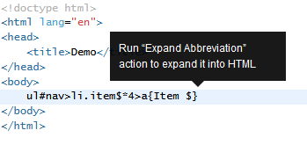

**What is CDN?**

A content delivery network, or content distribution network, is a geographically distributed network of proxy servers and their data centers. The goal is to provide high availability and performance by distributing the service spatially relative to end users.

A CDN is **a network of servers that distributes content from an “origin” server throughout the world by caching content close to where each end user is accessing the internet via a web-enabled device**. The content they request is first stored on the origin server and is then replicated and stored elsewhere as needed.



react@18 – is core

react-dom@18 – React DOM

**Cross Origin**

**Cross-Origin Resource Sharing** ([CORS](https://developer.mozilla.org/en-US/docs/Glossary/CORS)) is an [HTTP](https://developer.mozilla.org/en-US/docs/Glossary/HTTP)-header based mechanism that allows a server to indicate any [origins](https://developer.mozilla.org/en-US/docs/Glossary/Origin) (domain, scheme, or port) other than its own from which a browser should permit loading resources. CORS also relies on a mechanism by which browsers make a "preflight" request to the server hosting the cross-origin resource, in order to check that the server will permit the actual request. In that preflight, the browser sends headers that indicate the HTTP method and headers that will be used in the actual request.

For security reasons, browsers restrict cross-origin HTTP requests initiated from scripts. For example, XMLHttpRequest and the [Fetch API](https://developer.mozilla.org/en-US/docs/Web/API/Fetch_API) follow the [same-origin policy](https://developer.mozilla.org/en-US/docs/Web/Security/Same-origin_policy). This means that a web application using those APIs can only request resources from the same origin the application was loaded from unless the response from other origins includes the right CORS headers.

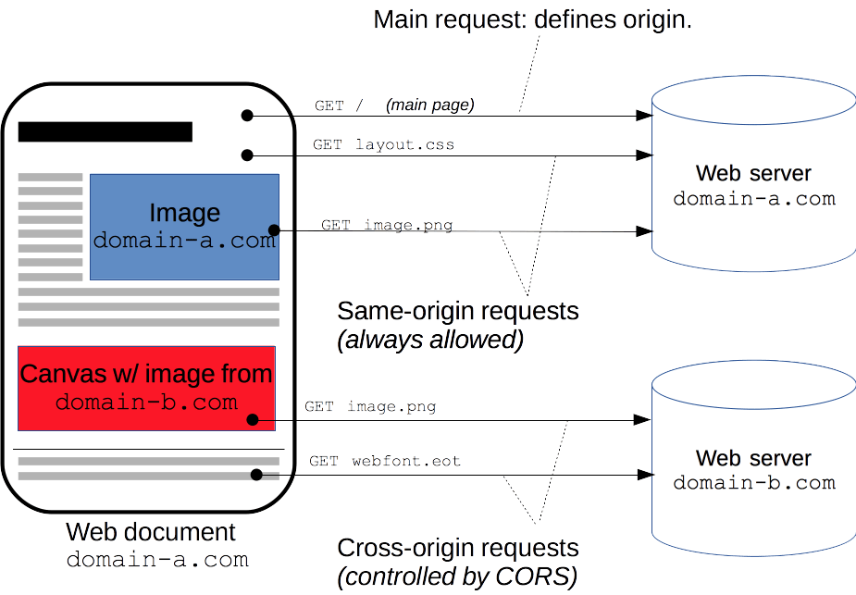

<https://developer.mozilla.org/en-US/docs/Web/HTTP/CORS>

We also recommend to verify that the CDN you are using sets the Access-Control-Allow-Origin: * HTTP header:

[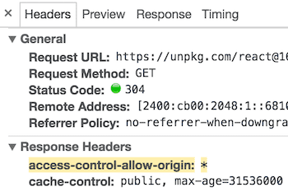](https://reactjs.org/static/89baed0a6540f29e954065ce04661048/13ae7/cdn-cors-header.png)

This enables a better [error handling experience](https://reactjs.org/blog/2017/07/26/error-handling-in-react-16.html) in React 16 and later.

**Difference between async and differ**

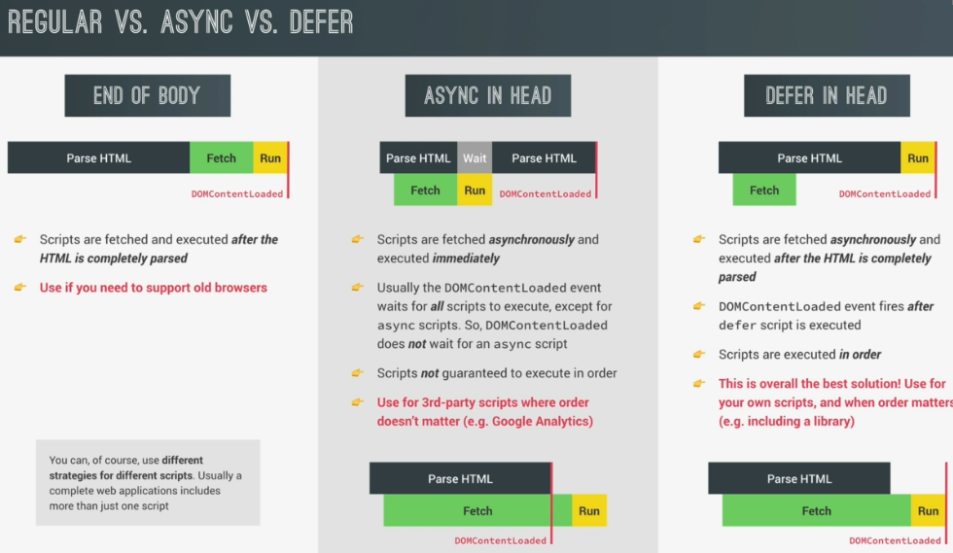

**What is React.createElement()?**

React element is an Object. It has three parameters.

*React.createElement(*

*type,*

*[props],*

*[...children]*

*)*