Name - Umesh Jain
SBU ID:110757159
Course: CSE 591
Final Project Report

I have tried to explore the Number Link Problem or more commonly known as "FlowFree" game on iOS and Android in this project.
Various solution with and without graphics are available for the same online.
My Major Contributions toward the problem is as below:
1) Understanding and analyzing different approaches to solve the problem.
2) Explore and Compare Logic/constraint based solutions
3) Write a program to solve this game in IDP(Web based IDP Interface)

Game Details:

Number Link is a Japanese Pencil game recently popularized by Nikoli, and a lot of researchers are interested in solving the same using logic rules and constraint Programming.
It is an NP-Complete Problem and below picture alone says it all.



The basic rules for the game are as below:
1)Connect pairs of the same numbers with a continuous line
2)Lines go through the center of the cells, horizontally, vertically, or changing direction, and never twice through the same cell.
3)Lines cannot cross, branch off, or go through the cells with numbers.

One of the Approach to solve this problem is given as below:

Algorithm based on backtracking
1. Initialazing matrix fullified with uninitialised variables.
2. Putting start position on matrix ( given by list of pairs ).
3. Finding way between pair of points i (i = 1,2,..|Pairs|).
If path between pair of points ...:
3a. Exists --> Step 3 && i++.
3b. Exists && i == |Pairs| --> Step 4.
3c. Doesn't exists --> Step 3 && i--.
3d. Doesn't exists && i == 1 --> Step 5.
4. Print the solution.
5. Solution doesn't exist.

Major Applications: Apart from being a popular game ,this puzzle is of extreme interest to researchers due to its various applications in the industry, like VLSI Design Boards, Optimized Delivery routes,essentially it can be used as a part of any SIMPLE PATH FINDING related problems.

I started out with a Picat based solution to the Problem available at :
https://github.com/hakank/hakank/blob/master/picat/numberlink.pi

This is pretty much a straight forward way of solving the game, however, it is very efficient, mainly due to the underlying solver used by Picat. This program uses SAT Solver as well as CP Solver and a difference in running time is clearly observed. SAT is found to be way faster than CP.
It runs a 42x 25 sized matrix with 63 points to connect in under 5 seconds.(CP Solver takes more than 10 minutes for the same).
The running time of the problem is estimated to be O(N^2xC) based on several running time observations.
A bunch of other inputs are run on this solution and the output can be found in “number_link_picat_details.txt”.

IDP : After looking at this simple and efficient solver I used the same logic to code it in IDP.
The program in IDP for this puzzle does not exists , and is written by me to check the feasibility of using IDP for this problem . The code can be found in : “numberlink_idp”
This program is basically a puzzle checker sort of thing, which can identify if the puzzle is solvable or not, if yes, it will print the possible models.
The source code is pretty neat and small , thanks to the structure of programs in IDP.
However the overall effect was disappointing because
1) The web based IDE quickly runs out of memory or some other issues, and the hence any puzzle of size more than 5 returned error.
2) The small input matrix of 3x2, 5x5 etc that I was able to feed this program still took somewhat in the range of 3 seconds.
Making an estimate of running time for this program did not seem justifiable because of the small number of input and input sizes it could be run feasibly.

The Program is in “numberlink_idp” file and the analysis and output is in “number_link_Picat_details.txt”

The major focus of this exercise was to find fast and scalable solutions to the number link problem, however in IDP, scalability was not observed,. It could be because of the underlying solver or could be the way the program is written or the machine that runs behind the web interface, but overall there were no signs that it could meet the speeds and scale of Picat or Python(discussed below) program.

Hence the IDP program is simply left as it is for demo purposes to show that it is indeed possible to solve this problem using IDP.

Another approach in Prolog was tried during the course of the project to check out the feasibility and support of SWI Prolog . The code is based on backtracking method and scores decent points in efficiency(seems O(n^2)) All the instances of the program that I ran on this took less than 10 miliseconds, but as soon as I scaled up to 15 x15 matrix, the program kind of stuck/hang or took too much time. From clarity perspective ts not a very clear program as per say.

One of the original ideas for the project included exploring and implementing the below paper:
“Finding All Solutions and instances if numberLink and Slitherlink by ZDDs”[3]
This paper talks about Zero Suppressed decision Diagram to solve this problem.
An elaborate study of the ZDD and an Algorithm is given as below:

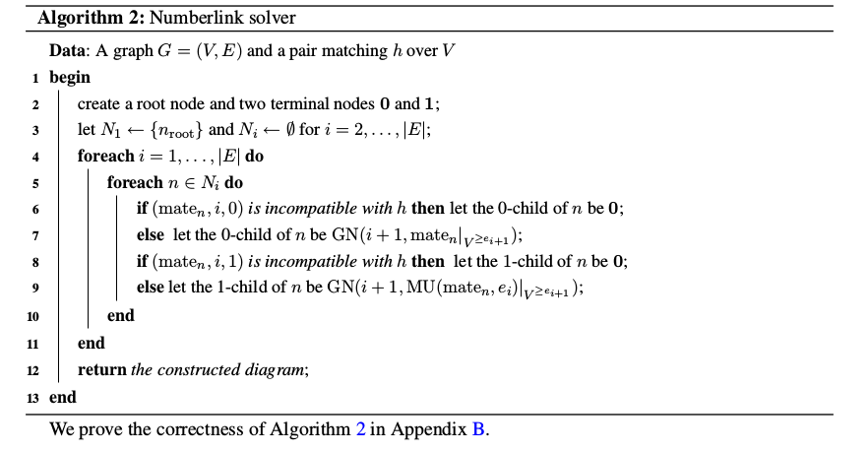

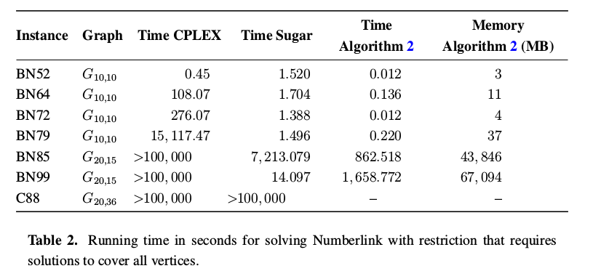

However I found another Program in Python, which similar to above uses an SAT based Solution , and is found to be even faster without using ZDD, and hence I was more attracted towards exploring this new program.

Python Solution: The Python Solution to Number Link was written by Matt Zucker and it is the most efficient program I found . The Code can be found at:
https://github.com/mzucker/flow_solver
The source code can be found in another file: pyflowsolver.py

This Program uses SAT Solver(pycosat) and is found to be way better in terms of efficiency than other programs.
Puzzles of size 14x14 run in less than 0.4 seconds.

The crux of the program goes as below:
1) Put down a list of constraints that form the algorithm/ logic rules to solve the program.
2) Convert these constraints to Conjunctive Normal Form, and then reduce them to SAT
3) Use Pycosat , a C PicoSAT based python solver to to solve the problem

List of Constraints:
Every cell is assigned a single color.
The color of every endpoint cell is known and specified.
Every endpoint cell has exactly one neighbor which matches its color.
The flow through every non-endpoint cell matches exactly one of the six direction types.
The neighbors of a cell specified by its direction type must match its color.
The neighbors of a cell not specified by its direction type must not match its color.

The puzzle of size N with C colors has NC color variables and about 6N direction type variables, with O(NC2) clauses over just the color variables and an additional O(NC) clauses for direction-color interactions.
This is a good performance for an NP-Complete problem being solved using SAT.
Overall this is a beautiful program , clear as well as efficient, by far the best out of all I analyzed.

Conclusion:

IN conclusion we can say that
As already observed with N-Puzzle and N-Queens programs, we find Picat to be more efficient clear and scalable(able to handle large inputs) than IDP.
The Picat Numberlink Program simply proves that SAT solver is more efficient than CP solver.
3)A ZDD based approach for the same problem finds CPLEX and Sugar solvers to be less efficient ,and upon comparing this with Python and and picat solution mentioned in this report, we find that it fairs close to the Picat based solution, but gets beaten by the Python solution using combination of Constraint based programming and SAT.
4) Exploration with IDP reveals limitations of the langauge/ interface, which hinders scalability and it still takes the most amount of time as compared to other solutions discussed here.(with same algorithm as in Picat based solution)
5) Number Link is an extremely interesting NP _Complete Problem, however we still dont have solutions efficient and scalable enough to take on millions of nodes as input and provide optimal solutions(needed in VLSI design), and definitely a topic that needs more research to find new ways to solve the same problem to bring it up to scale.

References:
https://mzucker.github.io/2016/09/02/eating-sat-flavored-crow.html
https://github.com/hakank/hakank/blob/master/picat/numberlink.pi
https://github.com/flowgrammable/freeflow
https://github.com/GameAutomators/Flow-Free/blob/master/flowsolver.cpp
https://github.com/thomasahle/numberlink/blob/master/src/numberlink/gen.go
https://github.com/kstarzyk/numberlink-solver/blob/master/numberlink.pl
http://adams.cs.kuleuven.be/idp/server.html#
https://pdfs.semanticscholar.org/8a24/1ac5ee8d34479e8849a72096713cc6bbfed5.pdf
http://web.mit.edu/picat_v1.9/picat_guide.pdf
https://mzucker.github.io/2016/09/02/eating-sat-flavored-crow.html
http://stackoverflow.com
www.mdpi.com/1999-4893/5/2/176/pdf
http://www.nikoli.com/en/puzzles/numberlink/
https://wikipedia.org/wiki/Numberlink
https://geeksforgeeks.org/a-number-link-game

