Web Technologies Experiments
1).Write a PHP script to print prime numbers between 1-50
<?php
function Prime($n){
echo"Prime number between 1-50<br>";
for($i=2;$i<=$n;$i++)
{
$flag=0;
for($j=2;$j<=sqrt($i);$j++)
{
if($i%$j==0)
$flag=1;
}
if($flag==0)
echo"$i &nbsp";
}
}
$n=50;
Prime($n);
?>

OUTPUT:
Prime number between 1-50
2 3 5 7 11 13 17 19 23 29 31 37 41 43 47

2) PHP script to
a. Find the length of a string.
b. Count no of words in a string.
c. Reverse a string.
d. Search for a specific string

<?php
$str="Hello Jntuhces";
$search="Jntuhces";

$len=strlen($str);
echo"<b>Length string</b>-'$str':<b>$len</b><br>";
$word=str_word_count($str);
echo"<b>No.of word string</b> -'$str':<b>$word</b><br>";
$rev=strrev($str);
echo"<b>Reverse string</b>-'$str':<b>$rev</b><br>";
$pos=strpos($str,$search);
if($pos!==false)
echo"String <b>-'$search'</b> found at <b>$pos</b> position in <b>'$str'</b><br>";
else
echo"String <b>'$search'</b> not found<br>";
?>

OUTPUT:
Length string-'Hello Jntuhces':14
No.of word string -'Hello Jntuhces':2
Reverse string-'Hello Jntuhces':sechutnJ olleH
String -'Jntuhces' found at 6 position in 'Hello Jntuhces'

3). Write a PHP script to merge two arrays and sort them as numbers, in descending order
<?php

$a=array(10,20,30,40,50);
$b=array(60,70,80,90,99);

$merge=array_merge($a,$b);
rsort($merge);
print_r($merge);
?>
OUTPUT:
Array ( [0] => 99 [1] => 90 [2] => 80 [3] => 70 [4] => 60 [5] => 50 [6] => 40 [7] => 30 [8] => 20 [9] => 10 )
4. Write a PHP script that reads data from one file and write into another file.
<?php
$source=fopen("source.txt","r");
$target=fopen("target.txt","w");
if($source==false)
exit("Error for open");
else
print("source file opened<br>");
while(!feof($source))
{
$line=fgets($source);
fwrite($target,$line);
}
print("Data read successfully");
fclose($source);
fclose($target);
?>

OUTPUT:
source file opened
Data read successfully

5). Develop static pages (using Only HTML) of an online book store. The pages should resemble:
www.amazon.com. The website should consist the following pages.
a) Home page
b) Registration and user Login
c) User Profile Page
d) Books catalog
e) Shopping Cart
f) Payment By credit card
g) Order Conformation
. a) Home page
<html>
<head>
<title>Home page</title>
<style>
li{
float:left;
padding: 5px;
}
ul{
list-style-type:none
}
</style>
</head>
<body>
<center>
<fieldset>
<h1><center>Amazon Home Page</center></h1>
<p>&copy; welcome to amazon store</p>
</fieldset>
<fieldset>
<ul>
<li><a href="profilePg.html" target="_blank">Profile</a></li>
<li><a href="homePg.html"target="_self">Home</a></li>
<li><a href="regisLoginPg.html"target="_blank">Register/login</a></li>
<li ><a href="booksCatlgPg.html"target="_blank">Books</a></li>
<li><a href="shoppingPg.html"target="_blank">Shopping</a></li>
<li><a href="paymentPg.html"target="_blank">Payments</a></li>
<li><a href="orderPg.html"target="_blank">orders</a></li>
</ul>
</fieldset>
<fieldset>
<h2 style="float:left;height:250px;">Featured Products</h2>
</fieldset>
<fieldset>
<p>&copy; www.amazon.com store</p>
</fieldset>
</center>
</body>
</html>

OUTPUT:
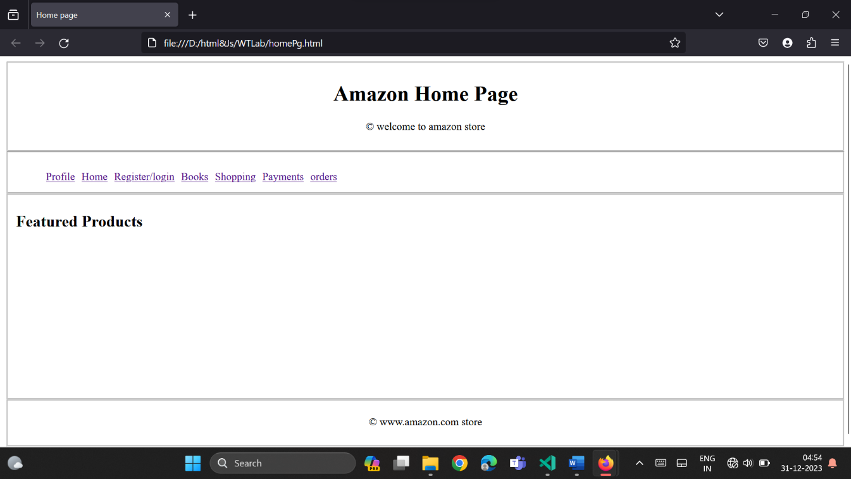
b) Registration and user Login
<!DOCTYPE html>
<html>
<head>
<title>Register/Login page</title>
<script src = "regLoginValidate.js"> </script>
</head>
<body><center>
<h1>Registeration/Login</h1>
<form method="post" onsubmit="validateform()">
<fieldset style="height:400px;width:300px;">
<legend>Register/Login Information</legend><br><br><br><br><br><br>
<table>
<tr>
<td>Username:</td>
<td ><input type="text" id="usrname" name="usrname" placeholder="Enter an username"></td>
</tr>
<tr>
<td>Password:</td>
<td><input type="password"id="pwd"name="pwd"></td>
</tr>
<tr>
<td>Confirm Password:</td>
<td><input type="password"id="confpwd"name="confpwrd"></td>
</tr>
</table><br><br><br><br><br><br>
<input type="submit" name="register" id="register"value="Register">
<input type="submit" name="login" id="login"value="Login">
</fieldset>
</form>
</center></body>
</html>

OUTPUT:

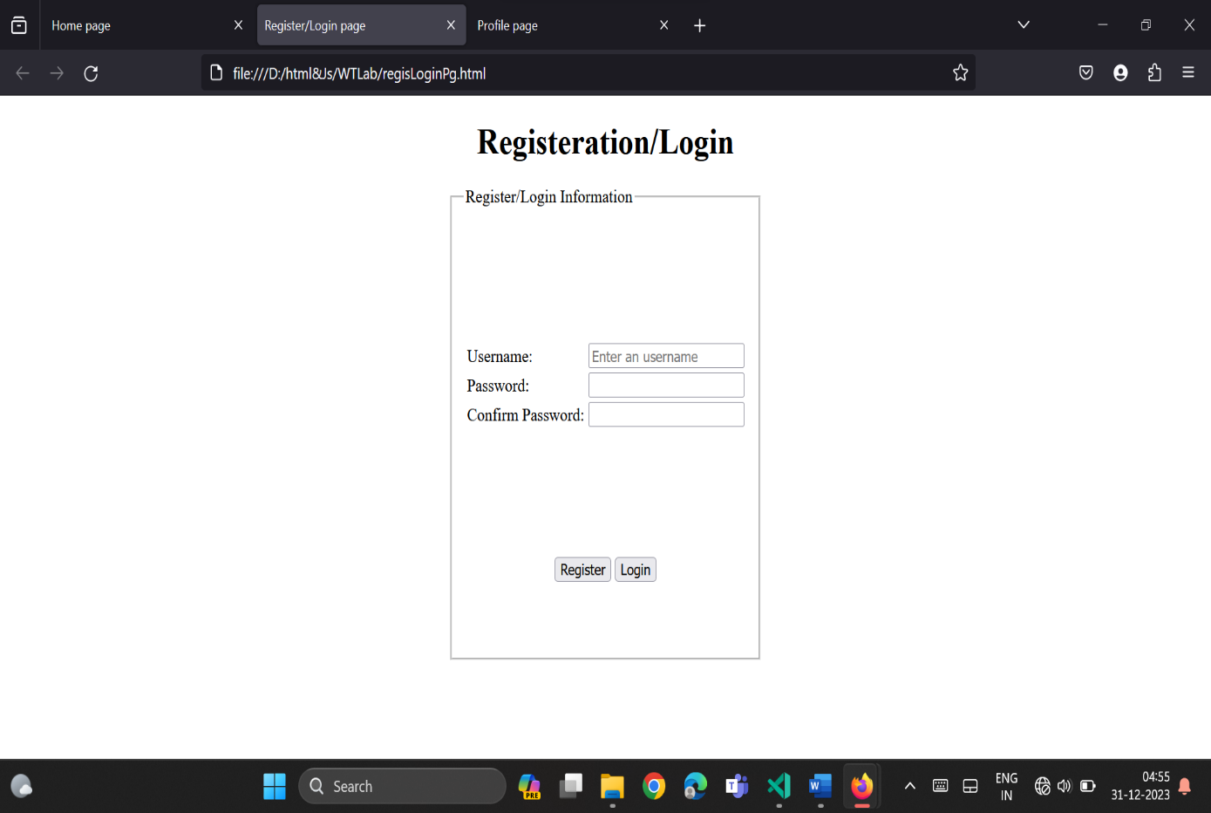

c) User Profile Page

<!DOCTYPE html>
<html>
<head>
<title>Profile page</title>
<script src = "profileValidate.js"></script>
</head>
<body><center>
<h1>Profile</h1>
<form method="post" onsubmit="validateform()">
<fieldset style="height:400px;width:300px;">
<legend>Profile Information</legend><br><br><br><br><br><br>
<table>
<tr>
<td>Username:</td>
<td><input type="text" id="usrname" name="usrname"placeholder="Enter username"></td>
</tr>
<tr>
<td>Password:</td>
<td><input type="password"id="pwd"name="pwd"placeholder="Enter password"></td>
</tr>
<tr>
<td>Email:</td>
<td><input type="email" id="email"name="email"placeholder="Enter email"></td>
</tr>
<tr>
<td>Mobile Number:</td>
<td><input type="number"id="phnnumber"name="phnnumber"placeholder="Enter phone number"</td>
</tr>
</table><br><br><br><br><br><br>
<input type="reset" name="reset" value="Reset">
<input type="submit" name="submit"value="Submit">
</fieldset>
</form>
</center></body>
</html>

OUTPUT:

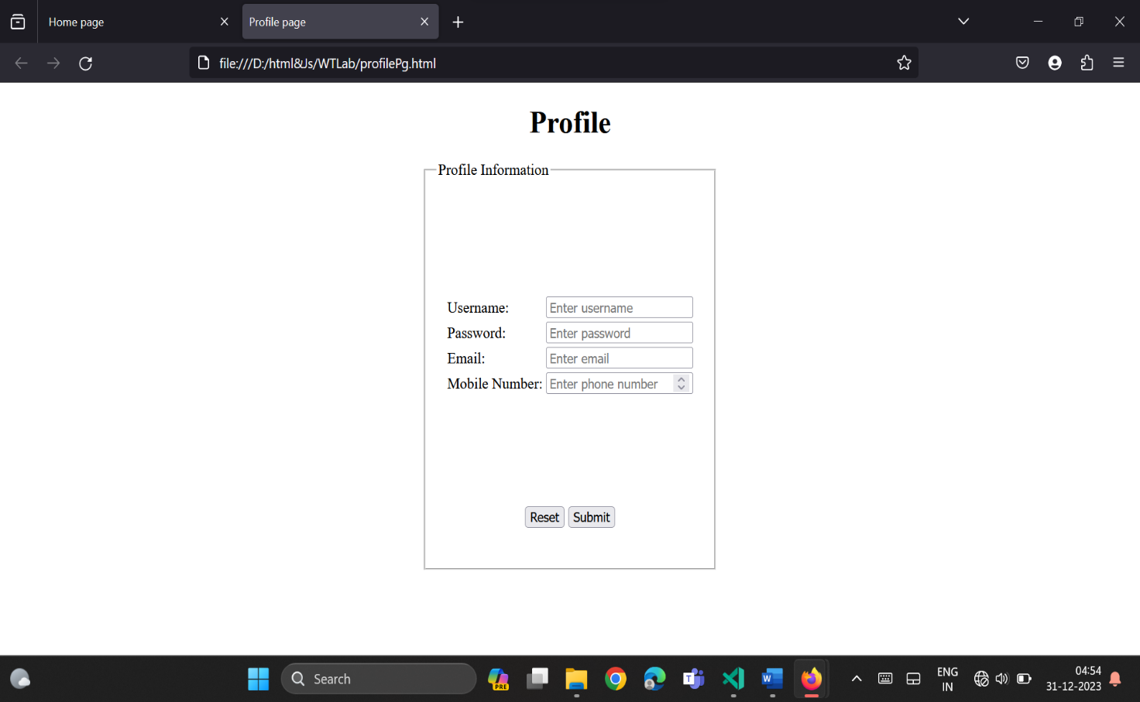
d) Books catalog

<!DOCTYPE html>
<html>
<head>
<title>BookCatalog page</title>
</head>
<style>
fieldset{
width:900px;
display:block;
justify-content: space-between;
}
img{
border: 1px solid;
height:130px;
width:200px;
}
.books{
display:flex;
justify-content:space-evenly;
}
</style>
<body>
<center>
<h1>Book Catalog</h1>
<fieldset>
<div class="books">
<img src="book1.jpg" alt="Book 1">
<div class="book-info">
<h3>Book Title 1</h3>
<p>Author: Author Name 1</p>
<p>Price: $69.99</p>
<button>Add to Cart</button>
</div>
</div>
<div class="books">
<img src="book2.jpg" alt="Book 2">
<div class="book-info">
<h3>Book Title 1</h3>
<p>Author: Author Name 2</p>
<p>Price: $367.99</p>
<button>Add to Cart</button>
</div>
</div>
<div class="books">
<img src="book3.jpg" alt="Book 3">
<div class="book-info">
<h3>Book Title 3</h3>
<p>Author: Author Name 3</p>
<p>Price: $599.99</p>
<button>Add to Cart</button>
</div>
</div>
</fieldset>
</center>
</body>
</html>

OUTPUT:
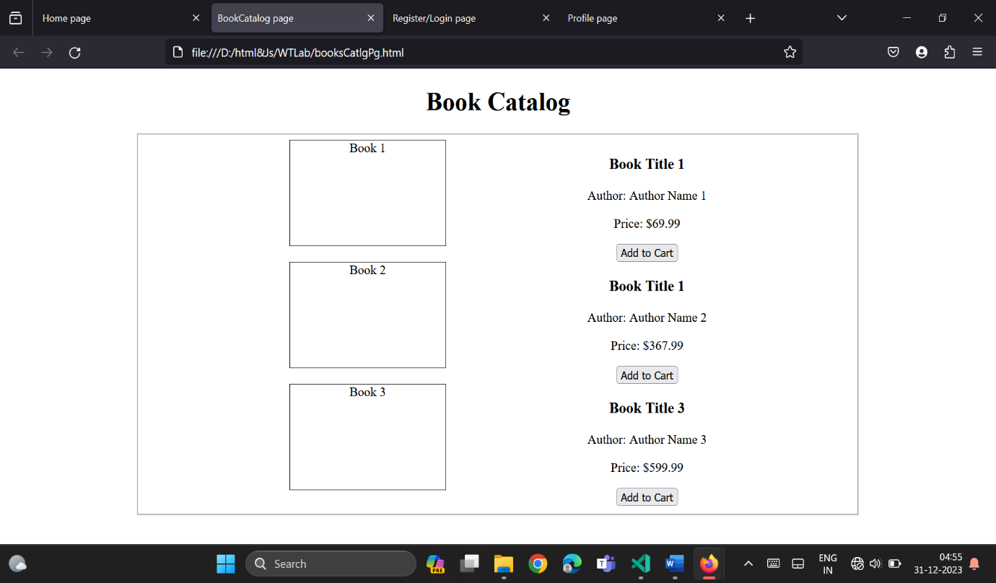

e) Shopping Cart
<!DOCTYPE html>
<html>
<head>
<title>Shopping page</title>
</head>
<style>
fieldset{
width:900px;
display:block;
justify-content: space-between;
}
img{
border: 1px solid;
height:130px;
width:200px;
}
.product{
display:flex;
justify-content:space-evenly;
}
</style>
<body>
<center>
<h1>Shopping page</h1>
<fieldset>
<div class="product">
<img src="product1.jpg" alt="Product 1">
<div class>
<h3>Product Title 1</h3>
<p>Brand Name 1</p>
<p>Price: $999.99</p>
<button>Remove</button>
</div>
</div>
<div class="product">
<img src="product2.jpg" alt="Product 2">
<div>
<h3>Product Title 2</h3>
<p>Brand Name 2</p>
<p>Price: $637.99</p>
<button>Remove</button>
</div>
</div>
<div class="product">
<img src="product3.jpg" alt="Product 3">
<div>
<h3>Product Title 3</h3>
<p>Brand Name 3</p>
<p>Price: $1999.99</p>
<button>Remove</button>
</div>
</div>
</fieldset>
</center>
</body>
</html>

OUTPUT:
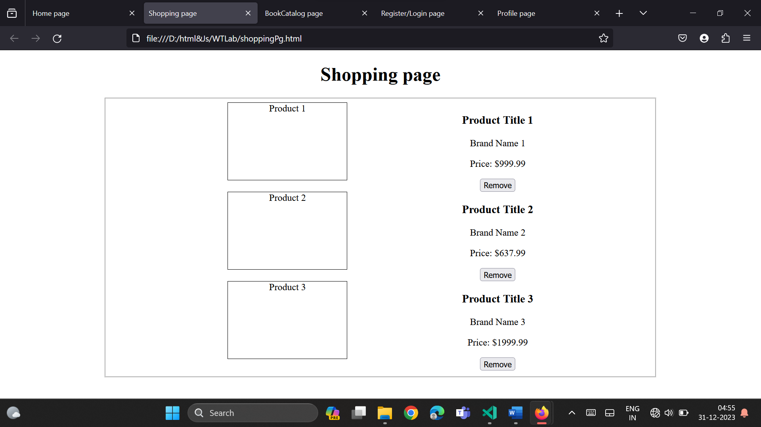
f) Payment By credit card
<!DOCTYPE html>
<html>
<head>
<title>Payment page</title>
<script src = "paymentValidate.js"> </script>
</head>
<body>
<center>
<h1>Payments</h1>
<form method="post" onsubmit="validateform()"></form>
<fieldset style="height:400px;width:300px;">
<legend>Payment Information</legend><br><br><br><br><br><br>
<table>
<tr>
<td>Credit Card Number:</td>
<td><input type="number" id="crdNo" name="crdNo" placeholder="Enter your card number" required></td>
</tr>
<tr>
<td>Expiration Date:</td>
<td><input type="text" id="expDate" name="expDate" placeholder="MM/YY" required></td>
</tr>
<tr>
<td>CVV:</td>
<td><input type="text" id="cvv" name="cvv" placeholder="Enter CVV" required</td>
</tr>
<tr>
<td>Cardholder Name:</td>
<td><input type="text" id="cardHolderName" name="cardHolderName" placeholder="Enter cardholder name" required></td>
</tr>
</table><br><br><br><br><br><br>
<input type="submit" name="payment"value="Make Payment">
</fieldset>
</center>
</body>
</html>

OUTPUT:

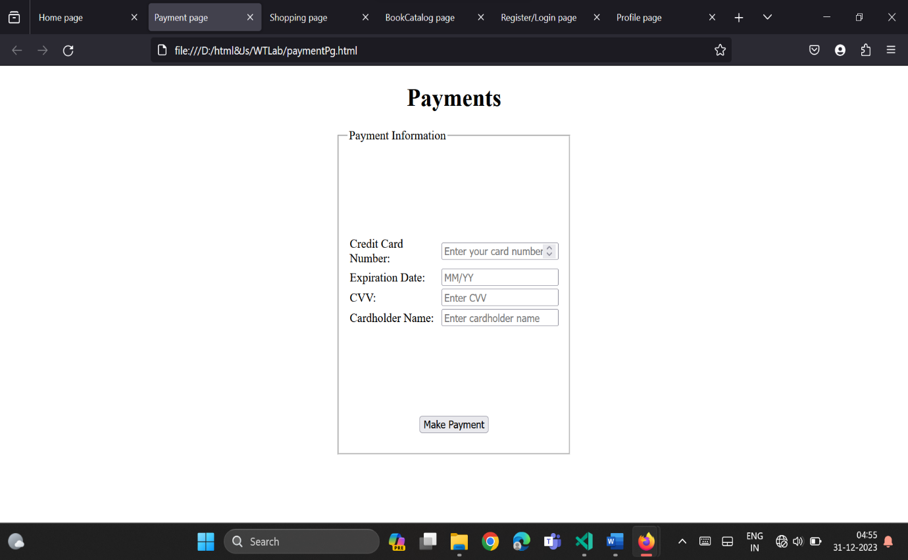
g) Order Conformation
<!DOCTYPE html>
<html>
<head>
<title>Order page</title>
</head>
<style>
fieldset{
width:900px;
display:block;
justify-content: space-between;
}
img{
border: 1px solid;
height:130px;
width:200px;
}
.product{
display:flex;
justify-content:space-evenly;
}
</style>
<body>
<center>
<h1>Order page</h1>
<fieldset>
<div class="product">
<img src="product1.jpg" alt="Product 1">
<div class>
<h3>Product Title 1</h3>
<p>order number:xxxxx</p>
<p>order date:xx.xx.xxxx</p>
<p>Shipping Address:xyxyx</p>
<p>Price: $999.99</p>
<button>Cancel order</button>
</div>
</div>
<div class="product">
<img src="product2.jpg" alt="Product 2">
<div>
<h3>Product Title 2</h3>
<p>order number:xxxxx</p>
<p>order date:xx.xx.xxxx</p>
<p>Shipping Address:xyxyx</p>
<p>Price: $637.99</p>
<button>Cancel order</button>
</div>
</div>
<div class="product">
<img src="product3.jpg" alt="Product 3">
<div>
<h3>Product Title 3</h3>
<p>order number:xxxxx</p>
<p>order date:xx.xx.xxxx</p>
<p>Shipping Address:xyxyx</p>
<p>Price: $1999.99</p>
<button>Cancel order</button>
</div>
</div>
</fieldset>
</center>
</body>
</html>

OUTPUT:

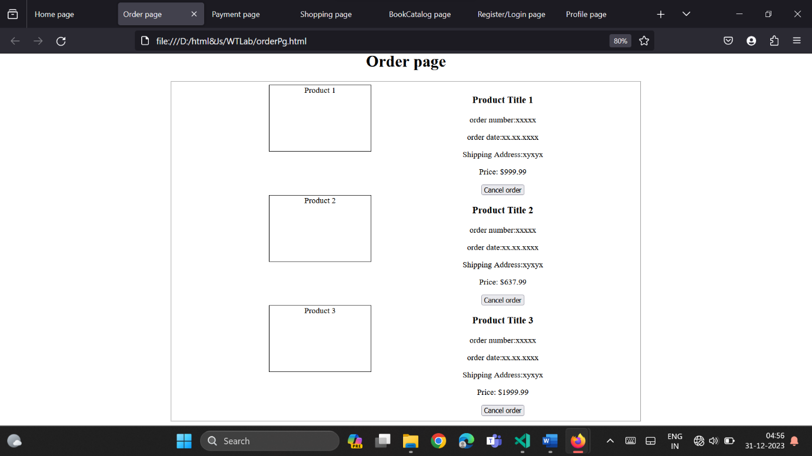

6. Validate the Registration, user login, user profile and payment by credit card pages using JavaScript.
Registration/login validation
function validateform(){

const usrname= document.getElementById("usrname").value;
const pwd=document.getElementById("pwd").value;
const confpwd=document.getElementById("confpwd").value;

if (usrname==null || usrname=="")
alert("usename can't be blank");
else if(pwd.length<6)
alert("Password must be at least 6 characters long.");
else if(pwd!=confpwd)
alert("Password must be same.");
else
alert("Sucessfully submitted");
}

Profile validation
<html>
<head>
<title>User Profile</title>
</head>
<body><center>
<h1>User Profile</h1>
<fieldset style="height:400px;width:300px;">
<legend>Profile Information</legend><br><br><br>
<form id="profileForm" onsubmit="validateForm();">
<table>
<tr>
<td><label for="name">Name:</label></td>
<td><input type="text" id="name" name="name" placeholder="Enter name"required></td>
</tr>
<tr>
<td><label for="email">Email:</label></td>
<td><input type="email" id="email" name="email" placeholder="Enter email"required></td>
</tr>
<tr>
<td><label for="password">New Password:</label></td>
<td><input type="password" id="password" name="password" placeholder="Enter password"></td>
</tr>
</table><br><br><br><br><br><br>
<button type="submit">Update Profile</button>
</form>
</fieldset>
<script>
function validateForm() {
var name = document.getElementById('name').value;
var email = document.getElementById('email').value;
var password = document.getElementById('password').value;
if (name === '') {
alert('Please enter your name.');
return;
}
if (email === '') {
alert('Please enter your email address.');
return;
}
if (password.length > 0 && password.length < 6) {
alert('Password must be at least 6 characters.');
return;
}
alert('Profile updated successfully!');
}
</script>
</center></body>
</html>

function validateform(){

const usrname=document.getElementById("usrname").value;
const pwd=document.getElementsById("pwd").value;
const phNo=document.getElementById("phnnumber").value;
const email=document.getElementById("email").value;
var atpos=email.indexOf("@");
var dotpos=email.indexOf(".");

if (usrname==null || usrname=="")
alert("userame can't be blank");
else if(pwd.length<6)
alert("Password must be atleast 6 characters long.");
else if(atpos<1 || (dotpos-atpos)<2)
alert("Invalid email ID");
else if(phNo.length!=10)
alert("Invalid Phone Number");
else
alert("Sucessfully submitted");
}

Payment validation
function validateform(){

const crdNo= document.getElementById("crdNo").value;
const expDate=document.getElementById("expDate").value;
const cvv=document.getElementById("cvv").value;
const cardHolderName=document.getElementById("cardHolderName").value;

if (crdNo.length<10)
alert("Invalid CardNumber");
else if(expDate.indexOf("/")<1)
alert("Invalid Expire date");
else if(cvv.length>4)
alert("Invalid CVV");
else if (cardHolderName==null || cardHolderName=="")
alert("cardholderName can't be blank");
else
alert("Payment Sucessfull");
}

7. Create and save an XML document on the server, which contains 10 users information. Write a program, which takes User Id as an input and returns the user details by taking the user information from the XML document.
users.xml
<?xml version="1.0" encoding="UTF-8"?>
<users>
<user id="1">
<name>John Smith</name>
<email>john.smith@example.com</email>
<password>123456</password>
<credit_card>1111-2222-3333-4444</credit_card>
</user>
<user id="2">
<name>Jane Doe</name>
<email>jane.doe@example.com</email>
<password>654321</password>
<credit_card>5555-6666-7777-8888</credit_card>
</user>
<!-- Add more user elements here -->
</users>

saxPaserXml.java
import javax.xml.parsers.DocumentBuilderFactory;
import javax.xml.parsers.DocumentBuilder;
import org.w3c.dom.Document;
import org.w3c.dom.NodeList;
import org.w3c.dom.Node;
import org.w3c.dom.Element;
import java.util.Scanner;

class DOMParserXML {

public static void main(String[] args)
{

try {
DocumentBuilderFactory factory = DocumentBuilderFactory.newInstance();
DocumentBuilder builder = factory.newDocumentBuilder();
Document document = builder.parse("users.xml");
document.getDocumentElement().normalize();
NodeList userList = document.getElementsByTagName("user");
Scanner scanner = new Scanner(System.in);
System.out.print("Enter the User Id: ");
int userId = scanner.nextInt();

boolean found = false;

for (int i = 0; i < userList.getLength(); i++) {
Node userNode = userList.item(i);
if (userNode.getNodeType() == Node.ELEMENT_NODE) {
Element userElement = (Element) userNode;
String id = userElement.getAttribute("id");
int idNum = Integer.parseInt(id);
if (userId == idNum) {
found = true;
System.out.println("User details:");

NodeList nameList = userElement.getElementsByTagName("name");
String name = nameList.item(0).getTextContent();
System.out.println("Name: " + name);

NodeList emailList = userElement.getElementsByTagName("email");
String email = emailList.item(0).getTextContent();
System.out.println("Email: " + email);

NodeList passwordList = userElement.getElementsByTagName("password");
String password = passwordList.item(0).getTextContent();
System.out.println("Password: " + password);
NodeList creditCardList = userElement.getElementsByTagName("credit_card");
String creditCard = creditCardList.item(0).getTextContent();
System.out.println("Credit card: " + creditCard);
break;
}
}
}
if (!found) {
System.out.println("User Id not found");
}
} catch (Exception e) {
e.printStackTrace();
}
}
}

OUTPUT:
Enter the User Id: 1
User details:
Name: John Smith
Email: john.smith@example.com
Password: 123456
Credit card: 1111-2222-3333-4444

8).Question replace XSD with XML doc
<!---XMl code-->
<student>
<sid>506</sid>
<sname>B.jaipal</sname>
<sclass>b.tech</sclass>
</student>

<!---XSD code-->
<xs:schema>
<xs:element name="student">
<xs:complexType>
<xs:sequence>
<xs:element name="sid" type="xs:string"/>
<xs:element name="sname" type="xs:string"/>
<xs:element name="sclass" type="xs:string"/>
</xs:sequence>
</xs:complexType>
</xs:element>
</xs:schema>

OUTPUT:
506 B.jaipal b.tech

9).Question replace DTD with XML doc
<!DOCTYPE student[
<!ELEMENT student(sid,sname,sclass)>
<!ELEMENT sid(#PCDATA)>
<!ELEMENT sname(#PCDATA)>
<!ELEMENT sclass(#PCDATA)>
]>
<student>
<sid>506</sid>
<sname>B.jaipal</sname>
<sclass>b.tech</sclass>
</student>

OUTPUT:
506 B.jaipal b.tech

