E-BOOK MANAGEMENT SYSTEM
-BY B.JAIPAL

ABSTRACT:

To create a system to performed e-book management system.An “e-book ” typically refer to a collection or facility where books are stored and made available libaries and manage e-books.They can be stored organize and manage e-books,as well as to lend, barrow and purchase e-books.

PROBLEM STATEMENT:

The website has to be maintained properly since the whole e-book purchase process can be improved.

- This process face issues in maintaining of database.Best example for e-book platform in Amazon.
- There will be two choices for buyer whether they need hard copy or pdf .In case of pdf it is easy to delivary but to face problems by the various in pdf.In case of hard copy we need full details address.
- E-book can be more expensive than physical books,and they can be difficult to access in some areas.

GOALS:

The goals of the project is to develope a solution that address the challenge of e-book .specificatially,all project should aim to:

- Make e-book easier to read on a small screen.
- Add feature to e-book that are similar to features of physical books.
- Make e-book more affordable.
- Make e-book more accessible.

PROPOSED SOLUTION:

The implementation of an e-book Management system aim to alleviate these challenge by creating a centralized reposity of textbooks.The system will allow students to barrow required textbooks for duration of academic terms ensuring equal access to learning resources.

By addressing issues,the propsed book bank sysytem seeks to enhance educational oppertunities,reduce academic disparities,and contribute to a more inclusive and environmentally conscious learning environment.advanced e-book system that addresses theses issues,providing an intuitive patform for user to effortlesslt organize,search and access the digital libraries.Such a system should also ensure compatibility with wide range of e-book devices,enhance metadata management, and offer a seamless user exoperience in the rapidly evolving landscape od digital reading.

SCOPE OF THE PROJECT:

The software provide the visitor,customer and administrator a easy and efficient way to buy and manage book in online,software provides following facilities to customer:

- Facilitates easy shopping online.
- Provides information about the products in categories.
- Provide e-mail facilitates for future correspondence.
- Provides Backup facility.
- Software provides the following facilities to the marchant.
- Manages the Transportation of hard copy of Book.
- Look after the payment method.

SOFTWARE REQUIREMENTS:

a) Functional Requirements:

- Register - Enter details in application form.
- Login - Enter the Username and password.
- Search - search book by attribute.
- Buy - Download softcopies and order for hard copy.
- Payment - Pay for book in different method.
- Upadate - Update user details

b) Non -Functional Requirements:

- Bookmarks - Bookmark the websites.
- Categories - Book categories in website.
- Most Downloaded - Highest purchased books.
- Offers - Offers given by marchant.
- Carting - Mark and select multiple books.

HARDWARE REQUIREMENTS:

PROCESSOR-Intel pentium 1V-2.0ghz.
HARDWARE-40 GB (segate)
RAM-512 mb
DVD RAM – 1nos.

SOFTWARE REQUIREMENTS:

OS- windows XP/vista.
FRONT END TOOL-Rational rose Enterprise suite.
BACK END TOOL-Oracle10i.

TECHNOLOGIEWS TO BE USED:

HTML- Markup language used for creating web page.

J2EE - Java 2 Enterprise Edition is a programming platform and it is the part of the
java platformfor developing and running distributed java applications.

HTTP -Hyper text Transfer Protocol.

TCP/IP - Transmission Control Protocol/Internet Protocol is the communication protocol used to connect host on the internet.

USER CASE DIAGRAM:
The E-book use cases in our system are:

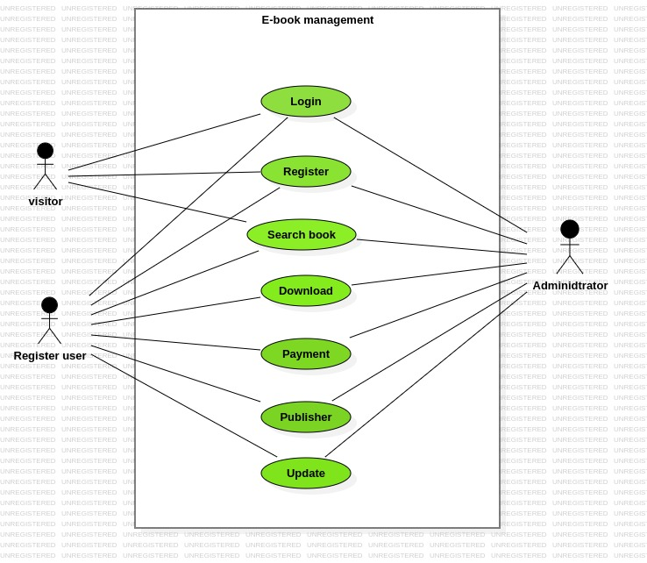

/

1.ADD:

A student record.Each student should have following attributes.

- Student id
- Name
- Address
- Phone No

2.UPDATE:
The record would be selected using the student id.The updates can be made on full items only.

- Name
- Address
- Phone No

3.ADD TO BOOK ITEM:
Each book should have following attribute.

- Call No
- Title
- ISBN (International Standard Book Number )
- Author Name

4.Query the book database:
The product shall let librarian query tools books detail information by their ISBN number(or)author(or)title.The search result would produce alist of books,which match thee search parameter.

5.Check out a book:
Librarians and member of the library can check out can be initialized from a previous
search operation where user has selected a set of books.

6.Check in a book:
Librarians and member of the library can check in a book using its call No.

CLASS DIAGRAM:

The class diagram,also referred to as object modeling is the main static analysis diagram.The main task of the object modeling is to graphically show what each object will do in the problem domain.The problem domain describes the structure and the relationships among objects.

The E-book Management system class diagram consists of five classes:

- Login
- Registered user
- Administrator
- Book
- Visitor
- Download
- Layout

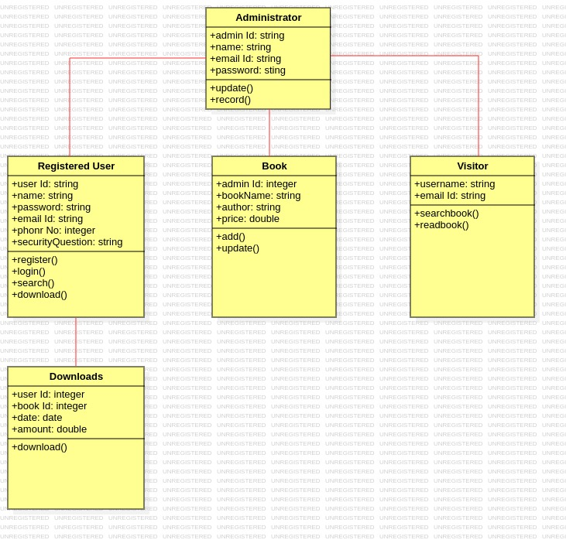

SEQUENCE DIAGRAM:

A sequence diagrame represents the sequence and interaction of the a given USE-CASE or scenario.Sequence diagrams can capture most of the information about the system.Most object to object interactions and operations are considered events and events include signals,inputs,decisions,interrupts,transitions and actions to or from user or external devices.

An event also is considered to be any action by an object that sends information.The event line represents a message from one object to another.

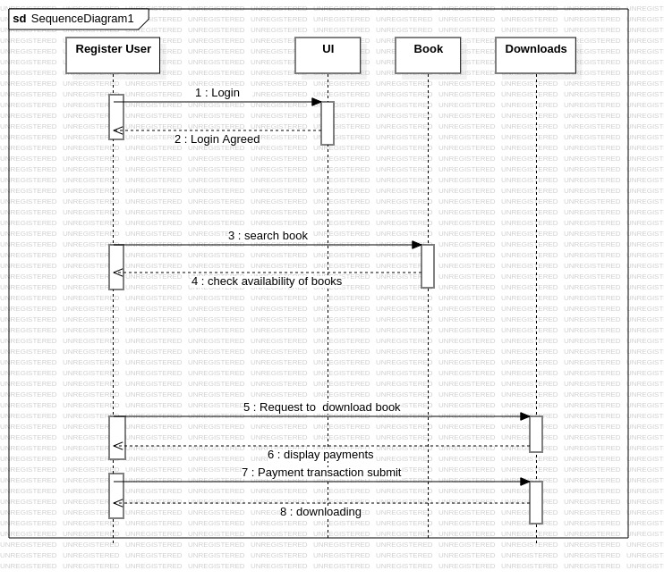

ACTIVITY DIAGRAM:

An activity diagram that represents the flow of control or action in a system.It can can also describe the steps in a use case diagram.set of components of the activity diagram describe user activity performance on a information system.

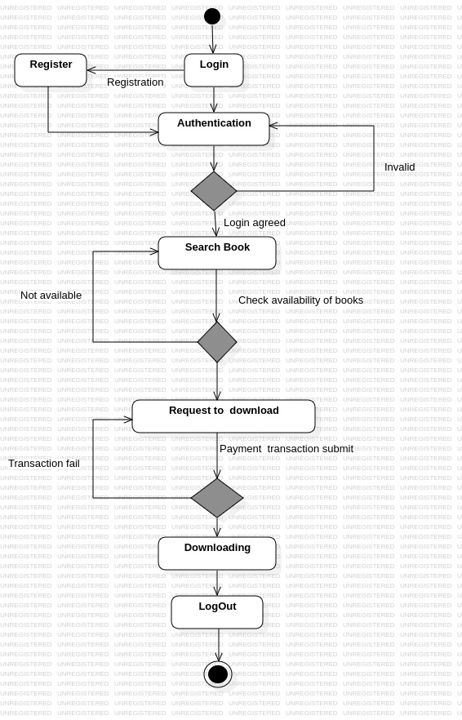

DEPLOYMENT DIAGRAM AND COMPONENT DIAGRAM:

Deployment diagrams are used to visualize the topology of the physical components of the system where the software components are deployed.

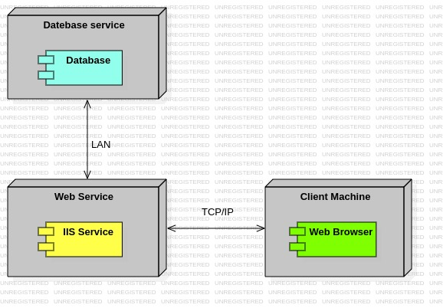

STATE CHART DIAGRAM:

The diagrams show first login to the system and view the books and search for required book is done and then required book is downloaded and amount paid in online.Finally logout from the system.

A user can aslo logged in,logged out, browsing, lending reviewing and rating.A user
can have different states depending on their role,activity, and preference.

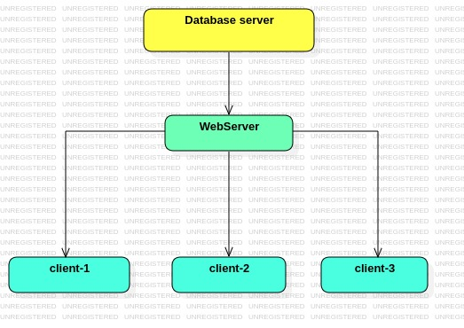

CONCLUSION:

To perform the testing for the generated code again select the tools option from menu bar and choose quality architecture option a sub window gets opened.We are going to perform unit testing and secnario testing for our project.Thus the E-BOOK MANAGEMENT SYSTEM has been successfully executed and codes are generated.

