## Docker-Compose:

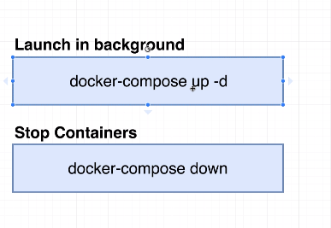

### Automatic container re-start:

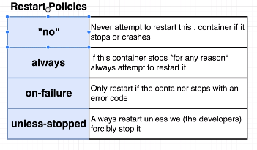

## frontEnd:

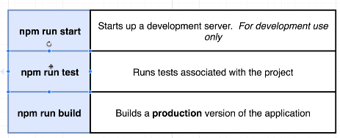

## Step1:

Create a dockerfile.dev

Run the command:

docker build -f "Dockerfile.dev" .

Issue:

Once you run you may see this error:

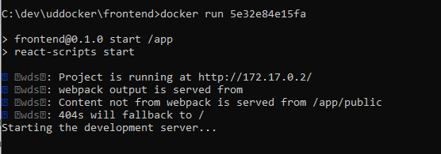

Solution:



Docker Volume:

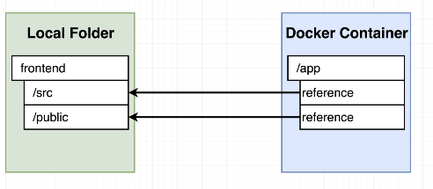

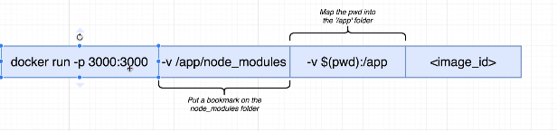

**Try to run only one option of -V:**

docker run -it -p 3000:3000 -v ${pwd}:/app 622f8dd364a7

which gives error:

