PORTFOLIO PROJECT

Secure Medical Clinic
Azure Environment
Security-focused Azure foundation aligned to AZ-900 concepts

Project | Implementation
Author | Jaiprakash Reddy
Region | Australia East
Environment | Development portfolio lab
Data handling | Fictitious medical records only
Prepared | 25 August 2026

No production patient data • No public RDP or SSH • Low-cost design

Executive summary
This project demonstrates the design and governance of a secure, low-cost Azure environment for a fictitious medical clinic. It focuses on identity, network segmentation, storage protection, monitoring, policy, and operational safeguards. No compute workload or production healthcare information was deployed; the result is a reusable security foundation and evidence-based portfolio case study.
Outcome | Evidence
Cost control | A$5 monthly budget configured at resource-group scope
Network segmentation | Three /24 subnets with dedicated NSGs
Identity | Microsoft Entra groups and scoped Azure RBAC
Data protection | Private blob container, TLS 1.2, Entra authorization, network restriction
Detection | Activity Log alert delivered through an email action group
Governance | Delete lock and deny policy for a required project tag

Objectives and constraints
- Apply AZ-900 concepts through a practical Azure deployment.
- Use free or low-cost control-plane services and avoid always-on compute.
- Never expose RDP (3389) or SSH (22) directly to the internet.
- Use only fictitious records and conceal subscription IDs, object IDs, emails, and personal details in public evidence.
- Avoid Azure Bastion, VPN Gateway, ExpressRoute, Azure Firewall, and NAT Gateway.

Architecture
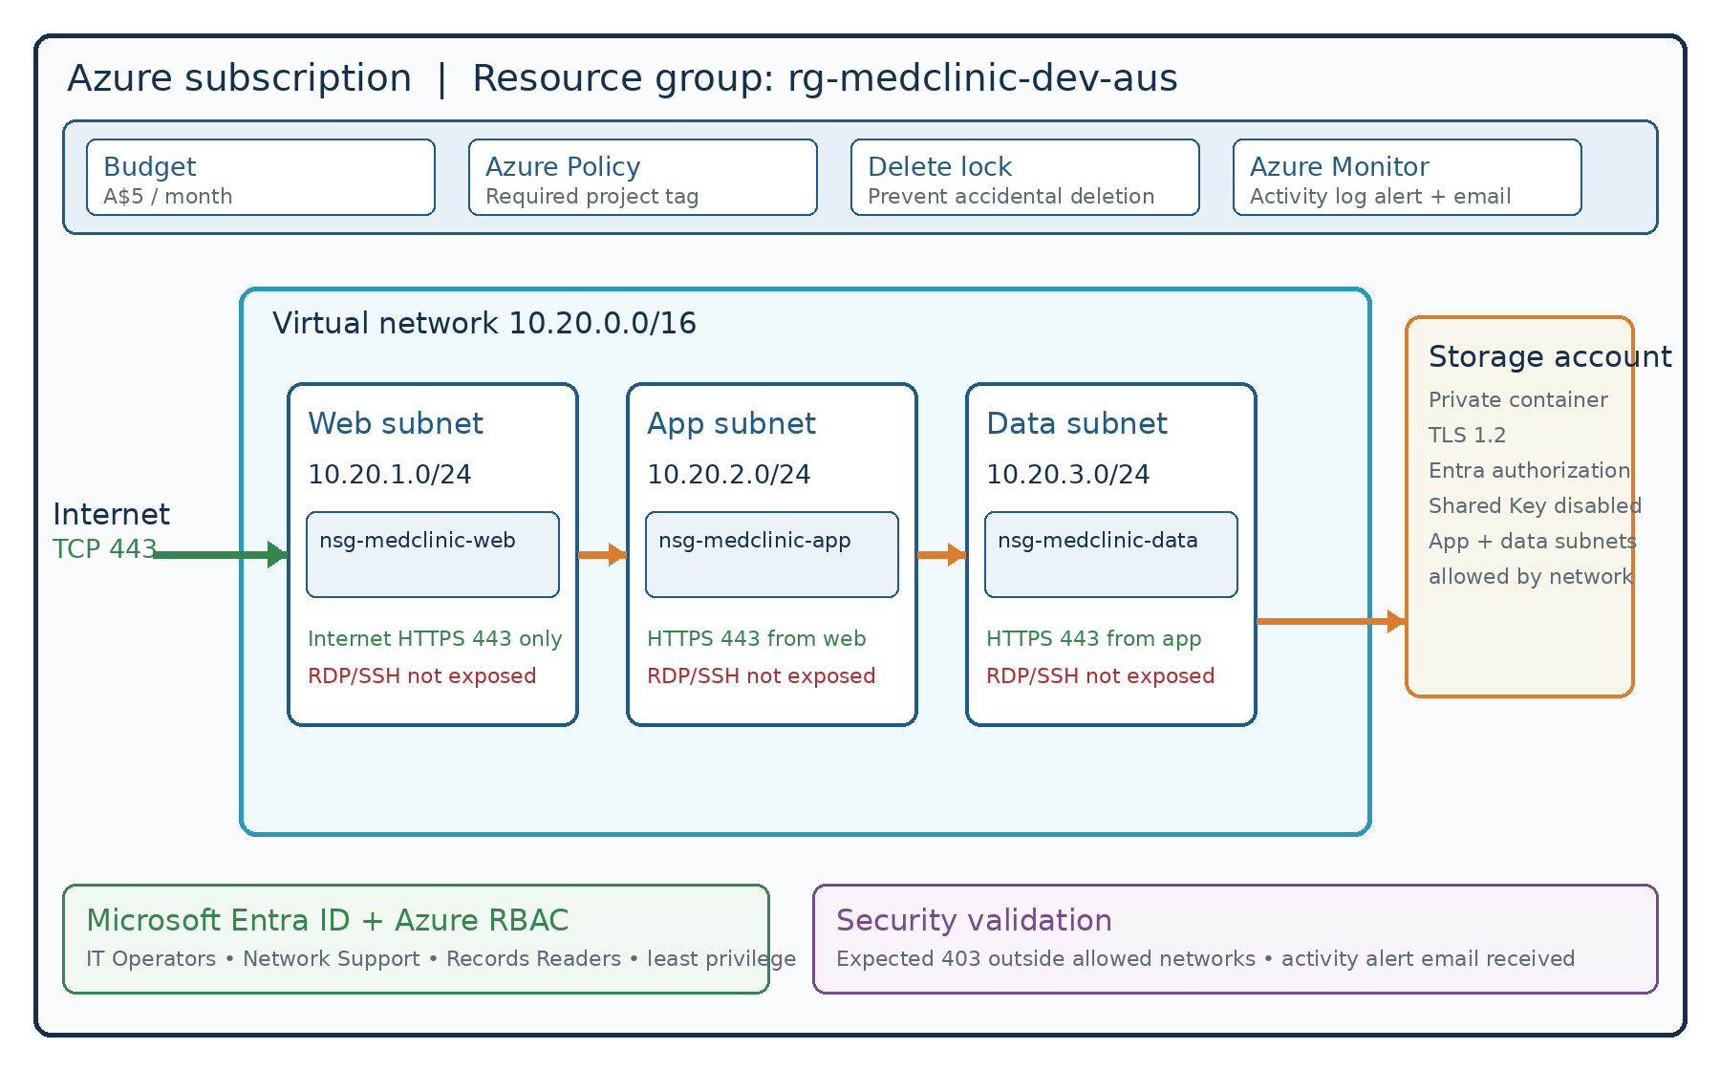
Figure 1. Logical security architecture. The web, app, and data tiers are network segments; no production application servers were deployed.

Resource inventory
Type | Name | Purpose
Resource group | rg-medclinic-dev-aus | Governance boundary
Virtual network | vnet-medclinic-dev-aus | 10.20.0.0/16
Web subnet | snet-web | 10.20.1.0/24
App subnet | snet-app | 10.20.2.0/24
Data subnet | snet-data | 10.20.3.0/24
Network security groups | nsg-medclinic-web / app / data | One NSG per subnet
Storage account | stmedclinicdev0207 | Private fictitious records
Monitor | alert-medclinic-nsg-change | Email via ag-medclinic-security
Governance | Policy + delete lock | Required tag and deletion protection

Network security design
Tier | Allowed inbound | Additional control
Web | TCP 443 from Internet | Explicitly deny Internet RDP/SSH and other Internet traffic
App | TCP 443 from 10.20.1.0/24 | Deny other VirtualNetwork traffic
Data | TCP 443 from 10.20.2.0/24 | Deny other VirtualNetwork traffic
Azure NSGs are stateful and evaluate lower priority numbers first. Dedicated NSGs reduce blast radius and make the intended web → app → data flow reviewable. AzureLoadBalancer service-tag exceptions were added above the custom VirtualNetwork deny rules so Azure platform health traffic is not unintentionally blocked.

Storage security
- Private container clinic-records containing only a fictitious CSV.
- Secure transfer required; minimum TLS version 1.2.
- Blob anonymous access disabled; Shared Key access disabled.
- Microsoft Entra authorization used for data access.
- Blob and container soft delete enabled for seven days.
- Public network access restricted to selected virtual-network subnets; an external portal request returned the expected HTTP 403.

Identity and access management
Principal | Role | Scope
MedClinic-IT-Operators | Contributor | Resource group
MedClinic-Network-Support | Network Contributor | Resource group
MedClinic-Records-Readers | Storage Blob Data Reader | Storage account
Project owner | Storage Blob Data Contributor | Storage account
This separates management-plane permissions from storage data-plane permissions and demonstrates least privilege through group-based access.

Monitoring, governance, and cost

Monitoring
An Azure Monitor Activity Log alert detects NSG changes and routes notifications through ag-medclinic-security. The action group was validated when an email notification arrived after a controlled NSG tag change.

Governance
A CanNotDelete resource lock protects the resource group from accidental deletion. Azure Policy uses a Deny effect to require the project tag and value on resources. The compliance view initially showed 6 of 7 resources compliant because the action group lacked the tag. After remediation, policy reevaluation may take time; the 86% screenshot is retained as evidence of detection and corrective action rather than presented as a failure.

Cost controls
A monthly A$5 budget was configured. The lab avoids charge-generating gateways, Bastion, public IPs, and always-on VMs. Budgets alert on spend but do not automatically stop resources, so cleanup remains essential.

Security validation results
Test | Observed evidence | Result
No public remote administration | NSGs contain no Internet allow rule for ports 22 or 3389 | Pass
Tier segmentation | Web, app, and data each use a dedicated subnet and NSG | Pass
Web exposure | Only TCP 443 is allowed from Internet | Pass
App restriction | TCP 443 allowed only from web subnet; other VNet traffic denied | Pass
Data restriction | TCP 443 allowed only from app subnet; other VNet traffic denied | Pass
Storage anonymity | Blob anonymous access disabled | Pass
Storage network test | External portal access returned HTTP 403 | Pass
Detection | Activity Log alert email received | Pass
Policy remediation | Missing tag detected and corrected; reevaluation pending in captured view | Pass with note

Problems found and corrected
- NSG association was reviewed and corrected so each subnet has its own matching NSG.
- Early app/data NSG rules were overly broad or had misleading names; source CIDRs, actions, and priorities were corrected.
- Custom VirtualNetwork deny rules triggered Azure warnings; explicit AzureLoadBalancer allows were placed at a higher priority.
- Azure Policy identified an untagged action group; the required project tag was added.

AZ-900 concepts demonstrated
Domain | Applied concept
Cloud concepts | Consumption awareness, shared responsibility, and service scope
Architecture and services | Region, subscription, resource group, VNet, subnet, NSG, storage
Identity | Microsoft Entra ID, groups, Azure RBAC, management vs data plane
Management and governance | Tags, Azure Policy, resource locks, budgets, Azure Monitor
Security | Defense in depth, least privilege, segmentation, encryption in transit, private data access

Limitations and future improvements
- Deploy a small application workload only if needed, with no public management ports.
- Replace selected-network storage access with a private endpoint and private DNS for a production design.
- Manage secrets with Azure Key Vault and managed identities.
- Evaluate Defender for Cloud, Log Analytics, Microsoft Sentinel, Conditional Access, MFA, and PIM based on licensing and cost.
- Rebuild the environment with Bicep or Terraform and validate with automated tests.
- Use a production-grade backup, recovery, data-retention, and regulatory program before handling real health information.

Résumé bullets
- Designed a secure Azure portfolio environment using a three-tier VNet (web, app, and data subnets) with dedicated NSGs, least-privilege traffic rules, and no public RDP/SSH exposure.
- Hardened Azure Blob Storage using private containers, TLS 1.2, Microsoft Entra authorization, disabled Shared Key and anonymous access, seven-day soft delete, and selected-network restrictions.
- Implemented Microsoft Entra groups and scoped Azure RBAC for Contributor, Network Contributor, Storage Blob Data Reader, and Storage Blob Data Contributor access.
- Configured Azure Monitor Activity Log alerts and an email action group; validated detection through a controlled NSG change and successful notification.
- Applied Azure governance with tags, a deny policy, a resource-group delete lock, and an A$5 monthly budget; remediated policy and NSG configuration findings during security testing.

LinkedIn project description
I built a Secure Medical Clinic Azure Environment as a hands-on portfolio project while developing my AZ-900 knowledge. The lab uses only fictitious data and demonstrates a three-tier virtual network, dedicated Network Security Groups, hardened Blob Storage, Microsoft Entra groups, scoped Azure RBAC, Activity Log alerts, email notifications, resource locks, Azure Policy, tags, and cost controls. I also tested expected-deny scenarios, corrected NSG and tagging issues, and documented the results as a security case study. No RDP or SSH was exposed to the internet, and the environment avoided high-cost gateway services and always-on compute.
#Azure #AZ900 #CloudSecurity #MicrosoftEntra #Cybersecurity #AzureMonitor #AzurePolicy

Evidence checklist
- Budget list showing A$5 monthly limit
- Resource group overview and tags
- VNet address space and three subnets
- Subnet list with one-to-one NSG associations
- Inbound rules for web, app, and data NSGs
- Storage configuration and expected HTTP 403
- Entra groups and RBAC assignments
- Activity Log alert, action group, and received email
- Azure Policy compliance and remediation
- Resource-group delete lock
Privacy reminder: Before publishing screenshots, conceal subscription IDs, tenant/object IDs, correlation IDs, email addresses, account names, and other personal information.

Official Microsoft documentation
Virtual networks: https://learn.microsoft.com/azure/virtual-network/virtual-networks-overview
Network security groups: https://learn.microsoft.com/azure/virtual-network/network-security-groups-overview
Storage network security: https://learn.microsoft.com/azure/storage/common/storage-network-security
Azure RBAC: https://learn.microsoft.com/azure/role-based-access-control/overview
Azure Monitor activity log: https://learn.microsoft.com/azure/azure-monitor/essentials/activity-log
Resource locks: https://learn.microsoft.com/azure/azure-resource-manager/management/lock-resources
Azure Policy: https://learn.microsoft.com/azure/governance/policy/overview
Cost budgets: https://learn.microsoft.com/azure/cost-management-billing/costs/tutorial-acm-create-budgets

Cleanup handoff
After final evidence is captured: remove the delete lock, delete rg-medclinic-dev-aus, verify deletion and cost status, then remove the fictitious Entra users and groups. Cleanup is intentionally handled as the final guided stage so evidence is not lost prematurely.

