Algorithms & Complexity 3/01/2017

0145-344-001

Note Taker: Jai Punjwani

ANNOUNCEMENTS

Midterm Monday 3/6 (study from midterm review sheet)

* induction question will be on it
* determining Big-OH
* know all complexity cases for sorts
* expect polyphase merge
* Minimum spanning trees
* prim’s & kruskal’s algorithm

Topic: Pattern Matching (cont’d)

PowerPoint: <http://home.adelphi.edu/~siegfried/cs344/344l7.pdf>

Finite State Machines (FSM) – a (theoretical) computing machine that takes a string as its input and outputs yes/no. **Meant to keep state to solve backtracking issue** and keep track of letters that have already matched without having to recheck ALL of them.

Example of translating state table into diagrams:

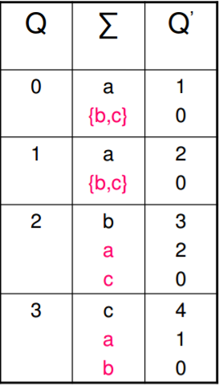 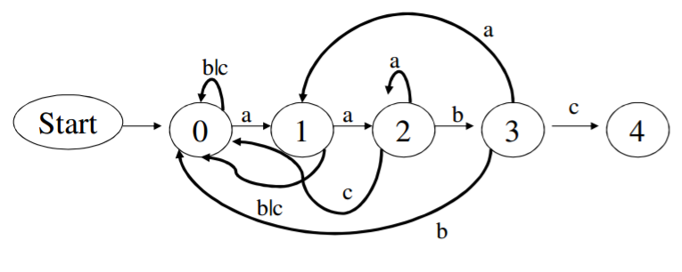

Explanation: observe state 0. we go to state 1 only if we have an ‘a’. inputs ‘b’ or ‘c’ (b | c) mean that we remain in the state. Similar rules apply for the other states. Note that if we have a ‘c’ in state 3, we proceed to state 4, which is our desired (end) state.