Algorithms & Complexity 4/7/17

0145-344-001

Note Taker: Jai Punjwani

ANNOUNCEMENTS

Topic: Numerical computation, numerical integration, and Fast Fourier Transform

PowerPoint: <http://home.adelphi.edu/~siegfried/cs344/344l11.pdf>

**How do computers computer derivatives, anti-derivatives, and functions that are infinite series?**

* One method is to use the rectangular approximation method. When finding the area under a curve in calculus, you can approximate by creating little rectangles and then summing up their areas. The smaller your rectangles are in the dimension over which you are integrating (X below), the more precise your area.  
    
  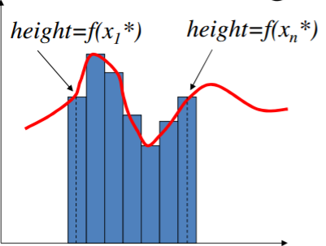
* Similarly, the trapezoidal rule can be used
* A much more accurate approximation can be obtained by using **Simpson’s Rule**

**Transforms**

* a function that results when a given function is multiplied by a kernel function [K(x, y)] and the product is integrated between suitable limits.