OTRS Install
@Changeme12345

sudo apt update
sudo apt upgrade -y
sudo apt install mariadb-server
sudo mysql_secure_installation
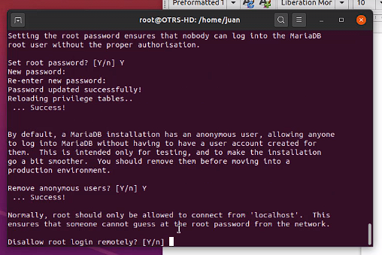
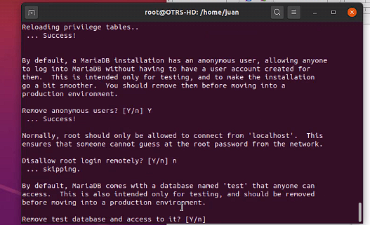
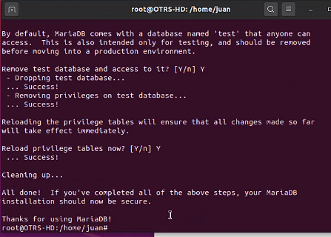
sudo mysql -u root
UPDATE mysql.user SET plugin = 'passwd' WHERE User = 'root';
FLUSH PRIVILEGES;
QUIT;
mysql -u root -p
(https://www.zeppelinux.es/corregir-error-1698-28000-access-denied-for-user-rootlocalhost-en-mariadb-mysql/)

(en el video se usa despues de la configuración de maria este --→)

sudo tee /etc/mysql/mariadb.conf.d/otrs.cnf<<EOF

[mysqld]
max_allowed_packet=64M
query_cache_size=36M
innodb_log_file_size=256M
EOF
sudo systemctl restart mariadb

mysql -u root -p

SI REPORTA ESTE ERROR
$ mysql -u root -p
Enter password:
ERROR 1698 (28000): Access denied for user 'root'@'localhost'

ENTONCES:

sudo mysql -u root -p
USE mysql;
SELECT user, plugin FROM user;
UPDATE user SET plugin="mysql_native_password" WHERE user="root";
SELECT user, plugin FROM user;
FLUSH PRIVILEGES;
exit;

mysql -u root -p
@Changeme12345

CREATE DATABASE otrs CHARACTER SET utf8 COLLATE utf8_general_ci;

GRANT ALL PRIVILEGES ON otrs.* TO otrs_user@localhost IDENTIFIED BY 'passwd';
FLUSH PRIVILEGES;

QUIT

sudo apt install apache2 libapache2-mod-perl2

sudo apt install libdatetime-perl libcrypt-eksblowfish-perl libcrypt-ssleay-perl libgd-graph-perl libapache-dbi-perl libsoap-lite-perl libarchive-zip-perl libgd-text-perl libnet-dns-perl libpdf-api2-perl libauthen-ntlm-perl libdbd-odbc-perl libjson-xs-perl libyaml-libyaml-perl libxml-libxml-perl libencode-hanextra-perl libxml-libxslt-perl libpdf-api2-simple-perl libmail-imapclient-perl libtemplate-perl libtext-csv-xs-perl libdbd-pg-perl libapache2-mod-perl2 libtemplate-perl libnet-dns-perl libnet-ldap-perl libio-socket-ssl-perl libmoo-perl

sudo apachectl -M | grep perl

sudo a2enmod perl

sudo systemctl restart apache2

sudo systemctl status apache2
(PULSAR Q PARA SALIR)

sudo useradd -d /opt/otrs -c 'OTRS user' otrs

sudo usermod -aG www-data otrs

id otrs

sudo apt-get install wget

wget https://download.znuny.org/releases/otrs-latest.tar.gz

!!! NO USAR ESTE ENLACE ES ANTIGUO!!! wget http://ftp.otrs.org/pub/otrs/otrs-latest.tar.gz

tar xvf otrs-latest.tar.gz

mv otrs-*/ otrs
sudo mv otrs /opt
sudo /opt/otrs/bin/otrs.CheckModules.pl

sudo cp /opt/otrs/Kernel/Config.pm.dist /opt/otrs/Kernel/Config.pm

sudo nano /opt/otrs/Kernel/Config.pm

!!!LA CONTRASEÑA ES: passwd!!! (CTRL O: PARA GUARDAR Y LUEGO PULSA ENTER, CTRL X: PARA SALIR)
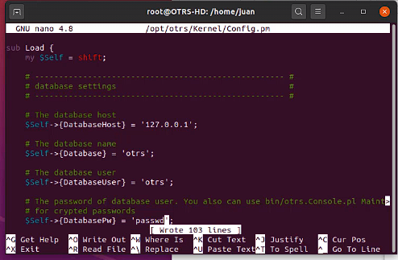

sudo nano /opt/otrs/scripts/apache2-perl-startup.pl

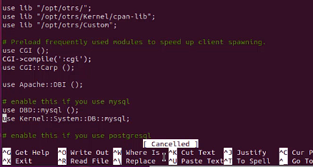
Quitar comentarios
use DBD::mysql ();
use Kernel::System::DB::mysql;
sudo /opt/otrs/bin/otrs.SetPermissions.pl –web-group=www-data

ls -ldh /opt/otrs/

sudo ln -s /opt/otrs/scripts/apache2-httpd.include.conf /etc/apache2/sites-enabled/otrs.conf

sudo perl -cw /opt/otrs/bin/cgi-bin/index.pl

sudo perl -cw /opt/otrs/bin/cgi-bin/customer.pl

sudo perl -cw /opt/otrs/bin/otrs.Console.pl

sudo systemctl restart apache2

http://serveripaddress/otrs/installer.pl
http://20.0.0.1/otrs/installer.pl


sudo ufw allow 80

Open the URL http://server-ip-address/otrs/installer.pl

http://127.0.0.1/otrs/index.pl
root@localhost
DlTWLBtUMTTz1t4H

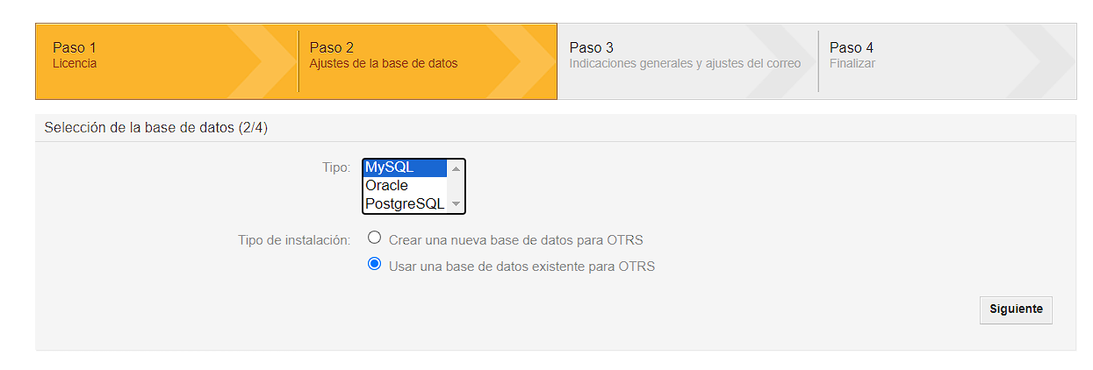
otrs_user
passwd
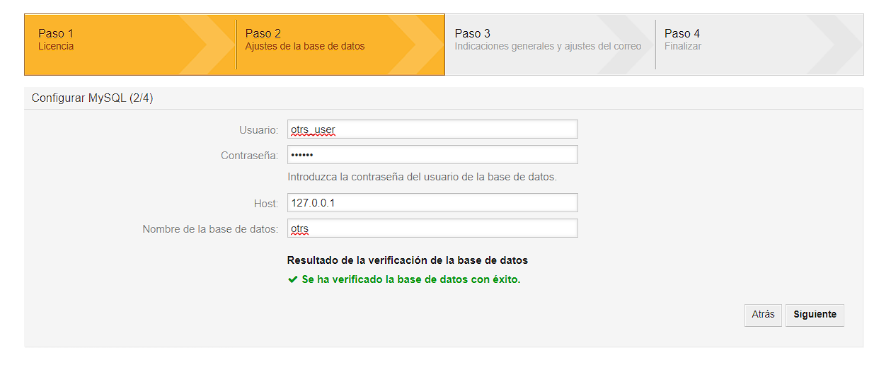

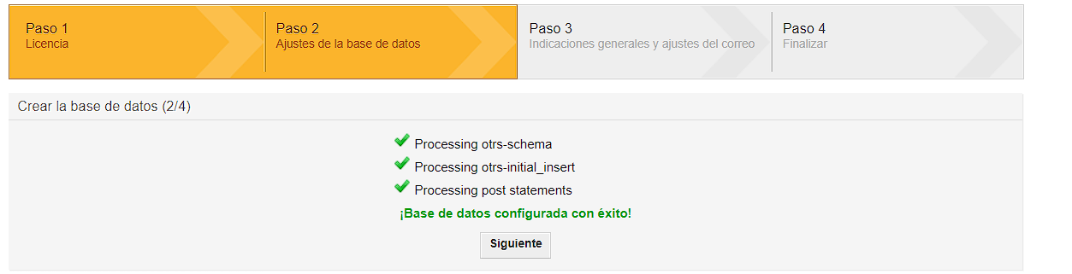
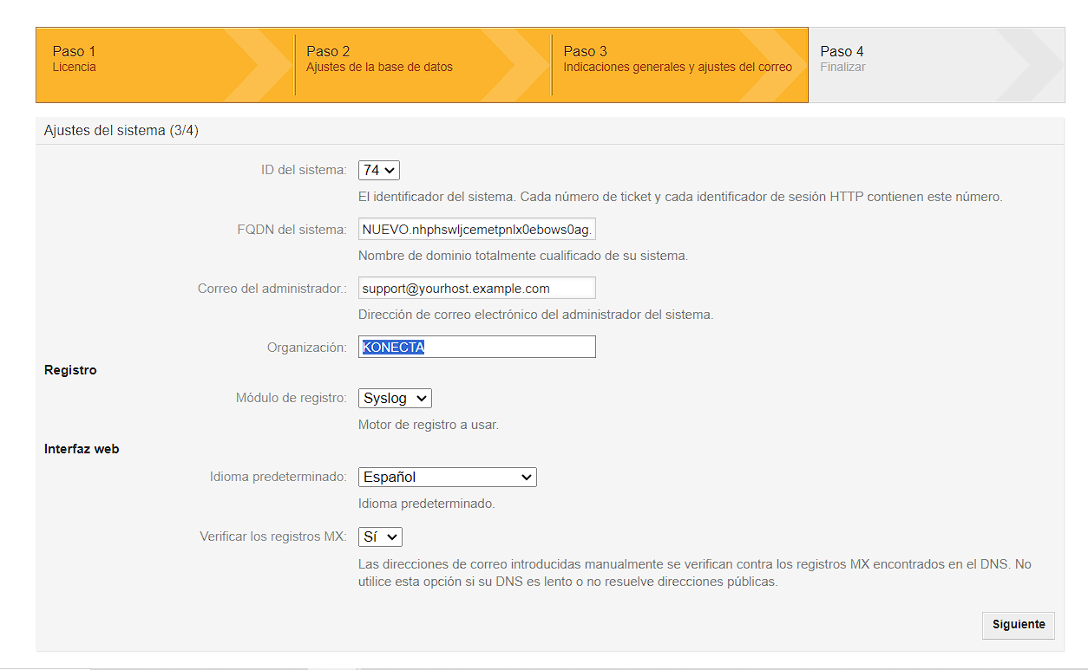
NUEVO.nhphswljcemetpnlx0ebows0ag.bx.internal.cloudapp.net
support@yourhost.example.com
KONECTA

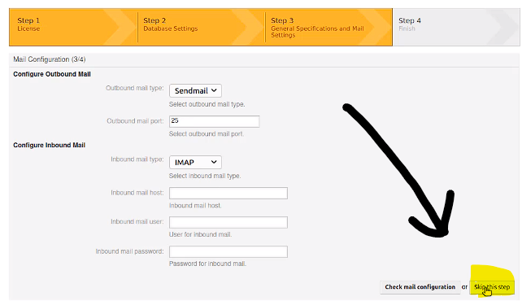

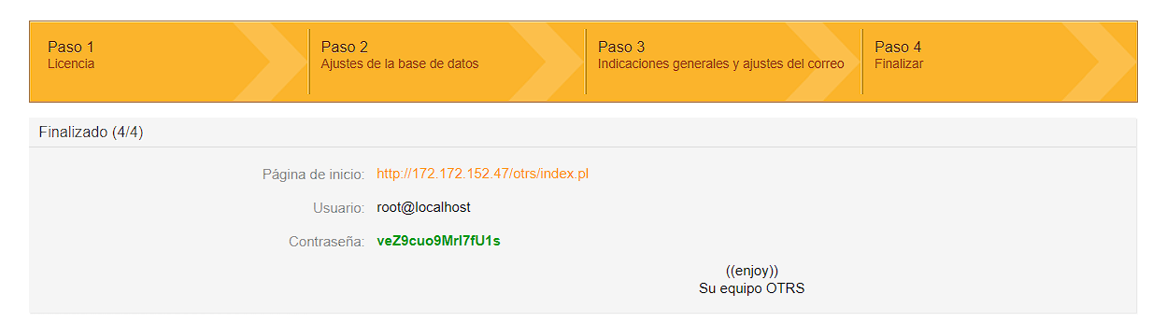
Página de inicio:
http://172.172.152.47/otrs/index.pl

Usuario:
root@localhost

Contraseña:
veZ9cuo9MrI7fU1s

