

Data Base Management System -23CSE202

Lab Manual

Submitted By

NAME | CH. JAI RAM CHARAN.
ROLL NO | AV.SC.U4CSE25106
YEAR/SEM/SECTION | 2ND YEAR/ SEM-3/CSE-B
CREDITS | 04

Submitted to

NAME | DR. N. VENKATA RAMANA
DESIGNATION | ASST.PROFFESSOR (Sl. Grade)
DEPARTMENT | SCHOOL OF COMPUTING

Index
Sno | Topic | Page
1 | Implementation of DDL commands of SQL with suitable examples | 3
2 | Implementation of DML commands of SQL with suitable examples | 9
3 | Implementation of different types of functions with suitable examples. | 17
4 | Implementation of different types of functions with suitable examples. | 26
5

Experiment No: 1
Title: Implementation of DDL commands of SQL with suitable examples
- Create table
- Alter table
- Drop Table
Objective:
- To understand the different issues involved in the design and implementation of a database system
- To understand and use data definition language to write query for a database
Theory:
Oracle has many tools such as SQL * PLUS, Oracle Forms, Oracle Report Writer, Oracle Graphics etc.
- SQL * PLUS: The SQL * PLUS tool is made up of two distinct parts. These are:
- Interactive SQL: Interactive SQL is designed for create, access and manipulate data structures like tables and indexes.
- PL/SQL: PL/SQL can be used to developed programs for different applications.
- Oracle Forms: This tool allows you to create a data entry screen along with the suitable menu objects. Thus it is the oracle forms tool that handles data gathering and data validation in a commercial application.
- Report Writer: Report writer allows programmers to prepare innovative reports using data from the oracle structures like tables, views etc. It is the report writer tool that handles the reporting section of commercial application.
- Oracle Graphics: Some of the data can be better represented in the form of pictures. The oracle graphics tool allows programmers to prepare graphs using data from oracle structures like tables, views etc.
SQL (Structured Query Language):
Structured Query Language is a database computer language designed for managing data in relational database management systems (RDBMS), and originally based upon Relational Algebra. Its scope includes data query and update, schema creation and modification, and data access control.
SQL was one of the first languages for Edgar F. Codd's relational model and became the most widely used language for relational databases.
- IBM developed SQL in mid of 1970s.
- Oracle incorporated in the year 1979.
- SQL used by IBM/DB2 and DS Database Systems.
- SQL adopted as standard language for RDBS by ASNI in 1989.
DATA TYPES:
- CHAR (Size): This data type is used to store character strings values of fixed length. The size in brackets determines the number of characters the cell can hold. The maximum number of character is 255 characters.
- VARCHAR (Size) / VARCHAR2 (Size): This data type is used to store variable length alphanumeric data. The maximum character can hold is 2000 character.
- NUMBER (P, S): The NUMBER data type is used to store number (fixed or floating point). Number of virtually any magnitude may be stored up to 38 digits of precision. Number as large as 9.99 * 10 124. The precision (p) determines the number of places to the right of the decimal. If scale is omitted then the default is zero. If precision is omitted, values are stored with their original precision up to the maximum of 38 digits.
- DATE: This data type is used to represent date and time. The standard format is DD-MM-YY as in 17-SEP-2009. To enter dates other than the standard format, use the appropriate functions. Date time stores date in the 24-Hours format. By default the time in a date field is 12:00:00 am, if no time portion is specified. The default date for a date field is the first day the current month.
- LONG: This data type is used to store variable length character strings containing up to 2GB. Long data can be used to store arrays of binary data in ASCII format. LONG values cannot be indexed, and the normal character functions such as SUBSTR cannot be applied.
- RAW: The RAW data type is used to store binary data, such as digitized picture or image. Data loaded into columns of these data types are stored without any further conversion. RAW data type can have a maximum length of 255 bytes. LONG RAW data type can contain up to 2GB.
SQL language is sub-divided into several language elements, including:
- Clauses, which are in some cases optional, constituent components of statements and queries.
- Expressions, which can produce either scalar values or tables consisting of columns and rows of data.
- Predicates which specify conditions that can be evaluated to SQL three-valued logic (3VL) Boolean truth values and which are used to limit the effects of statements and queries, or to change program flow.
- Queries which retrieve data based on specific criteria.
- Statements which may have a persistent effect on schemas and data, or which may control transactions, program flow, connections, sessions, or diagnostics.
- SQL statements also include the semicolon (";") statement terminator. Though not required on every platform, it is defined as a standard part of the SQL grammar.
- Insignificant white space is generally ignored in SQL statements and queries, making it easier to format SQL code for readability.
There are five types of SQL statements. They are:
- DATA DEFINITION LANGUAGE (DDL)
- DATA MANIPULATION LANGUAGE (DML)
- DATA RETRIEVAL LANGUAGE (DRL)
- TRANSATIONAL CONTROL LANGUAGE (TCL)
- DATA CONTROL LANGUAGE (DCL)
1. DATA DEFINITION LANGUAGE (DDL):
The Data Definition Language (DDL) is used to create and destroy databases and database objects. These commands will primarily be used by database administrators during the setup and removal phases of a database project. Let's take a look at the structure and usage of four basic DDL commands: 1. CREATE 2. ALTER 3. DROP 4. RENAME

1. CREATE:
(a) CREATE TABLE: This is used to create a new relation (table)
Syntax: CREATE TABLE <relation_name/table_name>
(field_1 data_type(size),field_2 data_type(size), .. . );
Example:
SQL> CREATE TABLE Student (sno NUMBER (3), sname CHAR (10), class CHAR (5));
2. ALTER:
(a) ALTER TABLE ...ADD...: This is used to add some extra fields into existing relation.
Syntax: ALTER TABLE relation_name ADD (new field_1 data_type(size), new field_2 data_type(size),..);
Example: SQL>ALTER TABLE std ADD (Address CHAR(10));
(b) ALTER TABLE...MODIFY...: This is used to change the width as well as data type of fields of existing relations.
Syntax: ALTER TABLE relation_name MODIFY (field_1 newdata_type(Size), field_2 newdata_type(Size),... field_newdata_type(Size));
Example:SQL>ALTER TABLE student MODIFY(sname VARCHAR(10),class VARCHAR(5));
c) ALTER TABLE..DROP ..... This is used to remove any field of existing relations.
Syntax: ALTER TABLE relation_name DROP COLUMN (field_name);
Example:SQL>ALTER TABLE student DROP column (sname);
d) ALTER TABLE..RENAME...: This is used to change the name of fields in existing relations.
Syntax: ALTER TABLE relation_name RENAME COLUMN (OLD field_name) to (NEW field_name);
Example: SQL>ALTER TABLE student RENAME COLUMN sname to stu_name;
3. DROP TABLE:
This is used to delete the structure of a relation. It permanently deletes the records in the table.
Syntax: DROP TABLE relation_name;
Example: SQL>DROP TABLE std;
4. RENAME:
It is used to modify the name of the existing database object.
Syntax: RENAME TABLE old_relation_name TO new_relation_name;
Example: SQL>RENAME TABLE std TO std1;

LAB PRACTICE ASSIGNMENT:
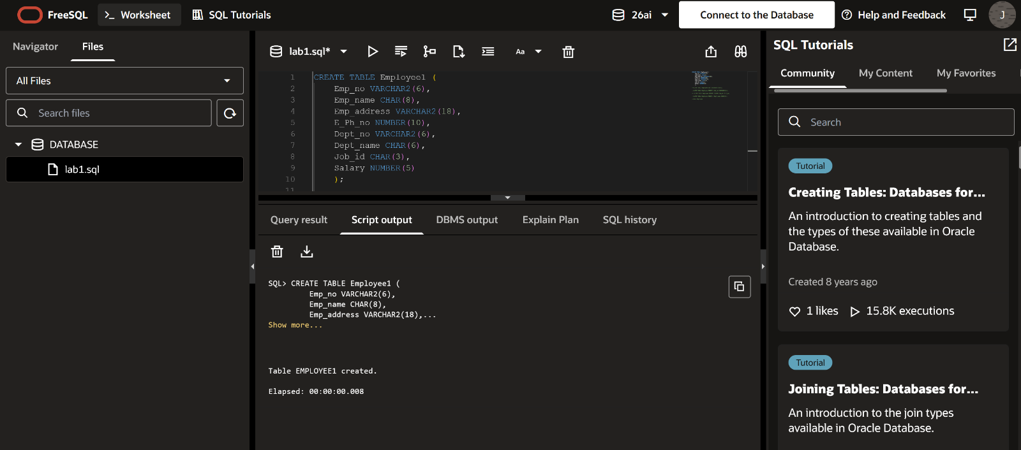
- Create a table EMPLOYEE with following schema: (Emp_no, E_name, E_address, E_ph_no, Dept_no, Dept_name,Job_id , Salary)

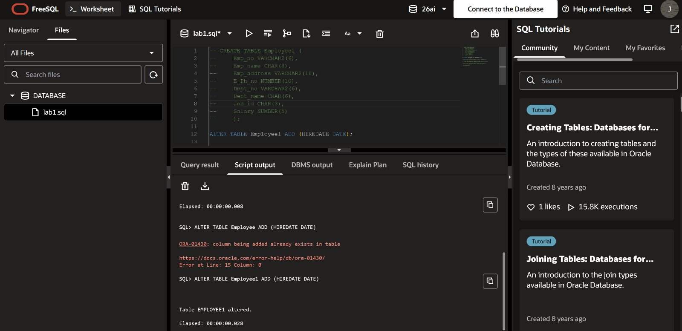
- Add a new column; HIREDATE to the existing relation.

- Change the datatype of JOB_ID from char to varchar2.
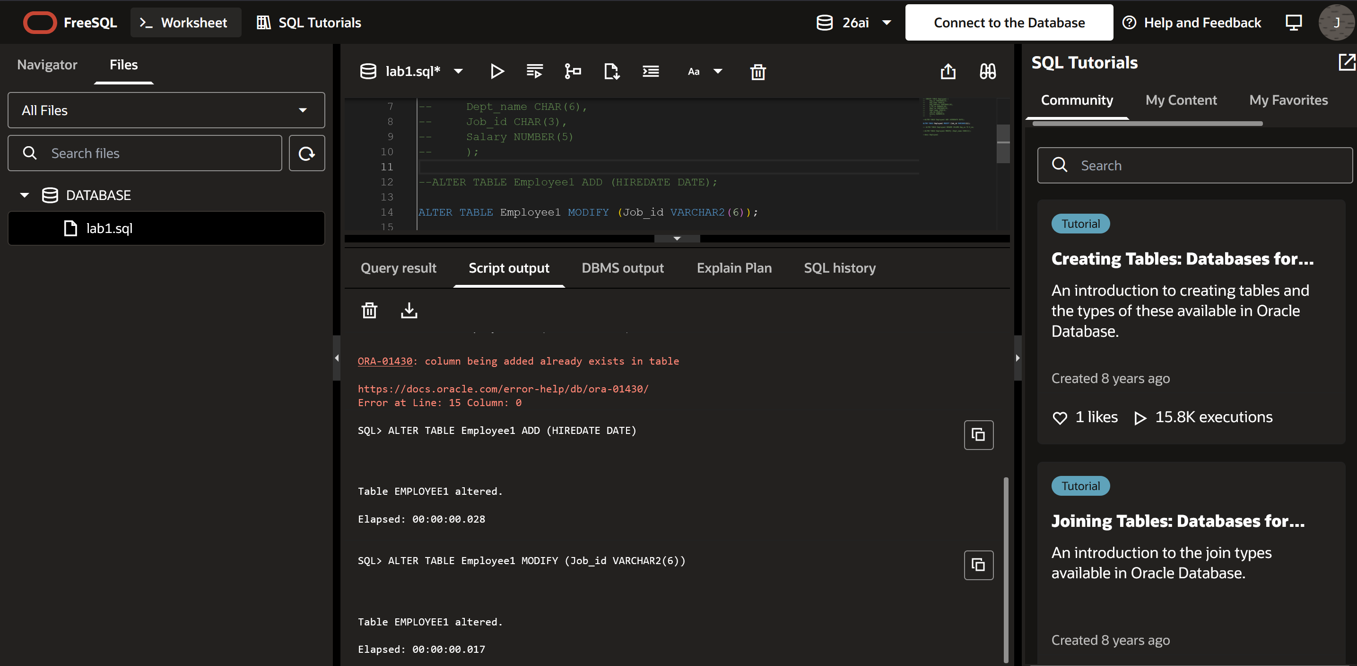

- Change the name of column/field Emp_no to E_no.
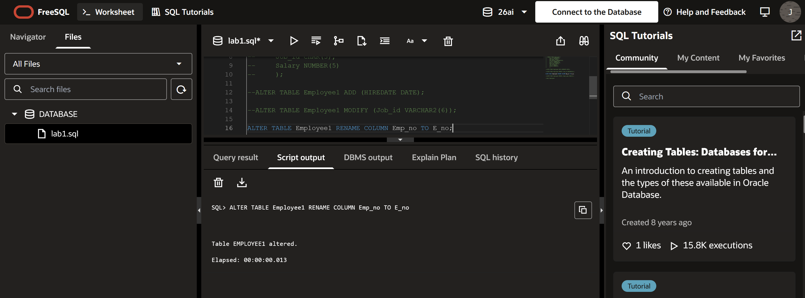
- Modify the column width of the job field of emp table
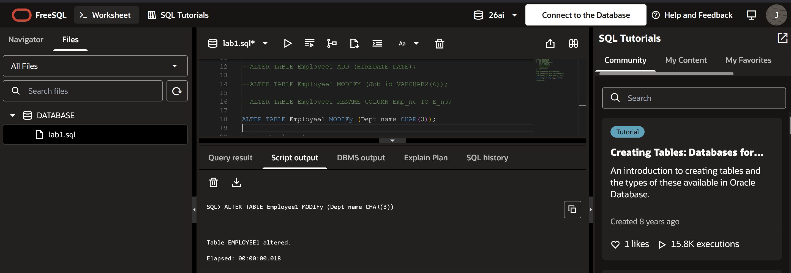
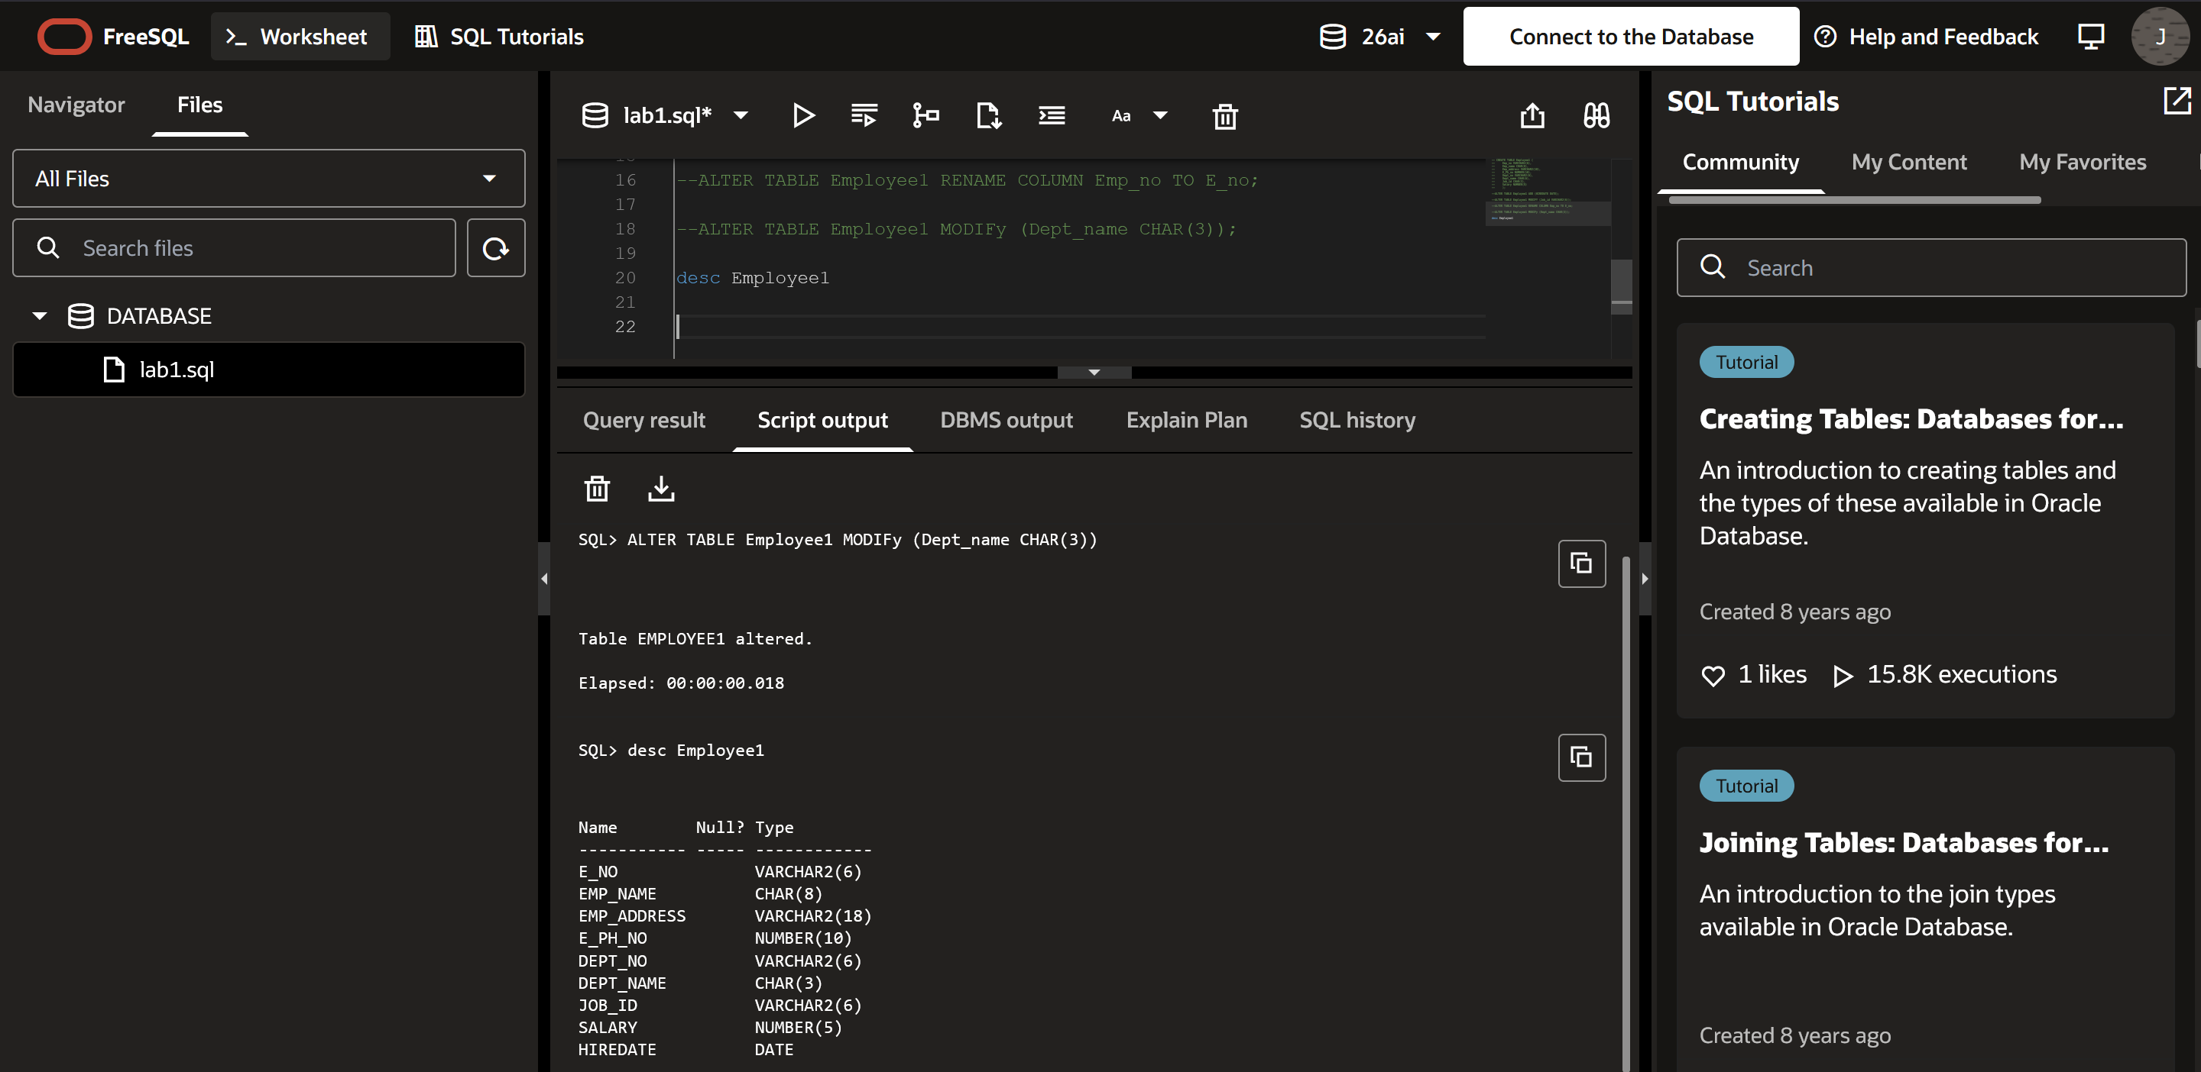

Experiment No: 2
Title : Implementation of DML commands of SQL with suitable examples
- Insert table
- Update table
- Delete Table
Objective :
- To understand the different issues involved in the design and implementation of a database system
- To understand and use data manipulation language to query, update, and manage a database
Theory :
DATA MANIPULATION LANGUAGE (DML): The Data Manipulation Language (DML) is used to retrieve, insert and modify database information. These commands will be used by all database users during the routine operation of the database. Let's take a brief look at the basic DML commands: 1. INSERT 2. UPDATE 3. DELETE
1. INSERT INTO:
This is used to add records into a relation. These are three type of INSERT INTO queries which are as:
a) Inserting a single record
Syntax: INSERT INTO <relation/table name> (field_1,field_2……field_n)VALUES (data_1,data_2, ....... data_n);
Example: SQL>INSERT INTO student(sno,sname,class,address)VALUES (1,’Ravi’,’M.Tech’,’Palakol’);
b) Inserting a single record
Syntax: INSERT INTO <relation/table name>VALUES (data_1,data_2, ........data_n);
Example: SQL>INSERT INTO student VALUES (1,’Ravi’,’M.Tech’,’Palakol’);
c) Inserting all records from another relation
Syntax: INSERT INTO relation_name_1 SELECT Field_1,field_2,field_n FROM relation_name_2 WHERE field_x=data;
Example: SQL>INSERT INTO std SELECT sno,sname FROM student WHERE name = ‘Ramu‘;
d) Inserting multiple records
Syntax: INSERT INTO relation_name field_1,field_2, .... field_n) VALUES (&data_1,&data_2, ....... &data_n);
Example: SQL>INSERT INTO student (sno, sname, class,address) VALUES (&sno,’&sname’,’&class’,’&address’);
Enter value for sno: 101
Enter value for name: Ravi
Enter value for class: M.Tech
Enter value for name: Palakol
2. UPDATE-SET-WHERE:
This is used to update the content of a record in a relation.
Syntax: SQL>UPDATE relation name SET Field_name1=data,field_name2=data, WHERE field_name=data;
Example: SQL>UPDATE student SET sname = ‘kumar’ WHERE sno=1;
3. DELETE-FROM:
This is used to delete all the records of a relation but it will retain the structure of that relation.
a) DELETE-FROM: This is used to delete all the records of relation.
Syntax: SQL>DELETE FROM relation_name;
Example: SQL>DELETE FROM std;
b) DELETE -FROM-WHERE: This is used to delete a selected record from a relation.
Syntax: SQL>DELETE FROM relation_name WHERE condition;
Example: SQL>DELETE FROM student WHERE sno = 2;
1. TRUNCATE:
This command will remove the data permanently. But structure will not be removed. Difference between Truncate & Delete:-
- By using truncate command data will be removed permanently & will not get back where as by using delete command data will be removed temporally & get back by using roll back command.
- By using delete command data will be removed based on the condition where as by using truncate command there is no condition.
- Truncate is a DDL command & delete is a DML command.
Syntax: TRUNCATE TABLE <Table name>
Example TRUNCATE TABLE student;

To Retrieve data from one or more tables.
1. SELECT FROM:
To display all fields for all records.
Syntax : SELECT * FROM relation_name;
Example : SQL> select * from dept;
DEPTNO | DNAME | LOC
10 | ACCOUNTING | NEW YORK
20 | RESEARCH | DALLAS
30 | SALES | CHICAGO
40 | OPERATIONS | BOSTON

2. SELECT FROM:
To display a set of fields for all records of relation.
Syntax: SELECT a set of fields FROM relation_name;
Example: SQL> select deptno, dname from dept;
DEPTNO | DNAME
10 | ACCOUNTING
20 | RESEARCH
30 | SALES

3. SELECT - FROM -WHERE:
This query is used to display a selected set of fields for a selected set of records of a relation.
Syntax: SELECT a set of fields FROM relation_name WHERE condition;
Example: SQL> select * FROM dept WHERE deptno<=20;
LAB PRACTICE ASSIGNMENT:
Create a table EMPLOYEE with following schema: (Emp_no, E_name, E_address, E_ph_no, Dept_no, Dept_name,Job_id , Salary)
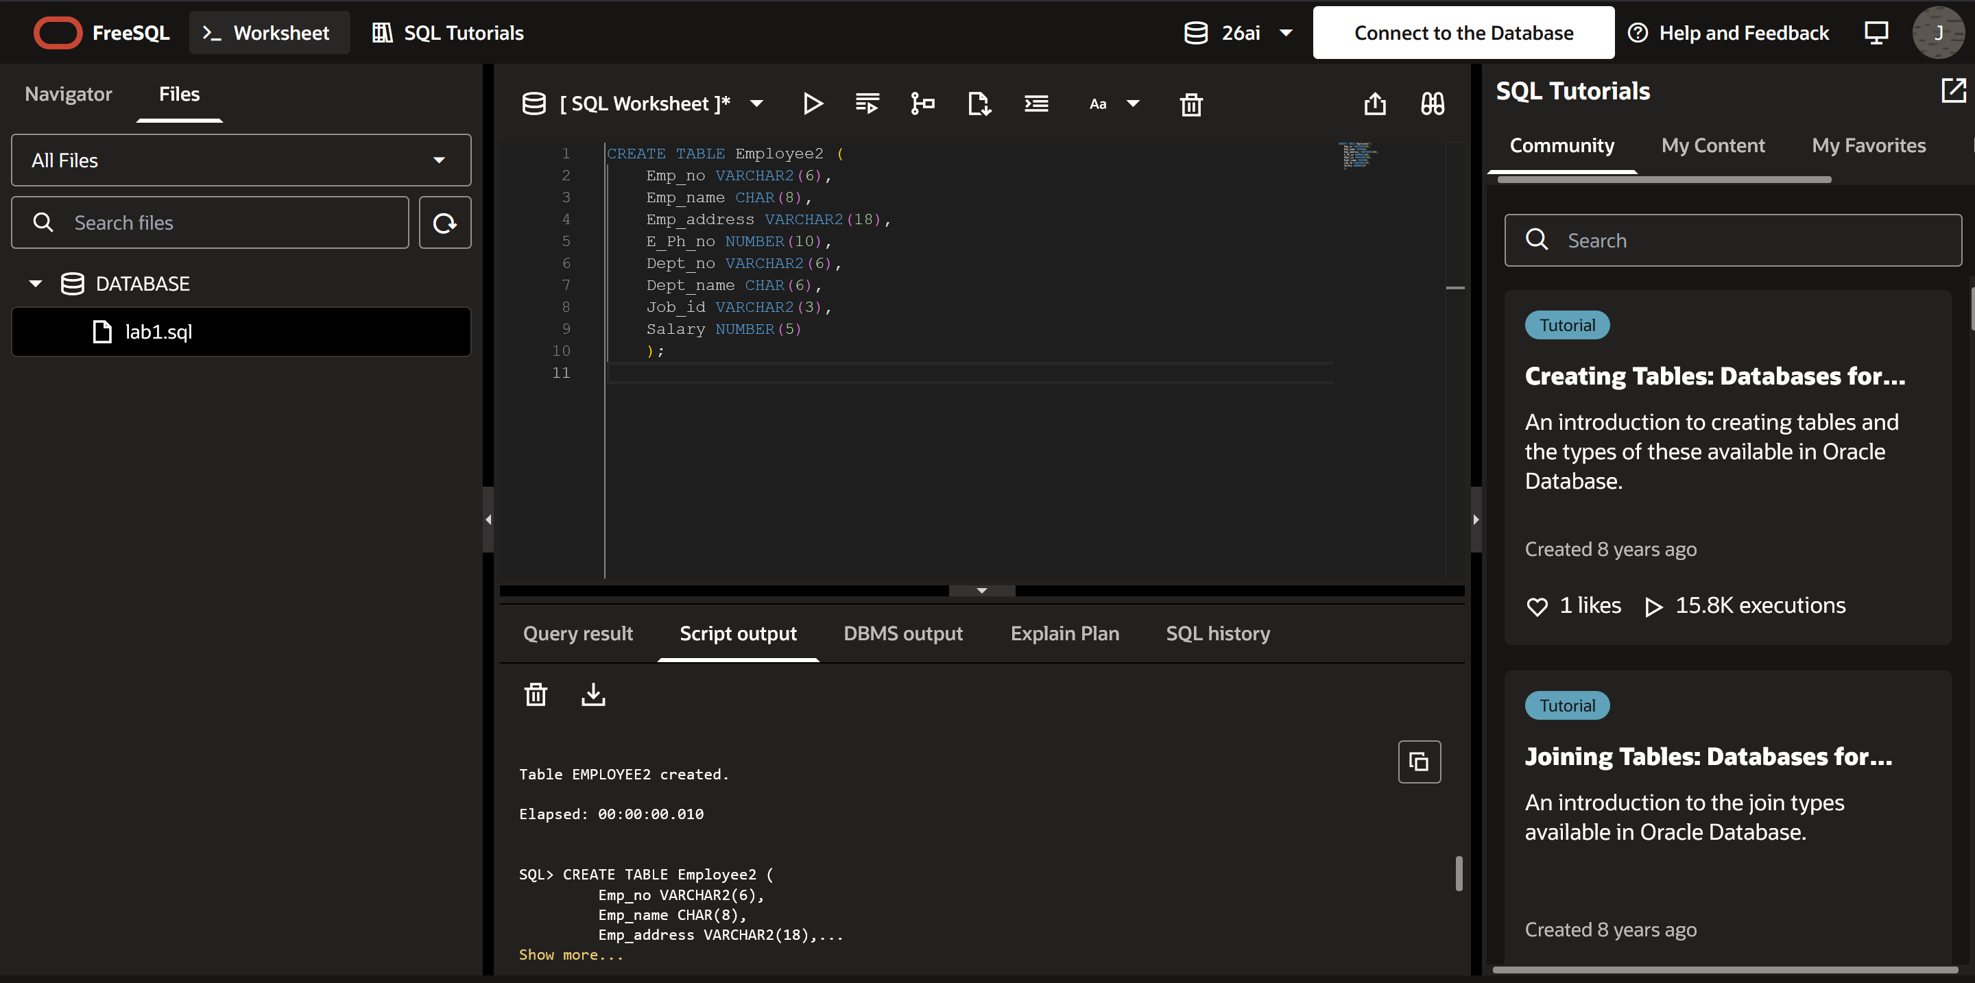
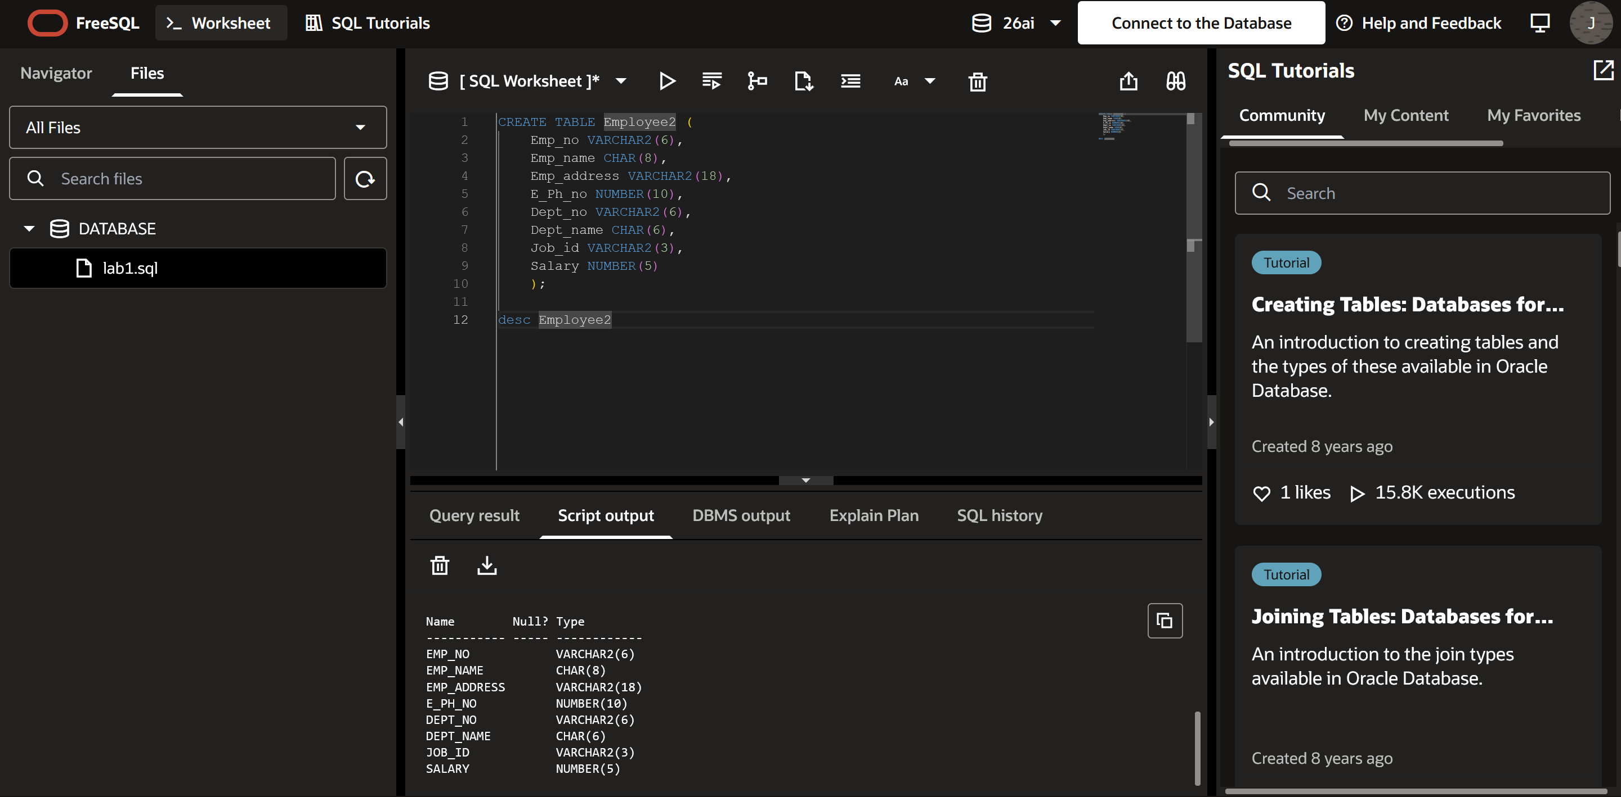

Write SQL queries for following question:
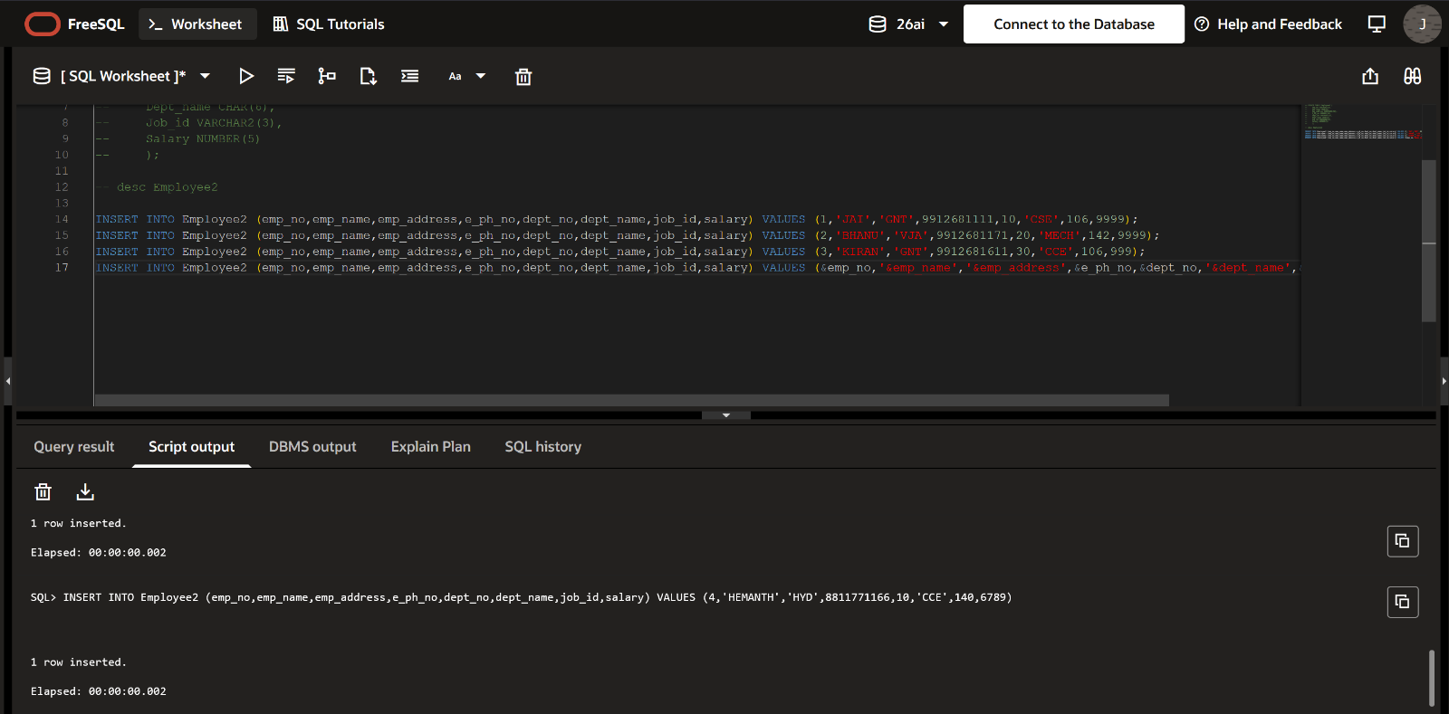
- Insert aleast 5 rows in the table.
- Display all the information of EMP table.
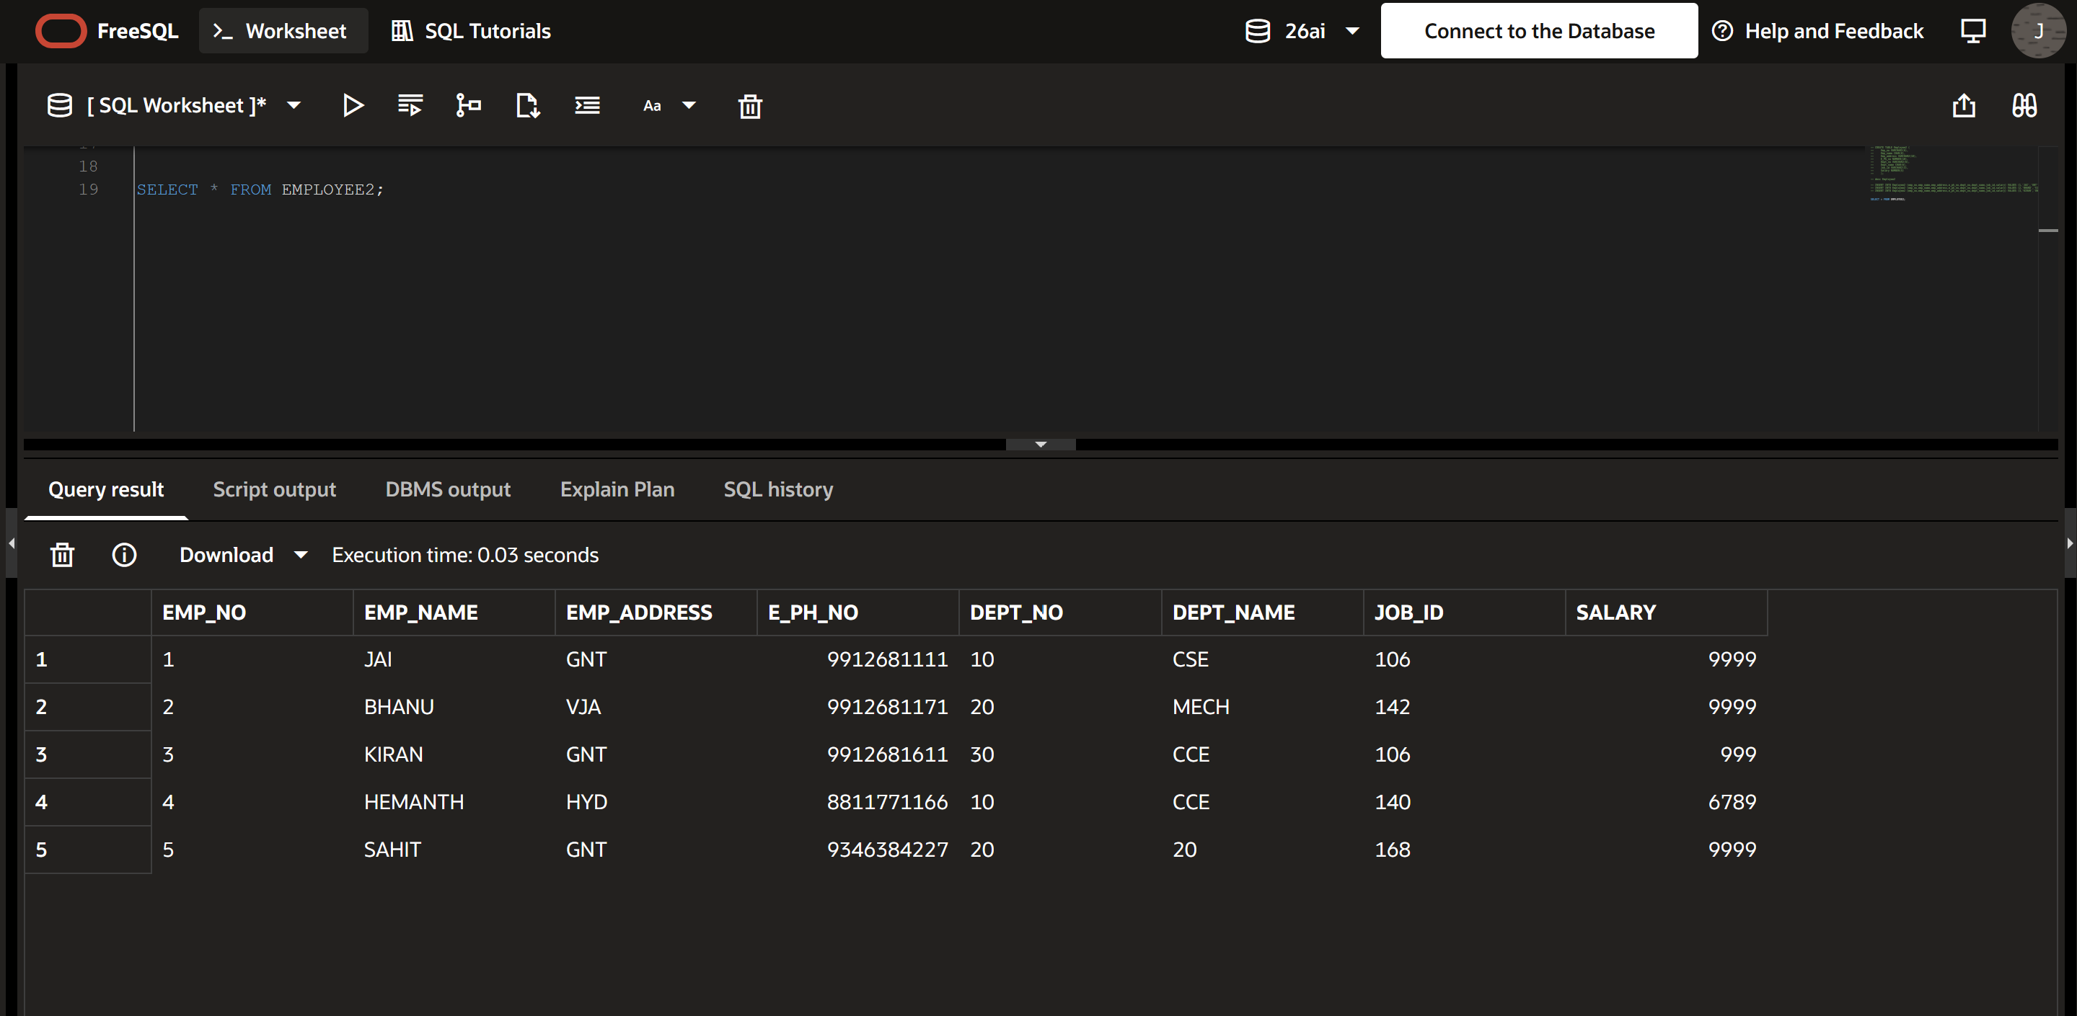

- Display the record of each employee who works in department D10.
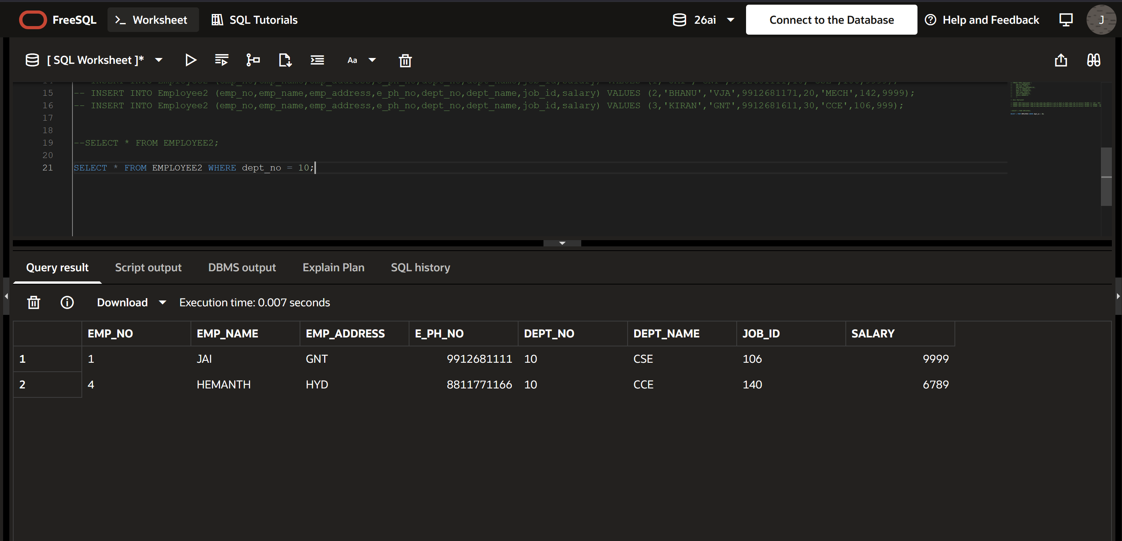
- Update the city of Emp_no-4 with current city as Nagpur.
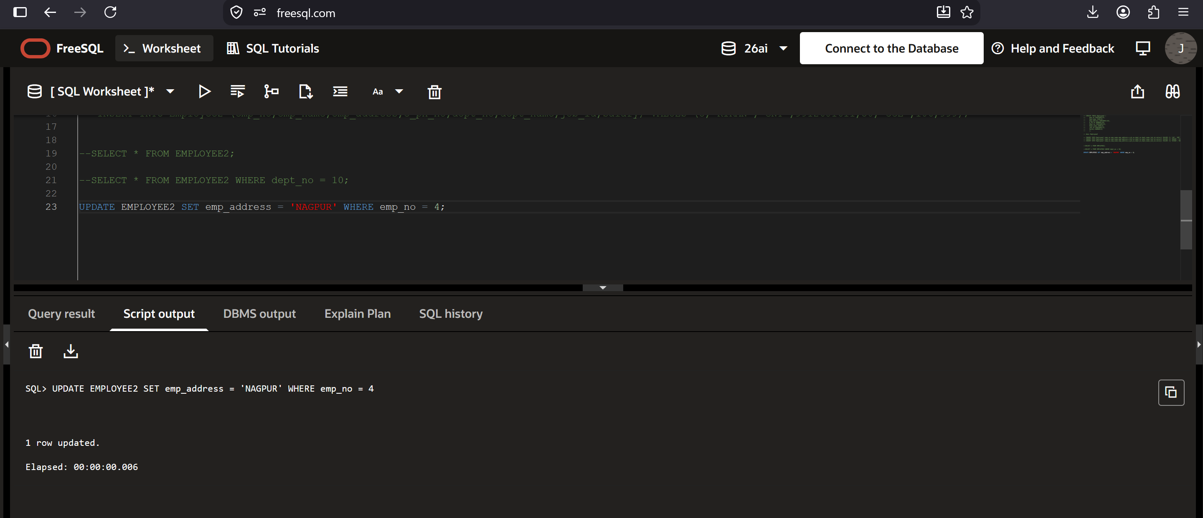

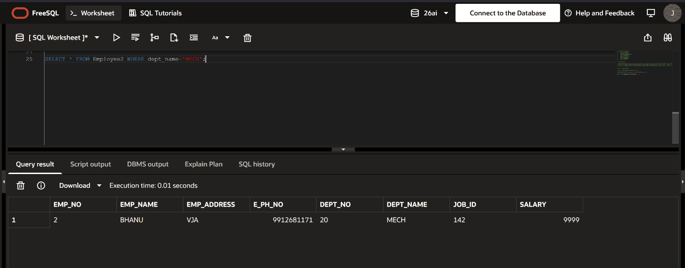
- Display the details of Employee who works in department MECH.

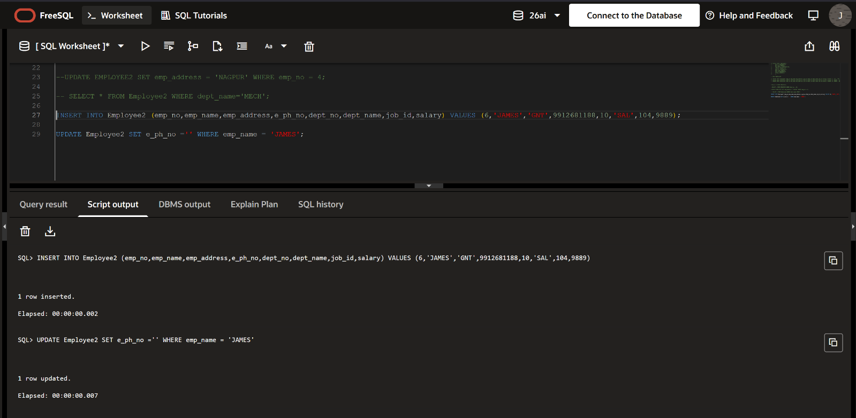
- Delete the phone number of employee James

- Display the complete record of employees working in SALES Department
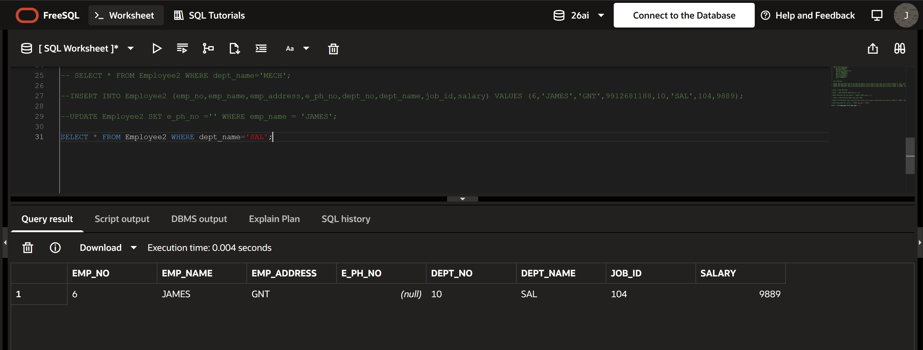

Experiment No: 3
Title: Implementation of different types of functions with suitable examples.
- Number Function
- Aggregate Function
- Character Function
- Conversion Function
- Date Function
Objective:
- Develop aggregate plan strategies to assist with summarization of several data entries.
Theory:
1. NUMBER FUNCTIONS:
(a) ABS: Returns the absolute value of n.
Syntax: ABS(n)
Example: SQL> SELECT ABS(-15) FROM DUAL;
(b) EXP: Returns e raised to the nth power.
Syntax: EXP(n)
Example: SQL> SELECT EXP(4) FROM DUAL;
(c) POWER: Returns m raised to the nth power.
Syntax: POWER(m, n)
Example: SQL> SELECT POWER(4, 2) FROM DUAL;
(d) MOD: Returns the remainder of m divided by n.
Syntax: MOD(m, n)
Example: SQL> SELECT MOD(10, 3) FROM DUAL;
(e) ROUND: Returns n rounded to m places right of the decimal point.
Syntax: ROUND(n, m)
Example: SQL> SELECT ROUND(100.256, 2) FROM DUAL;
(f) TRUNC: Returns n truncated to m places right of the decimal point.
Syntax: TRUNC(n, m)
Example: SQL> SELECT TRUNC(100.256, 2) FROM DUAL;
(g) SQRT: Returns the square root of n.
Syntax: SQRT(n)
Example: SQL> SELECT SQRT(16) FROM DUAL;
2. AGGREGATE OPERATORS:
In addition to simply retrieving data, SQL allows the use of arithmetic expressions for computing aggregate values such as MIN and SUM.
(a) COUNT: Returns the number of rows in the query.
Syntax: COUNT(column_name)
Example: SQL> SELECT COUNT(Sal) FROM emp;
(b) SUM: Returns the sum of all values in the column.
Syntax: SUM(column_name)
Example: SQL> SELECT SUM(Sal) FROM emp;
(c) AVG: Returns the average value of the column values.
Syntax: AVG(column_name)
Example: SQL> SELECT AVG(Sal) FROM emp;
(d) MAX: Returns the maximum value of the column.
Syntax: MAX(column_name)
Example: SQL> SELECT MAX(Sal) FROM emp;
(e) MIN: Returns the minimum value of the column.
Syntax: MIN(column_name)
Example: SQL> SELECT MIN(Sal) FROM emp;
3. CHARACTER/STRING FUNCTIONS:
4. CONVERSION FUNCTIONS:
(a) TO_CHAR: Converts a numeric or date value to a VARCHAR2 data type.
Syntax: TO_CHAR(n, [fmt])
Example: SQL> SELECT TO_CHAR(65, 'RN') FROM DUAL;
(b) TO_NUMBER: Converts a character expression to a value of NUMBER data type.
Syntax: TO_NUMBER(expr)
Example: SQL> SELECT TO_NUMBER('1234.64') FROM DUAL;
(c) TO_DATE: Converts character data to a value of DATE data type.
Syntax: TO_DATE(char, [fmt])
Example: SQL> SELECT TO_DATE('January 15, 1989', 'Month DD, YYYY') FROM DUAL;
(a) CONCAT: Returns char1 concatenated with char2.
Syntax: CONCAT(char1, char2)
Example: SQL> SELECT CONCAT('Hello', ' World') FROM DUAL;
(b) LPAD: Returns expr1, left-padded to length n with expr2.
Syntax: LPAD(expr1, n, expr2)
Example: SQL> SELECT LPAD('Page 1', 10, '*') FROM DUAL;
(c) RPAD: Returns expr1, right-padded to length n with expr2.
Syntax: RPAD(expr1, n, expr2)
Example: SQL> SELECT RPAD('Page 1', 10, '*') FROM DUAL;
(d) LTRIM: Removes leading blanks or specified characters from the left.
Syntax: LTRIM(char, [set])
Example: SQL> SELECT LTRIM(' Oracle') FROM DUAL;
(e) RTRIM: Removes trailing blanks or specified characters from the right.
Syntax: RTRIM(char, [set])
Example: SQL> SELECT RTRIM('Oracle ') FROM DUAL;
(f) LOWER: Converts uppercase character data to lowercase.
Syntax: LOWER(char)
Example: SQL> SELECT LOWER('ORACLE') FROM DUAL;
(g) UPPER: Converts lowercase character data to uppercase.
Syntax: UPPER(char)
Example: SQL> SELECT UPPER('oracle') FROM DUAL;
(h) LENGTH: Returns the number of characters in the given string.
Syntax: LENGTH(char)
Example: SQL> SELECT LENGTH('Oracle') FROM DUAL;
(i) SUBSTR: Returns a portion of a string starting from a specific position.
Syntax: SUBSTR(char, m, n)
Example: SQL> SELECT SUBSTR('Oracle', 2, 3) FROM DUAL;
(j) INSTR: Returns the position of the first occurrence of a substring.
Syntax: INSTR(char, substring)
Example: SQL> SELECT INSTR('Oracle', 'a') FROM DUAL;
5. DATE FUNCTIONS:
(a) SYSDATE: Returns the current system date and time.
Syntax: SYSDATE
Example: SQL> SELECT SYSDATE FROM DUAL;
(b) NEXT_DAY: Returns the date of the first weekday named in char that is later than date d.
Syntax: NEXT_DAY(d, char)
Example: SQL> SELECT NEXT_DAY(SYSDATE, 'FRIDAY') FROM DUAL;
(c) ADD_MONTHS: Returns the date d plus n months.
Syntax: ADD_MONTHS(d, n)
Example: SQL> SELECT ADD_MONTHS(SYSDATE, 2) FROM DUAL;
(d) LAST_DAY: Returns the date of the last day of the month that contains date d.
Syntax: LAST_DAY(d)
Example: SQL> SELECT LAST_DAY(SYSDATE) FROM DUAL;
(e) MONTHS_BETWEEN: Returns the number of months between date d1 and d2.
Syntax: MONTHS_BETWEEN(d1, d2)
Example: SQL> SELECT MONTHS_BETWEEN(SYSDATE, hiredate) FROM emp;
(f) LEAST: Returns the earliest date in the list.
Syntax: LEAST(d1, d2, ...)
Example: SQL> SELECT LEAST('10-JAN-07', '12-OCT-07') FROM DUAL;
(g) GREATEST: Returns the latest date in the list.
Syntax: GREATEST(d1, d2, ...)
Example: SQL> SELECT GREATEST('10-JAN-07', '12-OCT-07') FROM DUAL;
(h) TRUNC: Returns date d with the time portion of the day truncated to the unit specified.
Syntax: TRUNC(d, [unit])
Example: SQL> SELECT TRUNC(SYSDATE, 'DAY') FROM DUAL;
(i) ROUND: Returns date d rounded to the unit specified.
Syntax: ROUND(d, [unit])
Example: SQL> SELECT ROUND(SYSDATE, 'DAY') FROM DUAL;
(j) TO_CHAR: Converts a date to a character string in the specified format.
Syntax: TO_CHAR(d, [fmt])
Example: SQL> SELECT TO_CHAR(SYSDATE, 'DD-MM-YY') FROM DUAL;
(k) TO_DATE: Converts a character string to a date in the specified format.
Syntax: TO_DATE(char, [fmt])
Example: SQL> SELECT TO_DATE('01-01-2023', 'DD-MM-YYYY') FROM DUAL;
LAB PRACTICE ASSIGNMENT:
Create a table EMPLOYEE with following schema:
(Emp_no, E_name, E_address, E_ph_no, Dept_no, Dept_name,Job_id, Designation , Salary)
Write SQL statements for the following query.
- List the E_no, E_name, Salary of all employees working for MANAGER.
- Display all the details of the employee whose salary is more than the Sal of any IT PROFF..
- List the employees in the ascending order of Designations of those joined after 1981.
- List the employees along with their Experience and Daily Salary.
- List the employees who are either CLERK or ANALYST.
- List the employees who joined on 1-MAY-81, 3-DEC-81, 17-DEC-81,19-JAN-80 .
- List the employees who are working for the Deptno 10 or20.
- List the Enames those are starting with .
- Dislay the name as well as the first five characters of name(s) starting with
- List all the emps except & in asc order of Salaries.

Outputs:

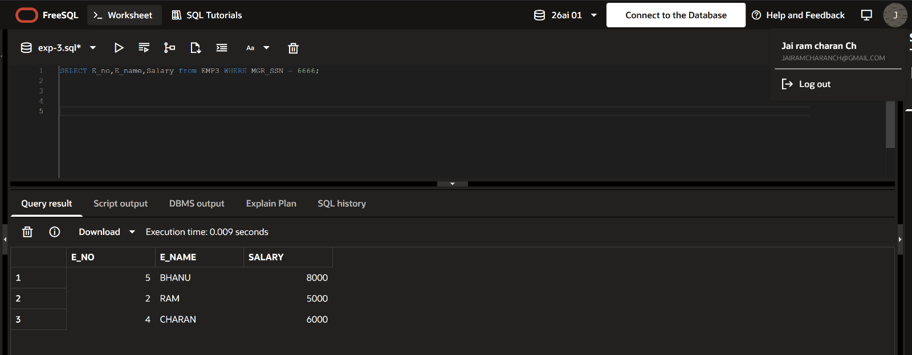
- List the E_no, E_name, Salary of all employees working for MANAGER.

- List the employees in the ascending order of Designations of those joined after 1981.
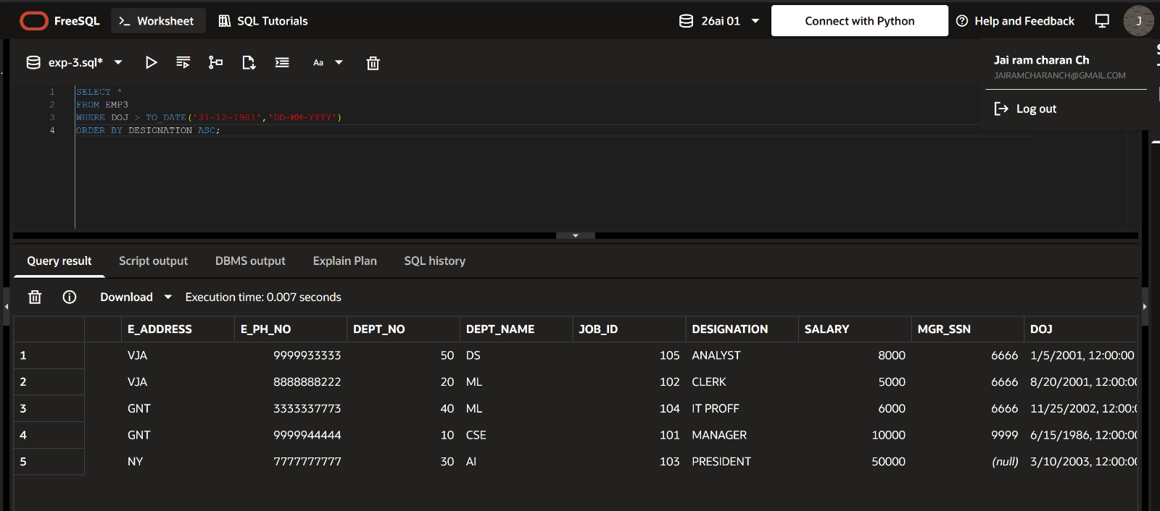

- List the employees in the ascending order of Designations of those joined after 1981.
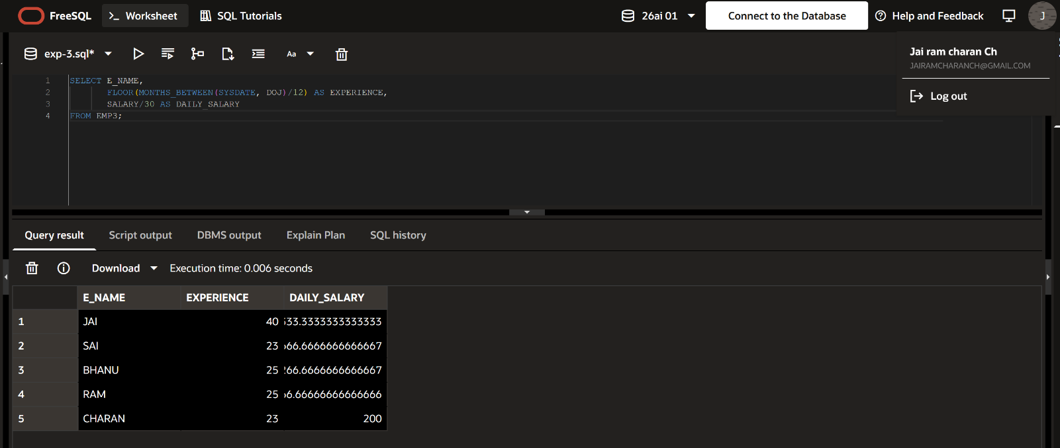
- List the employees along with their Experience and Daily Salary.

- List the employees who are either CLERK or ANALYST.
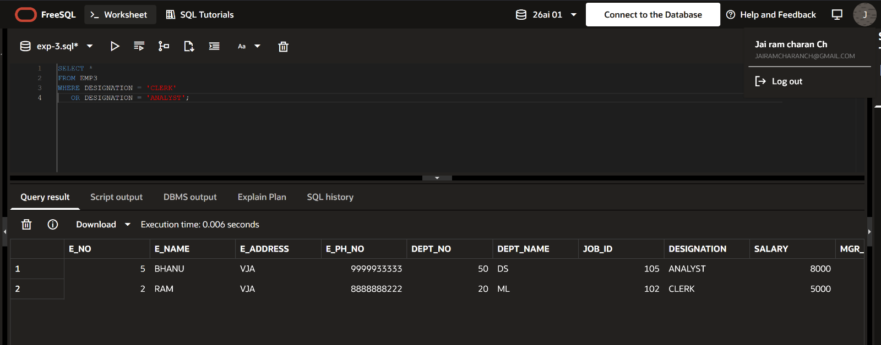
6) List the employees who joined on 1-MAY-81, 3-DEC-81, 17-DEC-81,19-JAN-80
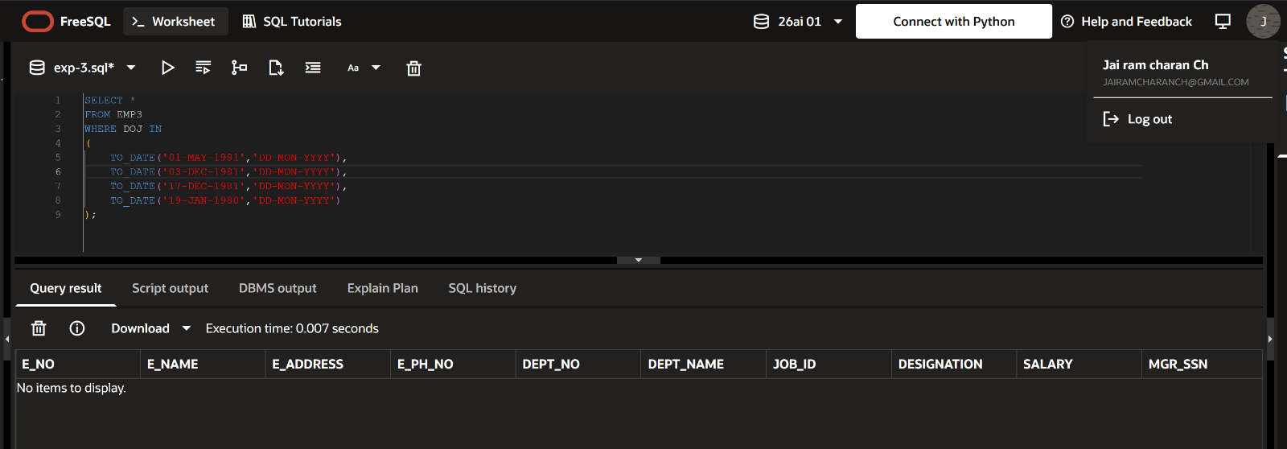
7) List the employees who are working for the Deptno 10 or20.
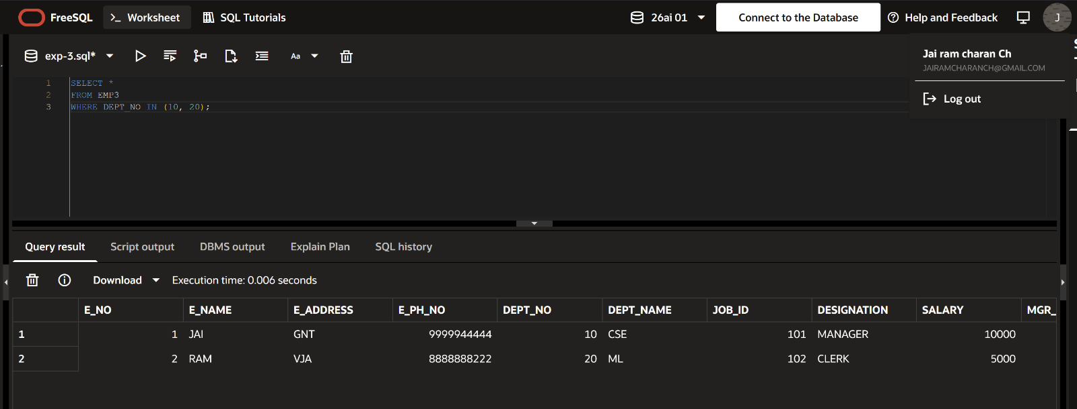
8) List the Enames those are starting with S.
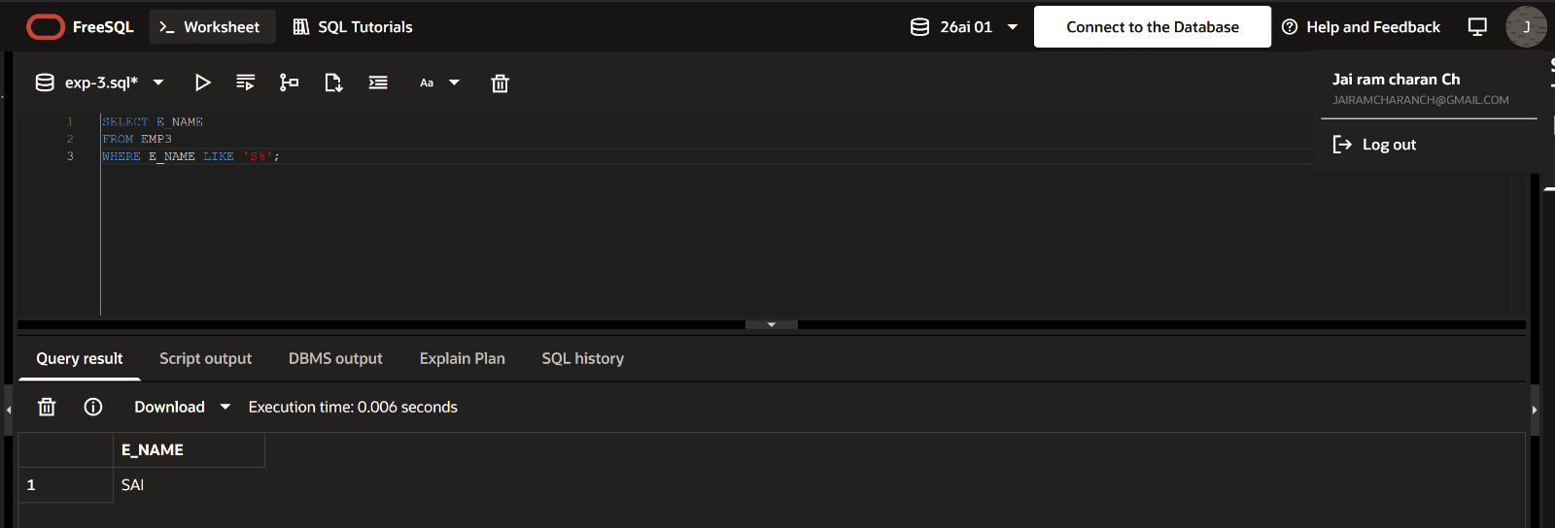

9) Display the name as well as the first five characters of name(s) starting with H.
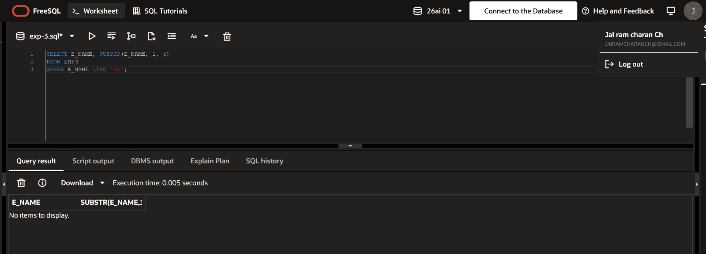
10) List all the emps except PRESIDENT & MANAGER in asc order of Salaries .
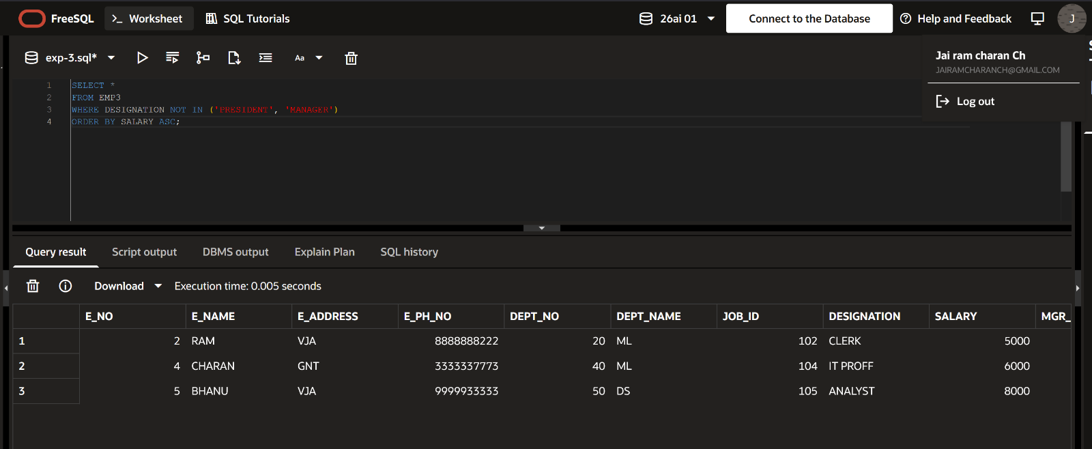

Experiment No: 4
Title: Implementation of different types of operators in SQL.
Objective: To learn different types of operator.
Theory:
- Logical Operator
- Arithmetic Operator
- Comparision Operator
- Special Operator
- Set Operator
ARITHMETIC OPERATORS:
- (+) Addition: Adds values on either side of the operator.
- (-) Subtraction: Subtracts right hand operand from left hand operand.
- (*) Multiplication: Multiplies values on either side of the operator.
- (/) Division: Divides left hand operand by right hand operand.
- (^) Power: Raise to power of.
- (%) Modulus: Divides left hand operand by right hand operand and returns remainder.
LOGICAL OPERATORS:
- AND: The AND operator allows the existence of multiple conditions in an SQL statement's WHERE clause.
- OR: The OR operator is used to combine multiple conditions in an SQL statement's WHERE clause.
- NOT: The NOT operator reverses the meaning of the logical operator with which it is used. Eg: NOT EXISTS, NOT BETWEEN, NOT IN, etc. This is a negate operator.
COMPARISION OPERATORS:
- (=): Checks if the values of two operands are equal or not, if yes then condition becomes true.
- (!=): Checks if the values of two operands are equal or not, if values are not equal then condition becomes true.
- (< >): Checks if the values of two operands are equal or not, if values are not equal then condition becomes true.
- (>): Checks if the value of left operand is greater than the value of right operand, if yes then condition becomes true.
- (<): Checks if the value of left operand is less than the value of right operand, if yes then condition becomes true.
- (>=): Checks if the value of left operand is greater than or equal to the value of right operand, if yes then condition becomes true.
- (<=): Checks if the value of left operand is less than or equal to the value of right operand, if yes then condition becomes true.
SPECIAL OPERATORS:
- BETWEEN: The BETWEEN operator is used to search for values that are within a set of values, given the minimum value and the maximum value.
- IS NULL: The NULL operator is used to compare a value with a NULL attribute value.
- ALL: The ALL operator is used to compare a value to all values in another value set.
- ANY: The ANY operator is used to compare a value to any applicable value in the list according to the condition.
- LIKE: The LIKE operator is used to compare a value to similar values using wildcard operators. It allows to use percent sign(%) and underscore (_) to match a given string pattern.
- IN: The IN operator is used to compare a value to a list of literal values that have been specified.
- EXIST: The EXISTS operator is used to search for the presence of a row in a specified table that meets certain criteria.
SET OPERATORS: The Set operator combines the result of 2 queries into a single result. The following are the operators:
- Union
- Union all
- Intersect
- Minus
- Union: Returns all distinct rows selected by both the queries.
- Union all: Returns all rows selected by either query including the duplicates.
- Intersect: Returns rows selected that are common to both queries.
- Minus: Returns all distinct rows selected by the first query and are not by the second.

LAB PRACTICE ASSIGNMENT:
- Display all the dept numbers available with the dept and emp tables avoiding duplicates.
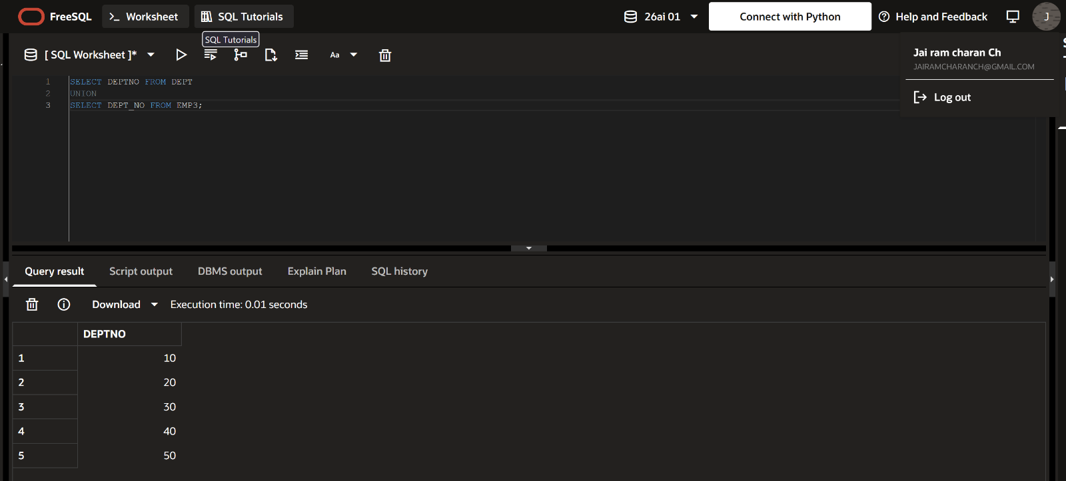
- Display all the dept numbers available with the dept and emp tables.
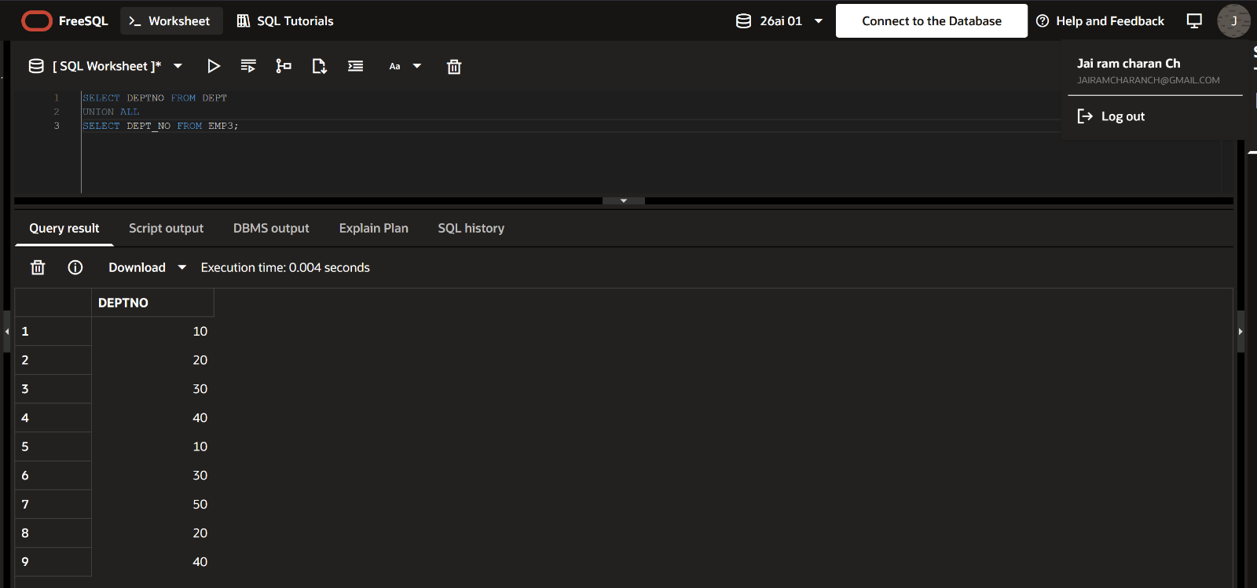
- Display all the dept numbers available in emp and not in dept tables and vice versa.
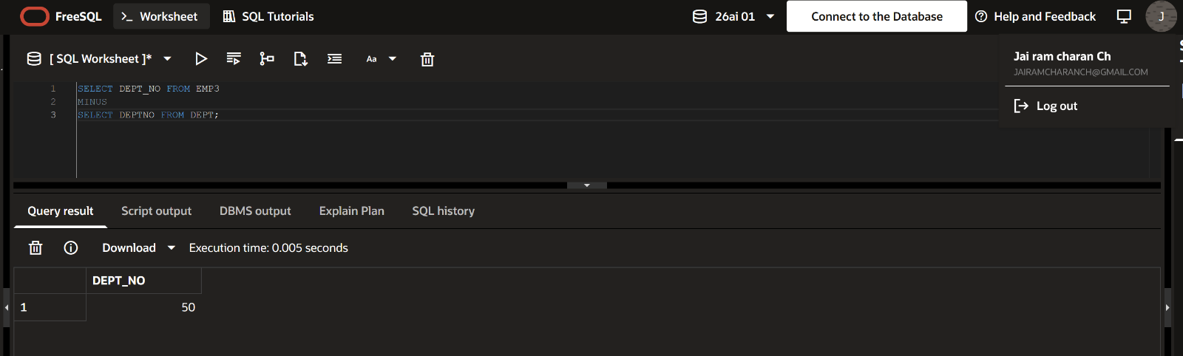
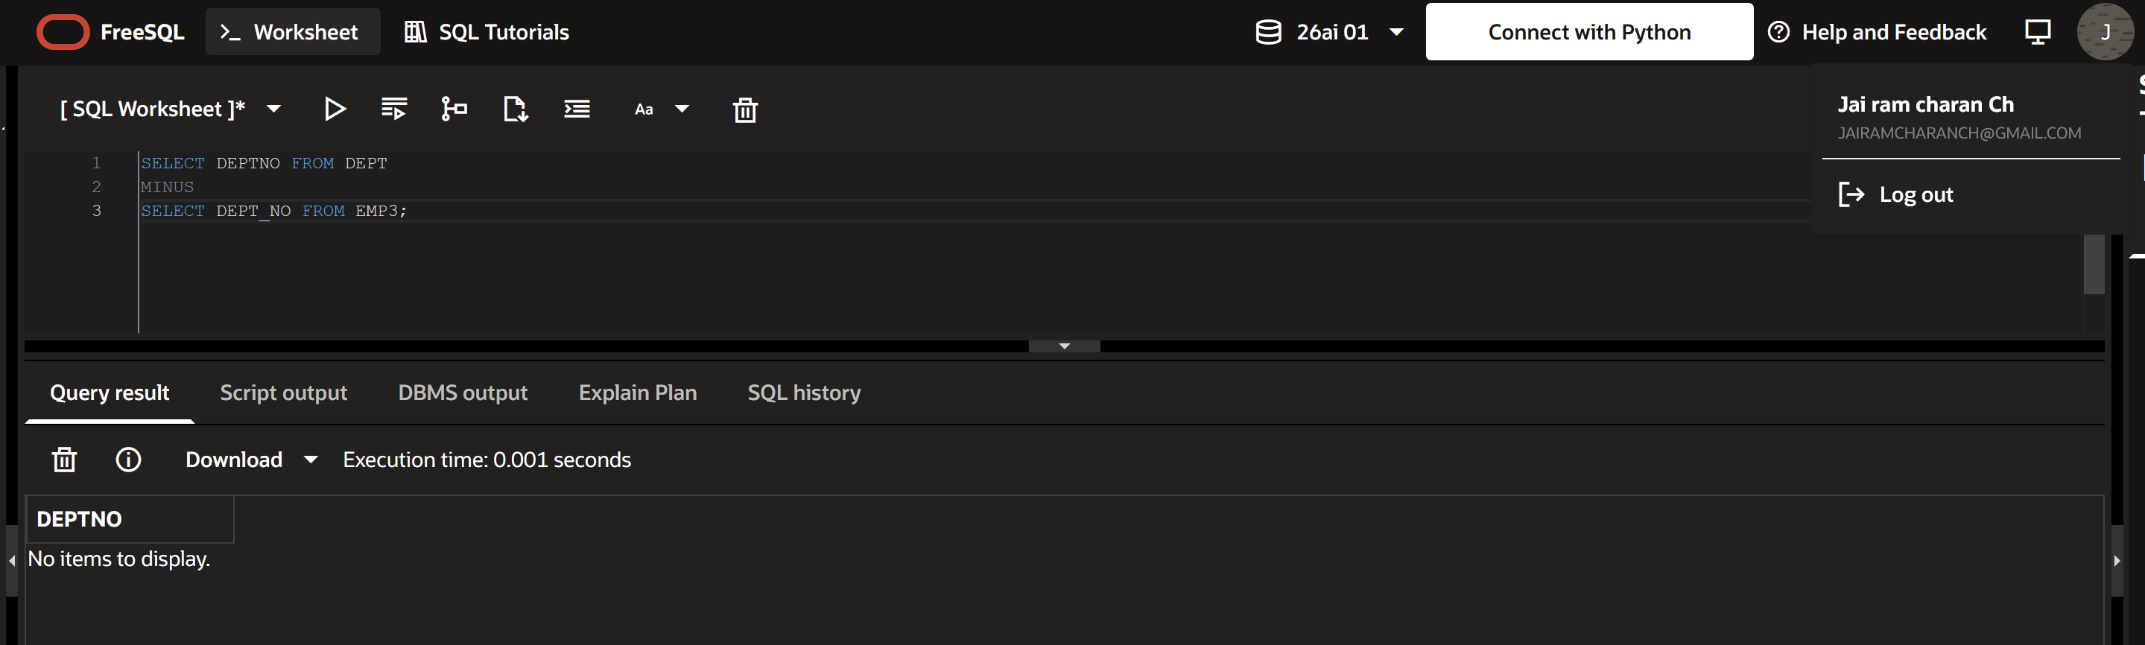

Experiment No: 5

LAB PRACTICE ASSIGNMENT:
- Create Sailors, Boats, and Reserves tables .
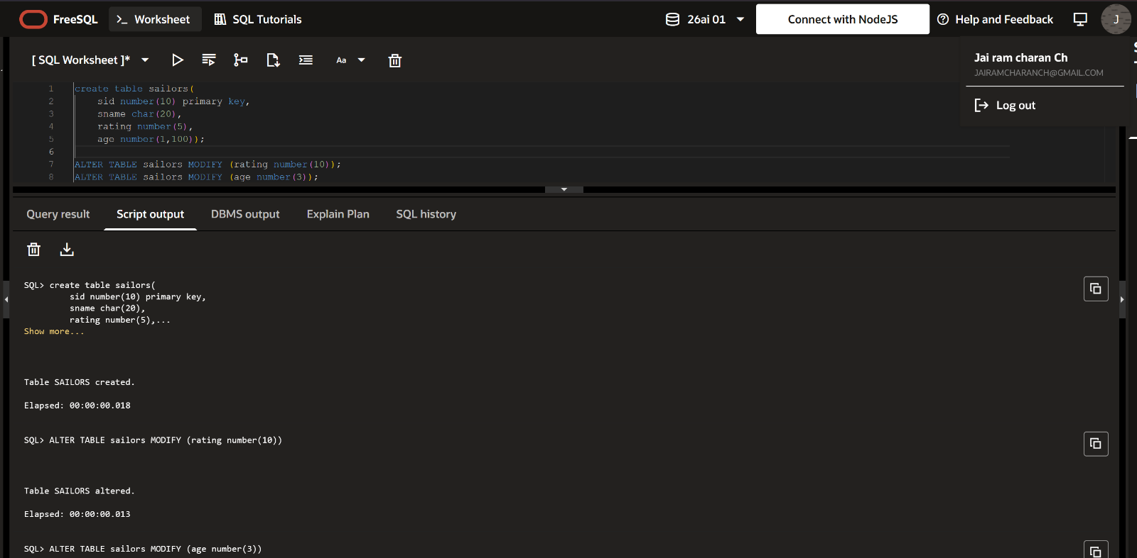
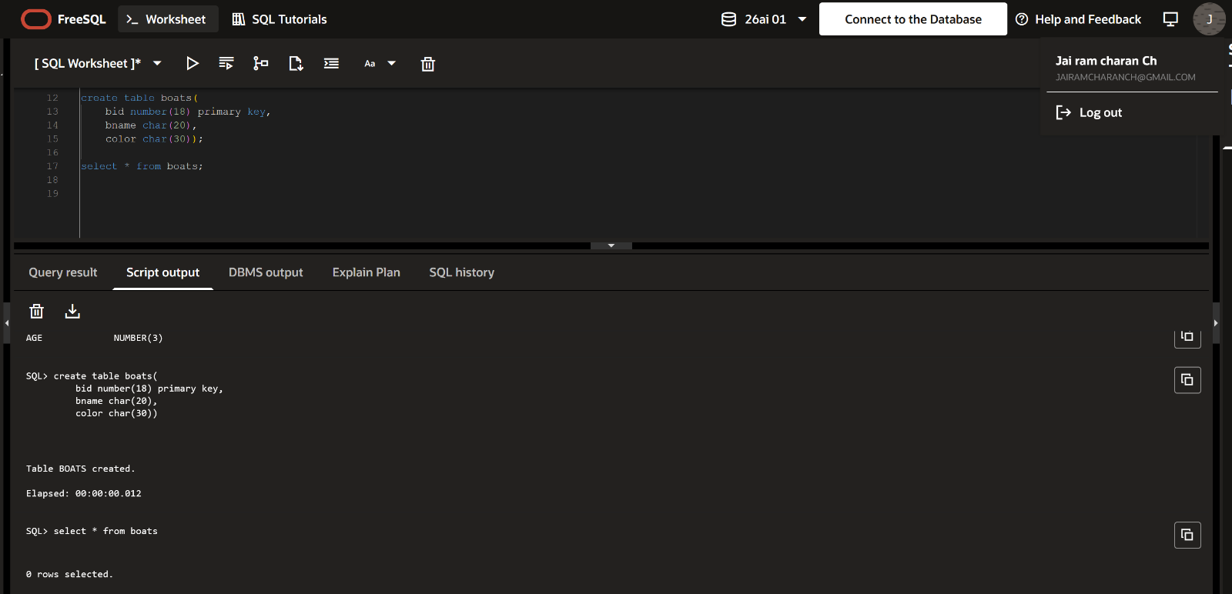
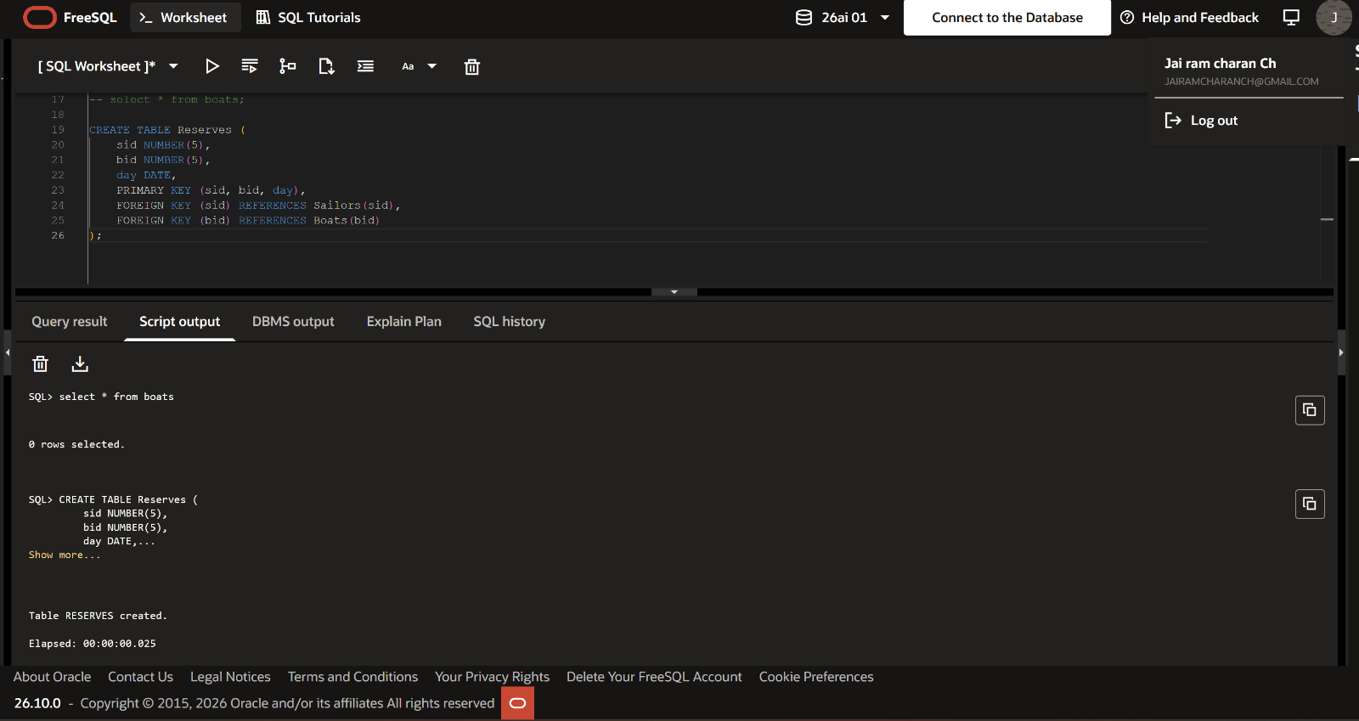
- Insert values to the tables.
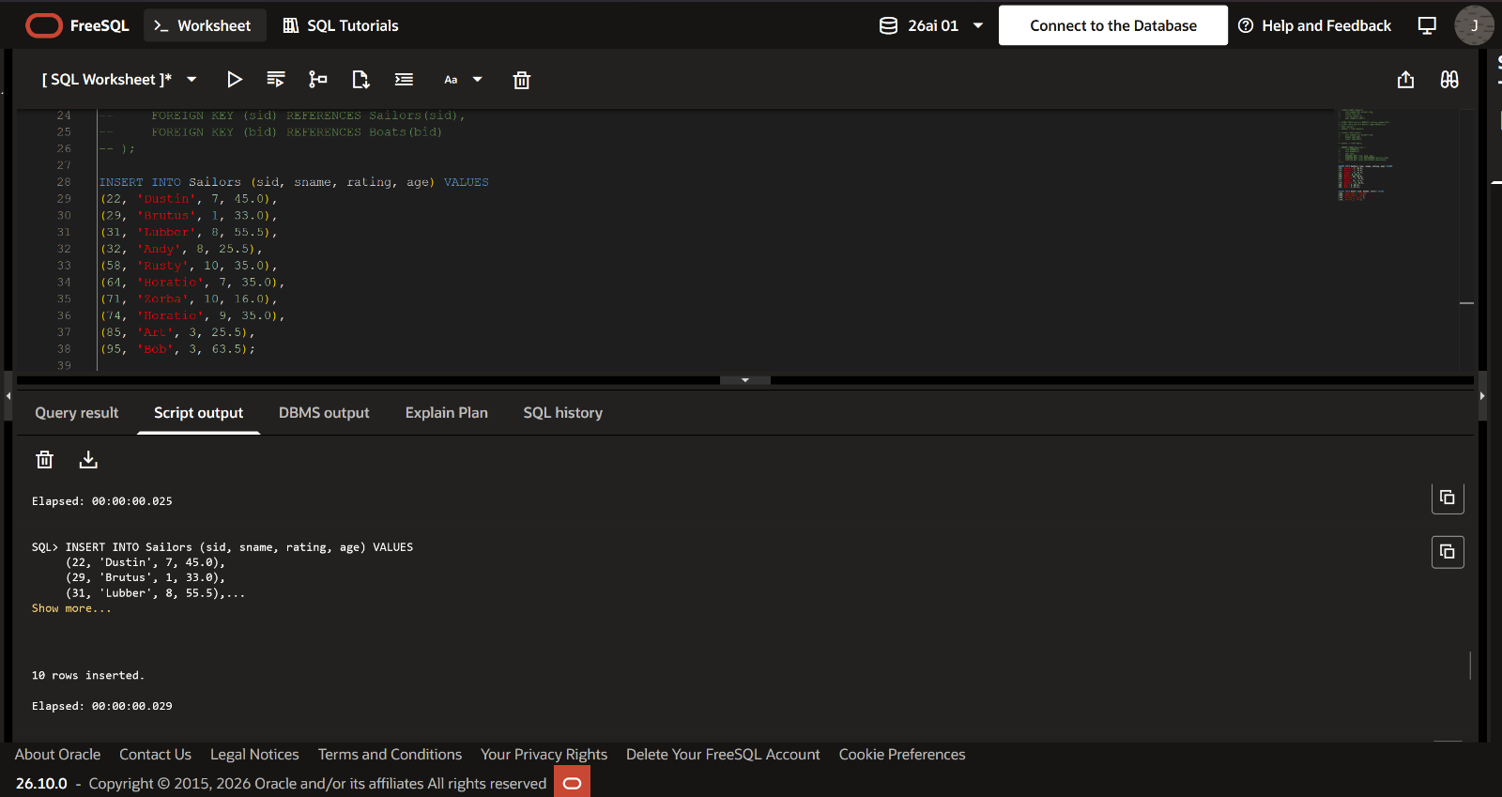
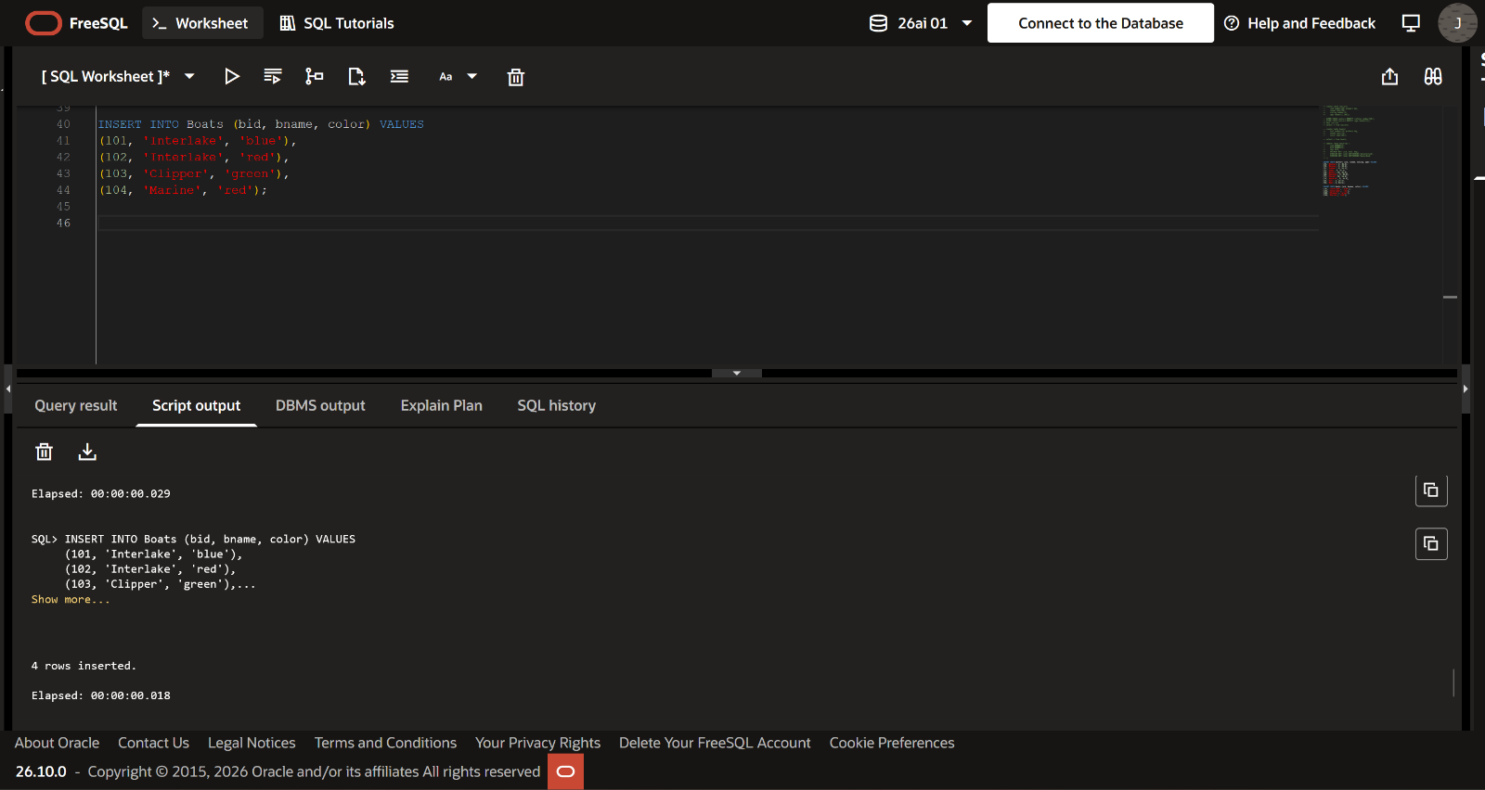

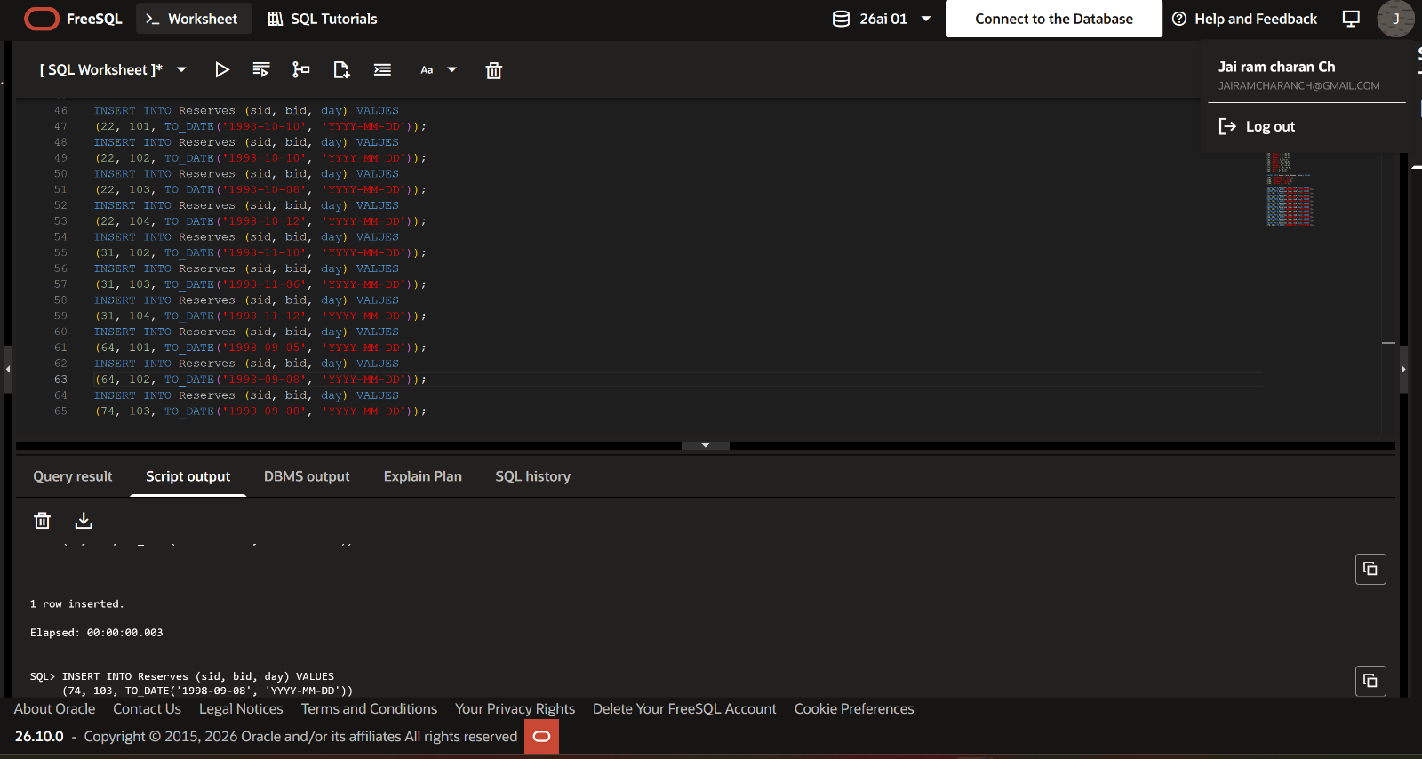

1.Find the names and ages of all the sailors.
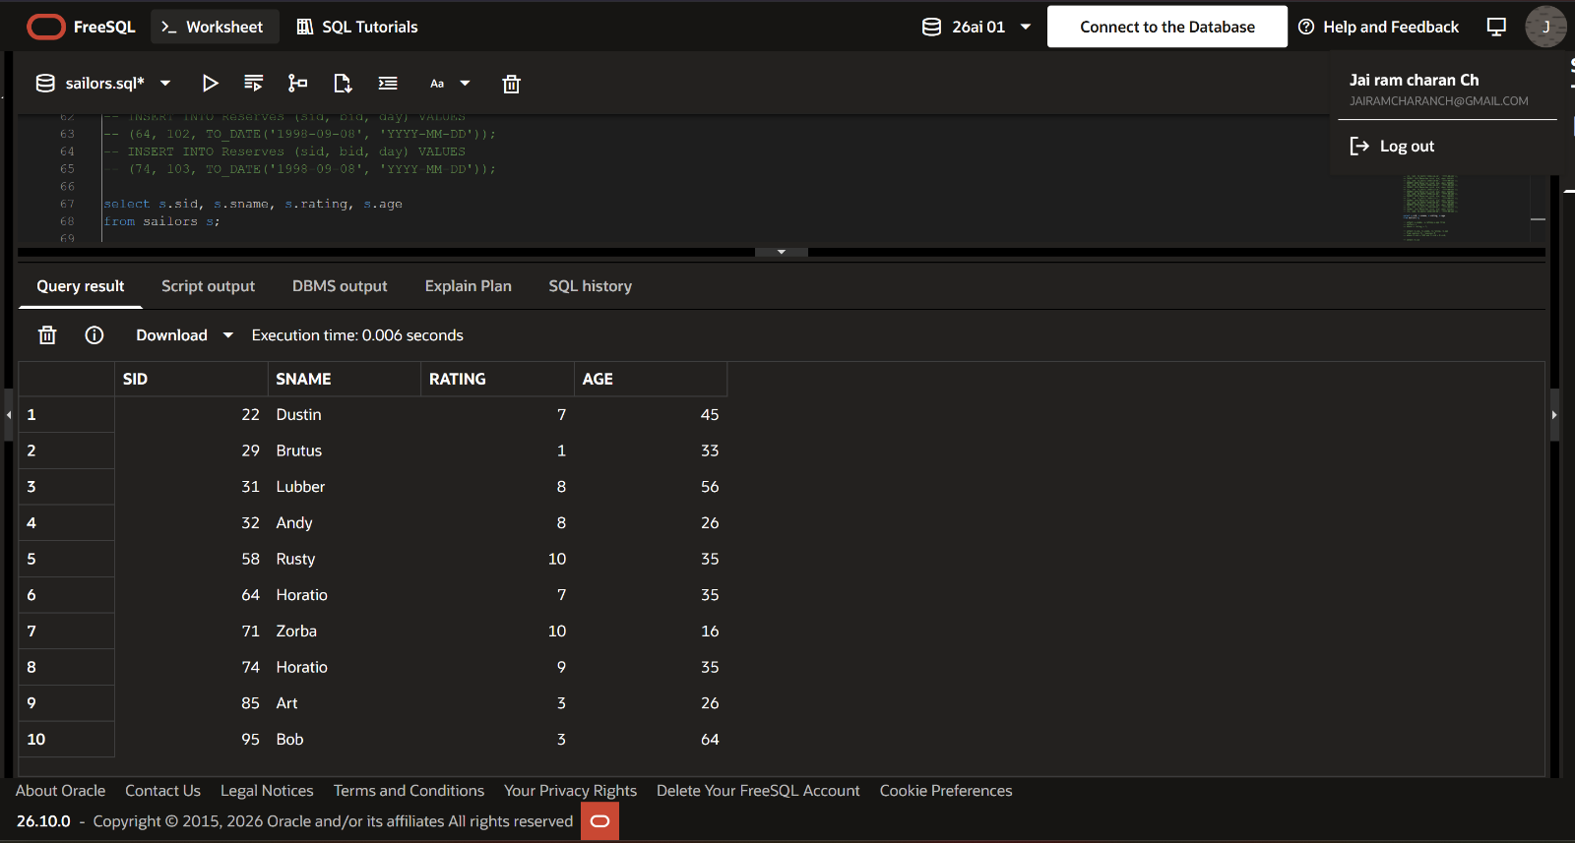
2. Find all the sailors with rating above 7.
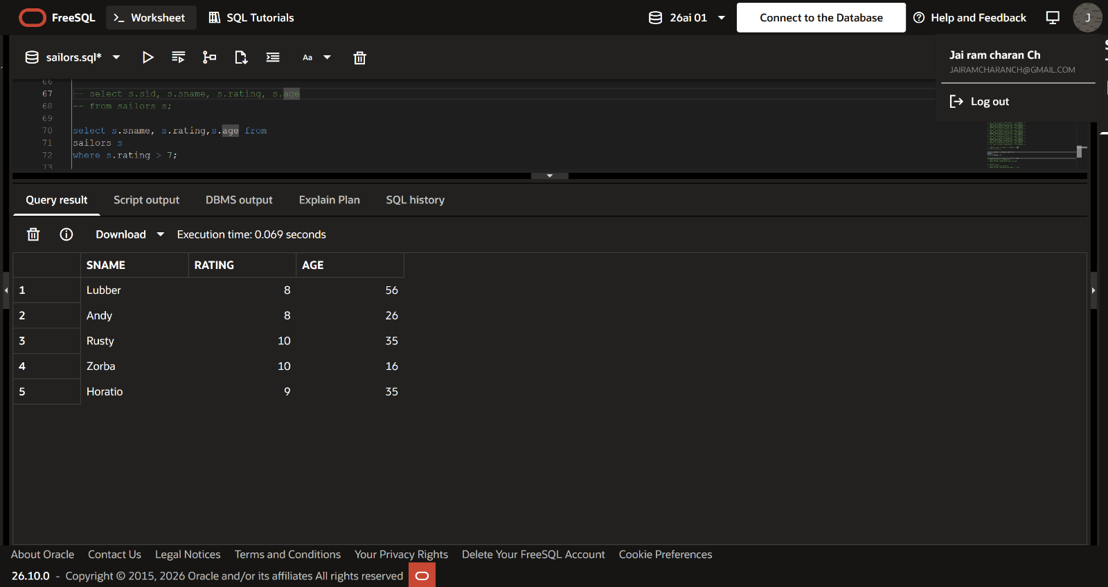

3.Find all the details of sailors who reserved the boat 103.
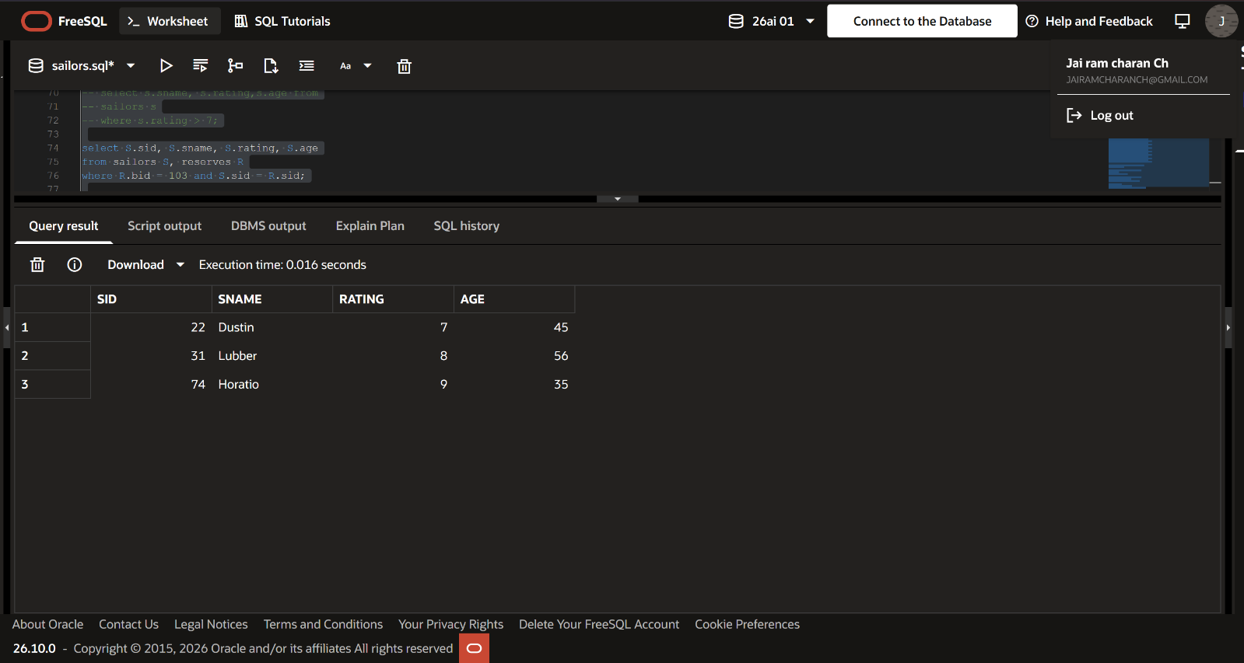
4. Find the sid of sailors who have reserved red boat.
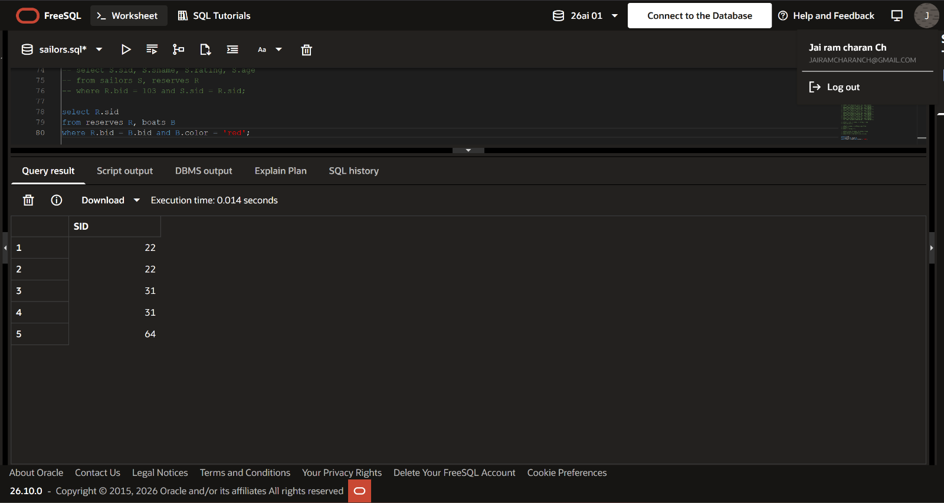

5. Find the colors of the boat reserved by lubber.
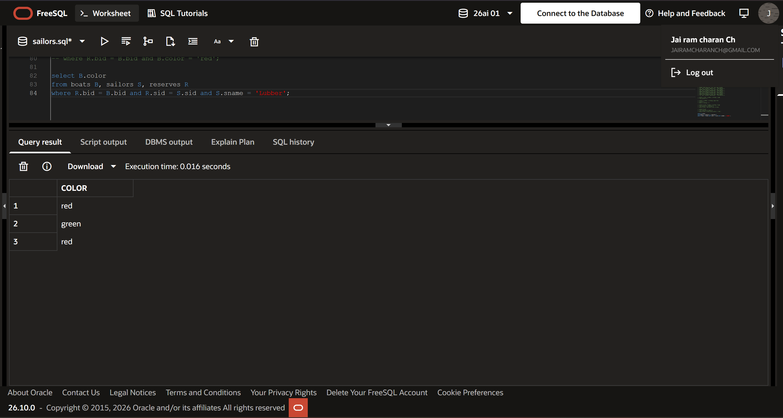
6. Find the names of sailors who have at least reserved at least one boat.
