

DBMS(23CSE202)

LAB MANUAL

Submitted by: -
NAME: | CH. JAI RAM CHARAN
ROLL NO: | AV.SC.U4CSE25106
YEAR/SEM/SECTION: | 2nd/YEAR/SEM-3/CSE-B
Submitted to: -
NAME: | Dr. N. Venkata Ramana
DEPARTMENT: | CSE
DESIGNATION: | Assistant Professor

MARKS:

INDEX

S.NO | TITLE | PAGE-NO | REMARKS
1. | WEEK-1  - Create a table EMPLOYEE with following schema:  (Emp_no, E_name, E_address, E_ph_no, Dept_no, Dept_name,Job_id , Salary)  - Add a new column; HIREDATE to the existing relation.  - Change the datatype of JOB_ID from char to varchar2.  - Change the name of column/field Emp_no to E_no.  - Modify the column width of the job field of emp table.
2. | WEEK-2
3. | WEEK-3
4. | WEEK-4
5. | WEEK-5
6. | WEEK-6
7. | WEEK-7
8. | WEEK-8
9. | WEEK-9
10. | WEEK-10
11. | WEEK-11
12. | WEEK-12

Week-1
- Create a table EMPLOYEE with following schema:
(Emp_no, E_name, E_address, E_ph_no, Dept_no, Dept_name,Job_id , Salary)
2. Add a new column; HIREDATE to the existing relation.
3. Change the datatype of JOB_ID from char to varchar2.
4. Change the name of column/field Emp_no to E_no.
5. Modify the column width of the job field of emp table.
- Input:
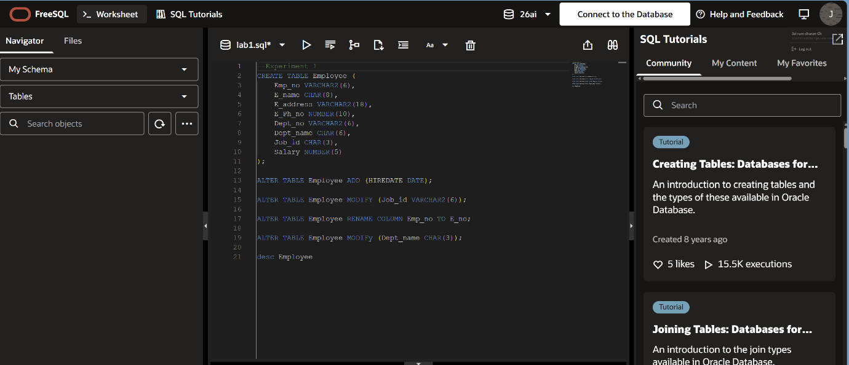
- Output:


Week-2
1. Insert aleast 5 rows in the table.
2. Display all the information of EMP table.
3. Display the record of each employee who works in department D10.
4. Update the city of Emp_no-12 with current city as Nagpur.
5. Display the details of Employee who works in department MECH.
6. Delete the phone number of employee JRC.
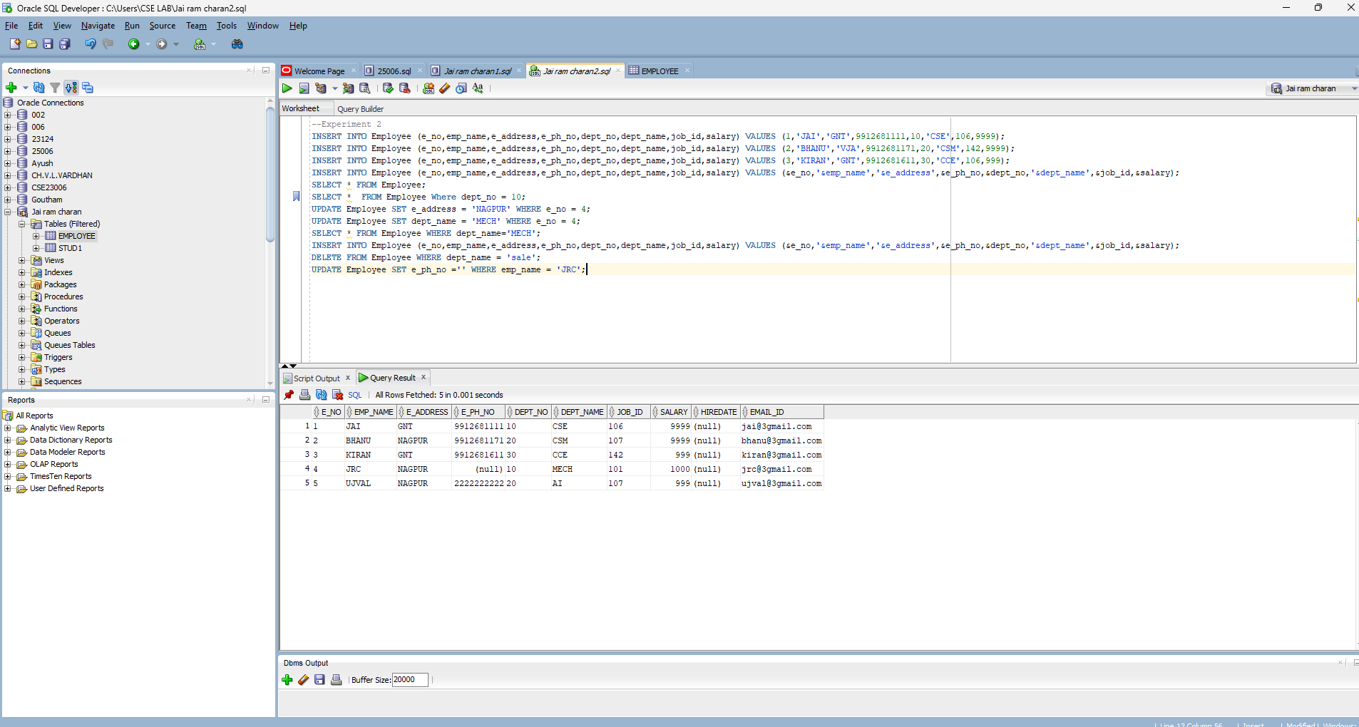
- Input:
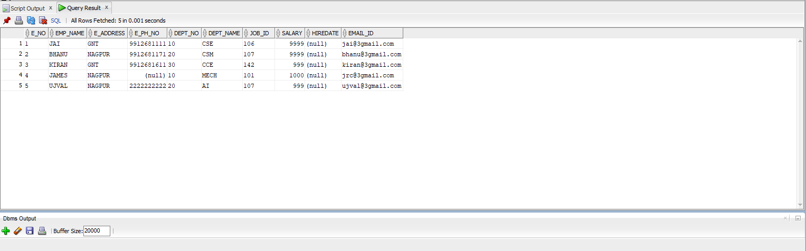
- Output:

Display the complete record of employees working in SALES Department

