

Data Structures and Algorithms (23CSE203)

Lab Manual

Submitted By

NAME | CH. JAI RAM CHARAN
ROLL NO | AV.SC.U4CSE25106
YEAR/SEM/SECTION | 1ST YEAR/ SEM-3/CSE-B
CREDITS | 05

Submitted to
NAME | DR. RAJ KUMAR BATCHU
DESIGNATION | ASST.PROFFESSOR (Sl. Grade)
DEPARTMENT | SCHOOL OF COMPUTING

Index
SNO | WEEK | Page-n0
1 | - A rocket launch system displays a count down before launch. Instead of using a loop, implement the count down using recursion. Write a recursive python program to display countdown from n to 1 followed by launch.  - Banks calculate the growth of investment using compound interest. The formula requires calculating powers, which can be implemented recursively. Write a recursive program to calculate P^n where P = Principal growth factor, n = number of years  - A HR department stores employee details in a list. Develop a recursive program to search for a given employee ID. Write a recursive function to search for an employee ID in a list.  - In a logistic department, the no of possible ways to arrange n diff parcels are calculated using the factorial formula(n!). Write a recursive formula to find the factorial of a given number  - Print first n terms in a fibanocci number series
2 | - Write the implementation for the linear search algorithm  - Write the implementation for the binary search algorithm  - Write the implementation for the binary search algorithm along with the sorting the input elements if they are not sorted.
3 | - Write a python program to implement bubble sort where the input elements are taken from the user.  - Write a python program to implement insertion sort where the input elements are taken from the user.  - Write a python program to implement selection sort where the input elements are taken from the user.
4

Lab – 1

1a)

Aim :
- A rocket launch system displays a count down before launch. Instead of using a loop, implement the countdown using recursion. Write a recursive python program to display count down from n to 1 followed by launch.

Program:
#Count Down #CSE25106
def countdown(n):
if n >= 0 :
if n != 0:
print(n)
return countdown(n-1)
else:
print("Launch!")

n= int(input("Enter the number:"))
countdown(n)

Output:
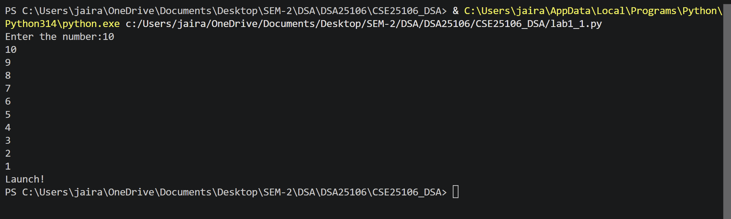

Error Table:
Error | Rectification
Output: None after launch! | Swapping if and else case.

Description:
- Recursion: Function called by itself.

1b)

Aim:
- Banks Calculate the growth of investment using compound interest. The formula requires calculating powers , which can be implemented recursively. Write a recursive program to calculate P^n where
P = Principal growth amount, n = no of years

Program:
#Growth #CSE25106
n = int(input("Enter number of years:"))
p = int(input("Enter annual principal:"))
def growth(p,n):
if n < 0:
return "Invalid input for number of years"
if n == 0:
return 1
else:
return p*growth(p,n-1)

print(growth(p,n))

Output:
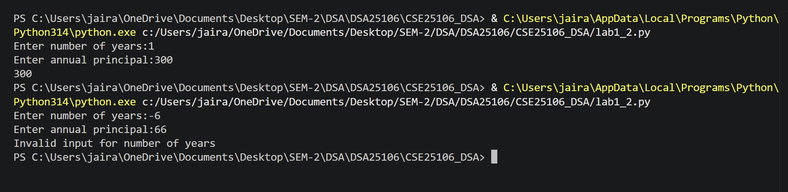

Error Table:
Error | Rectification
RecursionError: maximum recursion depth exceeded | Added if case to give valid input for n.

1c)

Aim:
- A HR department stores employee details in a list. Develop a recursive program to search for a given employee ID. Write a recursive function to search for an employee ID in a list.

Program:
#Searching of element #CSE25106
list = []
t=int(input("Enter number of inputs:"))
for _ in range(t):
n = int(input("Enter the ID:"))
list.append(n)
ID = int(input("Enter ID to seach:"))
start = 0
def search(list,ID,start):
if list[start] == ID:
print(f"ID found at : {start}")
elif list[start] == len(list):
print("ID not found")
else:
return search(list,ID,start+1)

search(list,ID,start)

Output:
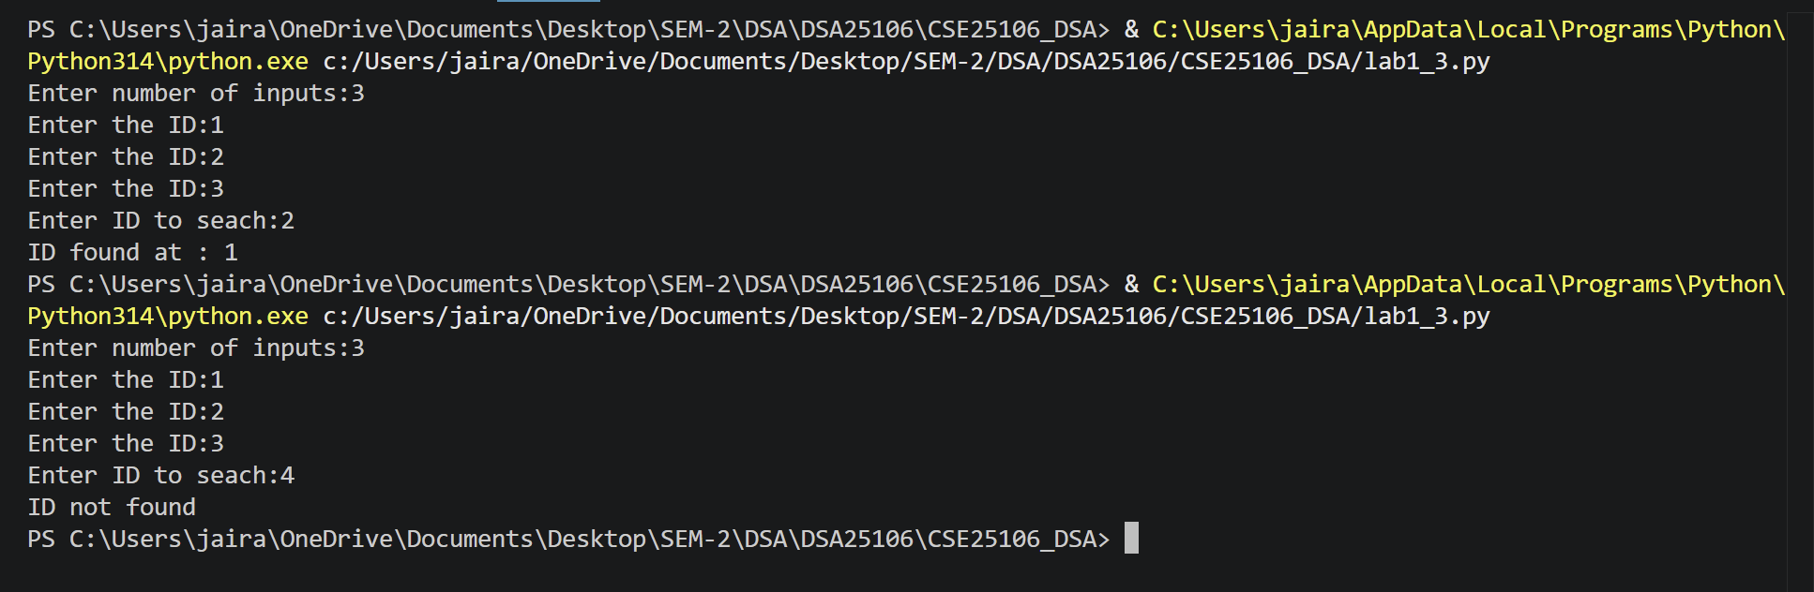

Error Table:
Error | Rectification
ValueError: invalid literal for int() with base 10: '2 3' | Should take a int value only

1d)

Aim:
- In a logistic department, the no of possible ways to arrange n diff parcels are calculated using the factorial formula(n!). Write a recursive formula to find the factorial of a given number

Program:
#Factorial #CSE25106
def factorial(n):
if n > 0:
if n == 1:
return 1
else:
return n*factorial(n-1)
else:
return "Please enter a positive number"
n = int(input("Enter the number:"))
print(factorial(n))

Output:
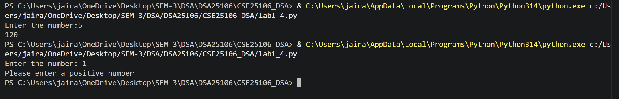

Error Table:
Error | Rectification
Didn’t implement for the negative values | Added else to make user to give positive input.

1e)

Aim:
- Print first n terms in a fibanocci number

Program:
#Fibonacci series #CSE25106
def fib(n):
if n == 1:
return 0
if n == 2:
return 1
else:
return fib(n-1) + fib(n-2)
def print_fib(n):
for i in range(1, n+1):
print(fib(i), end=" ")

n = int(input("Enter the number:"))
print_fib(n)

Output:
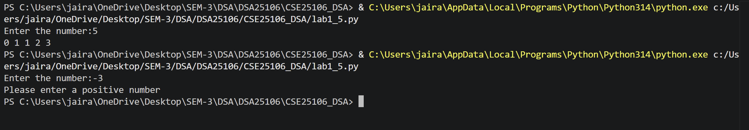

Error Table:
Error | Rectification
Numbers are not printed if there are in the same function. | Added a new function with for loop for printing the numbers

Lab – 2

2a)

Aim:
- Write a program for the linear search algorithm

Program:
# Linear search #CSE25106
arr=[]
n = int(input("Enter no of elements:"))
while n < 1:
print("no of elements should be greater than 0")
n = int(input("Enter no of elements:"))
for i in range(n):
elements = int(input("Enter the elements:"))
arr.append(elements)
key = int(input("Enter element to search:"))
def linear_search(arr,key):
for i in range(len(arr)):
if arr[i] == key:
return i
else:
i+= 1
return -1
result = linear_search(arr,key)
if result != -1 :
print("Element found at index ",result)
else:
print("Element not found")

Output:
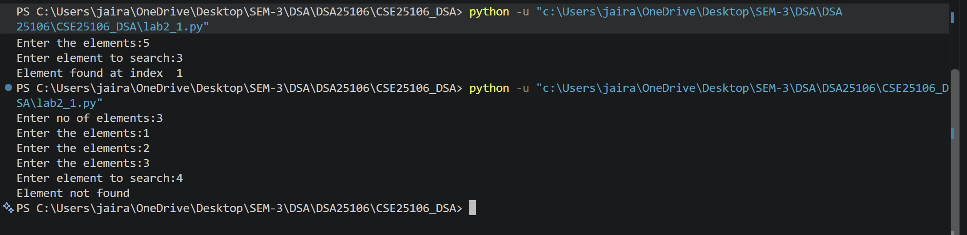

Error Table:
Error | Rectification
Forgot to return at the end which lead to the program returning none when the element is not found | Returned -1 at the very end which fixed the element not found case

2b)

Aim:
Write a program for binary search algorithm considering the elements to be sorted

Program:
# Binary search of sorted array #CSE25106
arr=[]
n = int(input("Enter no of elements:"))
for i in range(n):
elements = int(input("Enter the elements in sorted order:"))
arr.append(elements)
key = int(input("Enter element to search:"))
def binary_search(arr,key):
low = 0
high = len(arr) - 1
while low < high:
mid = (low+high)//2
if arr[mid] == key:
return mid
elif arr[mid] < key:
low = mid + 1
else:
high = mid - 1
return -1

result = binary_search(arr,key)
if result != -1 :
print("Element found at index :",result)
else:
print("Element not found")

Output:
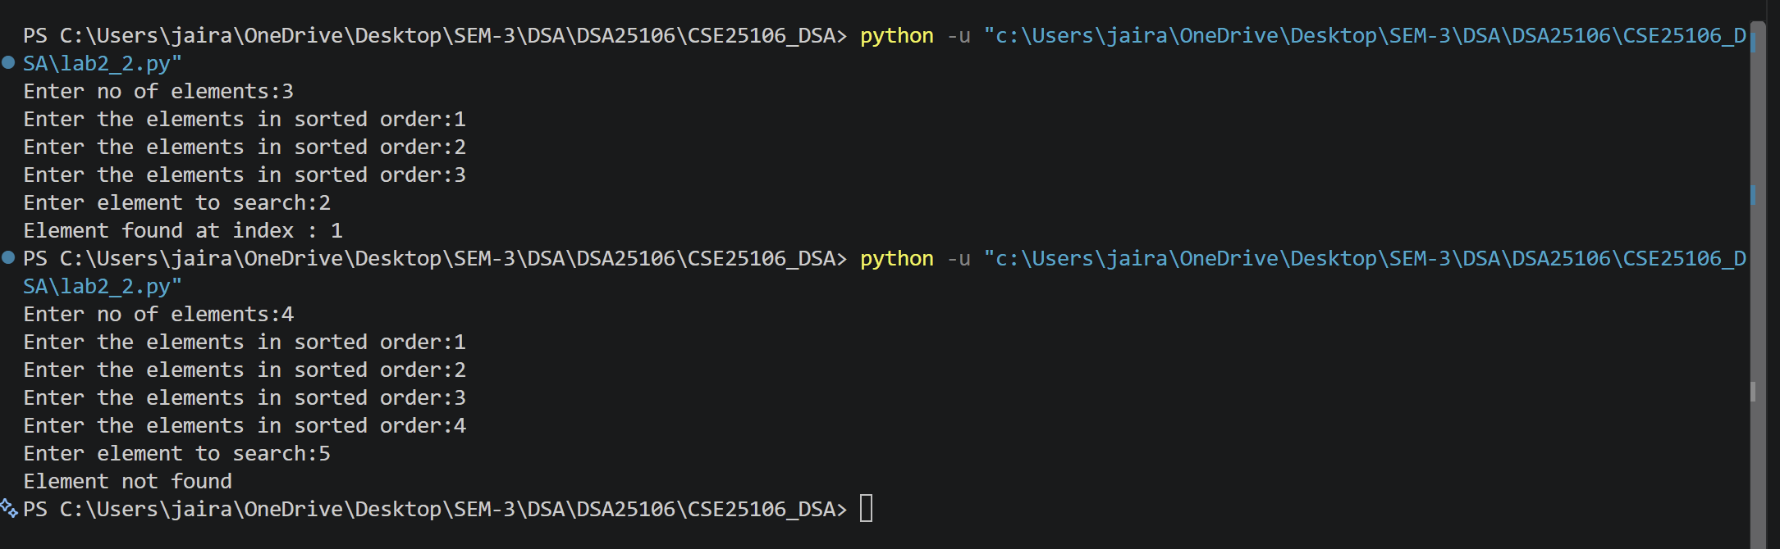

Error Table:
Error | Rectification
Wrote the mid formula outside the while loop which gave the infinite loop error | Added the mid formula inside the while loop

2c)

Aim:
Write a program for implementation of binary search along with the sorting the elements

Program:
#Binary search of unsorted array. #CSE25106
arr = []
n = int(input("Enter no of elements:"))
for i in range(n):
element = int(input("Enter the element:"))
arr.append(element)
# To check and sort the list.
if arr == sorted(arr):
print("\n The input list is already sorted")
else:
print("\nThe input list is not sorted")
print("\nSorting the list....")
arr.sort()
print("\nThe sorted list is:",arr)
key = int(input("Enter element to search:"))
def binary_search(arr,key):
low = 0
high = len(arr) - 1
while low < high:
mid = (low+high)//2
if arr[mid] == key:
return mid
elif arr[mid] < key:
low = mid + 1
else:
high = mid - 1
return -1

result = binary_search(arr,key)
if result != -1 :
print("Element found at index:",result)
else:
print("Element not found")

Output:
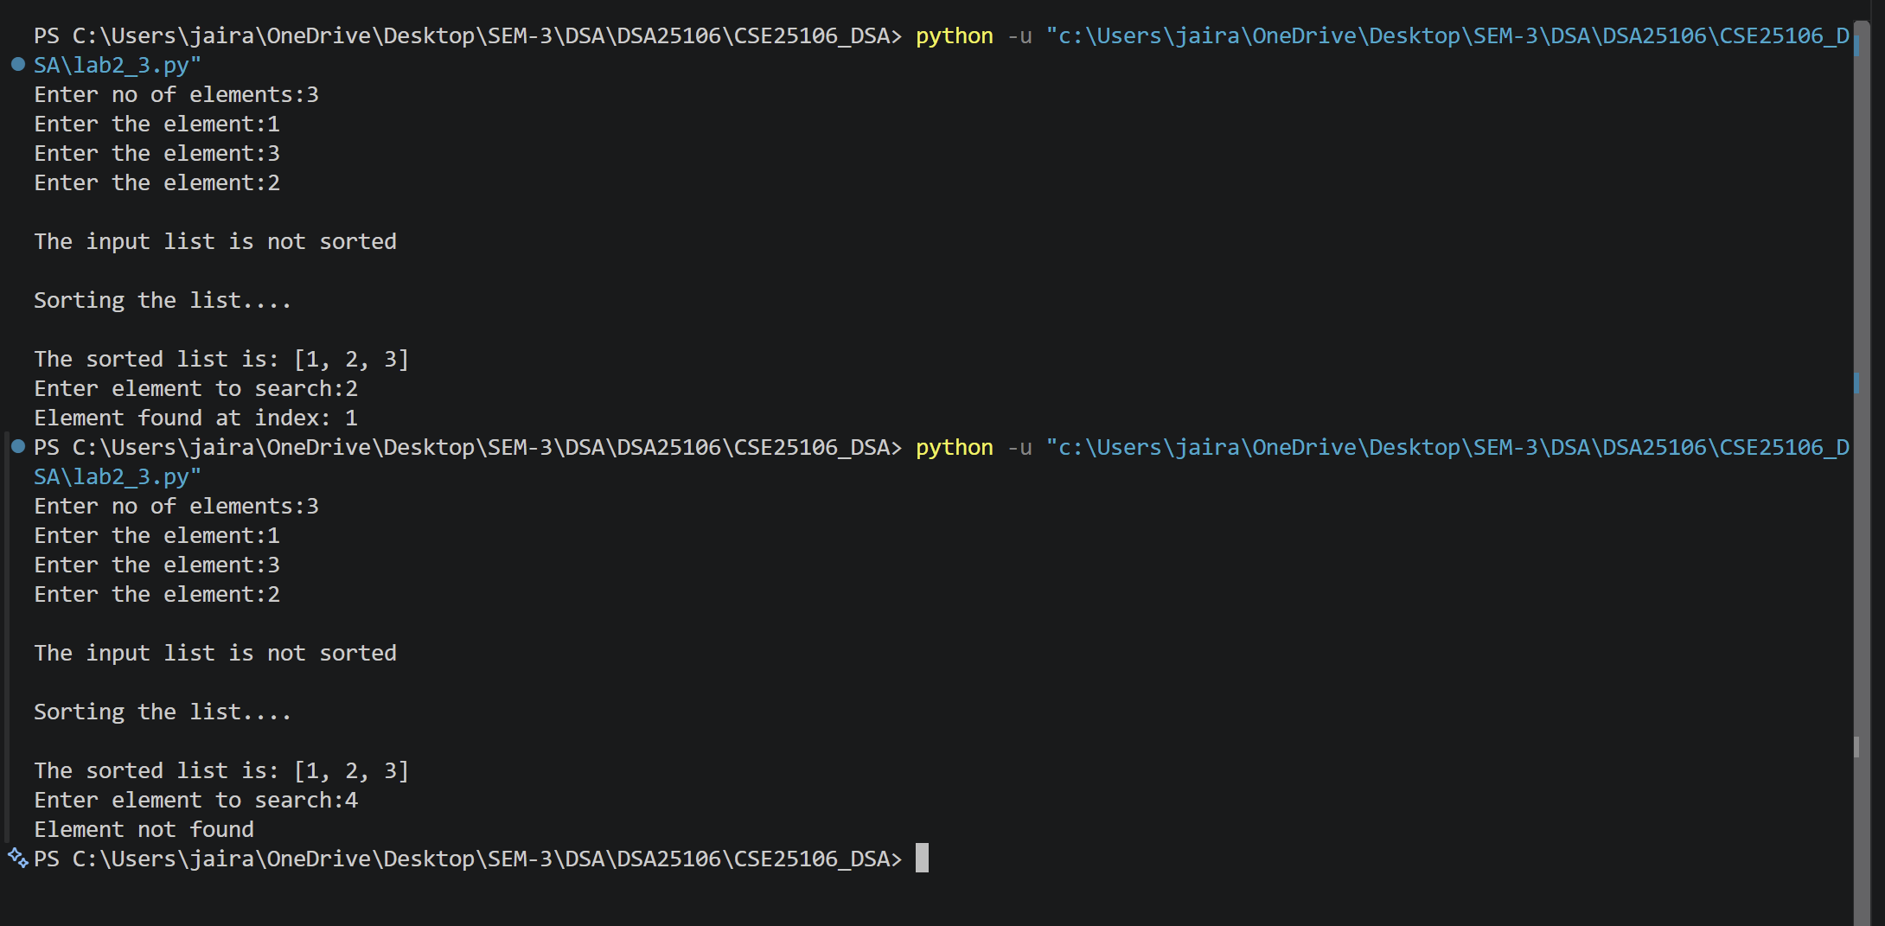

Error Table:
Error | Rectification
Used sorted method instead of which need to be referred to another variable as it returns a sorted array | Used the arr.sort() method which directly sorts the arr without using another variable

Lab – 3

3a)

Aim:
Write a python program to implement bubble sort where the input elements are taken from the user.

Program:
# BUBBLE SORT # CSE25106
def main():
arr = []
n = int(input("Enter number of elements: "))
for i in range(n):
num = int(input(f"Enter the {i+1} element: "))
arr.append(num)
bubble_sort(arr)
print("Sorted array:", arr)

def bubble_sort(arr):
n = len(arr)
for i in range(n - 1):
for j in range(n - i - 1):
if arr[j] > arr[j + 1]:
arr[j], arr[j + 1] = arr[j + 1], arr[j]

if __name__ == '__main__':
main()

Output:
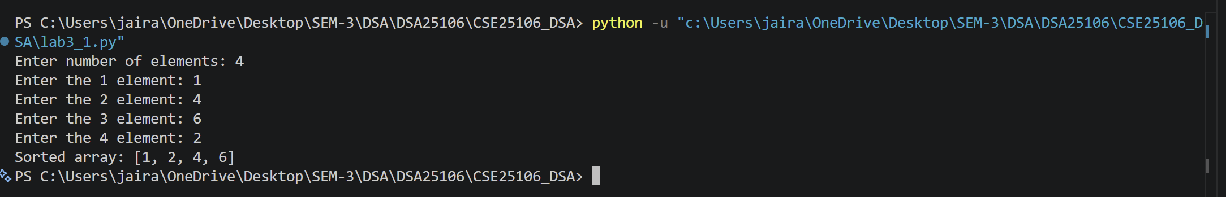

Error Table:
Error | Rectification
Gave the numbers in descending order | Changed the sign symbol while comparing the adjacent elements.

3b)

Aim:
Write a python program to implement insertion sort where the input elements are taken from the user.

Program:

def main():
arr = []
n = int(input("Enter number of elements: "))
for i in range(n):
num = int(input(f"Enter the {i+1} element: "))
arr.append(num)
insertion_sort(arr)
print(arr)

def insertion_sort(arr):
for i in range(1, len(arr)):
key = arr[i]
j = i -1
while j >=0 and arr[j] > key:
arr[j+1] = arr[j]
j = j-1
arr[j+1] = key

if __name__ == '__main__':
main()

Output:
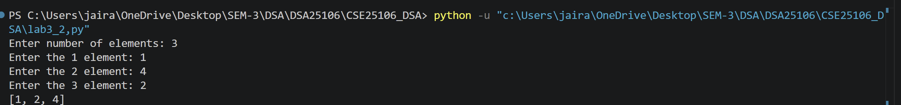

Error Table:
Error | Rectification

3c)

Aim:
Write a python program to implement selection sort where the input elements are taken from the user.

Program:

def main():
arr = []
n = int(input("Enter number of elements: "))
for i in range(n):
num = int(input(f"Enter the {i+1} element: "))
arr.append(num)
selection_sort(arr)
print(arr)

def selection_sort(arr):
for i in range(len(arr)-1):
min_index = i
for j in range(i+1, len(arr)):
if arr[j] < arr[min_index]:
min_index = j
arr[i], arr[min_index] = arr[min_index], arr[i]

if __name__ == '__main__':
main()

Output:
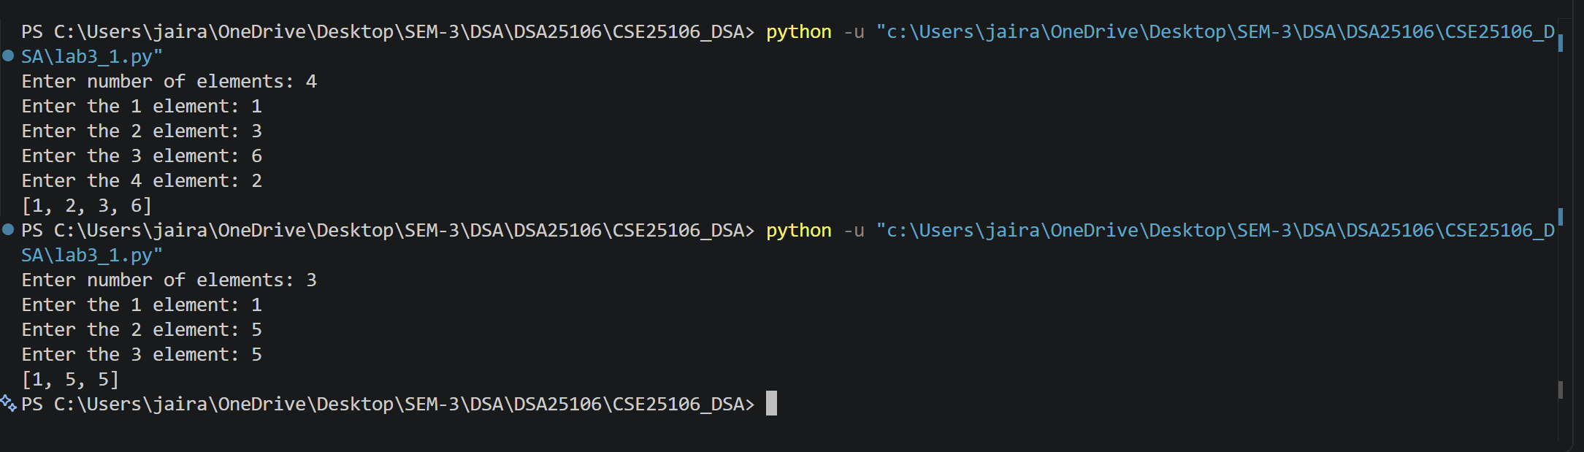

Error Table:
Error | Rectification

