Project
- Aim: To create a similar website using HTML, CSS, JAVASCRIPT
- Procedure:
- Input:

MAIN :
<!DOCTYPE html>
<html>
<head>
<title>
Project
</title>
<link rel="stylesheet" href="header.css">
<link rel="stylesheet" href="faq.css">
<link rel="stylesheet" href="payment.css">
<link rel="stylesheet" href="footer.css">
<script>
function changePlan(type, btn){
if(type=="monthly"){
document.getElementById("fanPrice").innerText="₹99/mo";
document.getElementById("megaPrice").innerText="₹149/mo";
} else {
document.getElementById("fanPrice").innerText="₹469/yr";
document.getElementById("megaPrice").innerText="₹569/yr";
}
let buttons = document.getElementsByTagName("button");
for(let i=0;i<buttons.length;i++){
buttons[i].classList.remove("active");
}
btn.classList.add("active");
}
</script>
</head>
<body class="body1">
<div class="div1">
<div class="header">
<div class="logo">Crunchyroll mini</div>

<div class="nav-buttons">
<a href="login.html">
<button class="login" onclick="login()">LOG IN</button>
</a>
<a href="#plans">
<button class="register">START FREE TRIAL</button>
</a>
</div>
</div>
<div class="main">
<div class="main-text">
<h1>Welcome to the world of anime.</h1>
<p>Join now and explore unlimited anime</p>
<a href="#plans">
<button class="main-btn">START FREE TRIAL</button>
</a>
</div>
</div>
</div>
<div class="body2" id="plans">
<h1>Choose Your Plan</h1>
<div class="toggle">
<div class="toggle-box">
<button class="active" onclick="changePlan('monthly', this)">Monthly</button>
<button onclick="changePlan('yearly', this)">Yearly</button>
</div>
</div>
<div class="container">
<div class="card">
<h1>Fan</h1>
<div class="price" id="fanPrice">₹99/mon</div>
<a href="https://sso.crunchyroll.com/register?return_url=%2Fauthorize%3Fclient_id%3Dkmj7imhjt_q90lcbzzsj%26redirect_uri%3Dhttps%253A%252F%252Fwww.crunchyroll.com%252Fcallback%26response_type%3Dcookie%26state%3D%252Fdiscover">
<button class="btn" onclick="register()">Start 7-Day Free Trial</button>
</a>
<a href="https://sso.crunchyroll.com/register?return_url=%2Fauthorize%3Fclient_id%3Dkmj7imhjt_q90lcbzzsj%26redirect_uri%3Dhttps%253A%252F%252Fwww.crunchyroll.com%252Fcallback%26response_type%3Dcookie%26state%3D%252Fdiscover">
<button class="trial" onclick="register()">Skip Free Trial</button>
</a>
<div class="features">
<p><span>✔</span>No ads</p>
<p><span>✔</span>Complete access to library</p>
<p><span>✔</span>New episodes after Japan</p>
<p><span>✔</span>1 device at a time</p>
<p><span>✔</span>Offline Viewing</p>
</div>
</div>
<div class="card">
<h1>Mega Fan</h1>
<div class="price" id="megaPrice">₹149/mo</div>
<a href="https://sso.crunchyroll.com/register?return_url=%2Fauthorize%3Fclient_id%3Dkmj7imhjt_q90lcbzzsj%26redirect_uri%3Dhttps%253A%252F%252Fwww.crunchyroll.com%252Fcallback%26response_type%3Dcookie%26state%3D%252Fdiscover">
<button class="btn fill" onclick="register()">Start 7-Day Free Trial</button>
</a>
<a href="https://sso.crunchyroll.com/register?return_url=%2Fauthorize%3Fclient_id%3Dkmj7imhjt_q90lcbzzsj%26redirect_uri%3Dhttps%253A%252F%252Fwww.crunchyroll.com%252Fcallback%26response_type%3Dcookie%26state%3D%252Fdiscover">
<button class="trial " onclick="register()">Skip Free Trial</button>
</a>
<div class="features">
<p><span>✔</span>No ads</p>
<p><span>✔</span>Complete access to library</p>
<p><span>✔</span>New episodes after Japan</p>
<p><span>✔</span>4 devices at a time</p>
<p><span>✔</span>Offline Viewing</p>
<p><span>✔</span>Game Vault Access</p>
</div>
</div>
</div>
<p style="margin-top:40px; color:gray; font-size:12px; max-width:700px; margin-left:auto; margin-right:auto;">
Free trial offer valid for new users. Plans renew automatically. Cancel anytime.</p>
<h1>Already a member?</h1>
<a href="login.html">
<button class="log" >Login</button>
</a>
<h2>Get more with premium</h2>
<p>Enjoy Crunchyroll mini's entire library ad-free, including episodes shortly after being released in Japan.</p>
<a href="#plans">
<button class="scroll-btn" >scroll to plans ⬆️</button>
</a>
<div class="images">
<div>
<img src="ad.png" alt="Ad" width="60%" height="60%">
<p>Ad-free streaming</p>
</div>
<div>
<img src="lib.png" alt="Library" width="60%" height="60%">
<p>Complete access to library</p>
</div>
<div>
<img src="new.png" alt="New" width="60%" height="60%">
<p>New episodes after Japan</p>
</div>
<div>
<img src="device.png" alt="Device" width="60%" height="60%">
<p>Multi-device access</p>
</div>
<div>
<img src="games.png" alt="Games" width="60%" height="60%">
<p>Game Vault Access</p>
</div>
<div>
<img src="download.png" alt="Download" width="60%" height="60%">
<p>Download HD videos</p>
</div>
</div>
<p>Benefits may differ based on the selected subscription tier and the region in which you are located.</p>
<div class="body3">
<div class="faq-container">
<h2>FAQ</h2>

<div class="faq-item">
<button class="faq-question" onclick="toggleFAQ(this)">
Does Crunchyroll offer a free trial?
<span class="icon">+</span>
</button>
<div class="faq-answer">
<div class="answer-content">
Crunchyroll offers a 7-day free trial of our Premium plans, letting users experience ad-free streaming and other benefits.
</div>
</div>
</div>

<div class="faq-item">
<button class="faq-question" onclick="toggleFAQ(this)">
What are the benefits of Crunchyroll Premium?
<span class="icon">+</span>
</button>
<div class="faq-answer">
<div class="answer-content">
Premium members get access to the entire library ad-free, simulcasts shortly after Japan, and offline viewing capabilities.
</div>
</div>
</div>

<div class="faq-item">
<button class="faq-question" onclick="toggleFAQ(this)">
Does Crunchyroll have dubbed anime?
<span class="icon">+</span>
</button>
<div class="faq-answer">
<div class="answer-content">
Yes, Crunchyroll offers both subtitled and dubbed versions of many popular anime titles.
</div>
</div>
</div>

<div class="faq-item">
<button class="faq-question" onclick="toggleFAQ(this)">
What anime titles can I watch on Crunchyroll?
<span class="icon">+</span>
</button>
<div class="faq-answer">
<div class="answer-content">
Crunchyroll features a vast selection of anime, including popular titles such as One Piece, Solo Leveling, Attack on Titan, My Hero Academia, Jujutsu Kaisen, and many more.
</div>
</div>
</div>

<div class="faq-item">
<button class="faq-question" onclick="toggleFAQ(this)">
How does Crunchyroll's streaming work?
<span class="icon">+</span>
</button>
<div class="faq-answer">
<div class="answer-content">
Crunchyroll allows users to stream anime anytime, anywhere on various devices, including smartphones, tablets, gaming consoles, and smart TVs. Premium members enjoy higher-quality streaming and faster access to new episodes.
</div>
</div>
</div>

<div class="faq-item">
<button class="faq-question" onclick="toggleFAQ(this)">
Can I download anime on Crunchyroll?
<span class="icon">+</span>
</button>
<div class="faq-answer">
<div class="answer-content">
Yes, Crunchyroll Premium members can download anime episodes for offline viewing on supported devices, allowing you to enjoy your favorite shows without an internet connection.
</div>
</div>
</div>

<div class="faq-item">
<button class="faq-question" onclick="toggleFAQ(this)">
How do I activate Crunchyroll on my device?
<span class="icon">+</span>
</button>
<div class="faq-answer">
<div class="answer-content">
Activating Crunchyroll is simple! Just open the Crunchyroll app on your device and select "Activate with Code." A six-character code will appear on your screen. Visit https://www.crunchyroll.com/activate on your computer or phone, enter the code, and you'll be logged in and ready to stream your favorite anime.
</div>
</div>
</div>

<div class="faq-item">
<button class="faq-question" onclick="toggleFAQ(this)">
How do I cancel my subscription?
<span class="icon">+</span>
</button>
<div class="faq-answer">
<div class="answer-content">
You can manage your subscription through your profile settings. Simply navigate to 'Membership Info' and follow the cancellation prompts.
</div>
</div>
</div>
</div>
<script>
function toggleFAQ(element) {
let item = element.parentElement;

item.classList.toggle("active");
}
</script>
</div>
<div>
<h1>QUESTIONS?</h1>
<p>Visit our <span>
<a href="https://help.crunchyroll.com/hc/en-us" class="help">Help Center</a>
</span> to know more.</p>
</div>
<div class="footer">
<div class="column">
<h3>Key Pages</h3>
<a href="https://www.crunchyroll.com/videos/new">Search New</a>
<a href="https://www.crunchyroll.com/videos/popular">Popular Search</a>
<a href="https://www.crunchyroll.com/videos/alphabetical">Search All</a>
<a href="https://www.crunchyroll.com/simulcasts/seasons/spring-2025">Browse Simulcast</a>
<a href="https://www.crunchyroll.com/simulcastcalendar">Release Calendar</a>
<a href="https://www.crunchyroll.com/music">Music & Concert Videos</a>
<a href="https://www.crunchyroll.com/games/">Games</a>
<a href="https://www.crunchyroll.com/news">News</a>
<a href="https://www.crunchyroll.com/animeawards/">Anime Awards</a>
<a href="https://www.crunchyroll.com/events/">Events & Experiences</a>
</div>

<div class="column">
<h3>Genre</h3>
<a href="https://www.crunchyroll.com/videos/action">Action</a>
<a href="https://www.crunchyroll.com/videos/adventure">Adventure</a>
<a href="https://www.crunchyroll.com/videos/comedy">Comedy</a>
<a href="https://www.crunchyroll.com/videos/drama">Drama</a>
<a href="https://www.crunchyroll.com/videos/fantasy">Fantasy</a>
<a href="https://www.crunchyroll.com/videos/music">Music</a>
<a href="https://www.crunchyroll.com/videos/romance">Romance</a>
<a href="https://www.crunchyroll.com/videos/sci-fi">Sci-Fi</a>
<a href="https://www.crunchyroll.com/videos/slice-of-life">Slice of Life</a>
<a href="https://www.crunchyroll.com/videos/shojo">Shojo</a>
<a href="https://www.crunchyroll.com/videos/shonen">Shounen</a>
<a href="https://www.crunchyroll.com/videos/sports">Sports</a>
<a href="https://www.crunchyroll.com/videos/seinen">Seinen</a>
<a href="https://www.crunchyroll.com/videos/thriller">Thriller</a>
</div>

<div class="column">
<h3>Top 15 Popular Series</h3>
<a href="https://www.crunchyroll.com/series/G3KHEVDJ7/the-apothecary-diaries">Apothecary Diaries</a>
<a href="https://www.crunchyroll.com/series/GR751KNZY/attack-on-titan">Attack on Titan</a>
<a href="https://www.crunchyroll.com/series/G4PH0WEKE/blue-lock">Blue Lock</a>
<a href="https://www.crunchyroll.com/series/GY5P48XEY/demon-slayer-kimetsu-no-yaiba">Demon Slayer</a>
<a href="https://www.crunchyroll.com/series/GG5H5XQ35/dragon-ball-daima">Dragon Ball DAIMA</a>
<a href="https://www.crunchyroll.com/series/GR19V7816/dragon-ball-super">Dragon Ball Super</a>
<a href="https://www.crunchyroll.com/series/GYQWNXPZY/fire-force">Fire Force</a>
<a href="https://www.crunchyroll.com/series/GRDV0019R/jujutsu-kaisen">Jujutsu Kaisen</a>
<a href="https://www.crunchyroll.com/series/GG5H5XQ7D/kaiju-no-8">Kaiju No 8</a>
<a href="https://www.crunchyroll.com/series/G6NQ5DWZ6/my-hero-academia">My Hero Academia</a>
<a href="https://www.crunchyroll.com/series/GY9PJ5KWR/naruto">Naruto</a>
<a href="https://www.crunchyroll.com/series/GYQ4MW246/naruto-shippuden">Naruto Shippuden</a>
<a href="https://www.crunchyroll.com/series/GRMG8ZQZR/one-piece">One Piece</a>
<a href="https://www.crunchyroll.com/series/GDKHZEJ0K/solo-leveling">Solo Leveling</a>
<a href="https://www.crunchyroll.com/series/G4PH0WXVJ/spy-x-family">Spy x Family</a>
</div>

<div class="column">
<h3>Language</h3>
<a href="https://www.crunchyroll.com/">English (US)</a>
<a href="https://www.crunchyroll.com/id/">Indionesia</a>
<a href="https://www.crunchyroll.com/de/">German</a>
<a href="https://www.crunchyroll.com/es/">Spanish (Latin America)</a>
<a href="https://www.crunchyroll.com/es-es/">Spanish (Spain)</a>
<a href="https://www.crunchyroll.com/fr/">French</a>
<a href="https://www.crunchyroll.com/it/">Italian</a>
<a href="https://www.crunchyroll.com/pt-br/">Portuguese (Brazil)</a>
<a href="https://www.crunchyroll.com/pt-pt/">Portuguese (Portugal)</a>
<a href="https://www.crunchyroll.com/hi/">Hindi</a>
<a href="https://www.crunchyroll.com/ru/">Russian</a>
<a href="https://www.crunchyroll.com/ar/">Arabic</a>
<a href="https://www.crunchyroll.com/hi/">Hindi</a>
<a href="https://www.crunchyroll.com/th/">Thai</a>
</div>

<div class="column">
<h3>Crunchyroll</h3>
<a href="https://www.crunchyroll.com/about/">About</a>
<a href="https://help.crunchyroll.com/hc/en-us">Help Center</a>
<a href="https://www.crunchyroll.com/tos/">Terms of Service</a>
<a href="https://intl.sonypictures.com/en/privacy-policy">Privacy Policy</a>
<a href="https://www.sonypictures.com/corp/privacy.html#section11B">AdChoices</a>
<a href="https://privacyportal-cdn.onetrust.com/dsarwebform/d19e506f-1a64-463d-94e4-914dd635817d/b9eb997c-9ede-451b-8fd4-29891782a928.html">Do Not Sell Info</a>
<a href="https://www.crunchyroll.com/about/jobs">Jobs</a>
<a href="https://www.crunchyroll.com/redeem">Redeem</a>
<a href="https://www.crunchyroll.com/devices/">Get the App</a>
</div>

<div class="column">
<h3>Follow Us</h3>
<a href="https://www.youtube.com/@Crunchyroll">YouTube</a>
<a href="https://www.facebook.com/Crunchyroll/">Facebook</a>
<a href="https://x.com/crunchyroll">Twitter</a>
<a href="https://www.instagram.com/crunchyroll/">Instagram</a>
</div>
</div>
<div class="footer-middle">
<div class="sony">
<p>SONY PICTURES | © CRUNCHYROLL MINI</p>
</div>
</div>

<div class="container2">
<div class="column1">

<p>
Welcome to Crunchyroll, your ultimate destination for streaming the best in anime entertainment.
Whether you’re a lifelong fan or just starting your anime journey, Crunchyroll offers an extensive
library of top-tier anime series and movies.
</p>

<div class="extra-text" id="leftText">
<p>
From action-packed adventures like Naruto and One Piece to fan-favorites such as Demon Slayer and
Attack on Titan, we bring the world of anime right to your screen. With thousands of hours of
content, you’ll find something for every mood and taste.
</p>
<br>
<p>
At Crunchyroll, we take pride in being the go-to-platform for anime lovers around the world.
You can dive into a wide variety of genres, including fantasy, slice of life, and sci-fi,
ensuring there’s always something new to discover.
</p>
</div>
<div class="btn2" onclick="toggleDetails()" id="toggleBtn">MORE DETAILS</div>
</div>

<div class="column1">
<p>
With simulcasts straight from Japan, you’ll never miss a moment of the latest and greatest anime
releases. Our selection goes beyond just series— enjoy a handpicked selection of anime movies
that showcase the best in animation and storytelling.
</p>
<div class="extra-text" id="rightText">
<br>

<p>
Watch anytime, anywhere, with the Crunchyroll app available across all your devices.
</p>
<br>

<p>
Beyond streaming, Crunchyroll is a hub for all things anime. Explore the Crunchyroll Store for
exclusive anime merchandise, collectibles, and apparel. Stay updated with Crunchyroll News,
delivering the latest on anime, manga, and pop culture.
</p>
<br>

<p>
And for gamers, Crunchyroll Games brings your favorite anime worlds to life in exciting and
interactive ways. Join the Crunchyroll community and immerse yourself in a world where anime
is more than just a genre—it’s a lifestyle.
</p>
</div>
</div>
</div>

<script>
function toggleDetails(){

let leftText = document.getElementById("leftText");
let rightText = document.getElementById("rightText");
let button = document.getElementById("toggleBtn");

if(leftText.style.display === "block"){
leftText.style.display = "none";
rightText.style.display = "none";
button.innerHTML = "MORE DETAILS";
}
else{
leftText.style.display = "block";
rightText.style.display = "block";
button.innerHTML = "FEWER DETAILS";
}
}
</script>
</div>
</body>
</html>

Login:
<!DOCTYPE html>
<html>
<head>
<meta charset="UTF-8">
<title>Login</title>

<style>
* {
margin: 0;
padding: 0;
box-sizing: border-box;
}

body {
background: black;
color: white;
font-family: Arial, sans-serif;
}
.logo {
font-size: 36px;
font-weight: bold;
color: orange;
text-align: center;
margin-top: 10px;
padding-bottom: 70px;
}

.container {
display: flex;
flex-direction: column;
align-items: center;
margin-top: 50px;
}

h1 {
font-size: 36px;
margin-bottom: 60px;
}

.label {
width: 500px;
color: gray;
margin-bottom: 10px;
}

input {
width: 500px;
background: transparent;
border: none;
border-bottom: 2px solid gray;
padding: 10px 0;
color: white;
font-size: 14px;
outline: none;
}
input:focus {
border-bottom: 2px solid orange;
}

button {
width: 500px;
margin-top: 60px;
padding: 15px;
border-radius: 40px;
border: 2px solid #555;
background: black;
color: #777;
font-size: 16px;
cursor: pointer;
}

.links {
margin-top: 30px;
}

.links a {
color: orange;
text-decoration: none;
font-weight: bold;
margin: 0 10px;
}
</style>

</head>

<body>

<div class="container">
<h1 class="logo">Crunchyroll mini</h1>

<h1>Log In</h1>

<div class="label">Email or Phone Number</div>
<input type="text" id="userInput">
<button onclick="validateInput()">Next</button>
<div id="result"></div>

<div class="links">
<a href="https://sso.crunchyroll.com/reset-password?return_url=%2Fauthorize%3Fclient_id%3Dkmj7imhjt_q90lcbzzsj%26redirect_uri%3Dhttps%253A%252F%252Fwww.crunchyroll.com%252Fcallback%26response_type%3Dcookie%26state%3D%252Fdiscover">FORGOT PASSWORD?</a> |
<a href="https://sso.crunchyroll.com/register?return_url=%2Fauthorize%3Fclient_id%3Dkmj7imhjt_q90lcbzzsj%26redirect_uri%3Dhttps%253A%252F%252Fwww.crunchyroll.com%252Fcallback%26response_type%3Dcookie%26state%3D%252Fdiscover">CREATE ACCOUNT</a>
</div>

</div>
<script>

function validateInput(){

let value = document.getElementById("userInput").value;

let result = document.getElementById("result");

let emailPattern = /^[^\s@]+@[^\s@]+\.[^\s@]+$/;

let phonePattern = /^[0-9]{10}$/;

if(emailPattern.test(value)){

result.innerHTML = "Valid Email Address";
result.style.color = "green";

}

else if(phonePattern.test(value)){

result.innerHTML = "Valid Phone Number";
result.style.color = "green";

}

else{

result.innerHTML = "Invalid Email or Phone Number";
result.style.color = "red";

}

}

</script>

</body>
</html>

CSS:
Header-CSS:
.body1{
margin: 0;
padding:0;
}
.div1{
background-image: url(wallpaper-2.png);
background-size: cover;
height: 100vh;
}
.header{
display: flex;
justify-content: space-between;
align-items: center;
padding-right: 100px;
padding-top: 10px;
padding-bottom: 10px;
padding-left: 100px;
position: fixed;
width: 100%;
background-color: rgba(139, 154, 168, 0.288);
backdrop-filter: blur(20px);
box-sizing: border-box;
}
.nav-buttons {
display: flex;
gap: 15px;
}
.logo{
color: orange;
font-size: 24px;
font-weight: bold;
}
.login{
padding: 8px 18px;
border: 1px solid white;
background: transparent;
color: white;
border-radius: 20px;
cursor: pointer;
}
.register{
padding: 8px 18px;
border: none;
background: orange;
color: black;
border-radius: 20px;
font-weight: bold;
cursor: pointer;
}
.login:hover{
background: white;
color: black;
}
.register:hover{
background: darkorange;
}
.main{
height: 100vh;
background:linear-gradient(to right,
rgba(0,0,0,0.9),
rgba(0,0,0,0.6),
rgba(0,0,0,0.2),
transparent);
display: flex;
color: white;
align-items: center;
padding-left: 50px;
}
.main-text h1 {
font-size: 60px;
max-width: 600px;
}
.main-text p {
font-size: 30px;
margin-top: 10px;
}
.main-btn {
margin-top: 20px;
padding: 12px 25px;
background: orange;
color: black;
border: none;
border-radius: 25px;
font-weight: bold;
cursor: pointer;
}

Payment-CSS:
.body2 {
background: black;
color: white;
font-family: Arial;
text-align: center;
padding-top: 80px;
}
.body2 h1 {
font-size: 44px;
padding-top: 40px;
}
.body2 h2{
font-size: 50px;
padding-top: 60px;
padding-bottom: 30px;
}
.toggle {
display: flex;
justify-content: center;
margin-top: 0;
padding-top: 20px;
}
.toggle-box {
border: 2px solid orange;
border-radius: 50px;
padding: 5px;
display: inline-flex;
background-color: black;
align-items: center;
}
.toggle-box button {
border: none;
background: transparent;
color: white;
padding: 15px 40px;
font-size: 18px;
font-weight: bold;
cursor: pointer;
border-radius: 40px;
transition: 0.3s;
line-height: 1.2;
}
button.active {
background: orange;
color: black;
font-weight: bold;
border-radius: 50px;
}
.toggle-box div {
padding: 10px 25px;
border-radius: 30px;
cursor: pointer;
}
.container {
display: flex;
justify-content: center;
gap: 40px;
margin-top: 50px;
flex-wrap: wrap;
}
.card {
border: 2px solid orange;
border-radius: 20px;
padding: 30px;
width: 320px;
text-align: center;
}
.card h1 {
font-size: 32px;
}
.price {
font-size: 24px;
margin: 10px 0;
}
.btn {
margin-top: 20px;
padding: 12px;
width: 100%;
border-radius: 30px;
border: 2px solid orange;
background: transparent;
color: orange;
cursor: pointer;
}
.btn.fill {
background: orange;
color: black;
border: none;
}
.trial{
border: none;
background: transparent;
color: orange;
margin-top: 20px;
cursor: pointer;
}
.trial.fill {
background: orange;
color: black;
border: none;
}
.skip {
margin-top: 10px;
color: gray;
}
.features {
text-align: left;
margin-top: 20px;
}
.features p {
margin: 8px 0;
}
.features span {
color: orange;
margin-right: 8px;
}
.popular {
color: orange;
font-size: 14px;
margin-bottom: 10px;
}
.noactive{
background-color: black;
color:white;
}
.log{
margin-top: 20px;
padding: 12px 25px;
background: orange;
color: black;
border: none;
border-radius: 25px;
font-weight: bold;
cursor: pointer;
font-size: 22px;
}
.log:hover{
background: darkorange;
}
.scroll-btn{
margin-top: 60px;
padding: 12px 25px;
background: transparent;
color: orange;
border: 2px solid orange;
border-radius: 25px;
font-weight: bold;
cursor: pointer;
}
.images{
display: flex;
justify-content: center;
gap: 40px;
margin-top: 50px;
flex-wrap: wrap;
padding-bottom: 50px;
}

Faq-CSS:

.body3 {
background-color: black;
color: white;
font-family: 'Segoe UI', Tahoma, Geneva, Verdana, sans-serif;
display: flex;
justify-content: center;
padding-top: 50px;
}
.faq-container {
width: 90%;
max-width: 600px;
}

.body3 h2 {
text-align: center;
font-size: 2rem;
margin-bottom: 30px;
}

.faq-item {
border-bottom: 1px solid whitesmoke;
}

.faq-question {
width: 100%;
display: flex;
justify-content: space-between;
align-items: center;
padding: 20px 0;
background: none;
border: none;
color: white;
font-size: 25px;
font-weight: 700;
cursor: pointer;
text-align: left;
outline: none;
}

.icon {
font-size: 1.5rem;
transition: transform 0.3s ease;
color: #f47521;
}

.faq-answer {
max-height: 0;
overflow: hidden;
transition: max-height 0.4s ease-out;
color: white;
line-height: 1.6;
}

.answer-content {
padding-bottom: 20px;
}

.faq-item.active .faq-answer {
max-height: 300px;
}

.faq-item.active .icon {
transform: rotate(45deg);
}

Footer-CSS:

body{
background: black;
color: white;
font-family: Arial, sans-serif;
}

.footer {
display: flex;
justify-content: space-around;
padding: 40px;
}

.column {
width: 15%;
padding-left: 70px;
}

.column h3 {
color: white;
margin-bottom: 15px;
font-size: 16px;
text-align: left;
}

.column a {
display: block;
color: grey;
text-decoration: none;
margin: 8px 0;
font-size: 14px;
text-align: left;
}

.column a:hover {
color: whitesmoke;
border-bottom: 1px solid whitesmoke;
width:fit-content;
}
.help{
color:orange;
text-decoration: none;
}
.help:hover{
color:white;
border-bottom: 1px solid white;
}
.footer-middle{
display:flex;
justify-content:space-between;
padding:10px ;
border-bottom:1px solid grey;
border-top: 1px solid grey;
}
.sony{
font-size:24px;
color: grey;
padding-left: 100px;
text-align: left;
}

.container2{
display:flex;
gap:80px;
line-height:1.7;
font-size:14px;
width: 100%;
color: gray;
}

.column1{
width:40%;
}

.extra-text{
display:none;
margin-top:30px;
}

.btn2{
margin-top:30px;
display:inline-block;
color:grey;
font-size:14px;
font-weight:bold;
cursor:pointer;
user-select:none;
border: none;
text-align: left;
}

.btn2:hover{
color:white;
}

- Output:
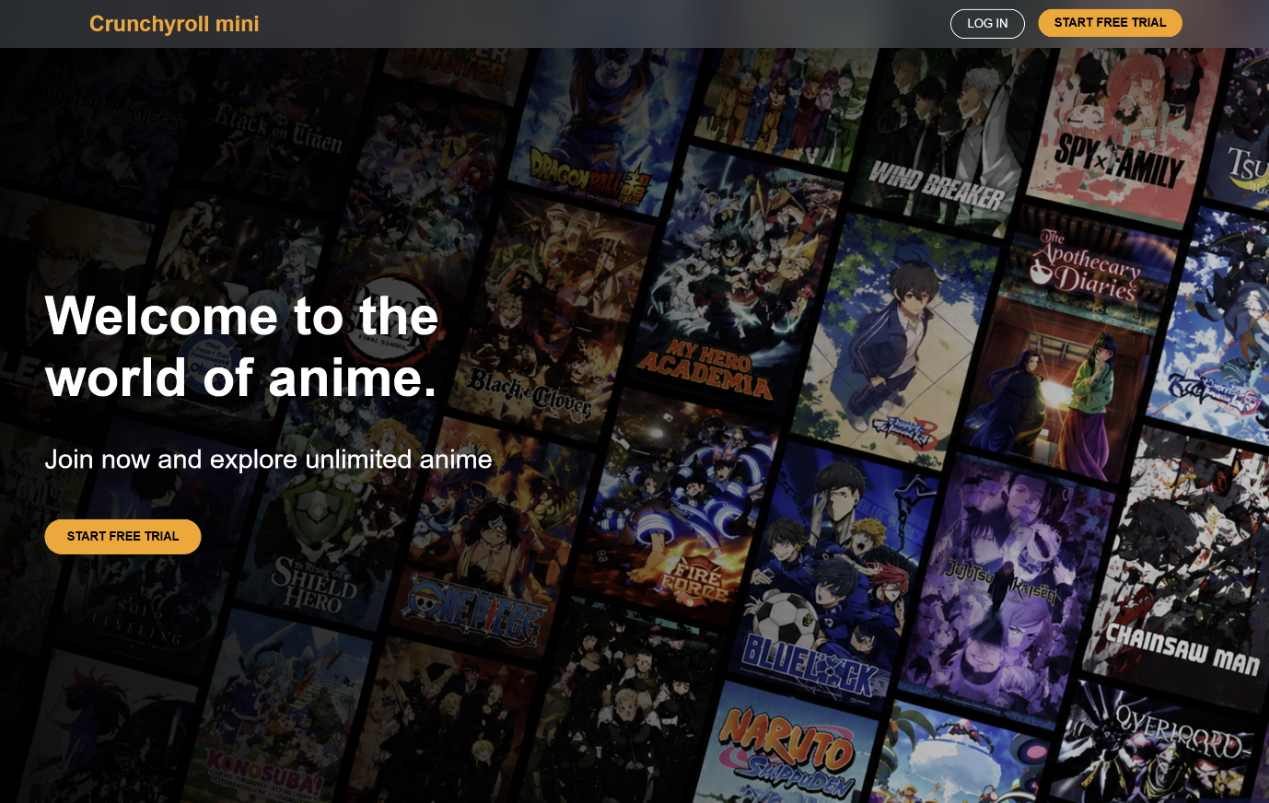
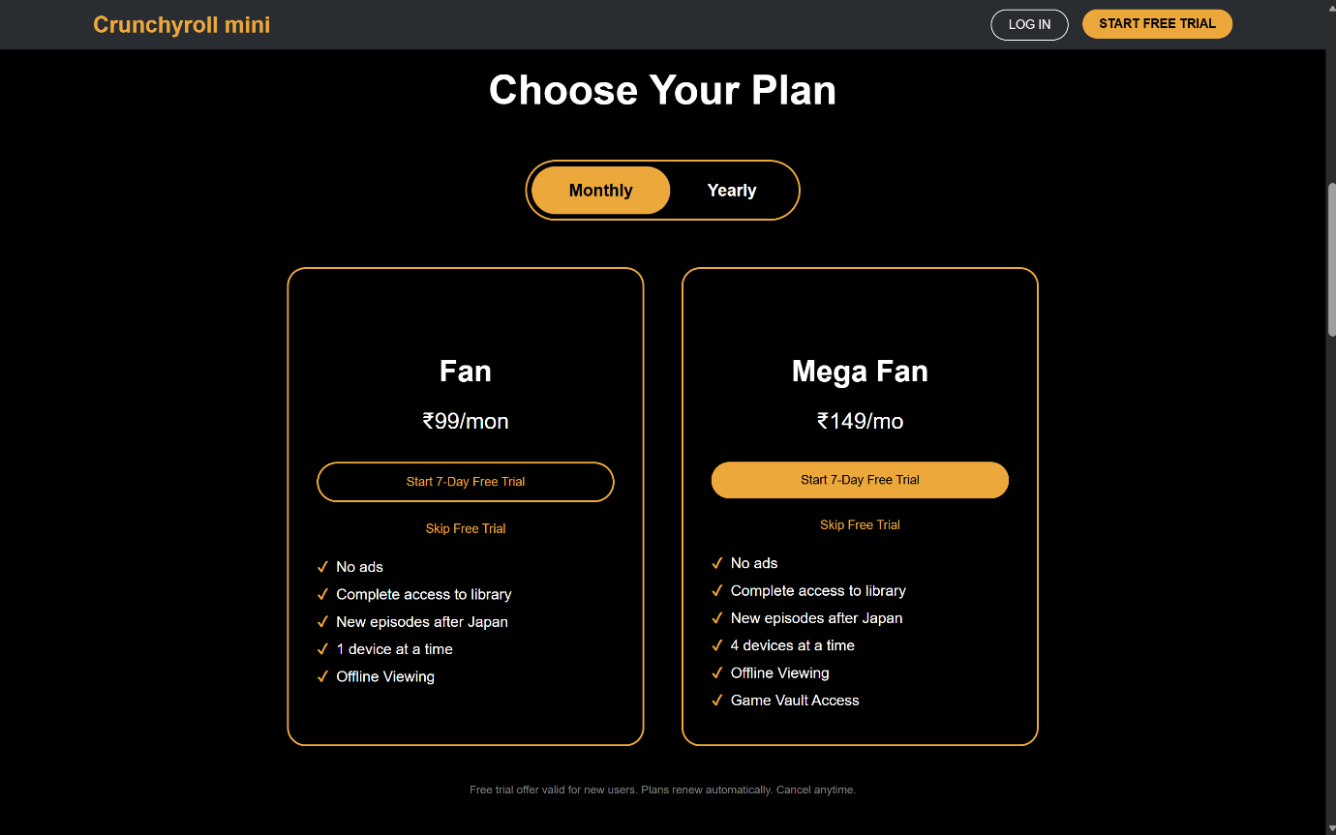

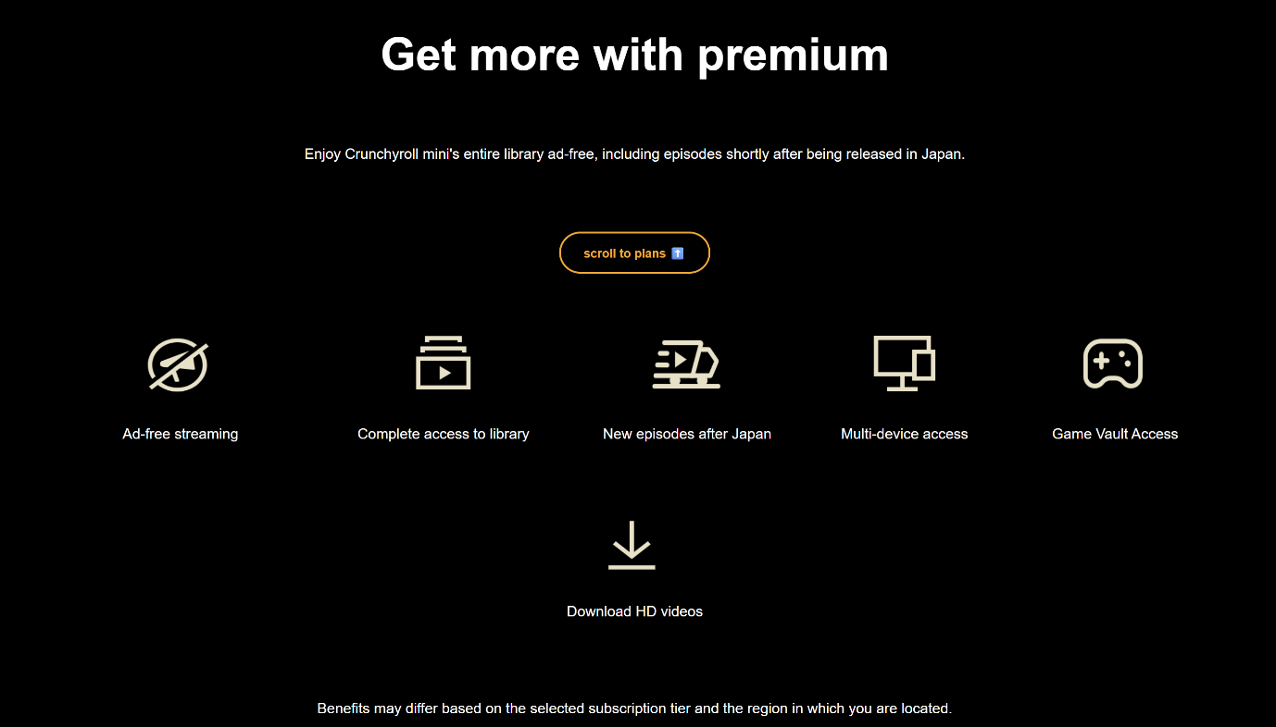
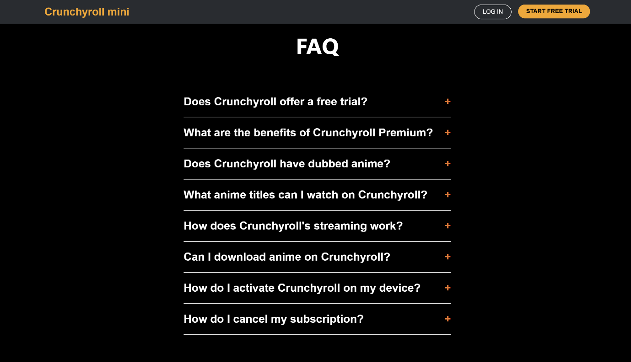
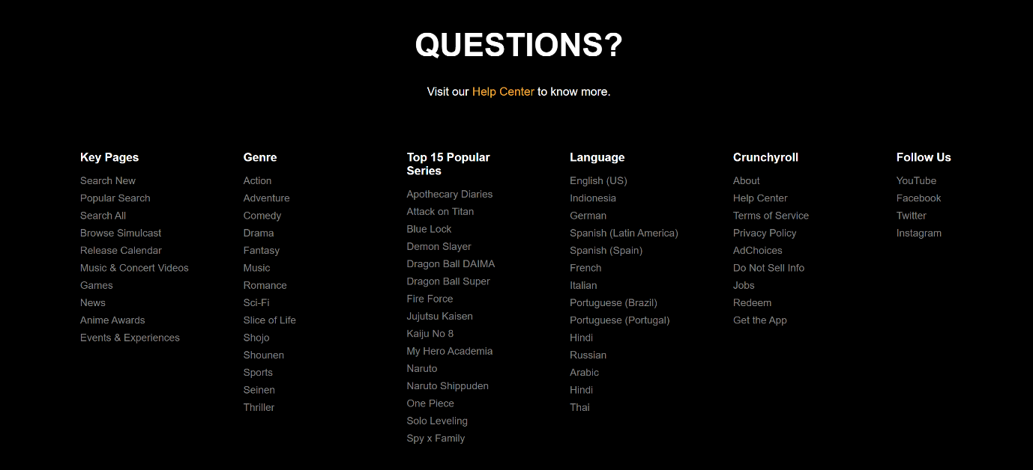
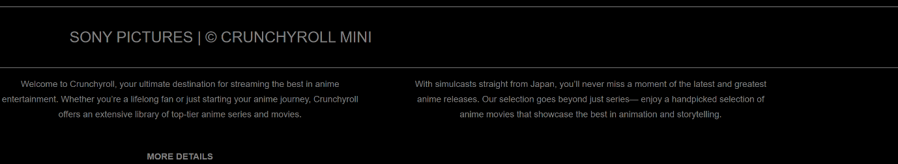
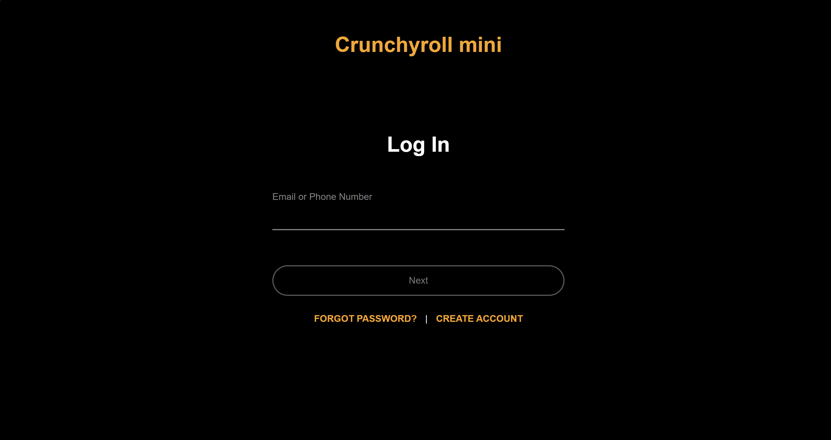

- Explanation:
- <!DOCTYPE html> defines the document as an HTML5 webpage.
- <html> is the root element of the webpage.
- <head> : Contains title, CSS links, and JavaScript code.
- <style> : Contains internal CSS styling for the webpage.
- header.css → Header section styling
- faq.css → FAQ section styling
- payment.css → Subscription plan styling
- footer.css → Footer section styling
- function changePlan(type, btn) : function changes subscription pricing between - Monthly plans & Yearly plans
- buttons[i].classList.remove("active"); : Removes active style from all buttons.
- btn.classList.add("active"); : Adds active style to the selected button.
- <button class="login">LOG IN</button> : Redirects user to login.html.
- <button class="register">START FREE TRIAL</button> : Scrolls to subscription plans section.
- <button onclick="changePlan('monthly', this)">Monthly</button> : Allows users to switch between - Monthly pricing & Yearly pricing
- <div class="faq-container"> : Contains frequently asked questions.
- Each FAQ item has: Question button & Hidden answer section.
- item.classList.toggle("active"); : Adds/removes the active class & used for showing and hiding answers.
- function toggleDetails() : Shows or hides extra descriptive text.
- leftText.style.display = "block"; : Displays hidden text.
- leftText.style.display = "none"; : Hides text again.
- button.innerHTML = "FEWER DETAILS"; : Changes button label dynamically.
- Centers all login elements vertically and horizontally using Flexbox.
- * { margin:0; padding:0; box-sizing:border-box; } : Removes default spacing and makes layout sizing easier.
- .logo : Styles the Crunchyroll Mini logo with orange color and large font size.
- .container : Uses Flexbox to center all login elements vertically.
- input:focus : Changes input underline color to orange when clicked.
- <button onclick="validateInput()">Next</button> : Calls JavaScript validation function when clicked.
- <a href="https://sso.crunchyroll.com/reset-password">FORGOT PASSWORD?</a> : Redirects user to password reset page.
- document.getElementById("userInput").value : Gets user input value.
- display: flex; : Arranges header elements in a horizontal row using Flexbox.
- justify-content: space-between; : Places logo on left and buttons on right.
- align-items: center; : Vertically centers header items.
- position: fixed; : Keeps header fixed at top while scrolling.
- backdrop-filter: blur(20px); : Creates glassmorphism blur effect behind header.
- box-sizing: border-box; : Includes padding inside total width calculation.
- cursor: pointer; : Changes mouse cursor to pointer on hover.
- background: linear-gradient(...) : Adds dark gradient overlay over wallpaper image.
- cursor: pointer; : Changes cursor to pointer when hovered.

