**ONLINE DOCTOR APPOINTMENT**

**ABSTRACT:**

The proposed project is online doctor appointment system that provides patients or any user an easy way of booking a doctor’s appointment online. This is an application project in android that overcomes the issue of managing and booking appointments according to user’s choice or demands. The task sometimes becomes very tedious for the compounder or doctor himself in manually allotting appointments for the users as per their availability. Hence this project offers an effective solution where users can view various booking slots available and select the preferred date and time. This system is very much useful to save the patients timing and also easy to analyze the doctor availability. The patient can easily interact with doctor for their problem and get solutions from the doctor. Another advantage is that the doctor cans easily knowing the duty time and duration.

**EXISTING SYSTEM:**

Under manual Online Doctor System, you have to first wait in line to take appointment for the doctors and wait for your time to have meet with them and discuss on your health problems.As you have to provide your information and other reports many times at different places such as the medicine store which is again a burden of carrying documents. You have to be present physically at the doctor’s cabin. Patients have to visit on another day of after some hours to take their health reports which involves extra care person with patients anytime. Under manual system, the only accepted payment method is by cash and if patients due to some reasons are not having cash on time may face difficulties and not able to get treatment.

## ****PROPOSED SYSTEM:****

To make a truly Online Doctor System system to have meet with online doctors, all manual process has been automated through this system. Patient have to fill online form by which id and password created and sended to their email and upon accepting data, automatic login to patient panel. Through this panel, patients can select the doctors and have appointment with them on their time from their own place. Patients will get all their reports and medicine prescriptions in their inbox by notification indication just after appointment session. There is no need of cash and a secure payment gateway has been used to pay the required fees using their account or debit or credit card.

**ARCHITECTURE DIAGRAM:**

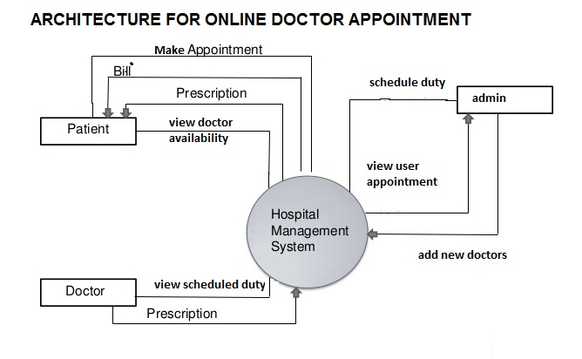

**MODULES DESCRIPTION**

**MODULES:**

* Hospital module
* Doctor module
* Patient module

**Hospital module:**

The hospital module is the admin module in this project. This module having the admin login and registration process, the admin module control the doctor’s duty scheduled, adding the new doctors and finally view the patients who make the appointments for check up and interact with doctor for their problems.

* Doctor scheduled duty
* Add new doctor
* User appointment

**Doctor module:**

The doctor module is the user module in the project. This module is allocate only for doctor who is working over there, This module is used to view the scheduling duty time for the doctor this scheduling time is very much useful for doctor to knowing the details about duty.

* View scheduled duty time.

**Patient module:**

The patient module is used to view the doctor’s details and make appointment with relevant doctor. Once the patient search the doctor for make appointment. The available doctor was display on the list. Then the patient registered the own details and problem and select the doctor then make the appointment with that doctor.

* view doctor availability
* make appointment

**SYSTEM SPECIFICATION:**

**HARDWARE REQUIREMENTS:**

* **System :** Pentium IV 2.4 GHz.
* **Hard Disk :** 40 GB.
* **Monitor** : 14’ Colour Monitor.
* **Mouse :** Optical Mouse.
* **Ram :** 2 gb.

**SOFTWARE REQUIREMENTS:**

* **Operating system :** Windows 7 Ultimate.
* **Coding Language :** Java.
* **Front-End :** Eclipse.
* **Data Base :** SQLite Manger.

**CONCLUSION:**

This project make the patients work easily and reduce the conception of waiting time. The project “online doctor’s appointment “is not only for making the patients appointments but also knowing the duty time of the doctor’s who working over there. The project can be implemented in hospitals and clinics. It can be utilized by companies and organizations (hospitals, schools, colleges) to automate their parking system.