**1. INTRODUCTION**

The ProTrack system is a Project Tracking and Management System designed specifically for the Computer Science Department. It streamlines the process of managing student projects by providing a structured platform for administrators, teachers, and students to collaborate efficiently. The system ensures proper tracking of project progress, submission deadlines, and review schedules, making project evaluation more organized and transparent.

The project consists of three modules: Admin (Head of the Department), Teacher, and Student. The Admin module, developed as a web application, enables department heads to manage students, assign teachers, and oversee project progress. The Teacher and Student modules, developed as mobile applications, allow teachers to review projects and provide feedback, while students can submit projects and track their review status. With features such as project type management, technology tracking, and scheduled reviews, ProTrack enhances efficiency in academic project management, ensuring a smooth and structured workflow for all users.

**2. SYSTEM ANALYSIS**

System analysis is the process of gathering and interpreting facts, diagnosing problems and using the facts to improve the system. Analysis is a detailed study of various operations performed by a system and their relationship within and outside of the system. This involves gathering information and using structured tools for analysis. System analysis is a step-by-step process used to identify and develop or acquire the software need to control the processing of specific application. System analysis is a continuing activity the stages of the systems development. System analysis is the process of gathering and interpreting facts, diagnosing problems and using the facts to improve the system. The outputs from the organization are traced through the various processing that the input phases through in the organization. This involves gathering information and using structured tools for analysis. A detailed study of this process must be made by various techniques like interviews; questionnaires etc. It is necessary to have such a good system analysis and then by a project development cycle so that the project can be completed in a strictly manner and able to finish with the desired time. The analyst must be so careful about his responsibilities. As the next step the current system analysis is done which identifies the real need of establishing our project in the environment, its opportunities and constraints etc. All of the steps discussed above are collectively known as the system analysis.

**2.1 EXISTING SYSTEM**

The current system for managing academic projects in educational institutions relies heavily on manual processes, spreadsheets, and basic digital tools such as emails or local file storage. Students submit their project proposals, reports, and review files through email or physical copies, which faculty members then review and provide feedback on. This method lacks centralized tracking, making it difficult for administrators and teachers to monitor project progress effectively. Communication between students and teachers often takes place through disconnected channels, leading to delays, miscommunication, and missed deadlines. Additionally, project records are often scattered across different platforms, making it challenging to maintain a structured workflow for submission, evaluation, and feedback.

**Drawbacks of the Existing System:**

1. Lack of Centralized Management: Data is scattered across multiple platforms, making it difficult to track project progress efficiently.
2. Time-Consuming Process: Manually handling project approvals, reviews, and feedback increases administrative workload.
3. Limited Collaboration: Communication gaps between students, teachers, and administrators lead to delays in project completion.
4. Difficulty in Tracking Changes: There is no structured version control for project updates, making it hard to track modifications and feedback.
5. Security Concerns: Sensitive project data may not be securely stored, increasing the risk of data loss or unauthorized access.

Due to these limitations, a more automated, centralized, and user-friendly system like ProTrack is needed to streamline project tracking, enhance communication, and ensure efficient management of academic projects.

**2.2 PROPOSED SYSTEM**

The ProTrack system is designed to provide an efficient and structured platform for managing academic projects in the Computer Science department. This system will automate project tracking, submission, review, and evaluation by integrating a centralized web and mobile application. It aims to enhance coordination between students, teachers, and administrators, ensuring seamless communication and efficient project management. The system will consist of three modules: the Admin (Head of Department) module as a web application, and the Teacher and Student modules as mobile applications.

The proposed system enables students to submit project files digitally, while teachers can review, provide feedback, and track progress in real-time. Automated notifications ensure deadline updates, and secure storage maintains data integrity. Analytics help administrators monitor progress and workload. ProTrack enhances efficiency, reduces errors, and improves academic collaboration.

**ADVANTAGES**

The ProTrack system introduces several key advantages over the existing manual or semi-digital project management methods.

1. Efficient Project Management – The system provides a structured and centralized platform for tracking project progress, making it easier for students, teachers, and administrators to stay updated on the status of each project.
2. Paperless Workflow – By digitizing project submissions, reviews, and approvals, the system eliminates the need for physical documentation, reducing paperwork and ensuring an eco-friendly approach.
3. Improved Communication – The system facilitates seamless communication between students and faculty members through real-time notifications, comments, and feedback mechanisms, reducing delays caused by miscommunication.
4. Automated Notifications and Reminders – Students and faculty receive automatic reminders for submission deadlines, review schedules, and progress updates, minimizing the chances of missing important tasks.
5. Secure and Organized Data Storage – All project-related documents and records are stored securely in a centralized database, making retrieval easy while preventing data loss or unauthorized access.
6. Enhanced Evaluation Process – Teachers can efficiently review submissions, provide feedback, and track students' progress, ensuring a transparent and systematic evaluation process.
7. Role-Based Access Control – The system ensures that only authorized users (admin, teachers, students) can access specific functionalities, enhancing security and maintaining confidentiality.
8. Time-Saving and User-Friendly Interface – The intuitive UI allows users to navigate effortlessly, making project management more efficient while saving time for both students and faculty.

**2.3 SYSTEM REQUIREMENT SPECIFICATION**

A software requirements specification (SRS) is a comprehensive description of the intended purpose and environment for software under development. The SRS fully describes what the software will do and how it will be expected to perform. An SRS minimizes the time and effort required by developers to achieve desired goals and also minimizes the development cost. A good SRS defines how an application will interact with system hardware, other programs and human users in a wide variety of real worked situations.

**Problem to be Solved**

This system solves the manual errors happening in a daycare.

**Customer requirements**

* The system should be fast.
* User friendly.
* Maintaining the security of customer’s data.
* Efficiency in data retrieval and appointment management

**What does the developer need to know?**

1. Must know the existing system and its drawbacks.
2. Must know what will be needed in the proposed system.

**Business Requirements**

The system should be feasible both for the developer and the client. It should be effective and should be able to be completed in time. The developer should be responsible for developing the system, installing the software, updating the software whenever necessary, and conducting any user training that may be needed for using the system.

**User Requirements**

The user requirement(s) specification is a document usually that specifies the requirements the user expects from software to be constructed in a software project.

The administrator has overall control of the system.

* Provide customer details.
* Faster processing

**Functional Requirements**

Functional requirements define what a system is supposed to do. The system should perform the following functionalities.

* Login – Login of admin, teacher, and student.
* Admission– Teacher can register new student.
* Edit profile– Students can update their profile.
* View status – Students can view the status of their activities in the app.
* Approve – The teacher can approve the abstract.
* Logout – System users can log out from the app.

**2.3.1 HARDWARE SPECIFICATIONS**

Processor: Intel core i5 or higher processor

Speed : 2.50GHz or Higher

System bus : 64 bits

Memory : 16 GB RAM or Higher

Hard disk : 40 GB or Higher

Monitor : 15.6” FHD

Keyboard : 104 Keys

Pointing Device: Two or Three Button Mouse.

**2.3.2 SOFTWARE SPECIFICATIONS**

Operating System: Windows 11

Front End: Flutter (Dart)

Back End: Supabase

Development Tools: Android Studio, Visual Studio Code

Platform: Android, Web

Browser Compatibility: Google Chrome,

**2.3.3 FRONT END**

**FLUTTER**

Flutter is an open-source UI software development kit created by Google. It is used to develop cross-platform applications from a single codebase, allowing developers to build high-performance, visually appealing apps for mobile, web, and desktop.

* Flutter uses the Dart programming language, which is optimized for fast app development.
* It provides a rich set of pre-designed widgets that help create responsive and attractive user interfaces.
* Flutter’s hot reload feature allows developers to see real-time updates without restarting the application.
* It ensures a smooth user experience with a high frame rate and native-like performance.

**Common Uses of Flutter**

* Flutter is used for building mobile applications that work on both Android and iOS.
* It enables web and desktop development using the same codebase.
* It is ideal for applications requiring rich UI elements and animations.
* It integrates seamlessly with Supabase for backend services such as authentication, cloud storage, and real-time databases.

**Characteristics of Flutter**

Flutter's advantages include:

Cross-Platform Development – Develop once, deploy anywhere.

Fast Development – Hot reload accelerates the development process.

Beautiful UI – Uses Material Design and Cupertino widgets.

High Performance – Delivers near-native performance.

Strong Community Support – Backed by Google and a vast developer community

**2.3.4 BACK END**

**SUPABASE**

Supabase is an open-source backend-as-a-service (BaaS) platform that provides a scalable and powerful alternative to Firebase. It is built on PostgreSQL and offers real-time capabilities, authentication, and cloud storage.

* Supabase Authentication allows secure user login using email, Google, and other OAuth providers.
* Supabase Database is a managed PostgreSQL database with real-time capabilities.
* Supabase Storage enables file and media storage with easy access control.
* Supabase Functions provide serverless computing for custom backend logic.
* Supabase API allows seamless integration with Flutter applications

**2.4 FEASIBILITY ANALYSIS**

A feasibility study is an evaluation and analysis of the potential of the proposed project which is based on extensive investigation and research to give full comfort to the decision makers. Feasibility studies aim to objectively and rationally uncover the strengths and weaknesses of existing business of proposed venture, opportunities and threats as presented by the environment, the resources required to carry through, and ultimately the process for success. In its simplest terms, the two criteria to judge feasibility are cost required and value to attain. As such, a well-designed feasibility study should provide a historical background of the business or project, a description of the product or service, accounting statements, details of the operations and management, marketing research and policies, financial data, legal requirements, and tax obligations.

The four aspects of the feasibility study are:

* Technical feasibility
* Economic feasibility
* Operational feasibility
* Behavioural feasibility

**Technical Feasibility**

The technical feasibility centers on the existing system and to what extent it can support the proposed addition. The technical feasibility assessment is focused on gaining an understanding of the present technical resources of the organization and their applicability to the expected needs of the proposed system. The minimum requirements of the system are met by the average user. The developer system has á modest technical requirements as only minimal or null changes are required for implementing the system.

Normally associated with the technical feasibility includes:

* Development risk
* Resource availability
* Technology

The proposed system can work without any additional hardware or software support other than the computer system and networks. So, I analyzed that the proposed system is much more technically feasible than other systems when compared with the benefits of the new system.

**Economic Feasibility**

Economic feasibility analysis is also known as cost/benefit analysis. The purpose of the economic feasibility assessment is to determine the positive economic benefits to the organization that the proposed system will provide. The proposed system reduces the operating cost in terms of time by automating the process. This system is economically feasible.

**Operational Feasibility**

Operational feasibility is a measure of how well a proposed system solves problems and takes advantage of the opportunities identified during scope definition and how it satisfies the requirements identified in the requirements analysis phase of system development.

**Behavioral Feasibility**

People are inherently resistant to changes and computer is known for facilitating the changes.

An estimate should be made to how strongly the users react toward the e development of the system. The proposed system consumes less time. Thus, the people are made to engage in some other important work.

**2.5 DATA FLOW DIAGRAM (DFD)**

A data flow diagram (DFD) is a graphical representation of the "flow" of data through an information system. It differs from the flowchart as it shows the data flow instead of the control flow of the program. A data flow diagram can also be used for the visualization of data processing (structured design).

Data flow diagrams were invented by Larry Constantine, the original developer of structured design based on Martin and Estrin's "data flow graph" model of computation.

Data flow diagrams (DFDs) are one of the three essential perspectives of Structured System Analysis and Design Method SSADM. The sponsor of a project and the end users will need to be briefed and consulted throughout all stages of a system's evolution. With a data flow diagram, users can visualize how the system will operate, and what the system will accomplish. and how the system will be implemented. The old system's data flow diagrams can be drawn up and compared with the new system's data flow diagrams to draw comparisons to implement a more efficient system. Data flow diagrams can be used to provide the end user with a physical idea of where the data they input ultimately has an effect on the structure of the whole system from order to dispatch to report. How any system is developed can be determined through a data flow diagram.

Developing a data flow diagram helps in identifying the transaction data in the data model. There are different notations to draw data flow diagrams, defining different visual representations for processes, data stores, data flow, and external entities. The first step is to draw a data flow diagram (DFD). A DFD also known as a "bubble chart" has the purpose of clarifying system requirements and identifying major transformations that will become programs in system design. So, it is the starting point of the design phase that functionally decomposes the requirements specification down to the lowest level of details DFD consists of a series of bubbles joined by lines. The bubbles represent data transformation and the Iines represent data flow in the system.

**DFD Symbols: -**

* Square- Defines the source or destination of the system.



* Data flow - Identifies data flow Circle.

* Bubble - Represents a process that transforms incoming data to outgoing data.

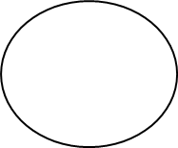

* Open rectangle- Data store

|  |  |
| --- | --- |
|  |  |

**LEVEL 0**

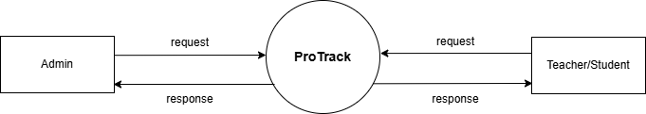

**LEVEL 1**

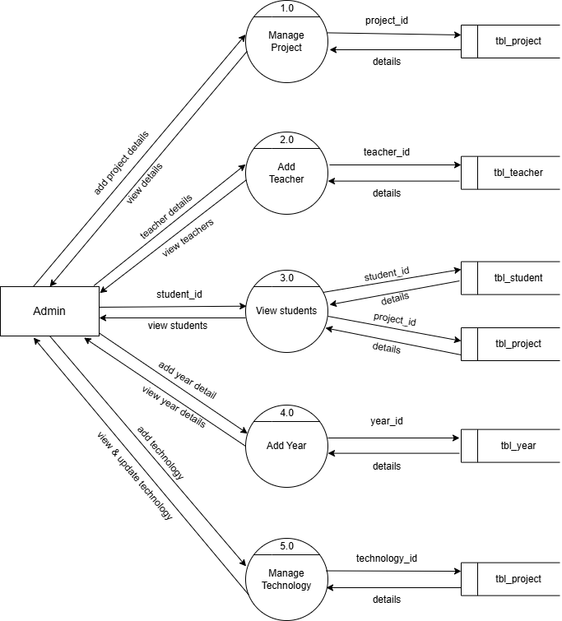

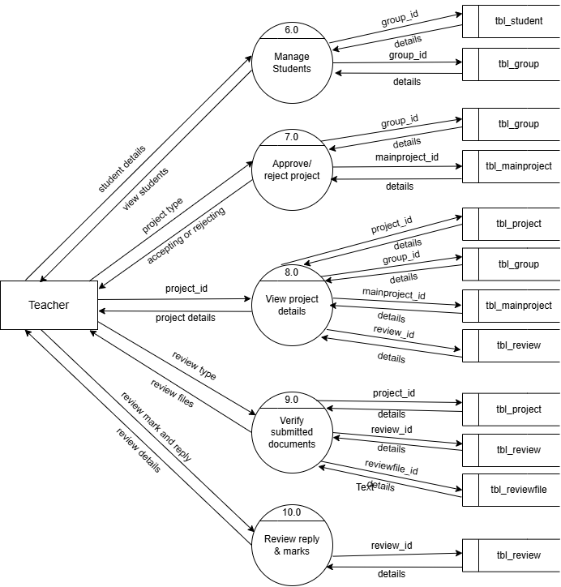

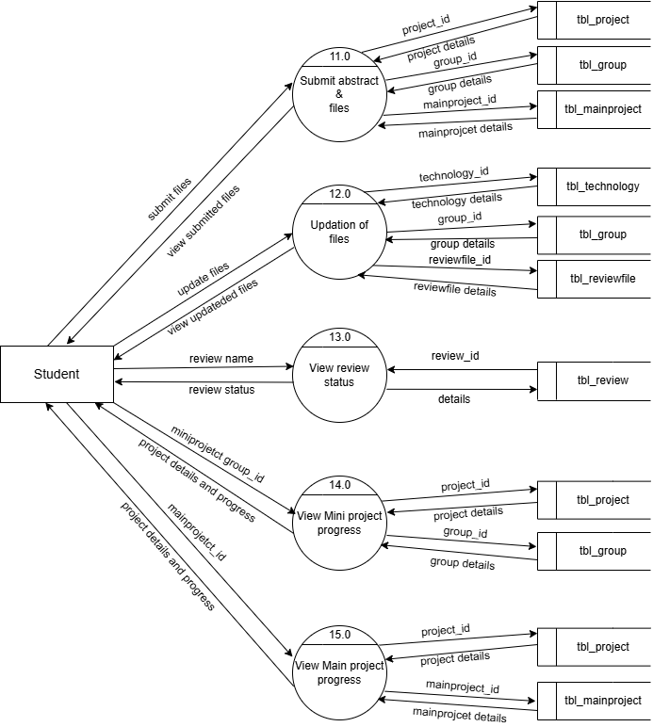

**3. SYSTEM DESIGN**

**3.1 INPUT DESIGN**

The quality of the system input determines the quality of the system output. Input specification describes the way data enter the system for processing. Input design features can ensure the reliability of the system and produce results from accurate data, or they can result in the production or erroneous information. The input design also determines whether the user can interact efficiently with the system.

In our system almost all inputs are being taken from the databases. To provide adequate inputs we have to select necessary values from the databases and arrange it to the appropriate controls.

**ADMIN**

The Admin oversees project management, assigning teachers to student groups, setting review schedules, and monitoring progress. They ensure smooth coordination, manage academic data, and generate reports for efficient project tracking.

**TEACHER**

The Teacher supervises student projects, reviews submissions, provides feedback, and tracks progress. They guide students throughout the project and ensure timely completion.

**STUDENT**

The **Student** submits project proposals, reports, and reviews, receives feedback from teachers, and tracks project progress through the system.

**3.2 OUTPUT DESIGN**

In ProTrack, output plays a vital role in delivering meaningful information to users—Admins, Teachers, and Students. The success of the system heavily depends on the clarity and relevance of its output, as users often evaluate a system based on what it delivers. Poor or confusing output can lead to user dissatisfaction, making even a well-developed system feel ineffective.

To ensure value, ProTrack generates structured and user-friendly outputs such as review results, feedback, submission statuses, and progress reports. Students receive timely notifications and remarks, while teachers can track project details, view submissions, and provide feedback. Admins access analytics and summaries for efficient monitoring.

Each output is designed through continuous interaction with users, ensuring the information is relevant, clear, and timely. This enhances transparency, improves academic coordination, and encourages effective usage of the system.

**3.3 TABLE DESIGN**

The data design transforms the information domain model created during analysis into the data structures that will be required to implement the software. The data objects and relationships defined in the entity relationship diagram and the detailed data content depicted in the data dictionary provide the basis for the data design activity.

The overall objective in the development of database technology has been to treat data as an organizational resource and as an integrated whole. Database Management System allows data to be protected and organized separately from other resources. A database is an integrated collection of data. This is the difference between logical and physical data.

The organization of data in the database aims to achieve three major objectives:

* Data integration
* Data integrity
* Data independence

The databases are implemented using a DBMS package. Each DBMS has unique

characteristics and general techniques for database design. There are 6 major steps in the design

process. The first 5 steps are usually done on paper and finally, the design is implemented.

* Identify the table and relationships.
* Identify the data that is needed for each table and relationship.
* Resolve the relationship.
* Verify the design.
* Implement the design.

The database uses tables for storage. A table also contains records, which is a set of fields.

All records, in a table have the same set of fields with different information. Uses 3 tables.

Each table contains key fields that establish relationships in the database and how the records are stored. There are primary key fields that uniquely identify a record in a table. There are also fields that contain the primary key from another table called foreign keys.

**Table Design**

1. Table name: tbl_admin

Primary key: admin_id

Description: Stores the details of admin.

|  |  |  |
| --- | --- | --- |
| **FIELD NAME** | **DATA TYPE** | **DESCRIPTION** |
| admin_id | UUID | Unique id of admin |
| admin_name | TEXT | Name of admin |
| admin_email | TEXT | Email id of admin |

2.Table name: tbl_teacher

Primary key: teacher_id

Description: Stores the details of teacher.

|  |  |  |
| --- | --- | --- |
| **FIELD NAME** | **DATA TYPE** | **DESCRIPTION** |
| teacher_id | UUID | Unique id of staff |
| teacher_name | TEXT | Name of staff |
| teacher_email | TEXT | Email id of staff |
| teacher_contact | TEXT | Contact of staff |
| teacher_password | TEXT | Password |
| teacher_photo | TEXT | Photo |

3. Table name: tbl_student

Primary key: student_id

Foreign key: teacher_id, year_id

Description: Stores the details of student.

|  |  |  |
| --- | --- | --- |
| **FIELD NAME** | **DATA TYPE** | **DESCRIPTION** |
| student_id | INT | Unique identifier for each attendance record. |
| student_name | TEXT | Name of student |
| student_photo | TEXT | Photo |
| student_contact | TEXT | Contact number of student |
| student_email | TEXT | Email of student |
| teacher_id | INT | The unique id of students project guide teacher |
| year_id | INT | Students year id |

4. Table name: tbl_group

Primary key: group_id

Foreign key: project_id

Description: Stores the details of group

|  |  |  |
| --- | --- | --- |
| **FIELD NAME** | **DATA TYPE** | **DESCRIPTION** |
| group_id | INT | Unique id of group |
| group_abstract | TEXT | Group abstract of project |
| group_status | INT | Status of group |
| group_center | TEXT | Center for group project |
| project_title | TEXT | Title of project |
| project_id | INT | Unique id of project |

5. Table name: tbl_groupmember

Primary key: groupmember_id

Foreign key: group_id, student_id

Description: Stores the details of groupmember.

|  |  |  |
| --- | --- | --- |
| **FIELD NAME** | **DATA TYPE** | **DESCRIPTION** |
| groupmember_id | INT | Unique id of groupmember |
| group_id | INT | Unique id of group |
| student_id | INT | Unique id of student |

6. Table name: tbl_mainproject

Primary key: event_id

Foreign key: student_id, technology_id, project_id

Description: Stores the details of the mainproject.

|  |  |  |
| --- | --- | --- |
| **FIELD NAME** | **DATA TYPE** | **DESCRIPTION** |
| mainproject_id | INT | Unique id of mainproject |
| mainproject_abstarct | TEXT | Abstract of mainproject |
| mainproject_status | INT | Status of mainproject |
| mainproject_center | TEXT | Center of mainproject |
| project_id | INT | Unique id of project |
| technology_id | INT | Unique id of technology |
| student_id | INT | Unique id of student |

7. Table name: tbl_project

Primary key: project _id

Description: Stores the details of the project.

|  |  |  |
| --- | --- | --- |
| **FIELD NAME** | **DATA TYPE** | **DESCRIPTION** |
| project _id | INT | Unique id of project |
| project _type | TEXT | Type of project |
| project _date | TEXT | Starting date of project |
| project _review1 | TEXT | First review date |
| project _review2 | INT | Second review date |
| project _review2 | TEXT | Third review date |
| project _status | TEXT | Status of project |

8. Table name: tbl_review

Primary key: review_id

Foreign key: group_id, mainproject_id

Description: Stores the details of the review.

|  |  |  |
| --- | --- | --- |
| **FIELD NAME** | **DATA TYPE** | **DESCRIPTION** |
| review_id | INT | Unique id of review |
| review_date | TEXT | Date of review |
| review_type | TEXT | Type of review |
| review_mark | TEXT | Mark of review |
| review_reply | TEXT | Reply of review |
| group_id | INT | Unique id of group |
| mainproject_id | INT | Unique id of mainproject |

9.Table Name: tbl_reviewfile  
 Primary Key: reviewfile_id

Foreign key: review_id  
 Description: Stores details of reviewfile.

|  |  |  |
| --- | --- | --- |
| **FIELD NAME** | **DATA TYPE** | **DESCRIPTION** |
| reviewfile_id | INT | Unique id of reviewfile |
| reviewfile_file | TEXT | Files in review |
| file_type | TEXT | Type of file |
| review_id | INT | Unique id of review |

10.Table Name: tbl_technology  
 Primary Key: technology_id  
 Description: stores details of technology.

|  |  |  |
| --- | --- | --- |
| **FIELD NAME** | **DATA TYPE** | **DESCRIPTION** |
| technology_id | INT | Unique id of technology |
| technology_name | TEXT | Name of technology |

11.Table Name: tbl_year  
 Primary Key: year_id  
 Description: store details of year

|  |  |  |
| --- | --- | --- |
| **FIELD NAME** | **DATA TYPE** | **DESCRIPTION** |
| year_id | INT | Unique id of year |
| year_name | TEXT | Name of year |

**4. SYSTEM IMPLEMENTATION AND TESTING**

**4.1 SYSTEM TESTING**

Testing is the process of examining the software to compare the actual behaviour with that of the excepted behaviour. The major goal of software testing is to demonstrate that faults are not present. In order to achieve this goal, the tester executes the program with the intent of finding errors. Though testing cannot show the absence of errors by not showing their presence it is considered that these are not present.

System testing is defined as the process by which one detects defects in the software. Any software development organization or team has to perform several processes. Software testing is one among them. It is the final opportunity of any programmer to detect and rectify any defects that may have appeared during the software development stage. Testing is the process of testing a program with the explicit intention of finding errors that make the program fail. In short system testing and quality assurance is a review of software products and related documentation for completion, correctness, reliability, and maintainability.

System testing is the first stage of implementation, which is aimed at ensuring that the system works accurately and efficiently before live operation commences. Testing is vital to the success of the system. System testing makes a logical assumption that if all the parts of the system are correct the goal will be successfully achieved. A series of tests are performed for the proposed system before the proposed system is ready for user acceptance testing. The testing steps are,

* Unit testing
* Integration testing
* Acceptance Testing
* Validation
* Output testing

System Testing provides the file assurance that software once validated must combined with all other system elements. System testing verifies whether all elements have been combined properly and that overall system function and performance are achieved. FA the integration of modules, the validation test was carried out over the system. It was that all the modules worked well together and met the overall system function and performance.

**1. Unit Testing**

Unit testing is carried out screen-wise, with each screen being identified as an object. Attention is diverted to individual modules, independently to one another to locate errors. This has enabled the detection of errors in coding and logic.

Various test cases are prepared. For each module, these test cases are implemented, and it is checked whether the module is executed as per the requirements and outputs the desired result.

In this test each service input and output parameters are checked.

In unit testing

* Module interface was tested to ensure that information properly flows into and out of the program under test.
* Boundary condition was tested to ensure that the module operates properly at boundaries established to limit or restrict processing.
* All independent paths through the control structures were executed to ensure that all statements in the modules have been executed at least once.
* Error handling paths were also tested.

**2. Integration Testing**

Integration testing is a systematic technique for constructing the program structure while at the same time conducting tests to uncover errors associated with interfacing.

Unit-tested modules were taken and a single program structure was built that has been dictated by the design. Incremental integration has been adopted here.

The modules are tested separately for accuracy and modules are integrated too.th tn. using bottom-up integration i.e., by integrating from moving from the bottom to the top of the system is checked and errors found during integration are rectified. In this testing individual modules were combined and the module-wise Shifting was verified to be right. The entire software was developed and tested in small segments, where errors were easy to locate and rectify. The program builds (group of modules) were constructed corresponding to the successful testing of user interaction, data manipulation analysis, display processing, and database management.

**3. Validation Testing**

Validation testing is done to ensure complete assembly of the error-free software. Validation can be termed successful only if it functions in a manner. Reasonably expected by the student under validation is alpha and beta testing. The student-side validation is done in this testing phase. It is checked whether the data passed to each student is valid or not. Entering incorrect values does the validation testing and it is checked whether the errors are being considered. Incorrect values are to be discarded. The errors are rectified.

In “ProTrack" verifications are done correctly. So, there is no chance for users to enter incorrect values. It will give error messages by using different validations. The validation testing is done very clearly and it is error-free.

**4. Output Testing**

After performing the validation testing the next step is output testing of the proposed system, since no system could be useful if it does not produce the required output in a specific format.

The output format on the screen was found to be correct as the format was designed in the system design phase according to the user's needs. For the hard copy also, the output comes out as specified requirement by the user. Hence output testing does not result in any Correction in the system.

Output This project is developed based on the user's choice. It is user-friendly. The output format is very clear to the user.

**5. Acceptance testing**

Acceptance involves running a suite of tests on the completed system. Each individual test, known as a Case, exercises a particular operating condition of the operating condition of the user's environment or feature of the system and will result in a pass-fail, or Boolean outcome.

**4.2 SYSTEM IMPLEMENTATION**

The implementation is the final stage, and it is an important phase. It involves invalid programming system testing. user training and the operational running of the developed proposed system that constitutes the application subsystems. A major task in preparing for implementation is the education of users. which should really have taken place much carrier in the project when they were belong involved in the investigation and design work. During the implementation phase system takes physical shape. In order to develop a system implemented planning is very essential.

The implementation phase of the software development is concerned with translating design specifications into source code. The user tests the developed system and changes are made according to their needs. Our system has been successfully implemented.

Before implementation several tests have been conducted to ensure that no errors are encountered during the operation. The implementation phase ends with an evaluation of the system after placing into operation for a period of time.

The process of putting the developed system into actual use is called system implementation. This includes all those activities that take place to convert from the old system to new system. The system can be implemented only after testing is done and is found to be working to specifications. The implementation stage is a systems project in its own right.

The implementation stage involves the following tasks:

* Careful planning.
* Investigation of system and constraints.
* Design of method to achieve changeover.
* Evaluation of the changeover method.

In the case of this project all the screens are designed first. To make it to be executable, codes are written on each screen, and performs the implementation by creating the database and connecting to the server. After that the system is Checked, whether it performs all the transactions correctly. Then databases are cleared and made it to be usable to the technicians.

Implementation Plans

The following are the steps involved in the implementation plan of " TinyTots daycare system":

* Test system with sample data
* Detection and correction of errors
* Make the necessary changes in the system.
* Check the existing system.
* Installation of hardware and software utilities
* Training and involvement of user personnel

**5. SECURITY TECHNOLOGIES AND POLICIES**

The protection of computer-based resources that includes hardware, software, data procedures and people against unauthorized use or natural disaster is known as System Security.

System Security can be divided into four related issues:

* Security
* Integrity
* Privacy
* Confidentiality

**SYSTEM SECURITY** refers to the technical innovations and procedures applied to the hardware and operation systems to protect against deliberate or accidental damage from a defined threat.

**DATA SECURITY** is the protection of data from loss, disclosure, modification, and destruction.

**SYSTEM INTEGRITY** refers to the power functioning of hardware and programs, appropriate physical security and safety against external threats such as eavesdropping and wiretapping.

**PRIVACY** defines the rights of the user or organizations to determine what information they are willing to share with or accept from others and how the organization can be protected against unwelcome, unfair, or excessive dissemination of information about it.

**CONFIDENTIALITY** is a special status given to sensitive information in a database to minimize the possible invasion of privacy. it is an attribute of information that characterizes its need for protection.

**SECURITY IN SOFTWARE** System security refers to various validations of data in the form of checks and controls to prevent the system from failing. It is always important to ensure that only valid data is entered, and only valid operations are performed on the system.

The system employees two types of checks and controls:

**CLIENT-SIDE VALIDATION**

Various client-side validations are used to ensure on the client side that only valid data is entered. Client-side validation saves server time and load to handle invalid data. Some checks imposed are:

* Forms cannot be submitted without filling up the mandatory data so that manual mistakes of submitting empty fields that are mandatory can be sorted out on the client side to save the server time and load.
* Tab indexes are set according to the need and take into account the ease of the user while working with the system.

**SERVER-SIDE VALIDATION**

Some checks cannot be applied on the client side. Server-side checks are necessary to save the system from failing and inform the user that some invalid operation has been performed or the performed operation is restricted. Some of the server-side checks imposed are:

* Server-side constraint has been imposed to check for the validity of the primary key and foreign key. A primary key value cannot be duplicated. Any attempt to duplicate the primary value results in a message intimating the user about those values through the forms using foreign keys can be updated only with the existing foreign key values.
* User is intimating through appropriate messages about the successful operations or exceptions occurring at the server side.
* Various Access Control Mechanisms have been built so that one user may not agitate upon another. Access permissions to various types of users are controlled according to the organizational structure. Only permitted users can log on to the system and can have access according to their category. User- names, passwords, and permissions are controlled on the server side.
* Using server-side validation, constraints on several restricted operations are imposed.

**6. MAINTENANCE**

Software maintenance is the modification of a software product and delivery to correct faults, and improve performance, or other attributes. Maintenance is the ease with which a program can be corrected if any error is encountered, adapted if its environment changes or enhanced if the customer desires a change in requirement. Maintenance follows conversation to extend that changes are necessary to maintain satisfactory operations relative to changes in the user's environment.

Maintenance often includes minor enhancements or corrections to problems that surface in the system's operation. Maintenance is also done based on fixing the problems reported, changing the interface with other software or hardware enhancing the software.

**CATEGORIES OF MAINTENANCE**

**Corrective Maintenance**

Corrective maintenance is the most used maintenance approach, but it is easy to see its limitations. When equipment fails, it often leads to downtime in production, and sometimes damages other parts. In most cases, this is expensive. Also, if the equipment needs to be replaced, the cost of replacing it alone can be substantial. The reliability of systems maintained by this type of maintenance is unknown and cannot be measured. Corrective maintenance is possible since the consequences of failure or wearing out are not significant and the cost of this maintenance is not great.

**Perfective Maintenance**

Modification of a software product alters delivery to improve performance or maintainability. This term is used to describe changes undertaken to expand the existing requirements of the system. A successful piece of software lends to be subjected to the Succession of changes resulting in an increase in our requirements. This is based on the premise that as the software becomes useful, the user experiments with new cases beyond the of

Scope for which it was initially developed. Vxpansi01 n requirements can take the form of enhancement of existing system functionality and improvement in computational efficiency.

**Adaptive Maintenance**

Modification of a software product performed after delivery to keep a product usable, changed or changing environment. Adaptive maintenance includes any work initiated because of moving the software to a different hardware or software platform. It is a change driven by the need to accommodate modifications in the environment of a software system. The environment in this context refers to the totality of all conditions and influences which act from outside upon the system. A change to the whole or part of this environment will Warrant a corresponding modification of the software.

**Preventive Maintenance**

Preventive maintenance is a schedule of planned maintenance actions aimed at the prevention of breakdowns and failures. The primary goal of preventive maintenance is to prevent the failure of equipment before it occurs. It is designed to preserve and enhance equipment reliability by replacing worn components before they fail. Preventive maintenance activities include equipment checks, and partial or complete overhauls at specified periods.

Long-term benefits of preventive maintenance include:

* Improved system reliability.
* Decreased cost of replacement.
* Decreased system downtime.

**7. SCOPE FOR FUTURE ENHANCEMENT**

In the future, the ProTrack system can be enhanced with advanced technologies to further streamline project management and improve academic collaboration. AI-powered features such as automated project topic recommendations, plagiarism detection, and intelligent feedback analysis can enhance evaluation processes. Machine learning algorithms could track student progress and suggest personalized improvements. Cloud-based integration will ensure seamless remote access, secure storage, and real-time collaboration among students and faculty. Blockchain technology can be implemented for secure and tamper-proof record-keeping of project submissions and evaluations. Additionally, a mobile application with push notifications will enable students and teachers to manage projects on the go. Augmented Reality (AR) can be incorporated for interactive project presentations, making evaluations more engaging. Integration with external research databases and industry mentorship platforms will provide students with valuable insights and networking opportunities. Furthermore, multilingual support and accessibility features will make the system more inclusive for a diverse academic community. By leveraging these technological advancements, ProTrack can evolve into a comprehensive, smart project management solution that enhances efficiency, transparency, and collaboration in educational institutions.

**8. CONCLUSION**

The ProTrack system revolutionizes project tracking and management within academic institutions by providing a structured, digital platform for students, teachers, and administrators. By eliminating manual paperwork and scattered communication, it ensures seamless collaboration, secure document storage, and efficient project evaluation. Features like real-time feedback, automated notifications, and analytics enhance productivity and transparency. The system not only simplifies project management but also fosters a more organized and engaging academic environment. With potential future enhancements such as AI-based recommendations, cloud integration, and blockchain security, ProTrack can continue evolving to meet the growing needs of modern education. Ultimately, it serves as a powerful tool to streamline project workflows, improve academic outcomes, and enhance overall efficiency.

**9. BIBLIOGRAPHY**

**BOOKS**:

* Marco L. Napoli, *Beginning Flutter: A Hands-On Guide to App Development*
* Eric Windmill, *Flutter in Action*
* Marco L. Napoli, *Mastering Dart: Advanced Techniques for Modern Applications*
* Slobodan Stojanović, *Serverless Applications with Node.js*
* Shyam Seshadri, *Building Scalable Apps with Firebase*
* Elias M. Awad, *System Analysis and Design*

**Websites:**

* <https://flutter.dev>
* <https://dart.dev>
* <https://firebase.google.com>
* <https://supabase.com>
* <https://flutterawesome.com>
* <https://developer.android.com>
* <https://medium.com>
* <https://stackoverflow.com>
* <https://pub.dev>

**10. APPENDIX**

**10.1 SCREENSHOTS**