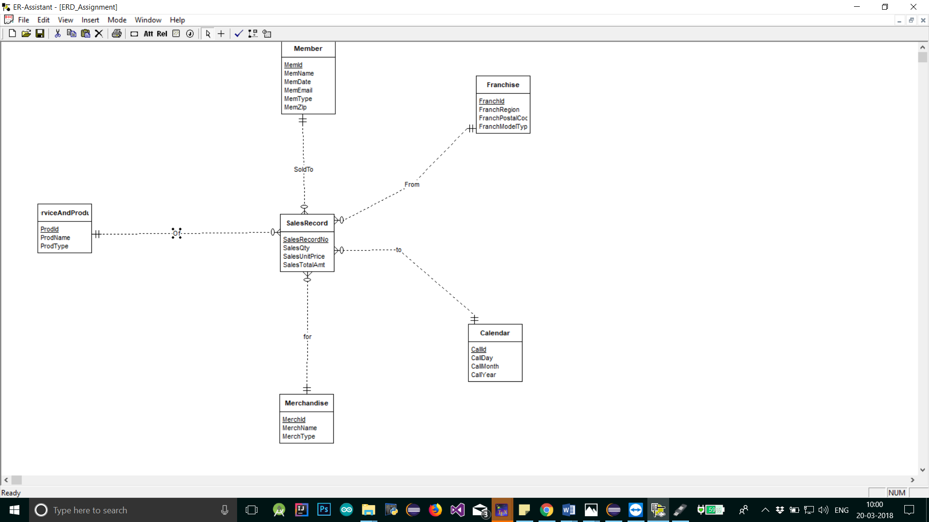

Fact Table -RecordOfSales-SalesRecordNo (Primary Key), SalesQty from contains, SalesUnitPrice, SalesTotalAmt, isService, isMerchandise .
Franchise-FranchId(primarykey),FranchRegion,FranchPostalCode,FranchModelType.
Member-MemId (Primary Key),MemName,MemZip,MemDate,MemEmail,MemType.
Calendar-CallId (primary key),CallDay ,CallMonth,CallYear.
ProductService -ProdId(Primary Key),ProdName,ProdType.
Merchandise-MerchId(PrimaryKey),MerchName,MerchType.

