**Subject: Digital Image Processing**

**Class: TY BSc CS**

**INDEX**

|  |  |  |  |
| --- | --- | --- | --- |
| **Sr No** | **Date** | **Particular** | **Signature** |
| 1 |  | 1. Linear Convolution between two matrices 2. Circular Convolution between two matrices |  |
| 2 |  | Apply DFT on an image |  |
| 3 |  | Apply the following Pre-Processing Techniques on an Image:   1. Log Transform 2. Power Law Transform 3. Image Negation |  |
| 4 |  | Apply the following Image Enhancement Techniques on an Image:   1. Brightness Adjustment 2. Contrast Stretching 3. Thresholding 4. Gray Level Slicing |  |
| 5 |  | Color Image Processing – I   1. Splitting RGB Planes 2. Pseudo Coloring |  |
| 6 |  | Color Image Processing – II   1. Brightness Adjustment 2. Contrast Stretching 3. Thresholding 4. Gray Level Slicing |  |
| 7 |  | Write a program to plot Histogram of an image |  |
| 8 |  | Write a program to perform Histogram Equalization of an image |  |
| 9 |  | Write a program to perform Smoothing on an image |  |
| 10 |  | Write a program to perform Sharpening on an image |  |
| 11 |  | Write a program to perform Dilation and Erosion on an image. |  |

**Practical No.: 1(A)**

**Aim:** Linear Convolution between two matrices.

**Code:**

x = [1,0,1]

disp(x);

x = [1,0,1;]

disp(x);

x = [1,0,1;7,8,9]

disp(x);

x = [4,5,6 ; 7,8,9]

disp(x);

h = [1; 1; 1]

disp(h)

y = conv2(x, h)

**Output:  
  
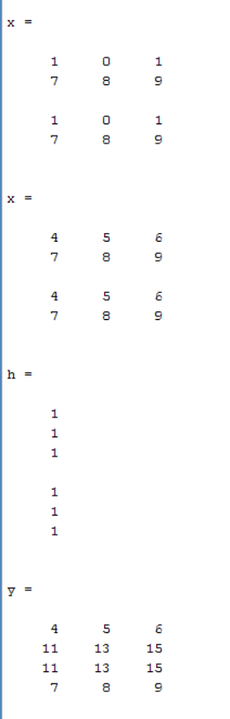**

**Practical No.: 1(B)**

**Aim:** Circular Convolution between two matrices

**Code:**

disp('TYCS - 582_Jaisal_Shah')

x = [1, 2; 3, 4;]

h = [5, 6; 7, 8]

lenX = length(x)

lenH = length(h)

n = max(lenX, lenH)

a = x'

v1 = reshape(a, 1, [])

b = h'

v2 = reshape(b, 1, [])

**Output:  
  
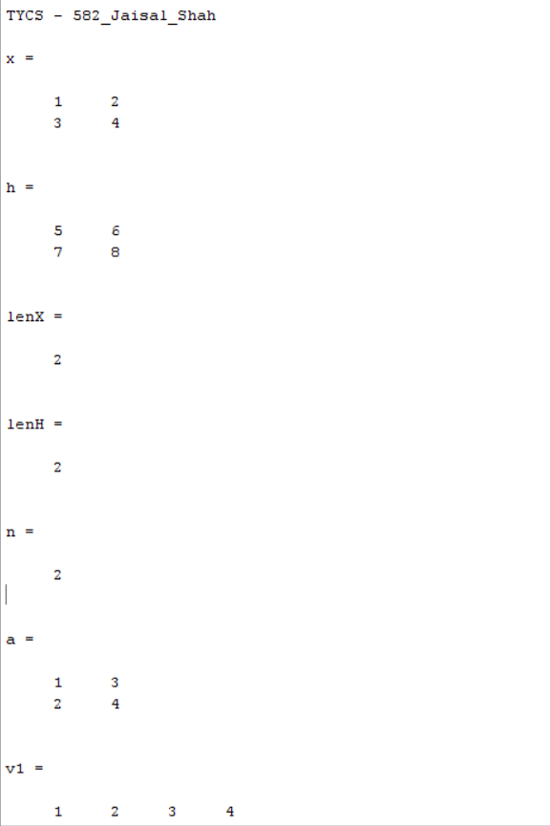**

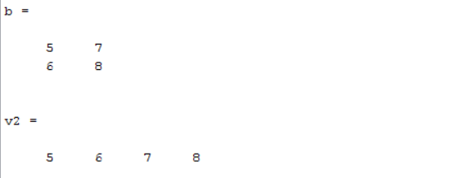

**Practical No.: 2**

**Aim:** Apply DFT on an image

**Code:**

clc;

clear all;

close all;

a = imread('C:\Users\Jaisal Shah\Desktop\TYCS-582\College-Stuff\Sem VI\DIP\Practicals\raw.png');

img = double(a);

subplot(1, 2, 1);

imshow(a);

title('Original image');

[row col] = size(a);

dft1 = size(a);

for x = 1: row

for y = 1:col

b(x, y) = img(x ,y) * ((-1) ^ (x + y));

end

end

for x = 1: row

for y = 1:col

dft1(x, y) = b(x, y) * exp(-1 * 1i * 2 * pi * (((x * x) / row) + ((y * y)/ col)));

end

end

subplot(1, 2, 2);

imshow(real(dft1));

title('DFT');

**Output:**

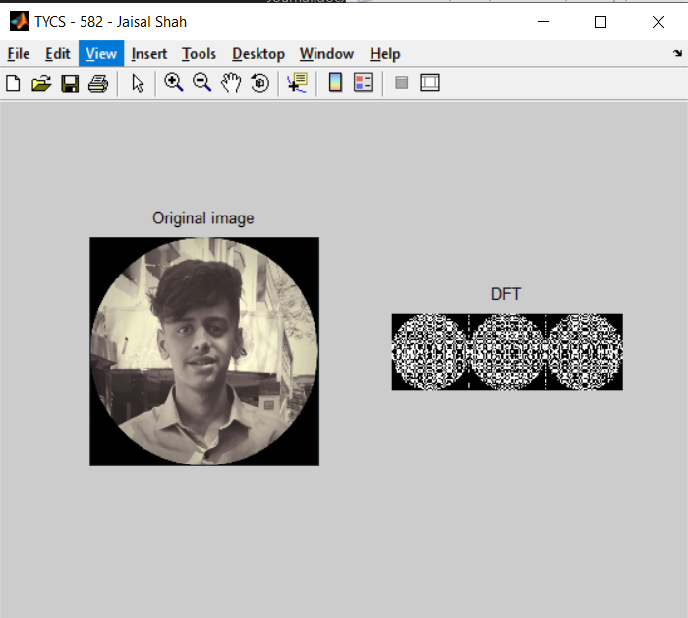

**Practical No.: 3(A)**

**Aim:** Apply the following Pre-Processing Techniques on an Image:

1. Log Transform
2. Power Law Transform
3. Image Negation

**Code:**

close all;

clear all;

clc;

img1 = imread('C:\Users\Jaisal Shah\Desktop\TYCS-582\College-Stuff\Sem VI\DIP\Practicals\raw.png');

img = rgb2gray(img1);

subplot(1, 2, 1);

imshow(img);

title('OG IMage');

L = 255;

c = L / log10(1 + L);

d = c * (log10(1 + double(img)));

a = uint8(d);

subplot(1, 2, 2);

imshow(uint8(a));

title('Transformed Image');

**Output:**

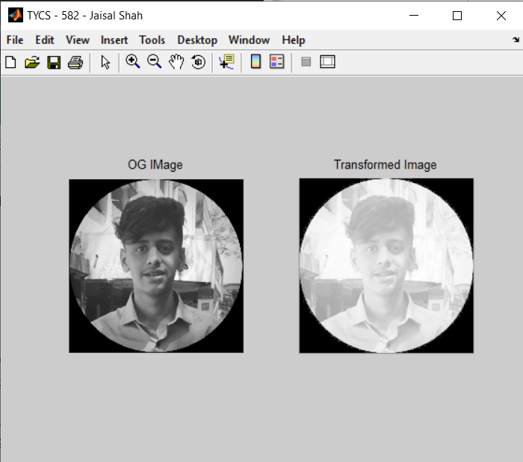

**Practical No.: 3(B)**

**Aim:** Power Law Transform

**Code:**

% Power Law Transformation

close all;

clear all;

clc;

figure('Name','TYCS - 582 - Jaisal Shah','NumberTitle','off');

img1 = imread('C:\Users\Jaisal Shah\Desktop\TYCS-582\College-Stuff\Sem VI\DIP\Practicals\raw.png');

img = rgb2gray(img1);

subplot(1, 2, 1);

imshow(img);

title('OG IMage');

s = size(img);

c = 1;

img = double(img);

gamma = 0.5;

for x = 1: s(1)

for y = 1: s(2)

j(x, y) = c * (img(x, y) ^ gamma);

end;

end

subplot(1, 2, 2);

imshow(j, []);

title('Power Law Transform Image');

**Output:**

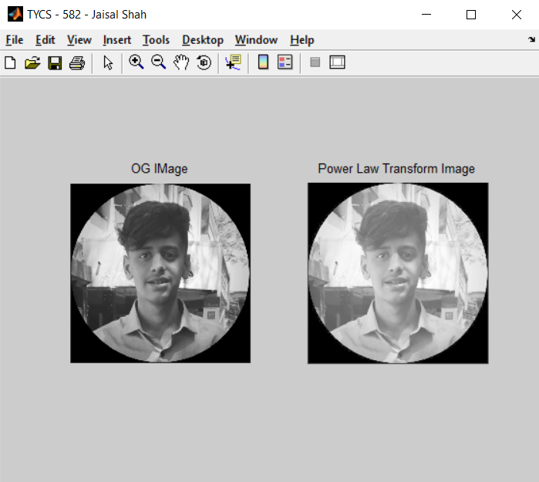

**Practical No.: 3(C)**

**Aim:** Image Negation

**Code:**

% Image Negation

close all;

clear all;

clc;

figure('Name','TYCS - 582 - Jaisal Shah','NumberTitle','off');

img1 = imread('C:\Users\Jaisal Shah\Desktop\TYCS-582\College-Stuff\Sem VI\DIP\Practicals\raw.png');

img = rgb2gray(img1);

subplot(1, 2, 1);

imshow(img);

title('OG IMage');

s = size(img);

for x = 1: s(1)

for y = 1: s(2)

img_neg(x, y) = 255 - img(x, y);

end;

end

subplot(1, 2, 2);

imshow(uint8(img_neg));

title('Nagative Image');

**Output:**

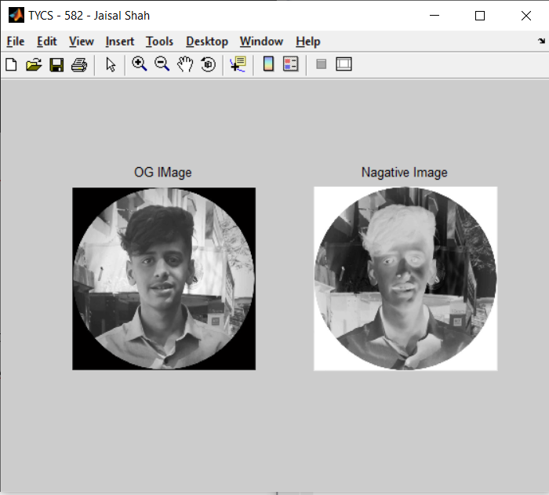

**Practical No.: 4(A)**

**Aim:** Apply the following Image Enhancement Techniques on an Image:

1. Brightness Adjustment
2. Contrast Stretching
3. Thresholding
4. Gray Level Slicing

**Code:**

close all;

clear all;

clc;

figure('Name','Simulation Plot Window','NumberTitle','off')

img1 = imread('C:\Users\Jaisal Shah\Desktop\TYCS-582\College-Stuff\Sem VI\DIP\Practicals\raw.png');

subplot(2, 3, 1);

imshow(img1);

title('OG Image');

B = double(img1) - 140;

subplot(2, 3, 2);

imshow(uint8(B));

title('Brightness Decreased');

B = double(img1) + 140;

subplot(2, 3, 3);

imshow(uint8(B));

title('Brightness Decreased');

img_bw = rgb2gray(img1);

subplot(2, 3, 4);

imshow(img_bw);

title('B/W Image');

B = double(img_bw) - 140;

subplot(2, 3, 5);

imshow(uint8(B));

title('Brightness Decreased');

B = double(img_bw) + 140;

subplot(2, 3, 6);

imshow(uint8(B));

title('Brightness Decreased');

**Output:**

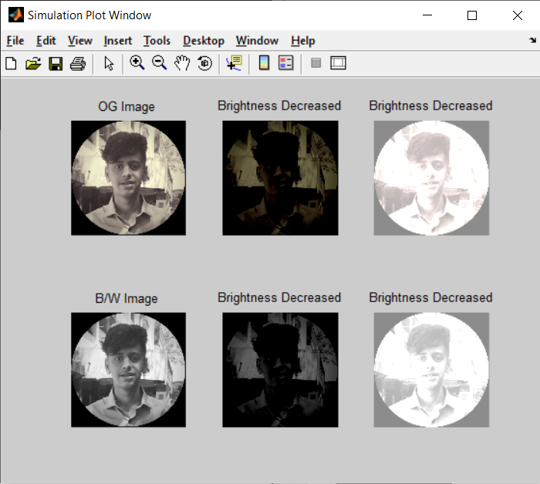

**Practical No.: 4(B)**

**Aim:** Contrast Stretching

**Code:**

close all;

clear all;

clc;

figure('Name','TYCS - 582 - Jaisal Shah','NumberTitle','off');

img1 = imread('C:\Users\Jaisal Shah\Desktop\TYCS-582\College-Stuff\Sem VI\DIP\Practicals\raw.png');

subplot(1, 2, 1);

imshow(img1);

title('OG Image');

B = double(img1) * (2);

subplot(1, 2, 2);

imshow(uint8(B));

title('Contrast Adjusted');

**Output:**

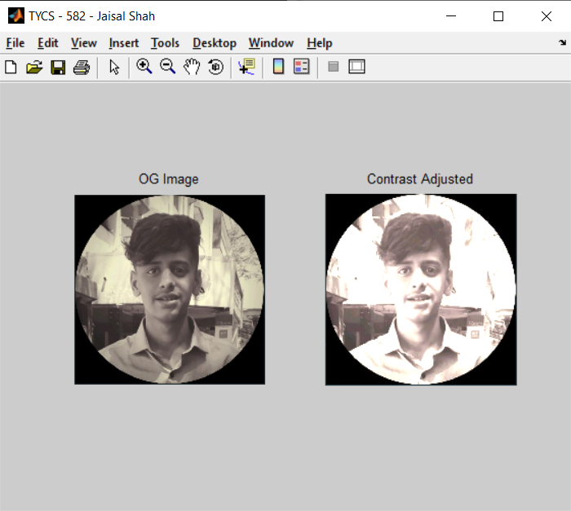

**Practical No.: 4(C)**

**Aim:** Thresholding

**Code:**

clc;

clear all;

close all;

figure('Name','TYCS - 582 - Jaisal Shah','NumberTitle','off');

p = imread('C:\Users\Jaisal Shah\Desktop\TYCS-582\College-Stuff\Sem VI\DIP\Practicals\raw.png');

p1 = rgb2gray(p);

subplot(1,2,1);

imshow(p1);

title('Original Image');

T = input('Enter threshold value: ');

[row column] = size(p1);

for x=1:row

for y=1:column

if((p1(x, y)) < T)

p1(x, y) = 0;

else

p1(x, y) = 255;

end;

end;

end;

subplot(1,2,2);

imshow(p1); title('Threshold Image');

**Output:**

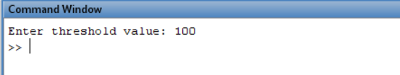

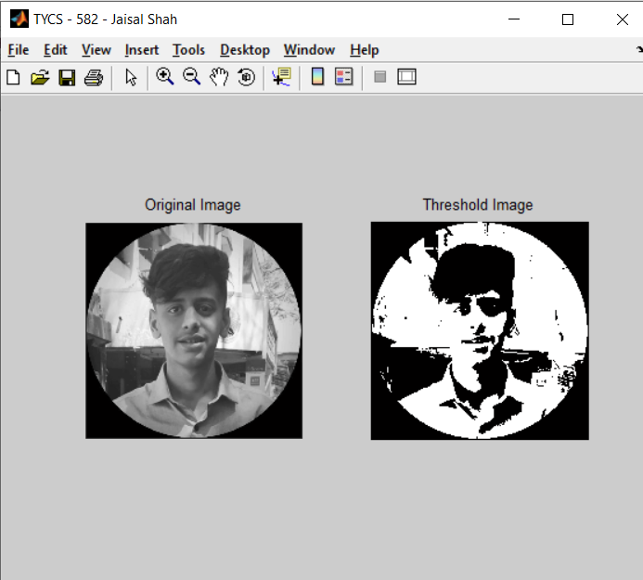

**Practical No.: 4(D)**

**Aim:** Gray Level Slicing

1. **Gray Level without Background**

**Code:**

clc;

clear all;

close all;

figure('Name','TYCS - 582 - Jaisal Shah','NumberTitle','off');

p = imread('C:\Users\Jaisal Shah\Desktop\TYCS-582\College-Stuff\Sem VI\DIP\Practicals\raw.png');

p1 = rgb2gray(p);

subplot(1,2,1);

imshow(p1);

title('Original Image');

T1 = input('Enter value for lower Threshold: ');

T2 = input('Enter value for higher Threshold: ');

j = double(p1);

[row column] = size(p1);

for x=1:1:row

for y=1:1:column

if(j(x, y) > T1 && (j(x, y) < T2))

j(x, y) = 255;

else

j(x, y) = 0;

end;

end;

end;

subplot(1,2,2);

imshow(uint8(j)); title('Threshold Image with Background');

**Output:**

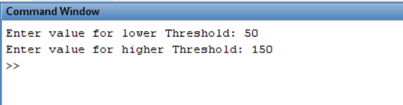

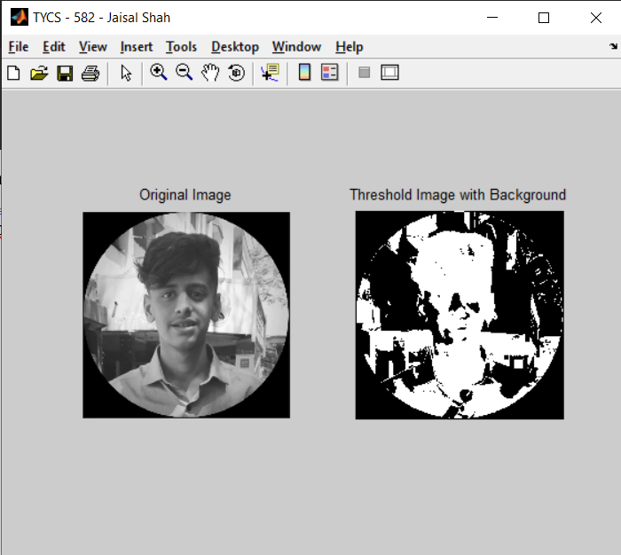

1. **Gray Level Slicing with Background**

**Code:**

clc;

clear all;

close all;

figure('Name','TYCS - 582 - Jaisal Shah','NumberTitle','off');

p = imread('C:\Users\Jaisal Shah\Desktop\TYCS-582\College-Stuff\Sem VI\DIP\Practicals\raw.png');

p1 = rgb2gray(p);

subplot(1,2,1);

imshow(p1);

title('Original Image');

T1 = input('Enter value for lower Threshold: ');

T2 = input('Enter value for higher Threshold: ');

j = double(p1);

[row column] = size(p1);

for x=1:1:row

for y=1:1:column

if(j(x, y) > T1 && (j(x, y) < T2))

j(x, y) = 255;

else

j(x, y) = p1(x, y);

end;

end;

end;

subplot(1,2,2);

imshow(uint8(j)); title('Threshold Image with Background');

**Output:**

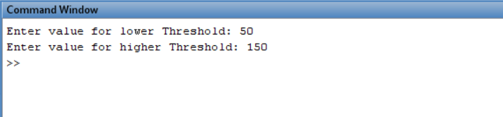

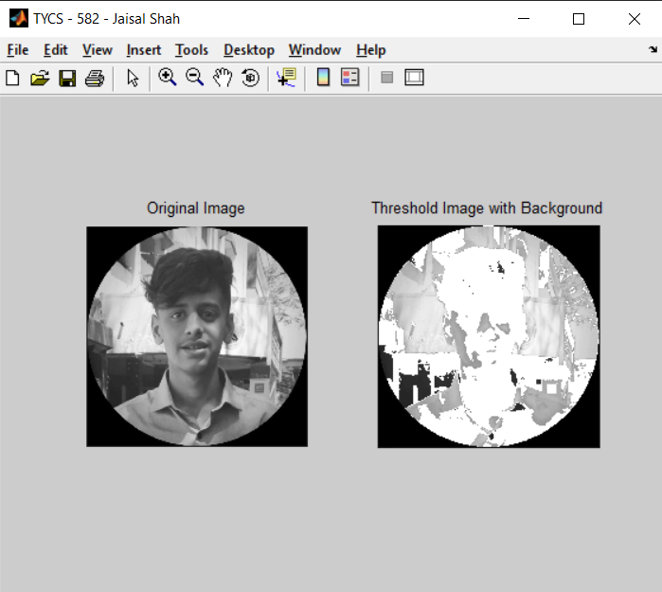

**Practical No.: 5(A)**

**Aim:** Color Image Processing – I

1. Splitting RGB Planes
2. Pseudo Coloring

**Code:**

%rgb planes

close all;

clear all;

clc;

img=imread('C:\Users\Jaisal Shah\Desktop\TYCS-582\College-Stuff\Sem VI\DIP\Practicals\raw.png');

subplot(1,4,1);

imshow(img);

title('original image')

s=size(img);

redp=img(:,:,1);

greenp=img(:,:,2);

bluep=img(:,:,3);

subplot(1,4,2);

imshow(greenp);

title('green plane');

subplot(1,4,3);

imshow(redp);

title('red plane');

subplot(1,4,4);

imshow(bluep);

title('blue plane')

**Output:**

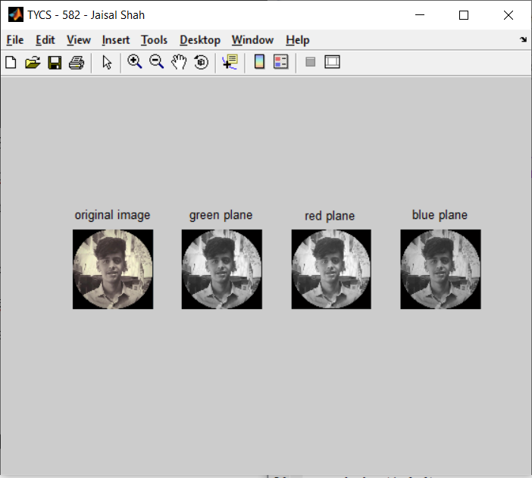

**Practical No.: 5(B)**

**Aim:** Pseudo Coloring

**Code:**

%pseudocoloring

close all;

clear all;

clc;

figure('Name','TYCS - 582 - Jaisal Shah','NumberTitle','off')

img=imread('C:\Users\Jaisal Shah\Desktop\TYCS-582\College-Stuff\Sem VI\DIP\Practicals\raw.png');

subplot(1,2,1);

imshow(img);

title('original image')

s=size(img);

redp=img(:,:,1);

greenp=img(:,:,2);

bluep=img(:,:,3);

OP(:,:,1)= greenp;

OP(:,:,2)= bluep;

OP(:,:,3)= redp;

subplot(1,2,2);

imshow(OP);

title('Pseudocoloring');

**Output:**

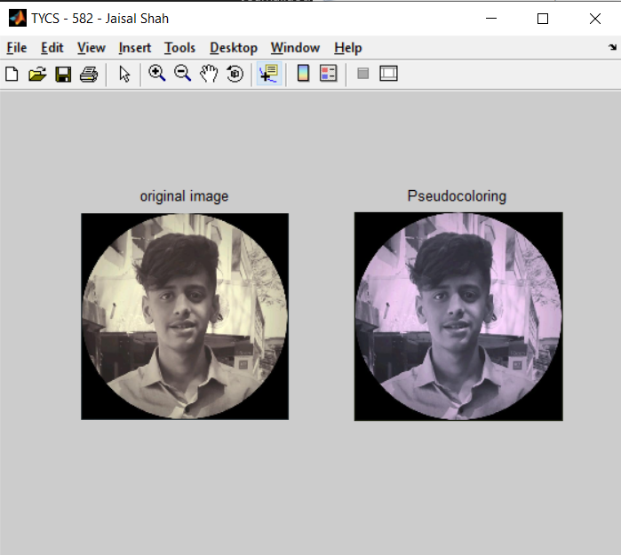

**Practical No.: 6(A)**

**Aim:** Color Image Processing – II

1. Brightness Adjustment
2. Contrast Stretching
3. Thresholding
4. Gray Level Slicing

**Code:**

close all;

clear all;

clc;

figure('Name','Simulation Plot Window','NumberTitle','off')

img1 = imread('C:\Users\Jaisal Shah\Desktop\TYCS-582\College-Stuff\Sem VI\DIP\Practicals\raw.png');

subplot(1, 3, 1);

imshow(img1);

title('OG Image');

B = double(img1) - 140;

subplot(1, 3, 2);

imshow(uint8(B));

title('Brightness Decreased');

B = double(img1) + 140;

subplot(1, 3, 3);

imshow(uint8(B));

title('Brightness Decreased');

**Output:**

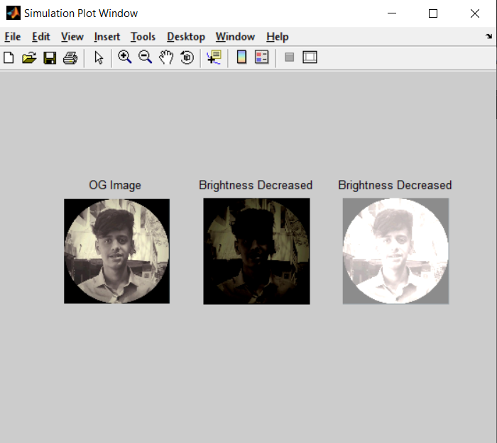

**Practical No.: 6(B)**

**Aim:** Contrast Stretching

**Code:**

close all;

clear all;

clc;

figure('Name','TYCS - 582 - Jaisal Shah','NumberTitle','off');

img1 = imread('C:\Users\Jaisal Shah\Desktop\TYCS-582\College-Stuff\Sem VI\DIP\Practicals\raw.png');

subplot(1, 2, 1);

imshow(img1);

title('OG Image');

B = double(img1) * (2);

subplot(1, 2, 2);

imshow(uint8(B));

title('Contrast Adjusted');

**Output:**

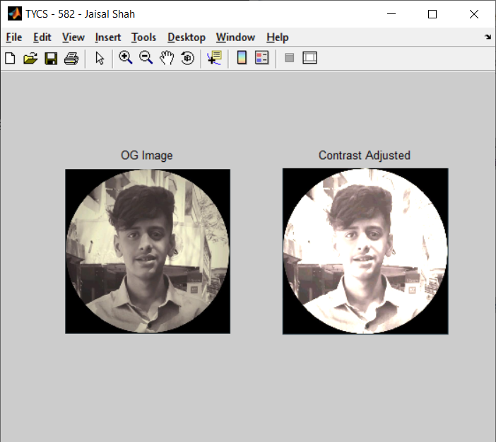

**Practical No.: 6(C)**

**Aim:** Thresholding

**Code:**

clc;

clear all;

close all;

figure('Name','TYCS - 582 - Jaisal Shah','NumberTitle','off');

p = imread('C:\Users\Jaisal Shah\Desktop\TYCS-582\College-Stuff\Sem VI\DIP\Practicals\raw.png');

subplot(1,2,1);

imshow(p);

title('Original Image');

T = input('Enter threshold value: ');

[row column] = size(p);

for x=1:row

for y=1:column

if((p(x, y)) < T)

p(x, y) = 0;

else

p(x, y) = 255;

end;

end;

end;

subplot(1,2,2);

imshow(p); title('Threshold Image');

**Output:**

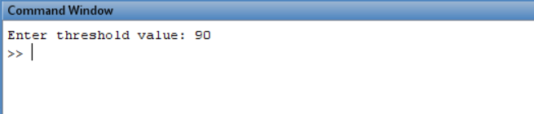

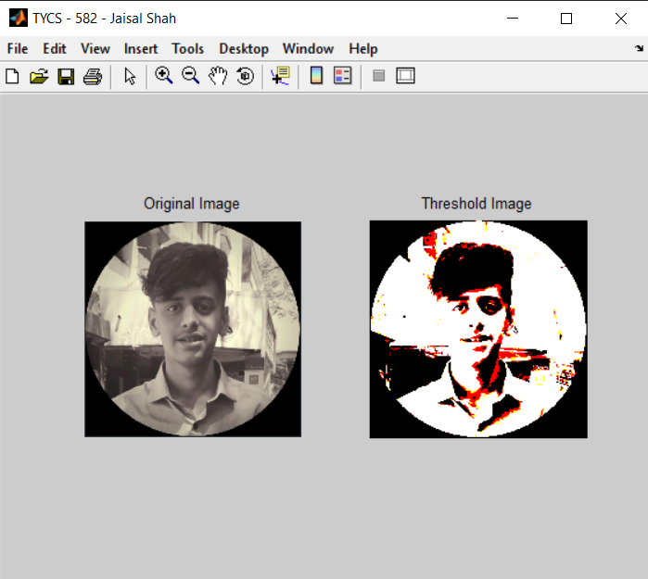

**Practical No.: 6(D)**

**Aim:** Gray Level Slicing

1. **Gray Level Slicing**

**Code:**

clc;

clear all;

close all;

p = imread('C:\Users\Jaisal Shah\Desktop\TYCS-582\College-Stuff\Sem VI\DIP\Practicals\raw.png');

subplot(1,2,1);

imshow(p);

title('Original Image');

T = input('Enter threshold value: ');

[row column] = size(p);

for x=1:row

for y=1:column

if((p(x, y)) < T)

p(x, y) = 0;

else

p(x, y) = 255;

end;

end;

end;

subplot(1,2,2);

imshow(p); title('Threshold Image');

**Output:**

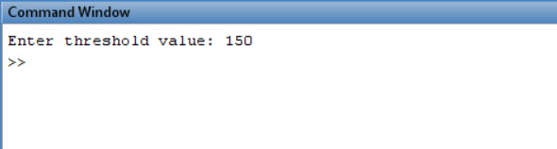

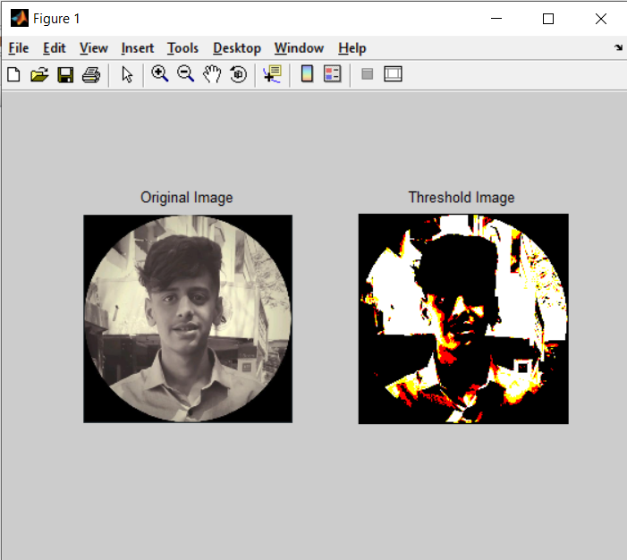

1. **Gray Level Slicing with Background**

**Code:**

clc;

clear all;

close all;

figure('Name','TYCS - 582 - Jaisal Shah','NumberTitle','off');

p = imread('C:\Users\Jaisal Shah\Desktop\TYCS-582\College-Stuff\Sem VI\DIP\Practicals\raw.png');

subplot(1,2,1);

imshow(p);

title('Original Image');

T1 = input('Enter value for lower Threshold: ');

T2 = input('Enter value for higher Threshold: ');

j = double(p);

[row column] = size(p);

for x=1:1:row

for y=1:1:column

if(j(x, y) > T1 && (j(x, y) < T2))

j(x, y) = 255;

else

j(x, y) = p(x, y);

end;

end;

end;

subplot(1,2,2);

imshow(uint8(j)); title('Threshold Image with Background');

**Output:**

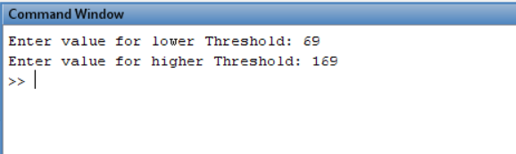

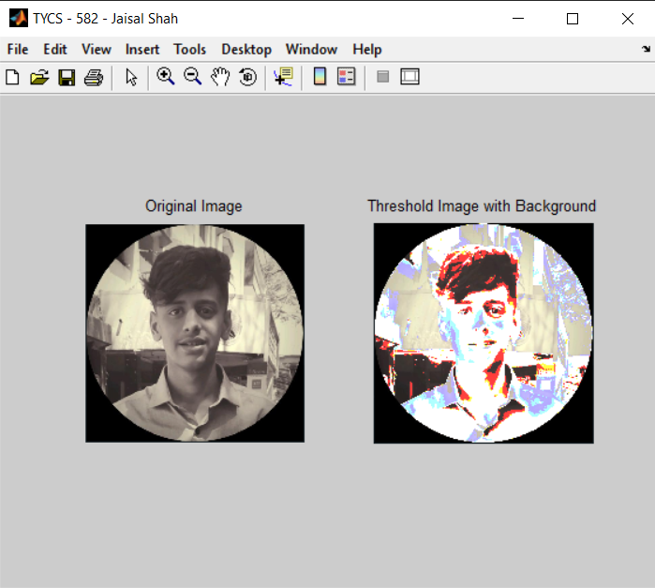

1. **Gray Level Slicing without Background**

**Code:**

clc;

clear all;

close all;

figure('Name','TYCS - 582 - Jaisal Shah','NumberTitle','off');

p = imread('C:\Users\Jaisal Shah\Desktop\TYCS-582\College-Stuff\Sem VI\DIP\Practicals\raw.png');

subplot(1,2,1);

imshow(p);

title('Original Image');

T1 = input('Enter value for lower Threshold: ');

T2 = input('Enter value for higher Threshold: ');

j = double(p);

[row column] = size(p);

for x=1:1:row

for y=1:1:column

if(j(x, y) > T1 && (j(x, y) < T2))

j(x, y) = 255;

else

j(x, y) = 0;

end;

end;

end;

subplot(1,2,2);

imshow(uint8(j)); title('Threshold Image with Background');

**Output:**

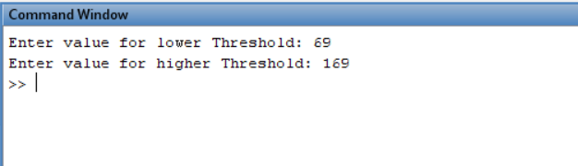

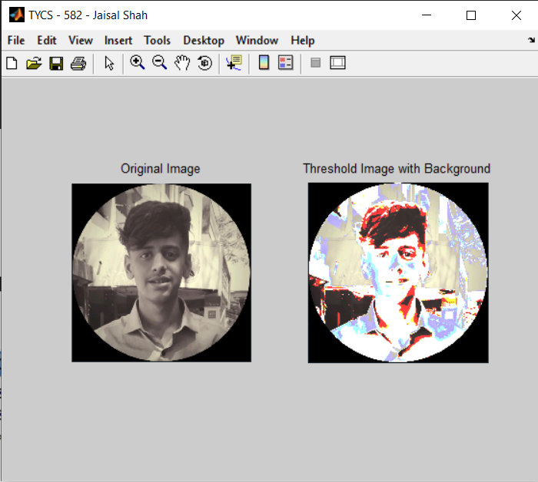

**Practical No.: 7**

**Aim:** Write a program to plot Histogram of an image

**Code:**

%histogram

close all;

clear all;

clc;

a = imread('C:\Users\Jaisal Shah\Desktop\TYCS-582\College-Stuff\Sem VI\DIP\Practicals\raw.png');

a1 = double(a);

a2 = rgb2gray(uint8(a1));

subplot(1, 2, 1);

imshow(uint8(a2));

title('OG IMage');

[row col] = size(a2);

h = zeros(1, 256);

for m = 1: 1: row

for n = 1: 1: col

t = a2(m, n);

h(t + 1) = h(t + 1) + 1;

end

end

subplot(1, 2, 2);

bar(h);

title('Histogram');

**Output:**

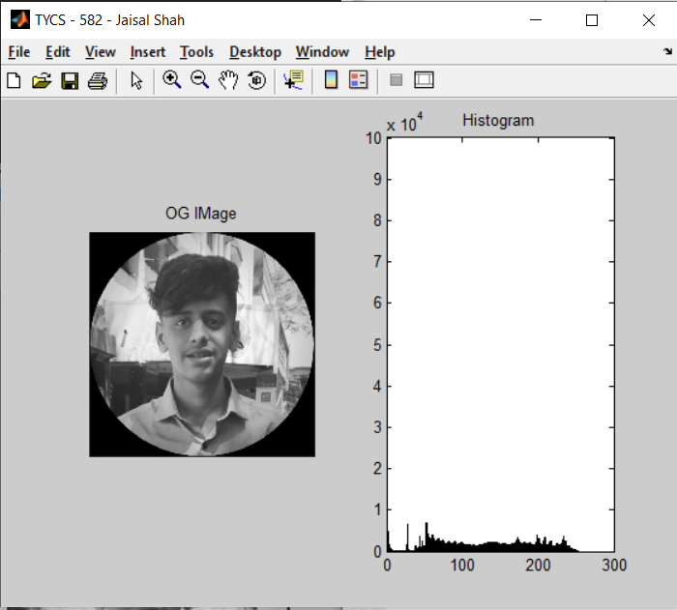

**Practical No.: 8**

**Aim:** Write a program to perform Histogram Equalization of an image

**Code:**

close all;

clear all;

clc;

a=imread('C:\Users\Jaisal Shah\Desktop\TYCS-582\College-Stuff\Sem VI\DIP\Practicals\raw.png');

a1 = double(a);

a2 = rgb2gray(uint8(a1));

[row col] = size(a2);

c = row * col;

h = zeros(1, 300);

z = zeros(1, 300);

for m = 1 : 1 :row

for n = 1 : 1 : col

t = a2(m, n);

h(t + 1) = h(t + 1) + 1;

end

end

pdf = h / c;

cdf(1) = pdf(1);

for x = 2 : 1 : 256

cdf(x) = pdf(x) + cdf(x - 1);

end;

new = round(cdf * 256);

new = new + 1;

for p = 1 : 1 : row

for q = 1 : 1 : col

temp = a2(p,q) + 1;

b(p,q) = new(temp);

t = b(p,q);

z(t+1) = z(t+1) + 1;

end;

end;

b = b - 1;

subplot(2,2,1);

imshow(uint8(a2));

title('Original Image');

subplot(2,2,2);

bar(h);

title('Histogram of Original Image');

subplot(2,2,3);

imshow(uint8(b));

title('Histogrammed Image');

subplot(2,2,4);

bar(z);

title('Eq. Histogram Image');

**Output:**

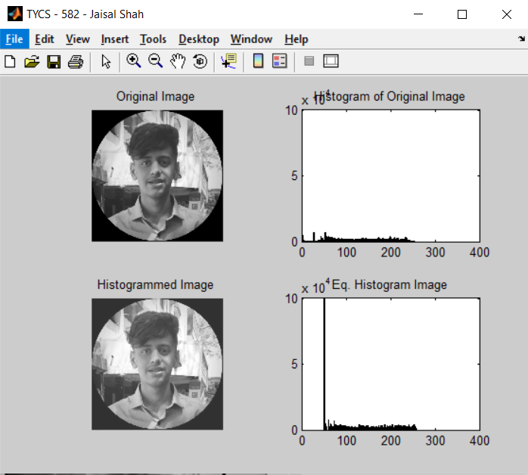

**Practical No.: 9**

**Aim:** Write a program to perform Smoothing on an image

**Code:**

close all;

clear all;

clc;

figure('Name','TYCS - 582 - Jaisal Shah','NumberTitle','off')

a=imread('C:\Users\Jaisal Shah\Desktop\TYCS-582\College-Stuff\Sem VI\DIP\Practicals\raw.png');

i = rgb2gray(a);

b = imnoise(i, 'gaussian');

h1 = 1 / 9 * ones(3, 3);

h2 = 1 / 25 * ones(5, 5);

output1 = conv2(b, h1, 'same');

output2 = conv2(b, h2, 'same');

subplot(2, 2, 1);

imshow(i);

title('Original Image');

subplot(2, 2, 2);

imshow(b);

title('Noised Image');

subplot(2, 2, 3);

imshow(uint8(output1));

title('Image smoothened with 3*3 mask');

subplot(2, 2, 4);

imshow(uint8(output2));

title('Image smoothened with 5*5 mask');

**Output:**

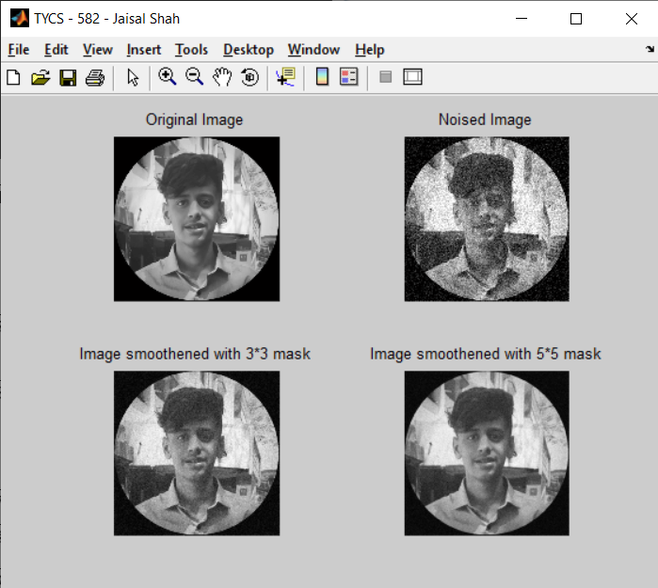

**Practical No.: 10**

**Aim:** Write a program to perform Sharpening on an image

**Code:**

close all;

clear all;

clc;

figure('Name','TYCS - 582 - Jaisal Shah','NumberTitle','off')

a=imread('C:\Users\Jaisal Shah\Desktop\TYCS-582\College-Stuff\Sem VI\DIP\Practicals\raw.png');

i = rgb2gray(a);

h = fspecial('unsharp');

b = imfilter(i, h);

subplot(1, 2, 1);

imshow(i);

title('Original Image');

subplot(1, 2, 2);

imshow(b);

title('High Pass Filtered Image');

**Output:**

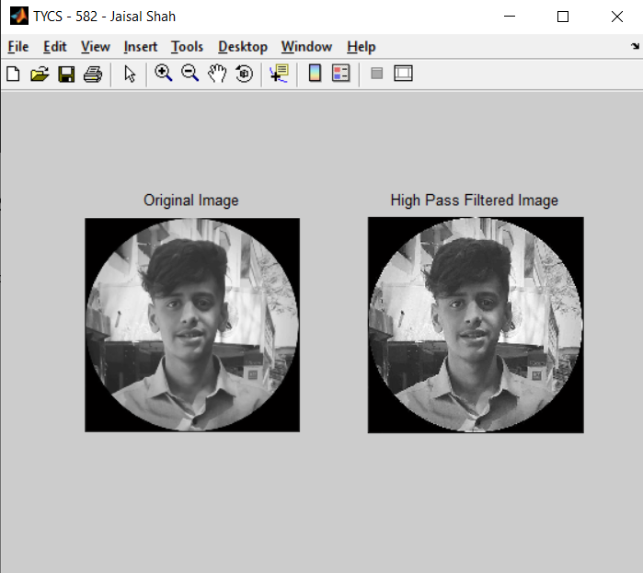

**Practical No.: 10**

**Aim:** Write a program to perform Dilation and Erosion on an image.

**Code:**

**For Erosion and Dilation**

close all;

clear all;

clc;

w = [0 0 0 0 0 0 0 0 0 0 0 0 0 0;0 1 1 1 1 0 0 0 0 1 1 1 1 0;0 1 1 1 1 0 0 0 0 1 1 1 1 0;0 1 1 1 1 1 1 1 1 1 1 1 1 0;0 1 1 1 1 1 1 1 1 1 1 1 1 0;0 1 1 1 1 0 0 0 0 1 1 1 1 0;0 1 1 1 1 0 0 0 0 1 1 1 1 0;0 0 0 0 0 0 0 0 0 0 0 0 0 0];

disp(w);

se1= strel('square',3);

disp(se1);

IM1 = imerode(w,se1);

IM2 = imdilate(w,se1);

subplot(1,3,1);

imshow(w);

title('original image');

subplot(1,3,2);

imshow(IM1);

title('eroded image');

subplot(1,3,3);

imshow(IM2);

title('dilated image');

**Output:**

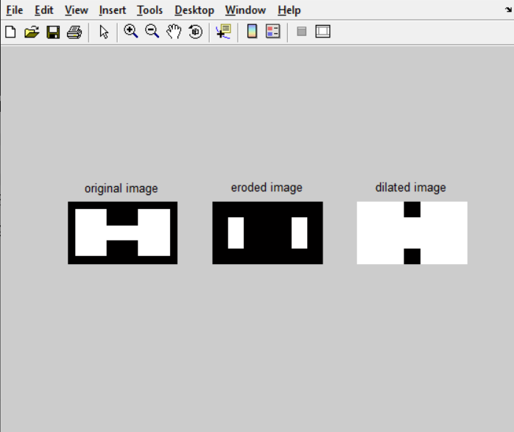

**For Opening and Closing**

close all;

clear all;

clc;

w = [0 0 0 0 0 0 0 0 0 0 0 0 0 0;0 1 1 1 1 0 0 0 0 1 1 1 1 0;0 1 1 1 1 0 0 0 0 1 1 1 1 0;0 1 1 1 1 1 1 1 1 1 1 1 1 0;0 1 1 1 1 1 1 1 1 1 1 1 1 0;0 1 1 1 1 0 0 0 0 1 1 1 1 0;0 1 1 1 1 0 0 0 0 1 1 1 1 0;0 0 0 0 0 0 0 0 0 0 0 0 0 0];

disp(w);

se1= strel('square',3);

disp(se1);

O1 = imerode(w,se1);

O2 = imdilate(O1,se1);

C1 = imdilate(w,se1);

C2 = imerode(C1,se1);

subplot(3,1,1);

imshow(w);

title('original image');

subplot(3, 1,2);

imshow(O2);

title('OPENING - Erosion followed by Dilation');

subplot(3,1,3);

imshow(C2);

title('CLOSING - Dilation performed by Erosion');

**Output:**

