Laporan COTS 1 Sistem Paralel Terdisitribusi

Haris Saputra 1301174227

Abdullah Azzam 1301174360

Salman Rachmadi 1301174440

Jaish Muhammad 1301174542

1. Screenshot Running Program Server

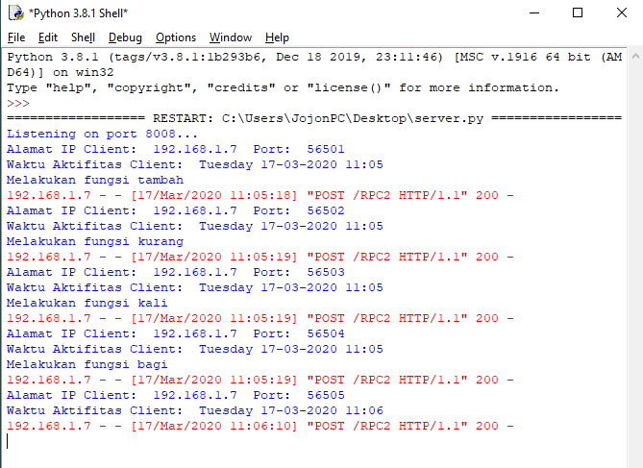

1. Screenshot Running Program Client

#input client activity

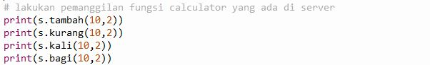

#output client activity

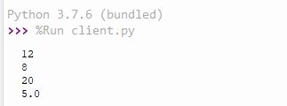

#input client timeactivitylog



#output client timeactivitylog fungsi cari

