
Assignment 01
Course Code: MSJ 11350
Course Title: History of Bangladeshi Media
Sec: 2
Fall 2023

Submitted By:
Name: Jahida Alam Jaishee
ID: 163014038

Submitted To:
Abul Mansur Ahmed, PhD

Submission Date: 29-11-2023

Slow Shutter speed
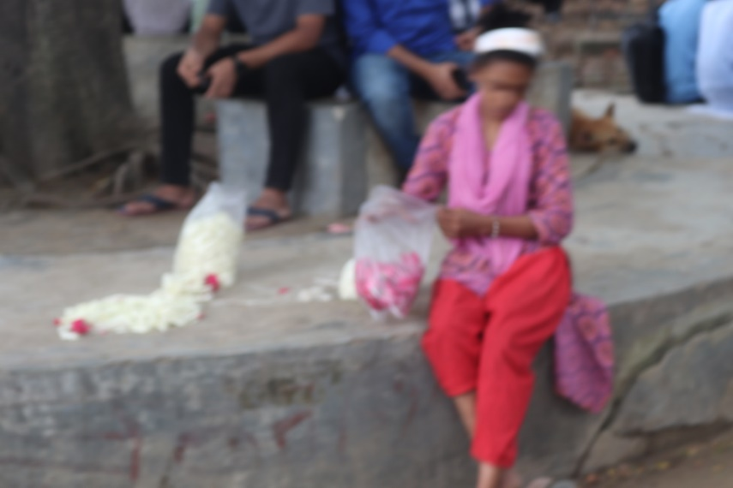
Shutter speed: 1/15 sec.
f/5.6 47mm
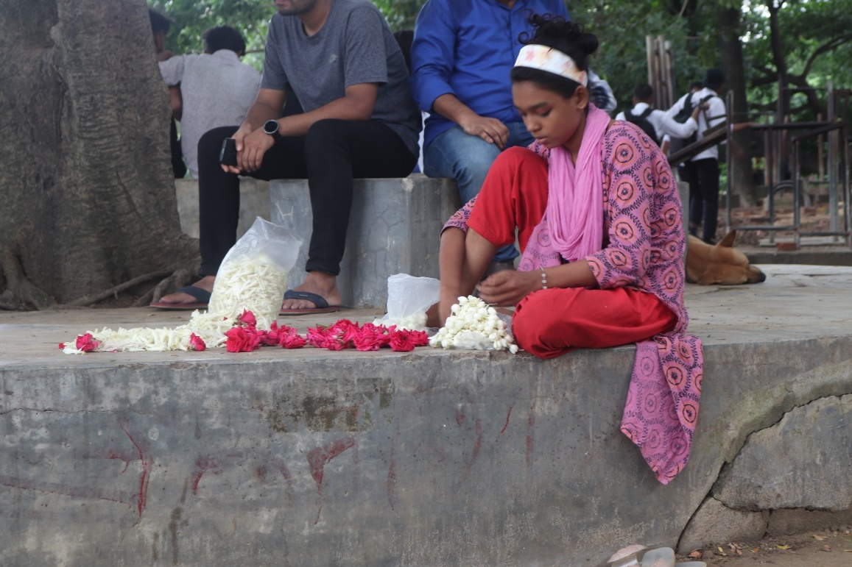
Shutter Speed: 1/16 sec.
f/5.7 47mm

Fast Shutter spreed
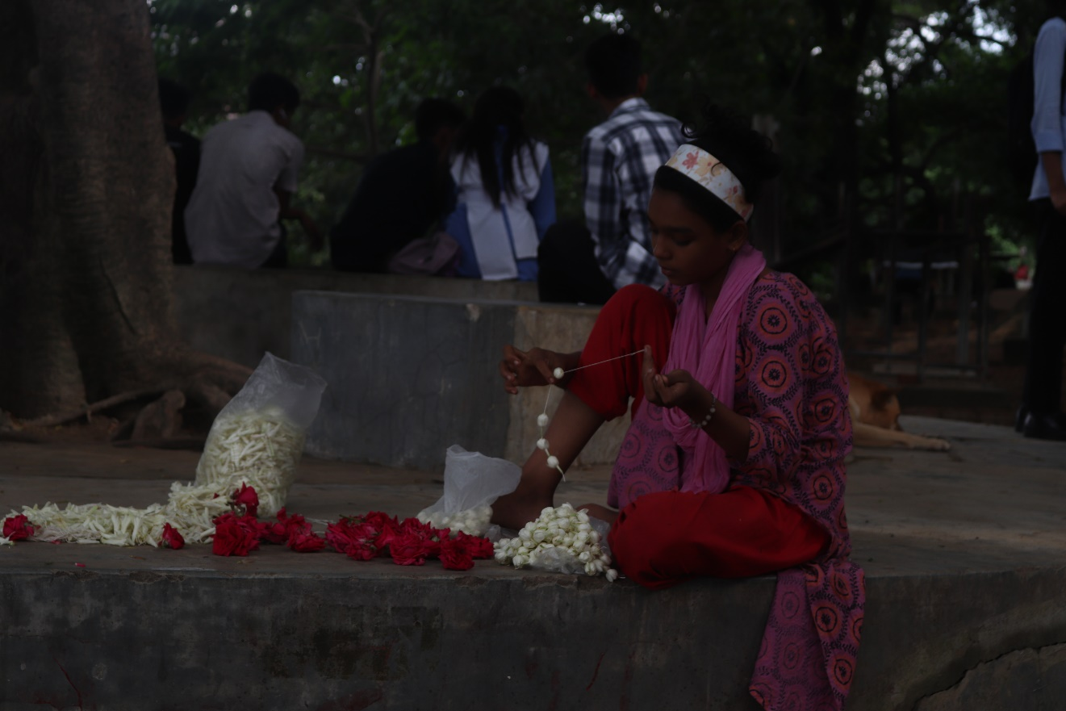
Shutter speed: 1/125 sec.
f/5 43m

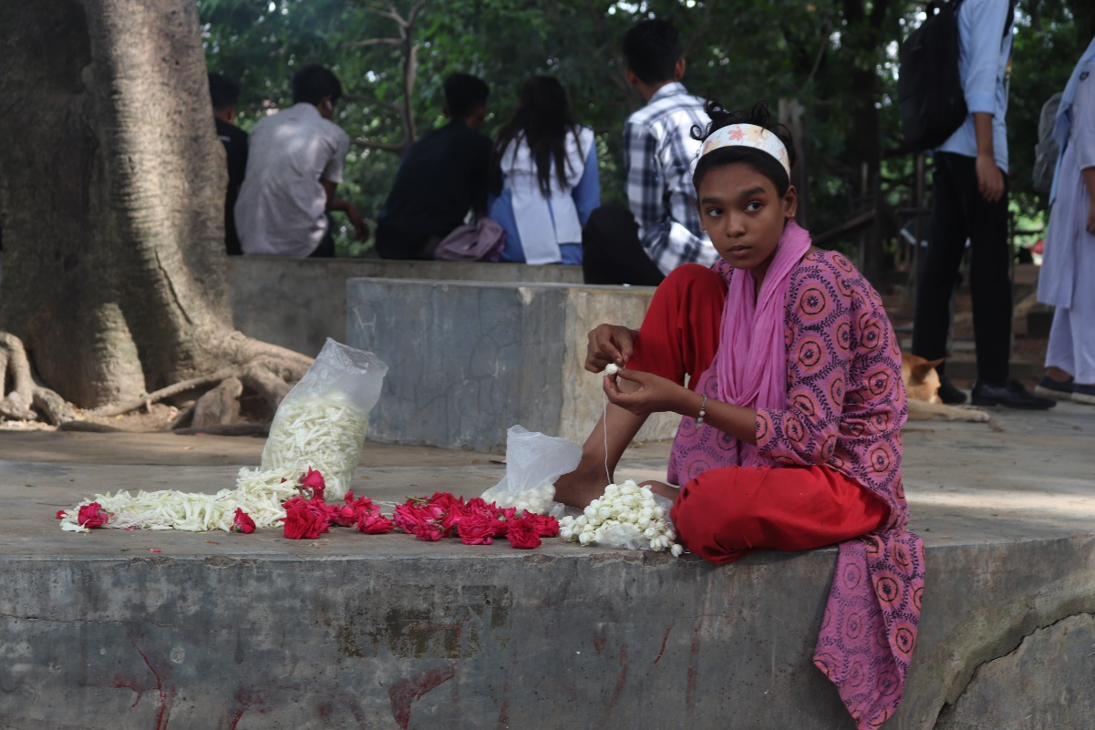
Shutter speed: 1/60 sec
f/5 40mm

