EX.NO: 5 Stack based buffer overflow attacks 231901011

DATE : 19.03.2025

JAISHREE S

AIM:

Sudo Buffer Overflow

Exploring CVE-2019-18634 in the Unix sudo program. Room two in the SudoVulns series

Buffer Overflow Prep

Practice stack based buffer overflows!

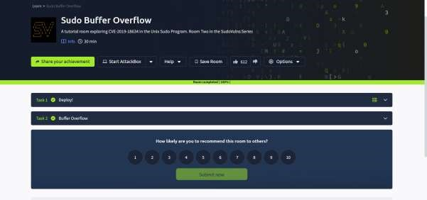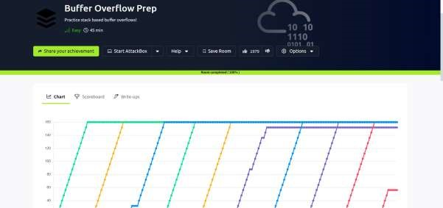

TASK 2 : BUFFER OVERFLOW

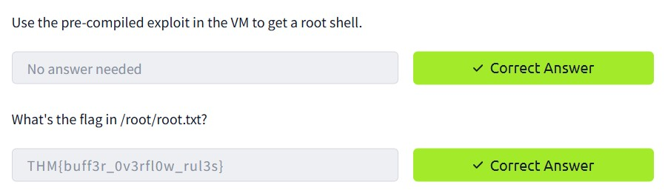

Buffer Overflow Prep

TASK 2 oscp.exe - OVERFLOW1

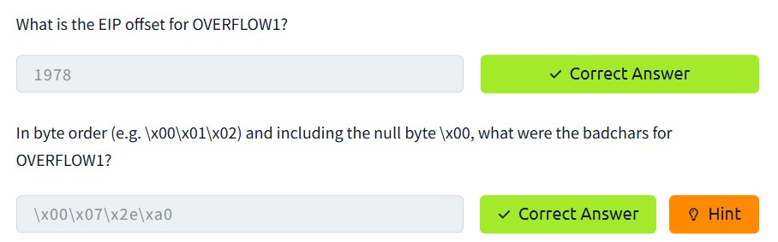

TASK 3 : oscp.exe - OVERFLOW2

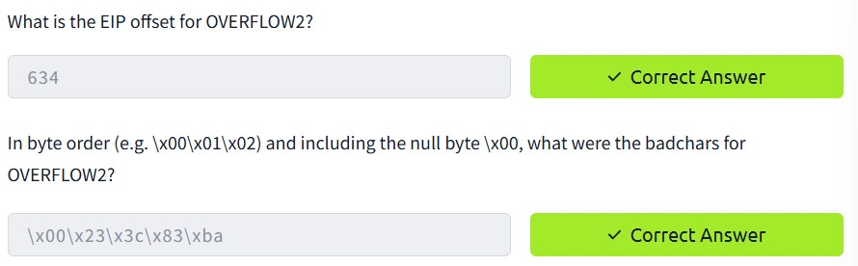

TASK 4 oscp.exe – OVERFLOW3

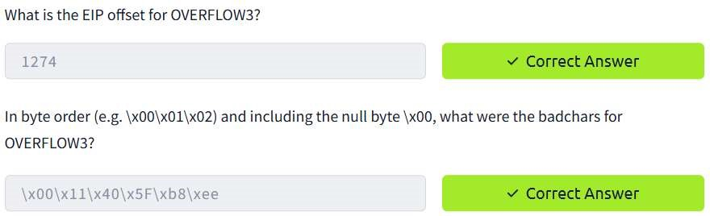

TASK 5 : oscp.exe - OVERFLOW4

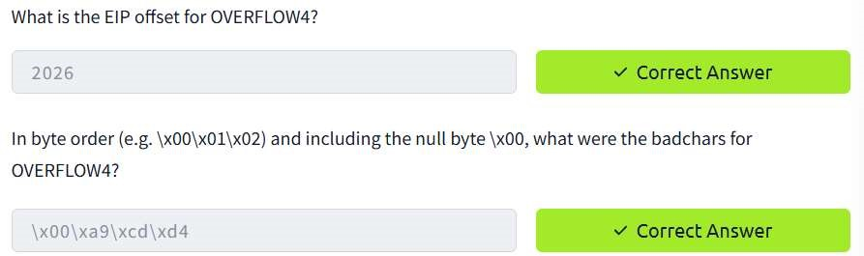

TASK 6 : oscp.exe - OVERFLOW5

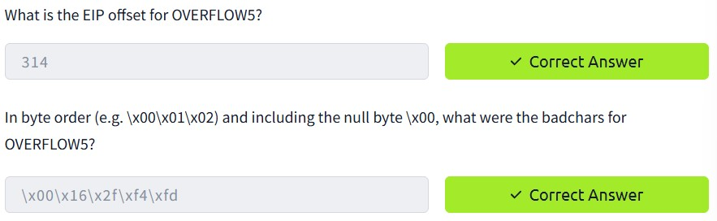

TASK 7 : oscp.exe - OVERFLOW6

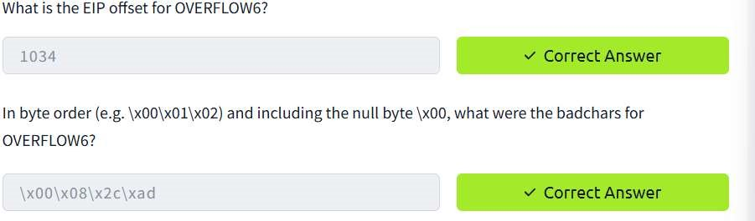

TASK 8 : oscp.exe - OVERFLOW7

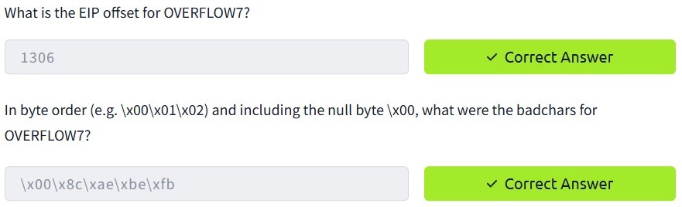

TASK 9 : oscp.exe - OVERFLOW8

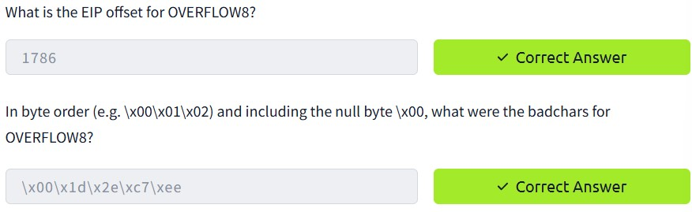

TASK 10 : oscp.exe - OVERFLOW9

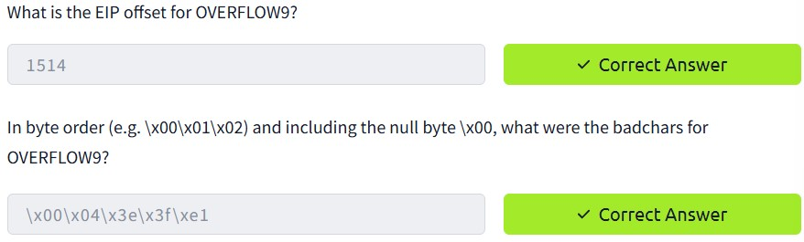

TASK 11 : oscp.exe - OVERFLOW10

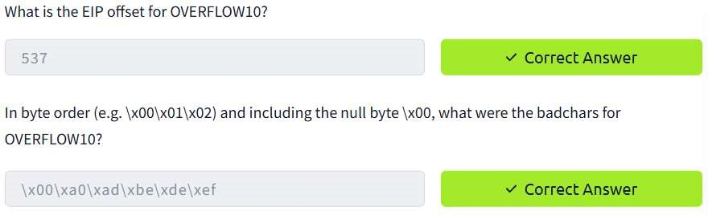

CONCLUSION:

Tryhackme platform Stack based buffer overflow attacks task is successfully completed.