Week 7 – 1:

ROLL NO.:240701200

Name: JAI SHURIYA

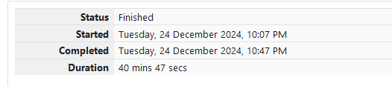

Q1)Sunny and Johnny like to pool their money and go to the ice cream parlor. Johnny

never buys the same flavor that Sunny does. The only other rule they have is that they

spend all of their money.

Given a list of prices for the flavors of ice cream, select the two that will cost all of

the money they have.

For example, they have m = 6 to spend and there are flavors costing cost = [1, 2, 3,

4, 5, 6]. The two flavors costing 1 and 5 meet the criteria. Using 1-based indexing, they are

at indices 1 and 4.

Complete the code in the editor below. It should return an array containing the

indices of the prices of the two flavors they buy, sorted ascending.

It has the following:

• m: an integer denoting the amount of money they have to spend

• cost: an integer array denoting the cost of each flavor of ice cream

Input Format

The first line contains an integer, t, denoting the number of trips to the ice cream parlor.

The next t sets of lines each describe a visit. Each trip is described as follows:

1. The integer m, the amount of money they have pooled.

2. The integer n, the number of flavors offered at the time.

3. n space-separated integers denoting the cost of each flavor: cost[cost[1], cost[2], .

. . , cost[n]].

Note: The index within the cost array represents the flavor of the ice cream purchased.

Constraints

• 1 ≤ t ≤ 50

• 2 ≤ m ≤ 104

• 2 ≤ n ≤ 104

• 1 ≤ cost[i] ≤ 104,  i [1, n]

• There will always be a unique solution.

Output Format

For each test case, print two space-separated integers denoting the indices of the two

flavors purchased, in ascending order.

Sample Input

2

4

5

1 4 5 3 2

4

4

2 2 4 3

Sample Output 1 4

1 2

Code:

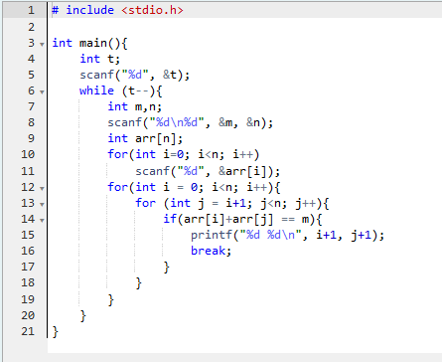

OUTPUT:

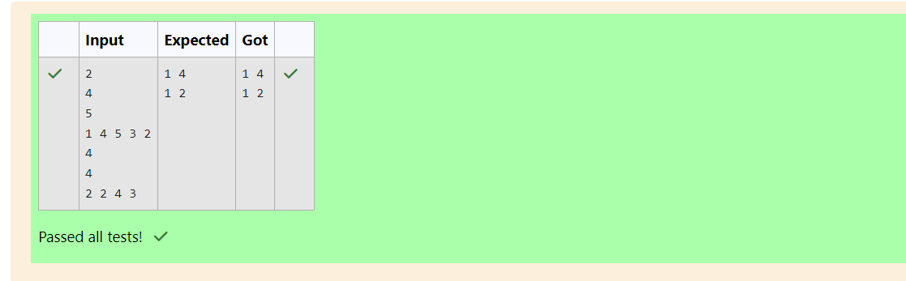

Q2)Numeros the Artist had two lists that were permutations of one another. He was very proud.

Unfortunately, while transporting them from one exhibition to another, some numbers

were lost out of the first list. Can you find the missing numbers?

As an example, the array with some numbers missing, arr = [7, 2, 5, 3, 5, 3]. The original

array of numbers brr = [7, 2, 5, 4, 6, 3, 5, 3]. The numbers missing are [4, 6].

Notes

• If a number occurs multiple times in the lists, you must ensure that the frequency of

that number in both lists is the same. If that is not the case, then it is also a missing

number.

• You have to print all the missing numbers in ascending order.

• Print each missing number once, even if it is missing multiple times.

• The difference between maximum and minimum number in the second list is less than

or equal to 100.

Complete the code in the editor below. It should return a sorted array of missing numbers.

It has the following:

• arr: the array with missing numbers

• brr: the original array of numbers

Input Format

There will be four lines of input:

n - the size of the first list, arr

The next line contains n space-separated integers arr[i]

m - the size of the second list, brr

The next line contains m space-separated integers brr[i]

Constraints

1 ≤ n, m ≤ 2 x 105, n ≤ m, 1 ≤ brr[i] ≤ 2 x 104, Xmax – Xmin< 101

Output Format

Output the missing numbers in ascending order.

Sample Input

10

203 204 205 206 207 208 203 204 205 206

13

203 204 204 205 206 207 205 208 203 206 205 206 204

Sample Output

204 205 206

Code:

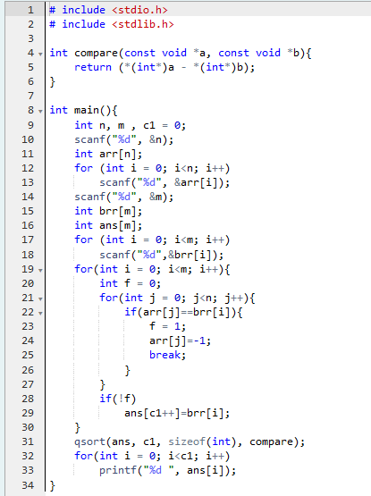

OUTPUT:

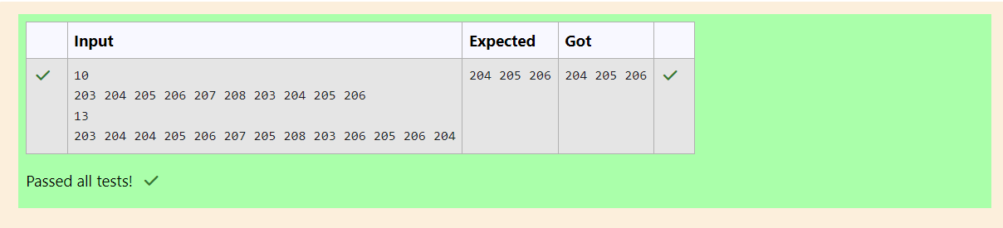

Q3)Watson gives Sherlock an array of integers. His challenge is to find an element of

the array such that the sum of all elements to the left is equal to the sum of all elements to

the right. For instance, given the array arr = [5, 6, 8, 11], 8 is between two subarrays that

sum to 11. If your starting array is [1], that element satisfies the rule as left and right sum

to 0. You will be given arrays of integers and must determine whether there is an element

that meets the criterion.

Complete the code in the editor below. It should return a string, either YES if there

is an element meeting the criterion or NO otherwise. It has the following: arr: an array of

integers

Input Format

The first line contains T, the number of test cases.

The next T pairs of lines each represent a test case.

- The first line contains n, the number of elements in the array arr.

- The second line contains n space-separated integers arr[i] where 0 ≤ i< n.

Constraints: 1 ≤ T ≤ 10, 1 ≤ n ≤ 105, 1 ≤ arr[i] ≤ 2 x 104, 0 ≤ i ≤ n

Output Format

For each test case print YES if there exists an element in the array, such that the sum of the

elements on its left is equal to the sum of the elements on its right; otherwise print NO.

Sample Input 0

2

3

1 2 3

4

1 2 3 3

Sample Output 0

NO

YES

Code:

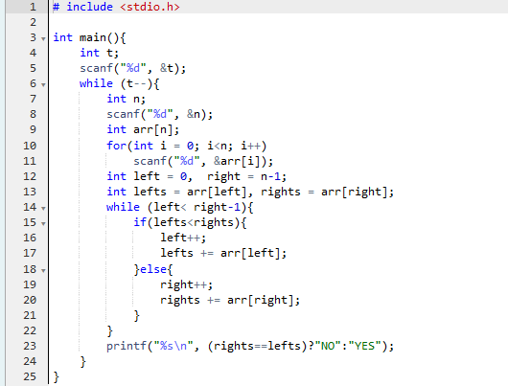

OUTPUT:

