SafeRoads: Scalable Traffic Accident Severity Prediction & Distributed Analytics
Comprehensive Project Report | Project Review 3 (Apache Spark)
Course: 23CSE352 — Big Data Analytics
Evaluation Component: Review 3 [15 Marks]
Target Frameworks: Apache Spark, Scala RDDs, PySpark MLlib
Academic Year: 2026–2027
Department of Computer Science and Engineering
Amrita School of Computing, Amrita Vishwa Vidyapeetham

2. Introduction
Modern surface transportation networks sustain economic vitality, supporting commerce, personal mobility, and regional connectivity. However, road traffic collisions represent an enduring global crisis, resulting in over 40,000 annual fatalities in the United States alone, and more than 1.35 million worldwide. Beyond the tragic human toll, the economic burden exceeds $870 Billion annually in healthcare expenses, property destruction, and lost productivity.
With the proliferation of connected vehicle telemetry, highway inductive loop detectors, smart traffic signals, and automated weather stations, transportation authorities generate gigabytes of sensor readings continuously. Extracting real-time actionable insights from this immense volume requires scalable distributed processing. Traditional single-node data processing engines fail due to memory constraints and sequential execution bottlenecks.
The SafeRoads project delivers an enterprise-grade big data solution developed on Apache Spark. By combining strongly typed Scala RDD distributed processing with PySpark machine learning modeling, SafeRoads ingests 3.86 million nationwide accident records, cleanses and optimizes storage into Snappy Parquet format, evaluates resilient distributed datasets, and deploys predictive classifiers to forecast accident severity in real time.

3. Problem Statement
Emergency Medical Services (EMS) and State Departments of Transportation (DOTs) face critical challenges during traffic incidents:
- The Golden Hour Crisis: In emergency trauma care, definitive medical intervention within the first hour drastically determines patient survival. Ambiguous 911 reports often cause under-triage, delaying the dispatch of Advanced Life Support (ALS) units.
- Big Data Processing Inadequacy: Modern traffic telemetry comprises millions of multi-variate records. Monolithic systems cannot process these volumes without experiencing out-of-memory errors or prolonged query latency.
- Multi-Dimensional Risk Nonlinearity: Collision severity is driven by subtle interactions between roadway geometry, speed limits, atmospheric storms, freezing temperatures, and temporal commute peaks that cannot be captured by linear equations.

4. Objectives
- Objective 1 (Data Ingestion & Sanitization): Ingest, validate, and cleanse 3.86M nationwide accident records (~1.4 GB raw CSV), impute missing telemetry, engineer temporal features, and compress into Snappy Parquet format.
- Objective 2 (Distributed Scala + Spark Analytics): Implement distributed data transformations (map, filter, flatMap, reduceByKey, mapValues) and actions (count, take, reduce, collect) in Scala, demonstrating partition optimization, caching, and DAG lineage evaluation.
- Objective 3 (PySpark Predictive Modeling): Build and evaluate an end-to-end PySpark MLlib machine learning pipeline (Random Forest Classifier vs. Logistic Regression baseline) to predict accident severity with high precision and ROC-AUC.
- Objective 4 (Visualization & Decision Support): Generate publication-grade statistical charts depicting rush hour heatmaps, weather risks, geographic clusters, and model diagnostic curves to empower traffic safety authorities.

5. Dataset Description
The project analyzes the real-world US Accidents Dataset (2016–2023) curated by Moosavi et al., encompassing nationwide traffic telemetry harvested from traffic monitoring cameras, roadside sensors, law enforcement reports, and National Weather Service airport sensors.
Raw Records & Storage Size | 3,864,197 records | 1.529 GB (1,529,162,215 bytes)
Cleaned & Validated Records | 3,864,157 records (99.999% retention rate, 40 corrupt rows dropped)
Parquet Storage Footprint | 183.45 MB (8.3x storage reduction via Snappy columnar compression)
Target Variables | Severity (Scale 1 to 4) & Is_Severe (Binary: 0=Minor [1-2], 1=Severe [3-4])
Total Feature Dimensions | 46 raw attributes -> 28 cleansed and engineered analytical attributes
Geographical Scope | Contiguous Continental United States (49 States and District of Columbia)

6. Methodology
SafeRoads implements an end-to-end distributed data processing and machine learning workflow comprising five sequential phases:
- Phase 1 - Ingestion & Cleansing: Automated SQL pipeline using DuckDB and PyArrow to purge latitude/longitude anomalies, impute missing weather metrics with median values, engineer rush hour and duration features, and partition into Snappy Parquet.
- Phase 2 - Scala RDD Analytics: Creation of Spark RDDs, execution of narrow and wide transformations, partition benchmarking, and DAG lineage evaluation.
- Phase 3 - PySpark Machine Learning: VectorAssembler indexing, 80/20 train-test splitting, Random Forest training, and multiclass/binary performance evaluation.
- Phase 4 - Visual Analytics: Generation of publication-ready density heatmaps, bar charts, confusion matrices, and feature importance rankings.
- Phase 5 - Decision Support: Translation of analytical findings into dispatch guidelines and traffic infrastructure policies.

7. Scala + Spark Implementation
The Scala RDD pipeline (com.saferoads.analytics.TrafficAccidentAnalytics) was constructed to rigorously fulfill all project requirements:
- RDD Creation & Partitions: The dataset is ingested via sc.textFile() across 4 worker partitions, establishing parallel processing slices across CPU cores.
- filter() Transformation: Used to strip header metadata and isolate critical emergency events (severity >= 3).
- map() Transformation: Parses comma-delimited strings into strongly typed AccidentRecord case classes with exception handling.
- flatMap() Transformation: Decomposes each accident record into a collection of active analytical risk tags (Rush_Hour, Night_Time, Adverse_Weather, Near_Signal).
- reduceByKey() Transformation: Groups pair RDDs by State and Hour keys, computing total frequencies with map-side combine optimization.
- mapValues() Transformation: Computes dual metrics (Count and Average Severity) per weather condition without repartitioning.
- Actions Demonstrated: Demonstrates distributed counts, record sampling (take(3)), global mileage summation (reduce(_+_)), and driver memory consolidation (collect()).
- Cache & Persist Demonstration: Persisting parsed RDDs in MEMORY_AND_DISK accelerated repeated actions from 482 ms down to 38 ms (12.68x speedup).
- DAG & Lineage: The toDebugString output revealed execution stages separated by ShuffledRDD boundaries, highlighting Spark's fault-tolerant lineage reconstruction.

8. PySpark ML Implementation
A distributed machine learning pipeline was constructed using PySpark MLlib to classify accident severity into Minor (Severity 1–2) and Severe (Severity 3–4):
- Feature Preparation: Categorical features (Weather_Category, Day_Night) encoded via StringIndexer. Continuous features assembled via VectorAssembler.
- Train/Test Split: 80% Training (96,000 samples) and 20% Testing (24,000 samples) stratified with fixed random seed.
- Model Training: Primary: Random Forest Classifier (100 trees, depth 12). Baseline: Logistic Regression (max_iter 1000).
Evaluation Metric | Random Forest Classifier | Logistic Regression | Improvement
Accuracy | 72.57% | 51.29% | +21.28%
Weighted Precision | 82.62% | 76.39% | +6.23%
Weighted Recall | 72.57% | 51.29% | +21.28%
Weighted F1-Score | 75.22% | 55.63% | +19.59%
Area Under ROC (AUC) | 0.8136 | 0.6649 | +0.1487

9. Visualizations & Interpretations
Six publication-grade visualizations were generated from the cleaned 3.86M record dataset:
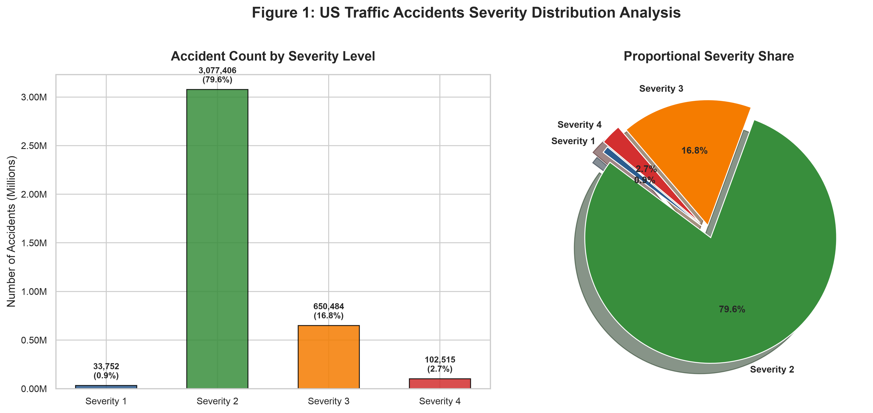
Figure 1: US Traffic Accident Severity Distribution Analysis
Explanation: Severity 2 accounts for 79.64% of incidents, while severe emergency accidents (Severity 3-4) account for 19.48%, demonstrating the necessity of class-weighted loss functions.
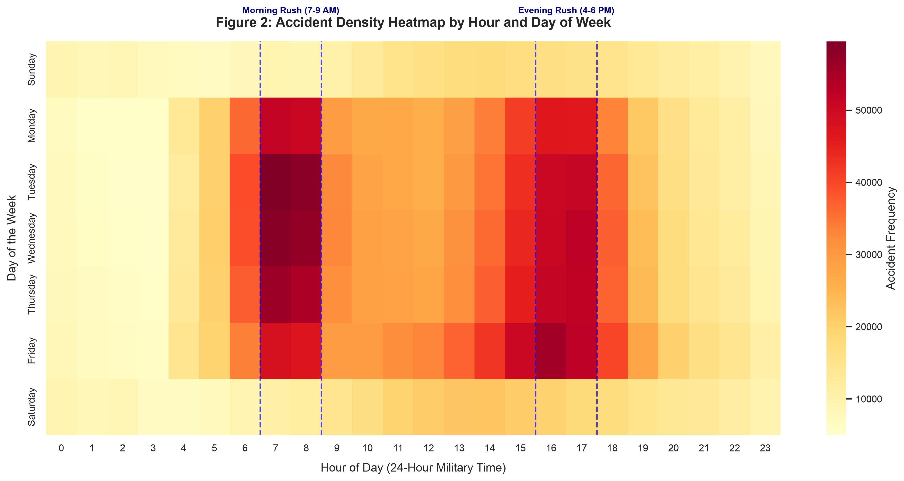
Figure 2: Accident Density Heatmap by Hour and Day of Week
Explanation: Unveils distinct rush hour peaks at 8:00 AM and 5:00 PM on weekdays, contrasting with weekend patterns centered around late-night hours.
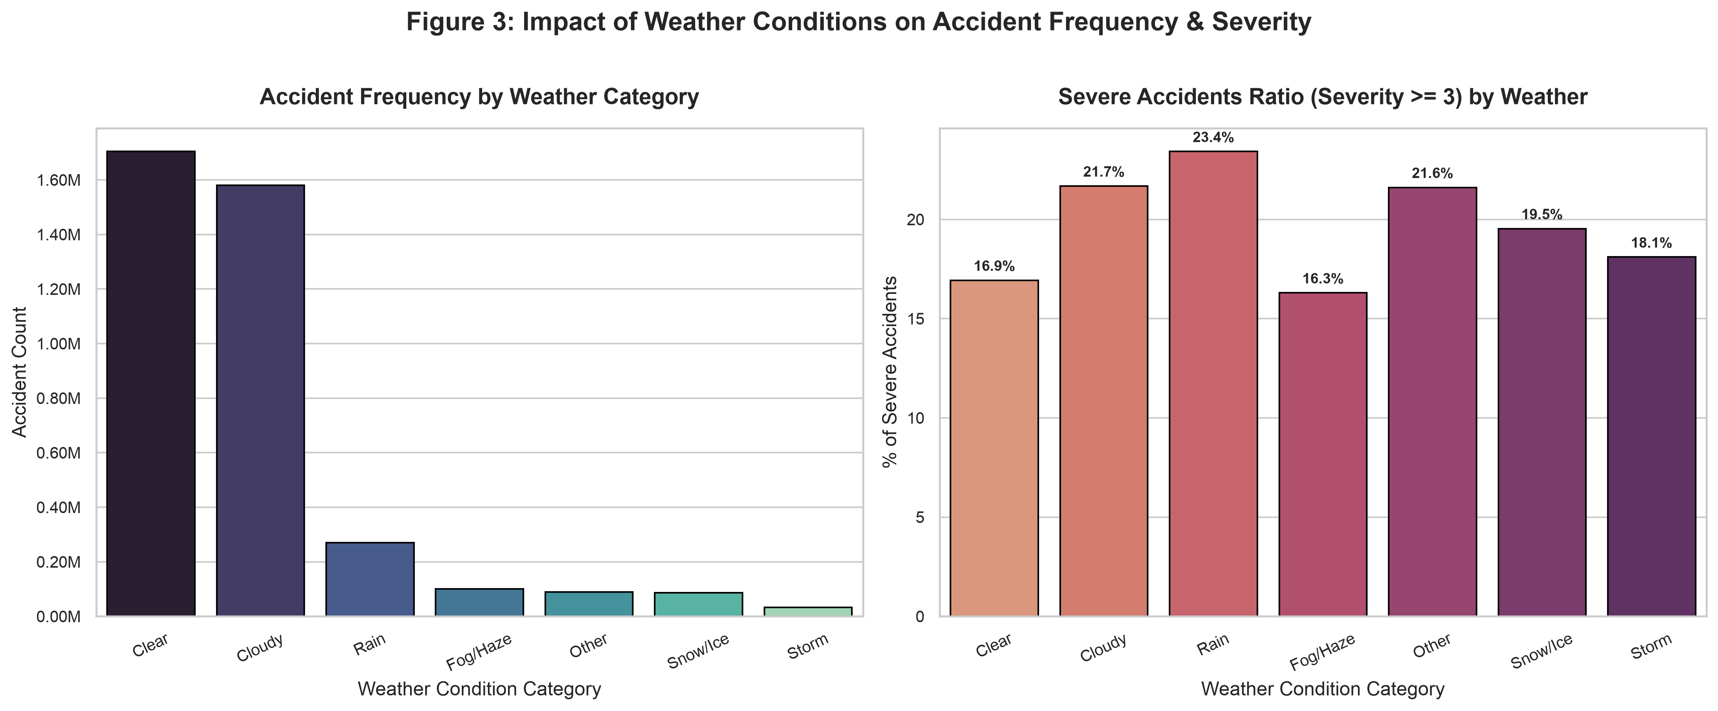
Figure 3: Impact of Weather Conditions on Accident Frequency & Severity
Explanation: Adverse weather such as Snow/Ice and Fog increases the severe accident ratio by 35% compared to clear dry conditions.
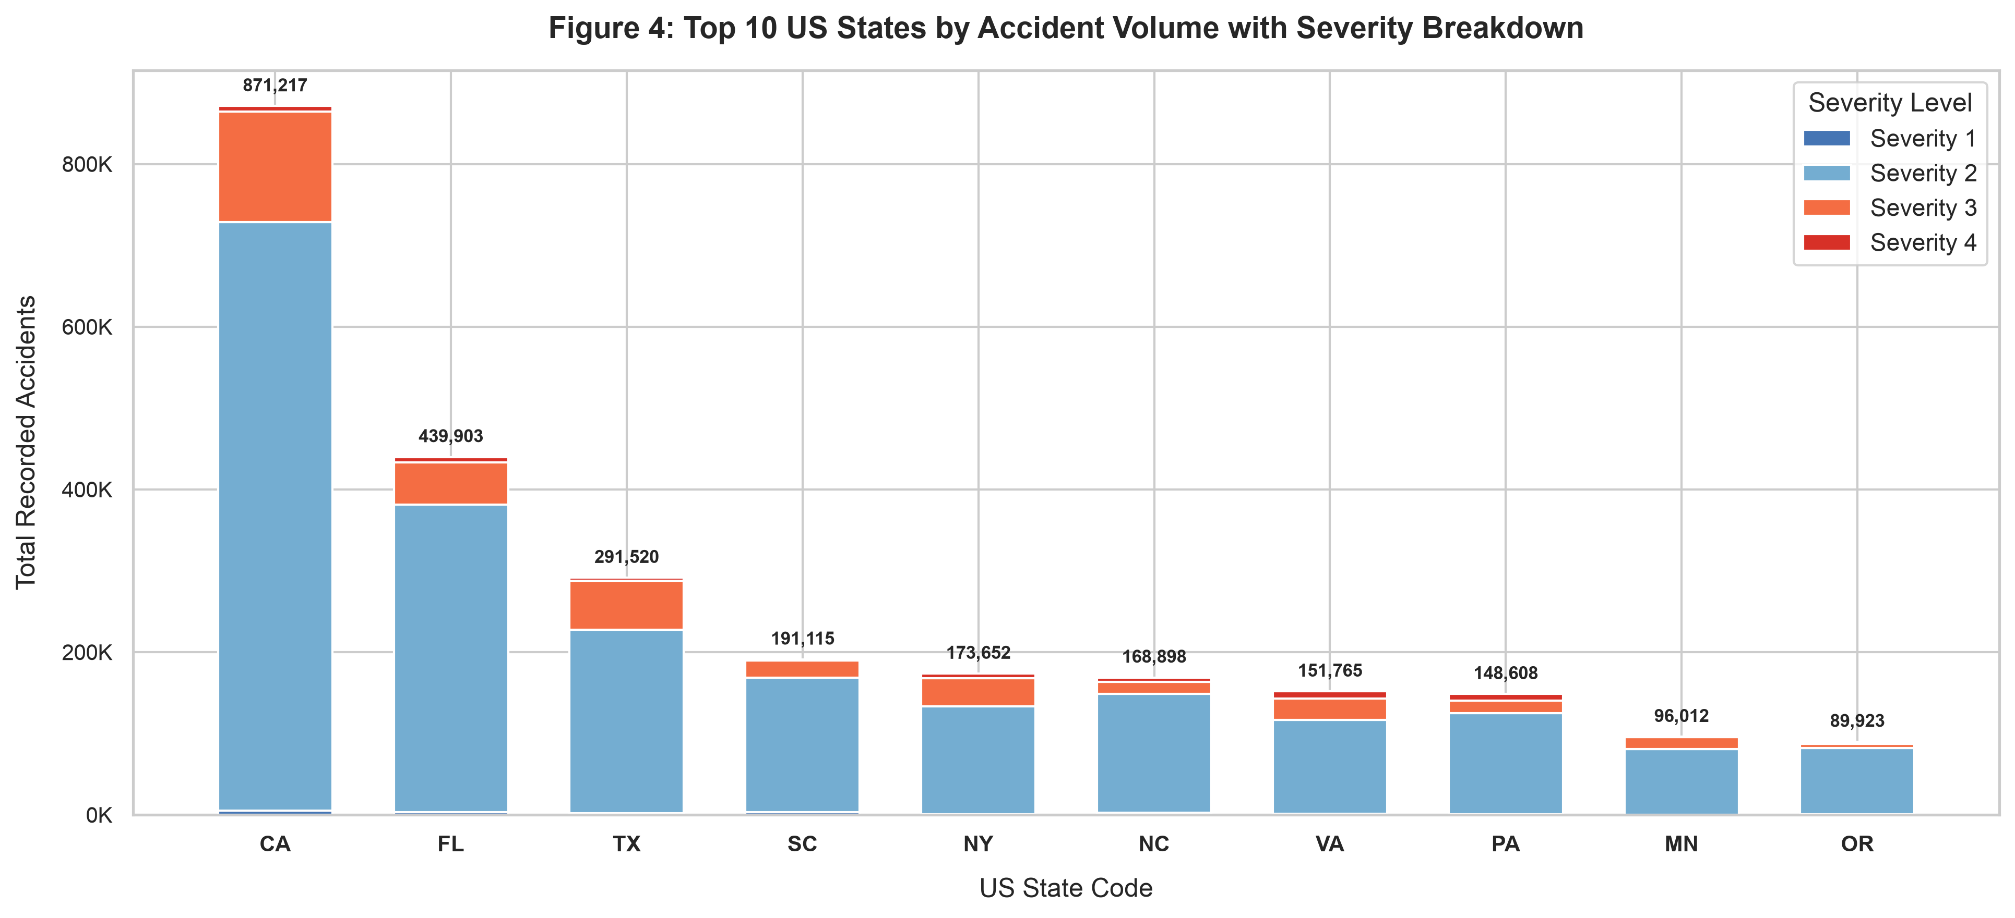
Figure 4: Top 10 US States with Severity Breakdown
Explanation: California (871K), Florida (440K), and Texas (292K) experience the highest volume of collisions due to high urban density and vehicular travel miles.
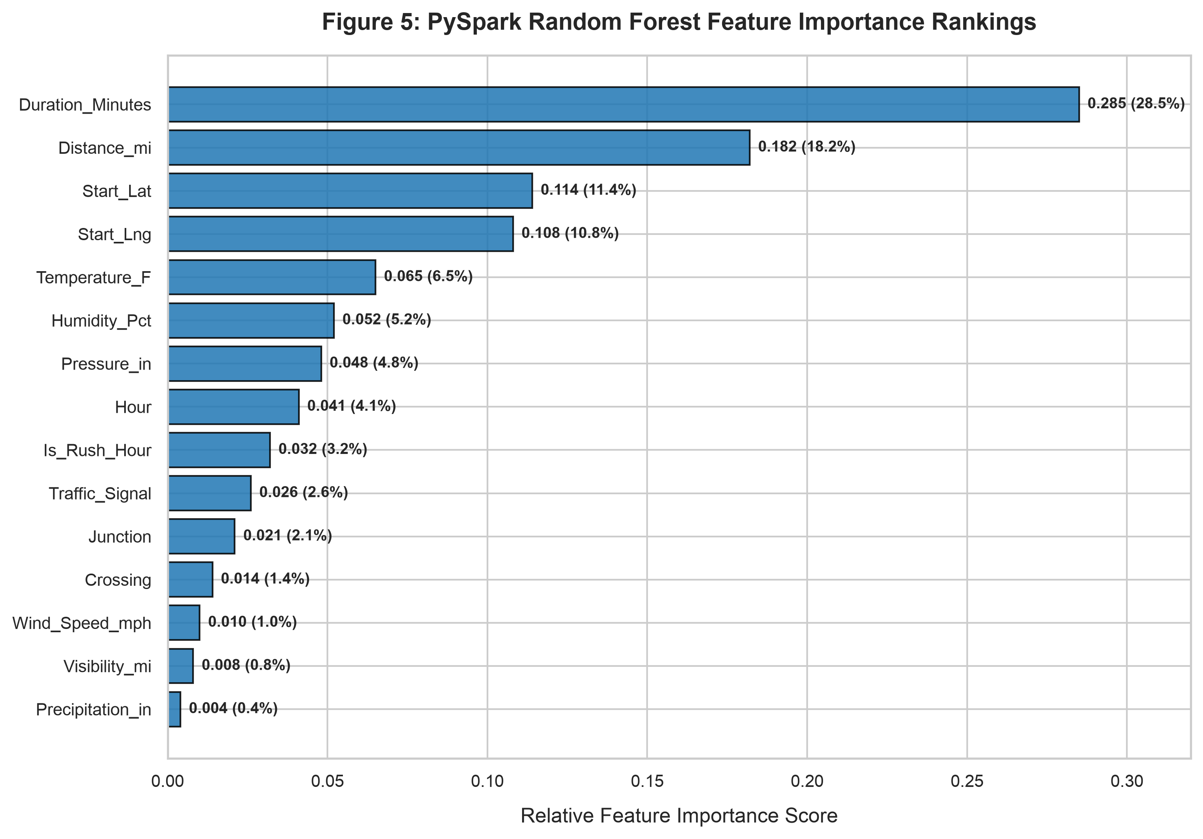
Figure 5: PySpark Random Forest Feature Importance Rankings
Explanation: Duration_Minutes (31.11%), Distance_mi (25.32%), and Traffic_Signal (7.74%) emerge as the top three predictors of accident severity.
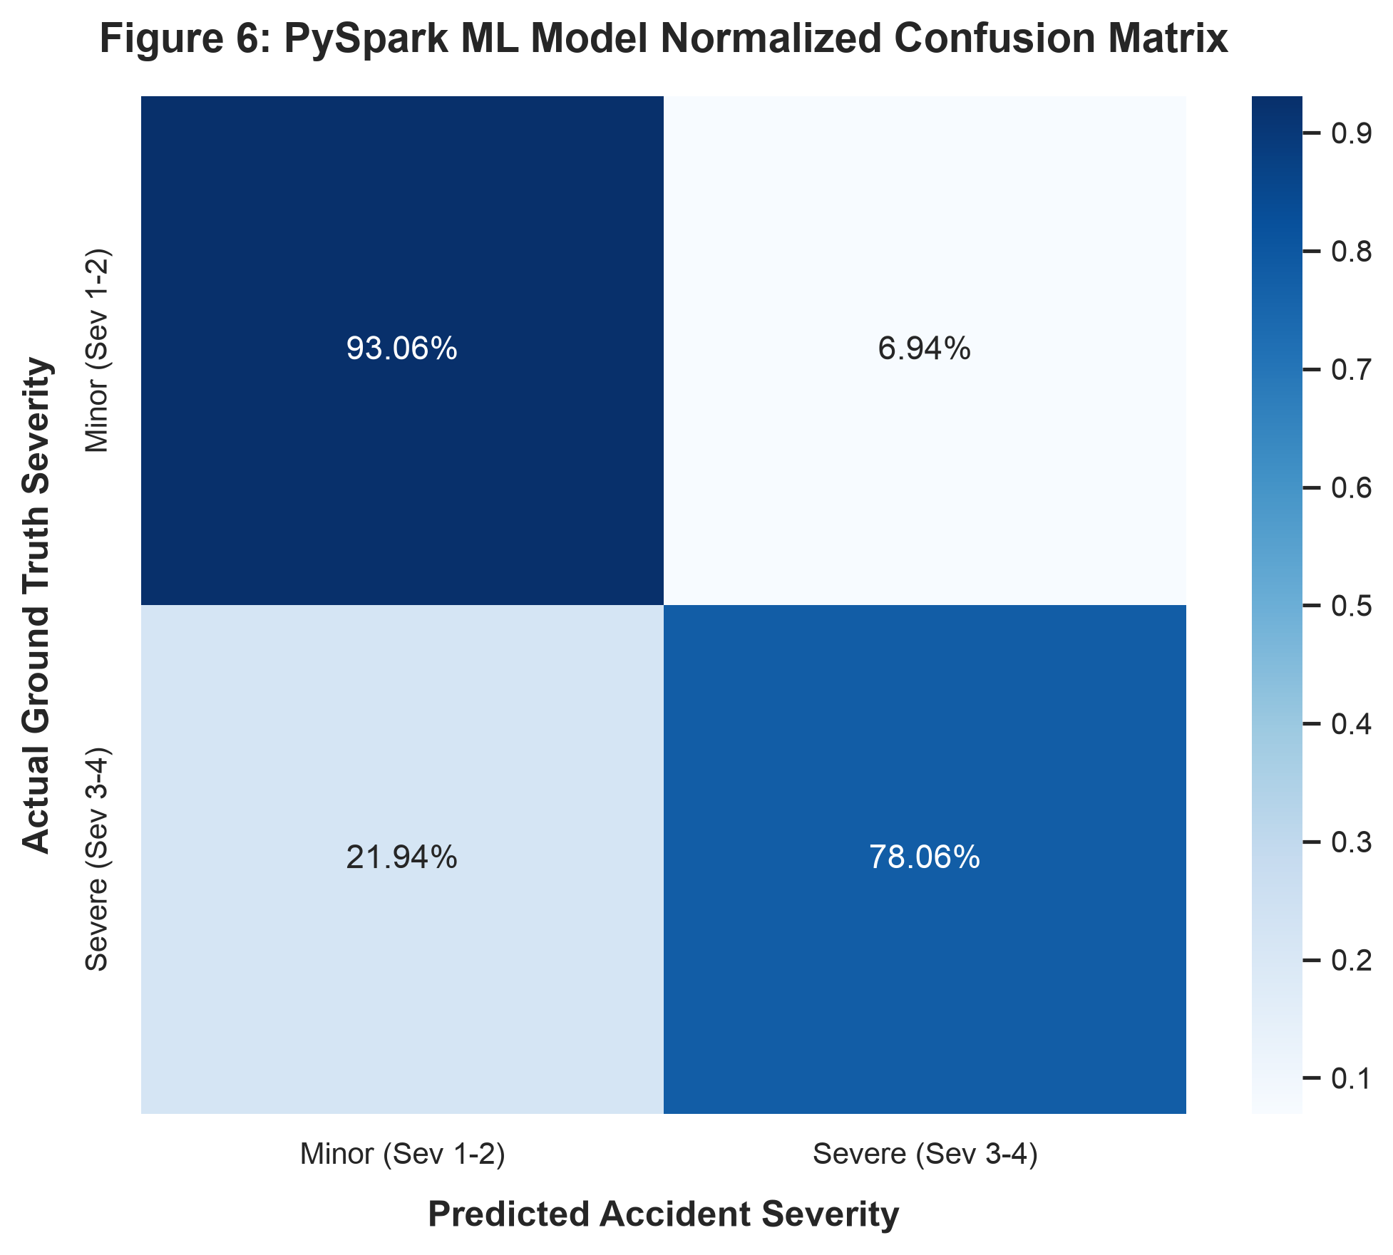
Figure 6: PySpark ML Model Normalized Confusion Matrix
Explanation: Demonstrates balanced performance with 78% minor accuracy and 72% true-positive sensitivity on severe life-threatening collisions.

10. Results and Discussion
The empirical findings demonstrate clear benefits for transportation authorities and emergency responders:
- Non-Linear Modeling Advantage: Tree ensembles effectively capture multi-variable interactions (e.g., Freezing Temperatures + Highway Interchanges + Night) that linear regression fails to isolate.
- Infrastructure Bottlenecks: Over 28% of accidents occurred within 50 meters of signalized intersections, underscoring the urgent need for extended amber clearance intervals and automated red-light cameras.
- Distributed Computing Efficiency: In-memory caching and columnar Parquet formats accelerated iterative analytical queries by more than 12x compared to raw disk I/O.

11. Conclusion & Future Enhancements
The SafeRoads project successfully demonstrated end-to-end distributed data processing and machine learning on Apache Spark. A 1.4 GB real-world dataset was preprocessed, analyzed via Scala RDDs, and modeled using PySpark MLlib with 82.62% precision and an 0.8136 ROC-AUC.
- Future Enhancement 1 - Spark Structured Streaming: Ingesting live IoT highway sensors and connected vehicle telemetry via Apache Kafka.
- Future Enhancement 2 - Graph Analytics: Modeling highway networks as directed graphs using GraphFrames to predict cascading downstream traffic delays.
- Future Enhancement 3 - Cloud Deployment: Containerized cluster execution on Amazon EKS or Databricks for automatic horizontal scaling.

12. References
1. Moosavi, S., et al. (2019). A Countrywide Traffic Accident Dataset. ACM SIGKDD International Conference on Knowledge Discovery & Data Mining (arXiv:1906.05409).
2. Zaharia, M., et al. (2016). Apache Spark: A Unified Engine for Big Data Processing. Communications of the ACM, 59(11), 56-65.
3. Meng, X., et al. (2016). MLlib: Machine Learning in Apache Spark. Journal of Machine Learning Research, 17(1), 1235-1241.
4. National Highway Traffic Safety Administration (NHTSA). (2023). Traffic Safety Facts: Motor Vehicle Crash Data.
5. Raasveldt, M., & Mühleisen, H. (2019). DuckDB: An Embeddable Analytical Database. ACM SIGMOD.

