**HEALTHY BITS**

**Description**

It will provide healthy habits to the users, such as articles on healthy lifestyle, beauty, home remedies.

**Analysis**

**Project Description**

A.

**Interviews, Surveys, Personas**

Persona:

-Target Devices:

-Android

-Target Markets:

-COMING FROM (<https://en.wikipedia.org/wiki/Immigration_to_Canada>):

-Philippines

-India

-Portugal

-Brazil

-China

These are the immigration stats of 2011 numbers of immigrants coming into Canada yearly, and the list constitutes approximately 37% of all those who came in 2011. 248,000 People Approx.

-Parents coming from another country (Late 20’s to 40’s)

-Mix of Tech Saavy and Non-Saavy

-MONETIZATION

-Not Much or LOTS

-Not Much

-Google Play Card

-Premium Purchase (Credit Card)

-Got Jobs, Looking For Jobs (With Gov.

Assistance)

-LOTS

-Google Play Card

-Premium Purchase (Credit Card)

-FINAL PERSONA:

-Mom

-Overseas (China, Philippines, India, Brazil, Portugal)

-Tech Saavy

-Have Credit Card

-20-45

Empathy Map:

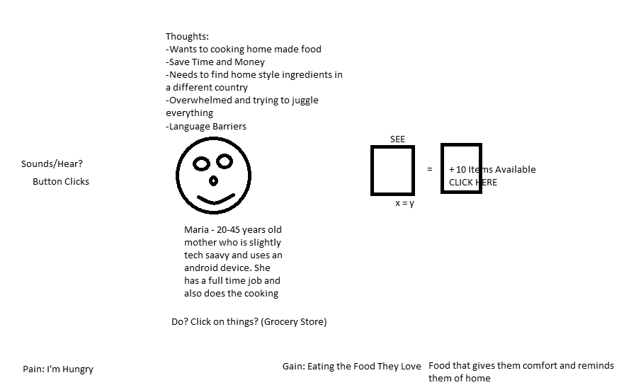

**Use Cases**

-When I’m in the grocery, I want to be able to decide if Product from HOME is equal to Product In My Hand?

**User Stories**

-When I get home and I want to cook I want to find similar ingredients to make the food I love.

As a <role>, I want <feature> so that <reason>

**Future Considerations (NEXT VERSION NOTES):**

-Take a photo with an example of what we are trying to use in a recipe to see if that would work.

-Coming to Canada

-Coming to X country and REVERSE

-Possible Barcode Scanner In Future

-User Reviews of Products and Substitutions

-Substitution Button for other Similar Items that can be used as Equivalent

Interviews, Surveys, Personas

-Students coming from another country to Canada

-Tech Saavy

-MONETIZATION

-Not Much or LOTS

-Not Much (How Do We Make Money From This User

Segment)

-Contract (Government)

-In Person Meeting (Flyers, Business Cards,

Meetings)

-Ads

-In-App Purchases

-Google Play Card

-Premium Purchase (Credit Card)

-OTHER IDEAS

-India, Portugal, Philippines, Brazil

-LOTS (How Do We Make Money From This User

Segment)

-Premium Purchase (Credit Card)

-Google Play Card

-China & United States

-Seniors (Grandparents) coming from another country

-MONETIZATION

-Not Much or LOTS

-Not Much

-LOTS

-Analysis

-Interviews, Surveys, Personas

-Empathy Map

-Use Cases

-User Stories

-Design

-Onboarding Design (How You Welcome)

-Flow Diagrams

-Interaction Design

-User eXperience Design

-Monetization, Retention and Attrition Design

-$2.99 Premium

-Freemium => Free to download, MAIN FUNCTIONS

-Unlock Full App for $2.99

IAP

-Testing

-Paper Prototype

-Clickable Wireframes

-Usability Tests

-Visual & High Fidelity

-Implementation