Vancouver Urban Safety Intelligence Platform
A secure web application for exploring, forecasting, and safely entering Vancouver crime data

MidCourse Progress Report

Course | CSIS 4495, Section 002
Instructor | Padmapriya Arasanipalai Kandhadai
Team Lead | Jaismine Kaur (responsible for all joint submissions)
Team Member | Jaismine Kaur (300415820) - Data Analytics
Team Member | Shashank Chaudhary (300392521) - Cybersecurity
Date | October 26, 2026

MidCourse Progress Video Demonstration (link):
VIDEO LINK: []

Checklist
Each entry is checked when it is done.
[x] GitHub Repository Code Check-In: All work completed so far is checked into the GitHub repository (last push: October 26, 2026).
[ ] Video Demo of the Product: One joint video (at least 6 minutes, one video per team) showing a demo of all features. Each team member presents and demos the work they completed. Uploaded to a publicly viewable link, and the link is on the title page of this report.
[ ] Video Link: Clickable, public link of the video is provided on the title page.
[x] Installation Instructions: The README file states a clear project description and has a Setup section with installation instructions (how to install and run the app).
[x] MidCourse Progress Report Blackboard Submission: Report submitted on Blackboard by the Team Lead.
[x] GitHub Repository MidCourse Progress Report Check-in: Report checked into the GitHub repository under DocumentsAndReports.

Note: A MidCourse Progress grade will not be given without the mandatory in-person check-in during class hours. All students must be present.

1. Introduction

1.1 Domain and background
Crime data tells us a lot about a city, but only if it is easy to understand. The Vancouver Police Department (VPD) publishes its reported crime data on an open data portal called GeoDASH. Anyone can download it. The dataset has around 928,000 rows and covers all 24 neighbourhoods of Vancouver from 2003 up to now. Each row is one reported incident with its crime type, neighbourhood, and approximate location and time.
The problem is that raw open data is hard to use. The data has duplicates, missing values, and rows with no location. It also has privacy rules built into it - for example, violent crimes do not show their exact time. A normal person, like a resident or a small business owner, cannot simply open the CSV file and learn something from it.
Our project brings two fields together. The data analytics side cleans the data, finds patterns, and builds an interactive web app with maps, charts, statistical tests, and a simple forecast. The cybersecurity side makes sure the app itself is safe - safe login, safe input handling, safe database queries, and a record (audit log) of who did what. Together they make a prototype that is useful and safe to use.

1.2 Framing the problem
We wanted to answer these questions:
- How does crime in Vancouver change over time - by hour, by day of week, by month, by season, and by year?
- Which neighbourhoods look similar in their crime mix, and can we group them in a helpful way?
- Are crime type and season, or crime type and day of week, connected in a statistically meaningful way?
- Can we make a simple, honest forecast of future crime counts and be clear about how wrong it is?
- How do we let authorized users safely add their own incident records without mixing them into the public data?
- What security controls does such a web prototype need, and can we build and test them in real code?
These questions matter because a tool like this could be used by researchers, students, or community groups. If the numbers are wrong or the app is unsafe, the tool is worse than useless.

1.3 Relevant literature and research
We looked at existing work to learn how others have handled this kind of project:
- Open crime data projects: many cities publish crime data, but published studies and blog posts warn about data quality problems like missing years, duplicate rows, and location hiding for privacy.
- Predictive policing research: papers such as Richardson, Schultz and Crawford (2019) "Dirty Data, Bad Predictions" show that flawed crime data leads to flawed predictions and unfair outcomes. This is why we kept our forecast simple and honest instead of claiming accuracy we do not have.
- Security standards: we used the OWASP Top 10 list of web application risks and the STRIDE threat modeling method from Microsoft to decide what could go wrong and what controls we needed.
- Streamlit and open source tools: we studied the official documentation of Streamlit, Folium, pandas and scipy to build the app.
The gap we fill: most tutorials show either a data dashboard or a security demo, but not both in one small prototype. We wanted one working app where the analytics and the security controls are both real code, not just slides.

1.4 Initial hypotheses, assumptions, and potential benefit
- Hypothesis: crime counts have strong time patterns (more incidents in summer, more on weekends, more in the evening) and these patterns are different for different crime types.
- Hypothesis: neighbourhoods group into a small number of crime-profile clusters, which makes the map easier to read.
- Assumption: the VPD data is accurate enough for exploration, but it represents reported incidents, not all crime that actually happens.
- Assumption: a prototype with demo users is enough to show real security controls working (hashing, roles, lockout, validation, audit log).
- Benefit: a working template for a safe, explainable public-safety data tool that is honest about data limits and privacy.

2. Summary of the Initially Proposed Research Project
In the proposal we committed to these deliverables:
- Download and clean the VPD crime dataset (GeoDASH open data) with a reproducible script pipeline.
- Build a Streamlit web app with pages for overview, crime map, temporal analysis, statistical analysis, machine learning, an Add Incident form, a security page, and a methodology page.
- Analyze the data with charts, notebooks, statistical tests (chi-square) and machine learning (clustering and a forecast).
- Add a login system with three roles (Administrator, Analyst, Data Entry) with hashed passwords and role-based access.
- Write security documents: a threat model (STRIDE + OWASP Top 10) and a privacy and data protection review.
- Follow the proposed weekly timeline from September 24 to the end of the term, with check-ins through progress reports and an in-person mid-course check-in.
The overall goal stayed the same: one secure prototype that combines data analytics and cybersecurity on real open crime data.

3. Changes to the Proposal
The direction of the project did not change, but we made a few specific decisions along the way. Each change is explained below with the reason.

3.1 Dataset: VPD GeoDASH open data (as planned), but with a documented gap
Change: the dataset has no rows at all for the year 2022, which we found during the quality inspection. We decided not to try to patch it with another source; instead we document it clearly in the app and the reports.
Why: mixing two sources could introduce errors we cannot verify. Being honest about the gap is safer than guessing. We are still investigating why 2022 is missing and will write about it in the final report.

3.2 Database choice: SQLite for the prototype
Change: the proposal left the database open (SQLite vs PostgreSQL). We decided on SQLite for the prototype.
Why: SQLite needs no server, keeps the demo simple for the professor to run on any machine, and still allows parameterized queries and a real table design. The code is written so the same idea can move to PostgreSQL later if the project ever becomes a real product.

3.3 Add Incident feature pulled forward
Change: the Add Incident feature and its database were planned for Oct 29-Nov 9, but we finished the main part of it by Oct 26.
Why: the professor asked to see the full login-to-form-to-database flow at the mid-course check-in, and having it early makes the demo stronger. No other phase was delayed by this.

3.4 Map tiles: switched to ESRI World Street Map
Change: the map originally used CartoDB tiles, which started asking for an API key. We switched to the free ESRI World Street Map tiles.
Why: the app must run without secret API keys (we do not want keys in the repository), and the ESRI tiles work reliably without one.

3.5 Machine learning: honest baseline forecast instead of a complex model
Change: the proposal said "machine learning" for forecasting. We built a simple moving-average forecast plus a "same as last year" baseline, with MAE and RMSE scores shown to the user.
Why: with missing 2022 data and only monthly counts, a complex model would pretend to be accurate. Research like "Dirty Data, Bad Predictions" warns exactly about that. A simple model with honest error numbers is the right choice for a research prototype. We do still have real machine learning in the project: k-means clustering on the Crime Map.

3.6 Privacy: neighbourhood-level summaries instead of exact points
Change: on the Crime Map we show circles per neighbourhood (with counts and cluster groups) instead of individual incident points.
Why: the VPD data only has hundred-block locations, but showing even those as a dot cloud is misleading and less useful than clean neighbourhood summaries. This also follows the data-minimization principle from our privacy review.

4. Project Planning and Timeline (Current to End of Term)

4.1 Updated timeline
Phase | Dates | Milestones and deliverables
Mid-course demo prep | Oct 26 - Nov 1 | Record the joint 6+ minute demo video; assemble this report; final polish of demo flow
MidCourse submission | Nov 2 - Nov 8 | Submit report on Blackboard (Team Lead); check report into GitHub; in-person check-in with professor (mandatory)
Security testing phase | Nov 9 - Nov 15 | Run pip-audit dependency scan; do manual OWASP-style tests (SQL injection, XSS, auth bypass, role matrix); fix what is found; document results
Analytics polish | Nov 9 - Nov 15 | Forecast evaluation on test window; map refinements from demo feedback; statistical page wording
Findings documentation | Nov 16 - Nov 22 | Write up the missing-2022 investigation; finalize notebook findings; update dataset documentation
Security hardening | Nov 16 - Nov 22 | Session security review; final threat model and privacy review versions
Final report draft | Nov 23 - Nov 29 | Both members draft their sections; merge and review together
Final submission | Nov 30 - Dec 8 | Record final video; submit final report on Blackboard and GitHub

4.2 Individual responsibilities
Member | Responsibilities for the remaining term
Jaismine Kaur (Team Lead, Data Analytics) | Owns the analytics pages (Crime Map, Statistical, ML forecast), the analysis notebooks, findings documentation (including the missing-2022 investigation), and leads joint submissions (report PDF, Blackboard, video).
Shashank Chaudhary (Cybersecurity) | Owns security: threat model, auth/RBAC, validation, audit log, SQLite store, security tests, pip-audit and manual OWASP testing, and the security sections of the final report.

4.3 Project management chart (Gantt)
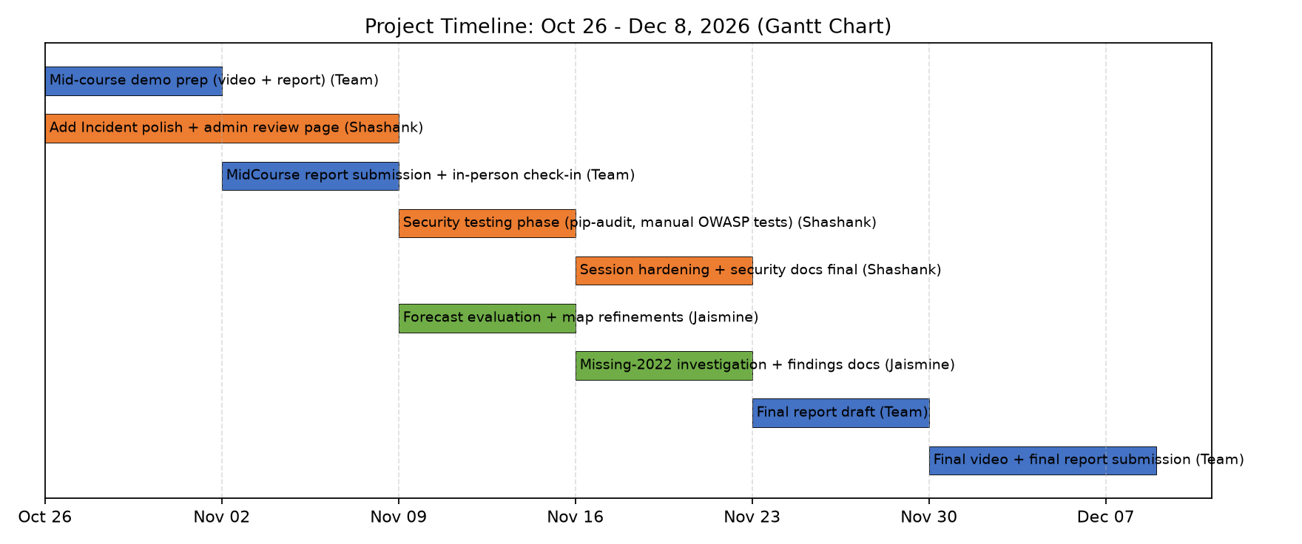
Figure 1: Gantt chart of the remaining timeline. Team tasks are shared; individual tasks show who owns them.

5. Implemented Features
Everything below is working code in the GitHub repository (https://github.com/jaismine19/F26_4495_S2_JaismineK), covered by 73 passing tests. Each section says who built what.

5.1 Feature 1: Secure Add Incident (login -> form -> database)
Individual contributions: Shashank built the validation rules, the hour-of-day check, and the security wiring of the database module. Jaismine built the end-to-end form flow and the database module. The two versions were merged into one shared module (app/utils/db.py) on Oct 24.
What it does: only logged-in users with the right role can open the form. They pick a crime type and neighbourhood from dropdown lists (the same 11 types and 24 neighbourhoods as the real data), pick a date (2003 to today, no future dates), an hour, a block-level location, and optional notes. On submit, the record is checked, saved to a SQLite database with a parameterized query, and written to the audit log. Records are tagged source='user' and are never mixed into the public data.
Security details shown in the demo:
- Administrator sees all entered records; Analyst and Data Entry see only their own records.
- XSS: any HTML or script text is cleaned before storing.
- SQL injection: all queries are parameterized; tests prove a DROP TABLE payload is stored as harmless text.
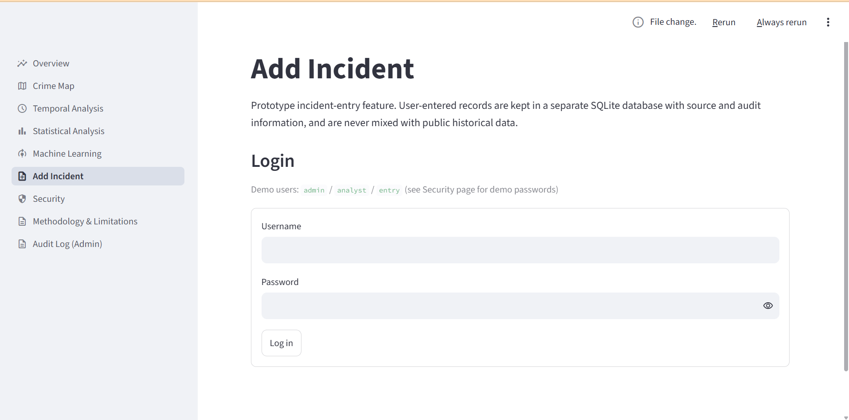
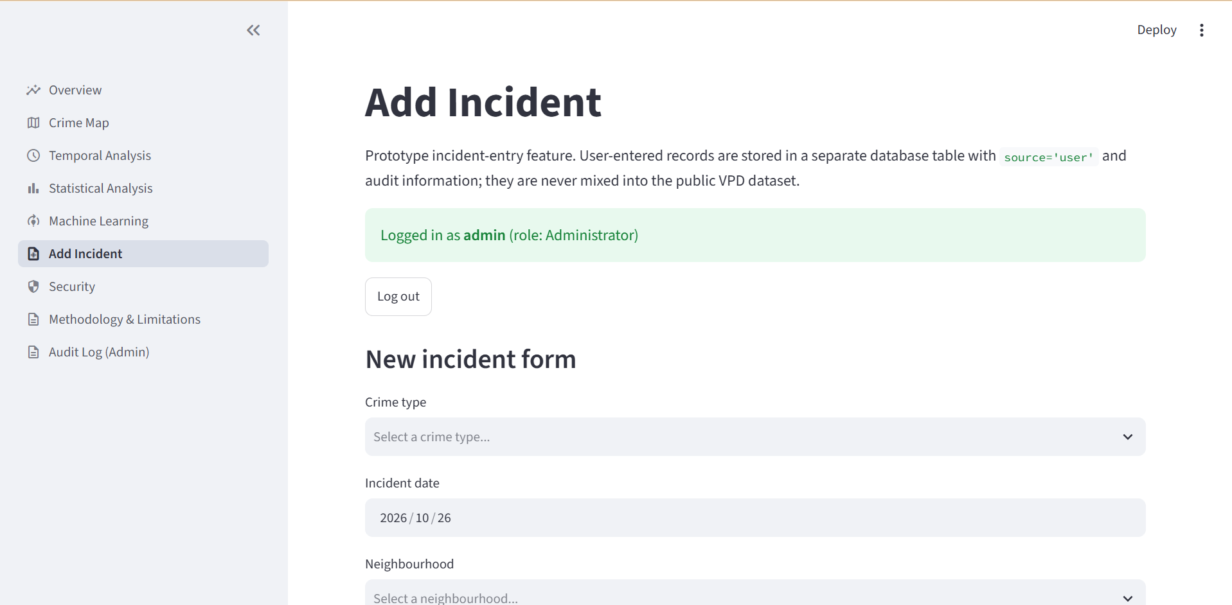
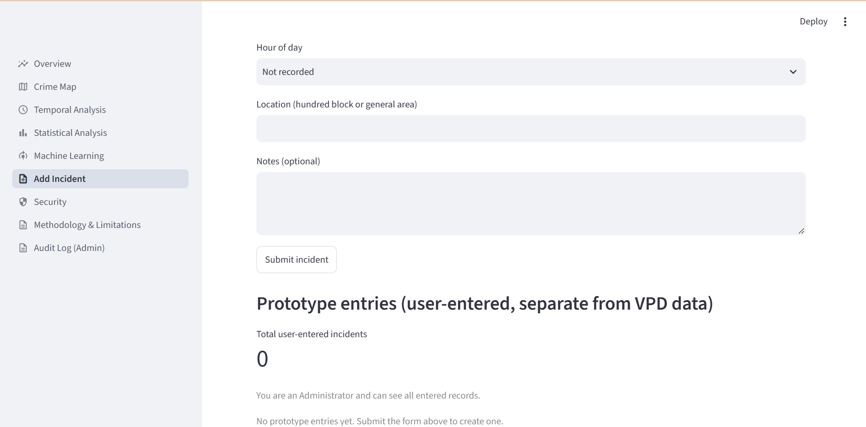
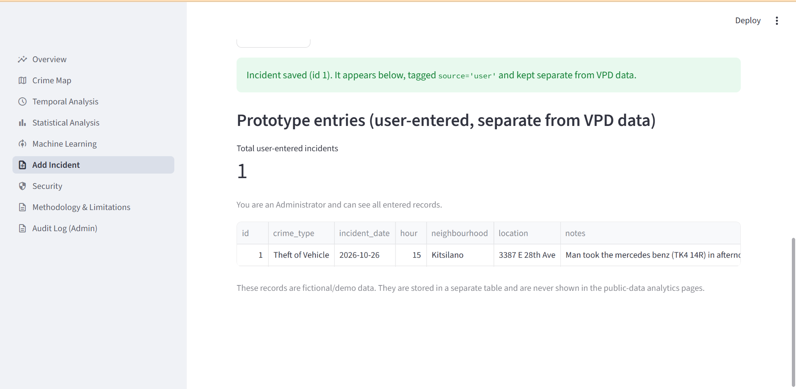

5.2 Feature 2: Authentication, RBAC, Login Lockout, and Audit Log
Individual contribution: Shashank.
What it does: passwords are hashed with PBKDF2-HMAC-SHA256 (200,000 iterations, per-user salt). Three roles have different permissions (Administrator, Analyst, Data Entry). Five wrong password attempts lock the account for 60 seconds. Every login success, login failure, logout, and incident addition is appended to an audit log. A separate page shows the audit log - but only to the Administrator role.
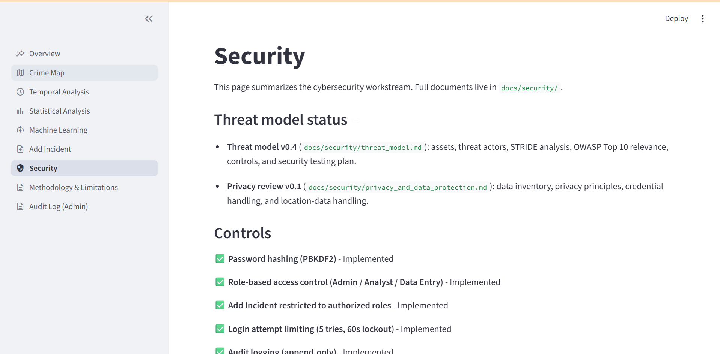
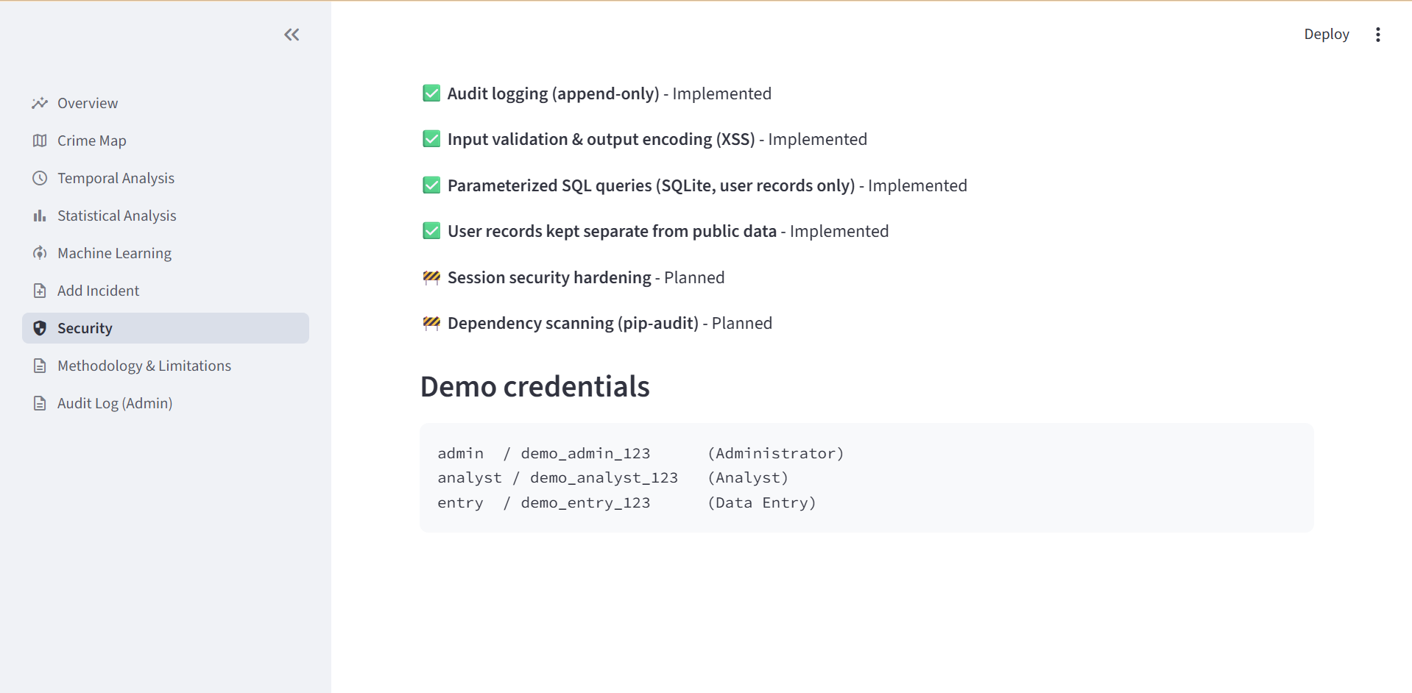

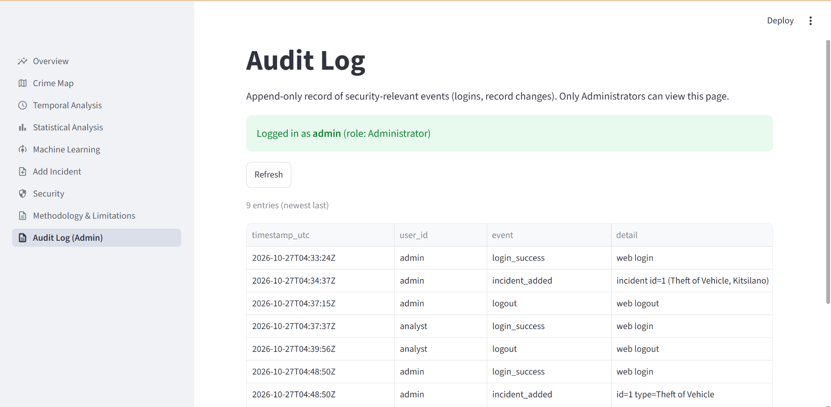
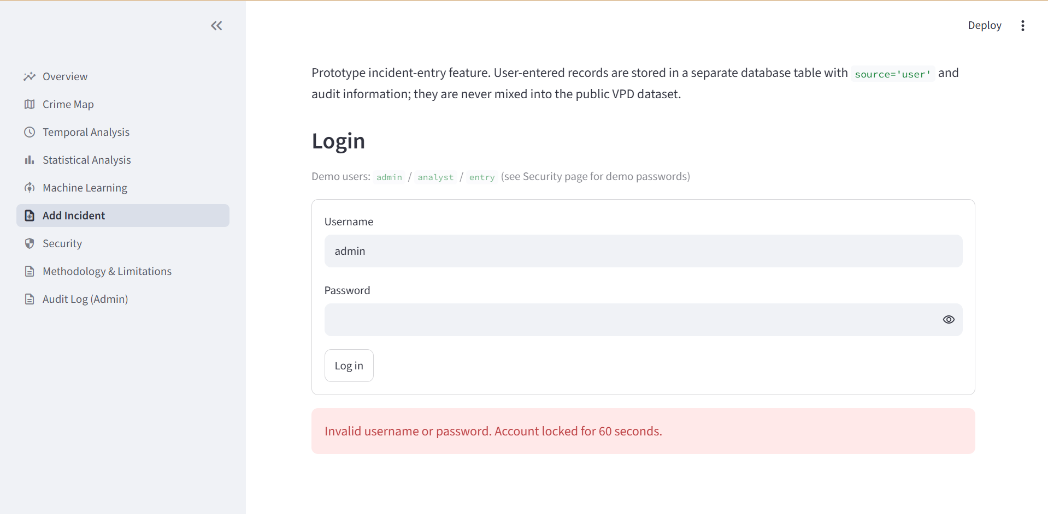

5.3 Feature 3: Reproducible data pipeline and quality analysis
Individual contribution: Shashank (with Jaismine reviewing).
What it does: three scripts download the VPD dataset, inspect its quality, and clean it (928,362 rows -> 893,851 rows). The cleaning removes duplicates, standardizes text, flags zero coordinates, and adds year/month/day/hour/season columns. Every step is written to a log file. Key findings documented: missing year 2022, 34,511 duplicate rows, 83,020 rows with zero coordinates.
Cleaning log
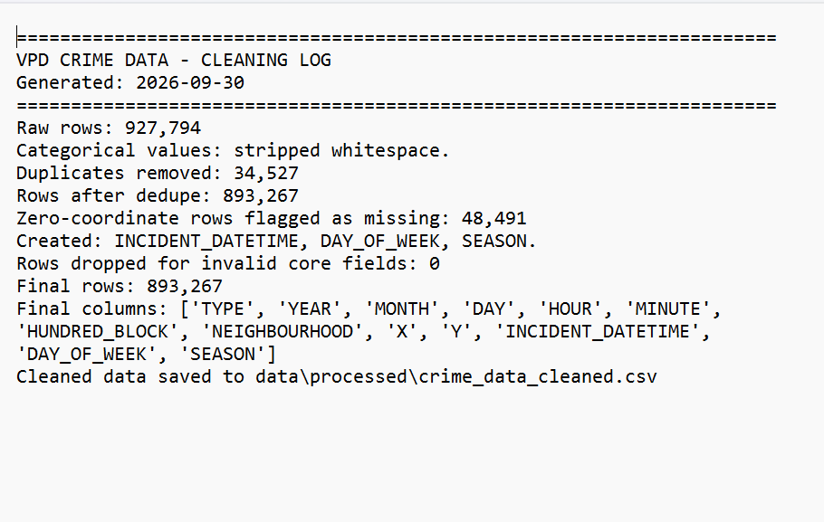

Data quality summary files
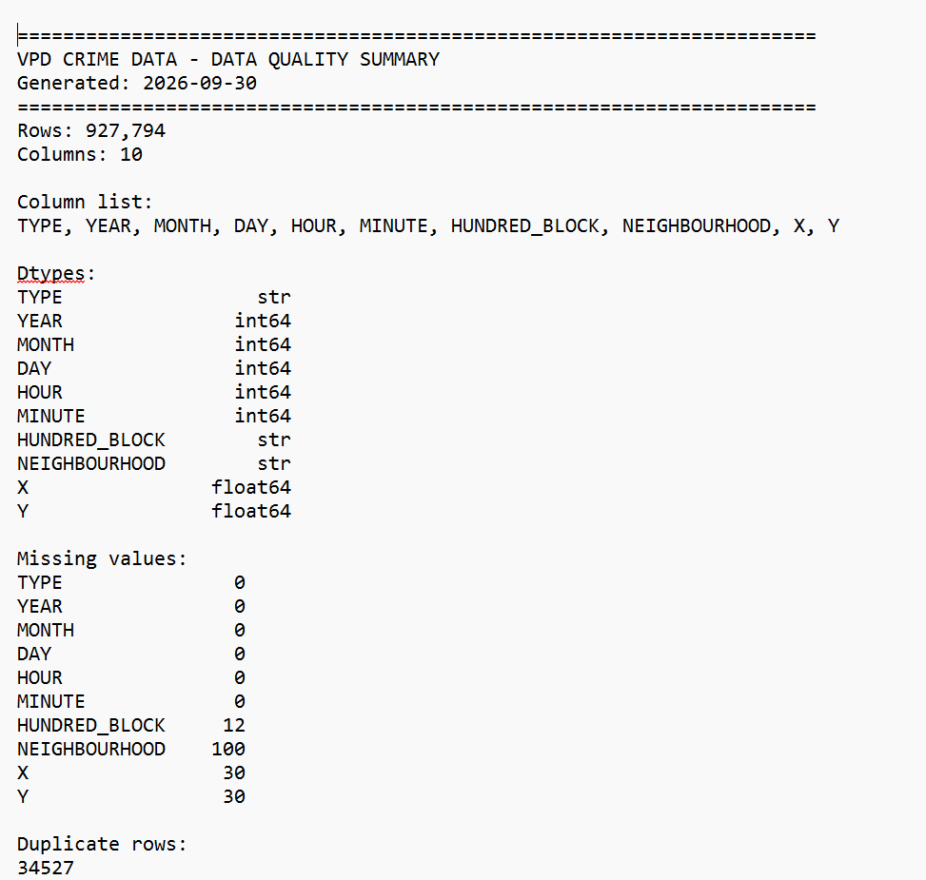
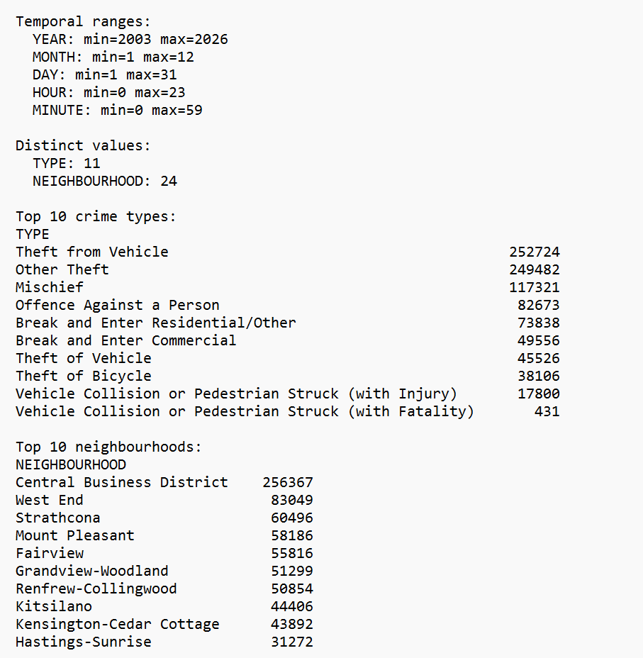
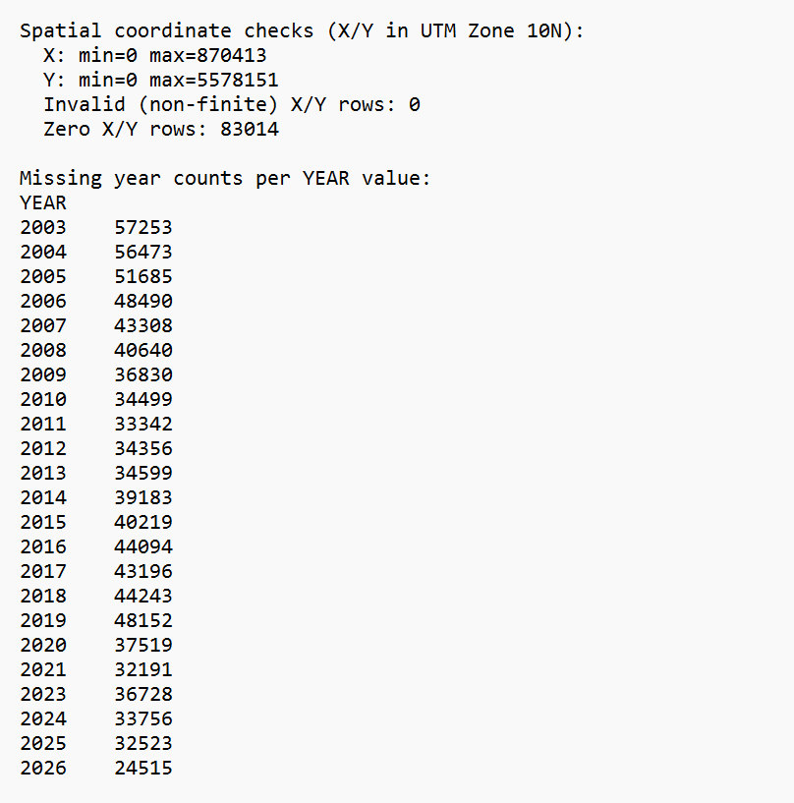

5.4 Feature 4: Overview and Temporal Analysis
Individual contribution: Jaismine (pages), with the pipeline and dataset documentation from Shashank.
What it does: the Overview page shows key figures, incidents by year, and top crime types, plus the separate user-entered prototype counter. The Temporal page has filters and charts for hour of day, day of week, month, season, and a year-by-month heatmap with automatic plain-English insights.
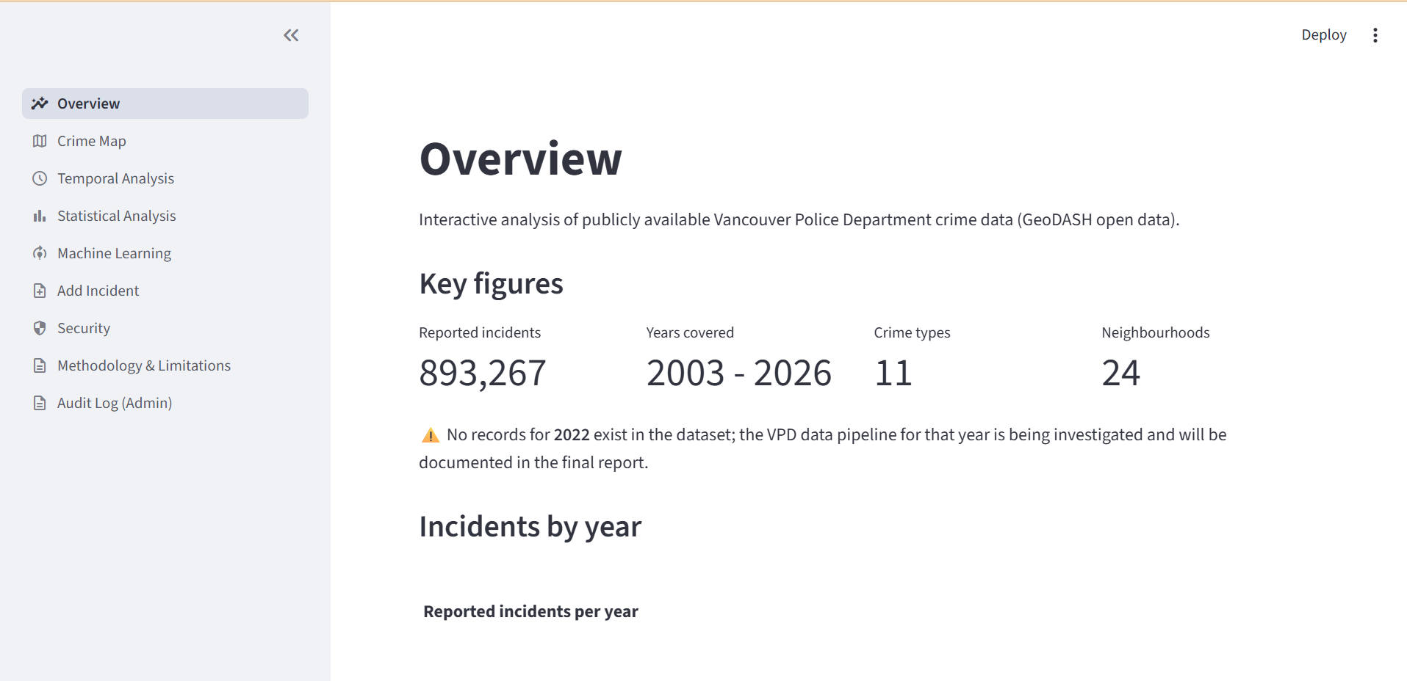
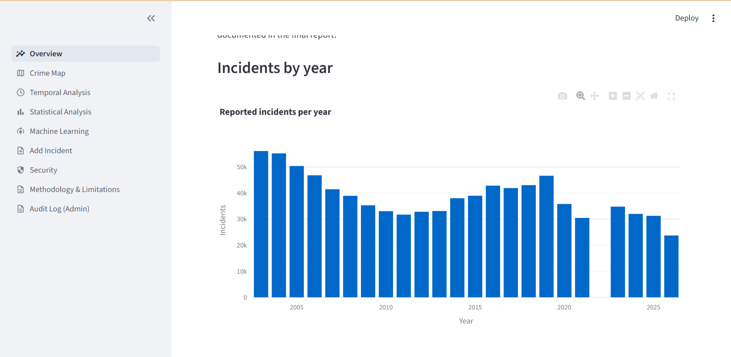
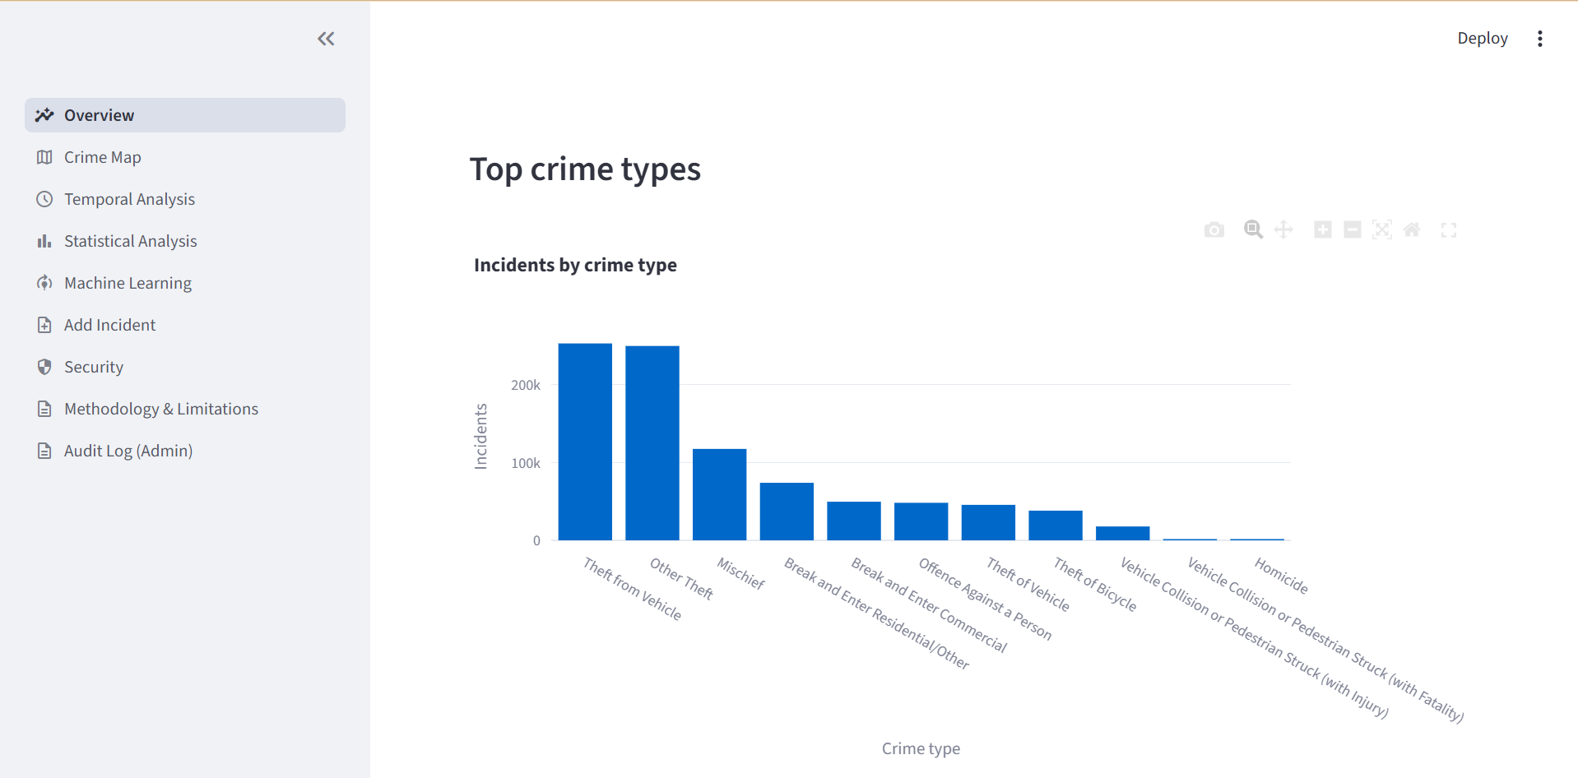
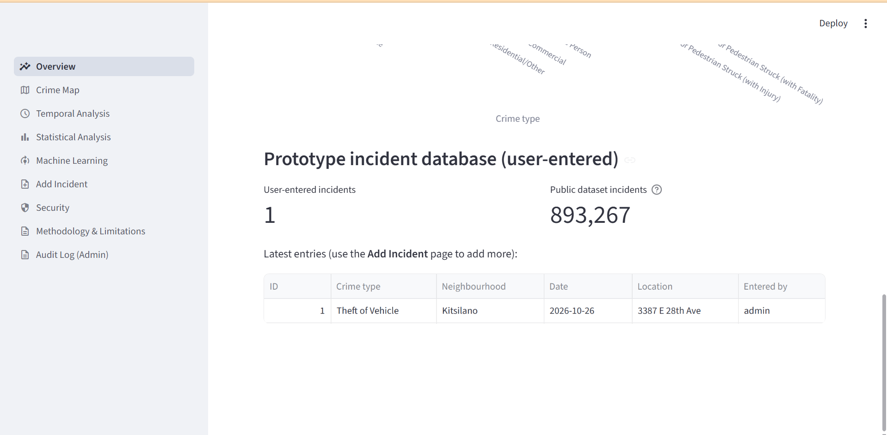

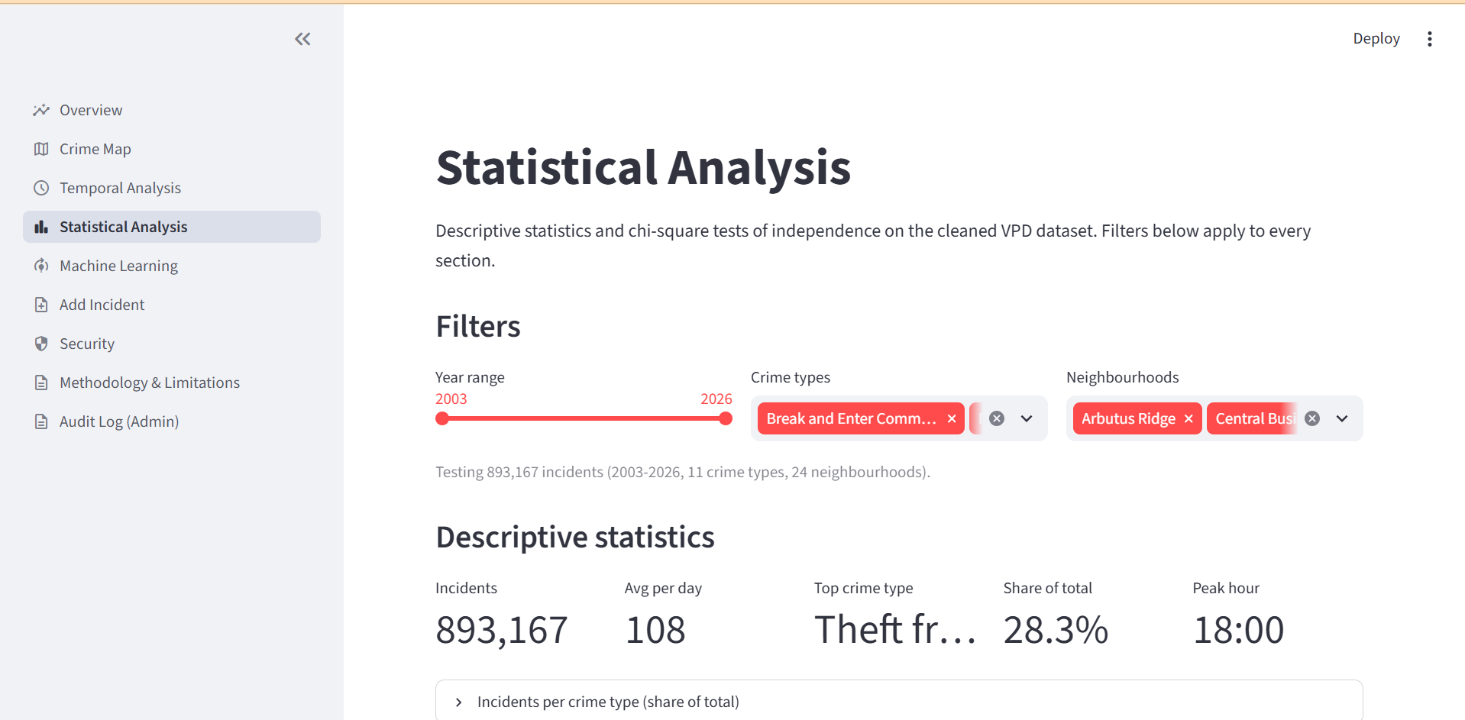
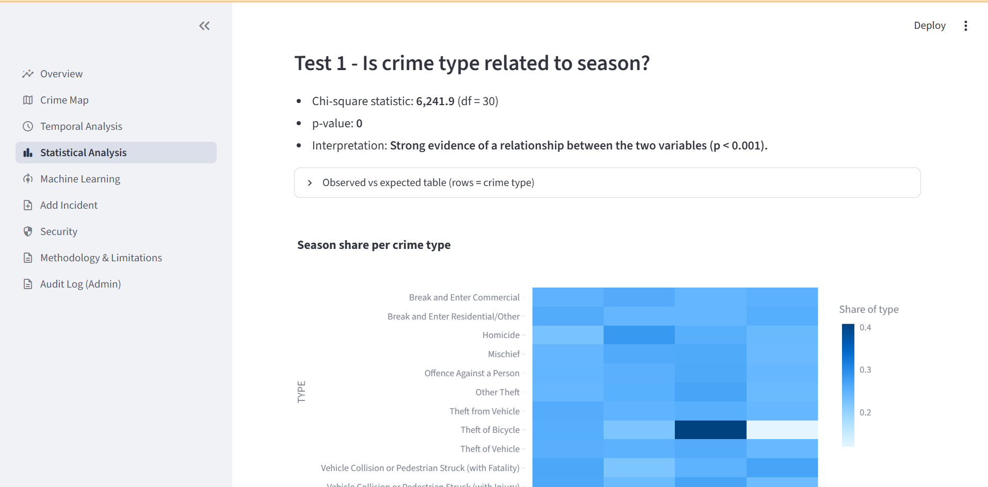
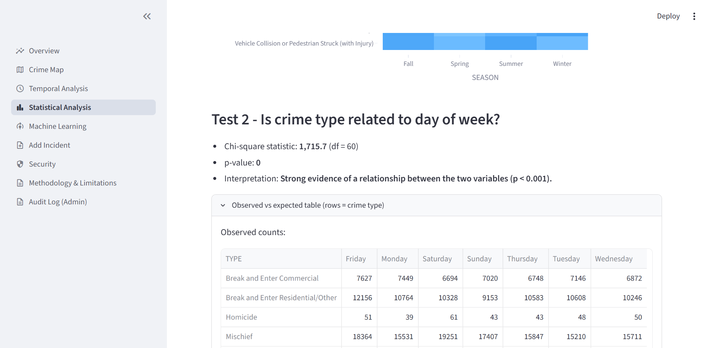
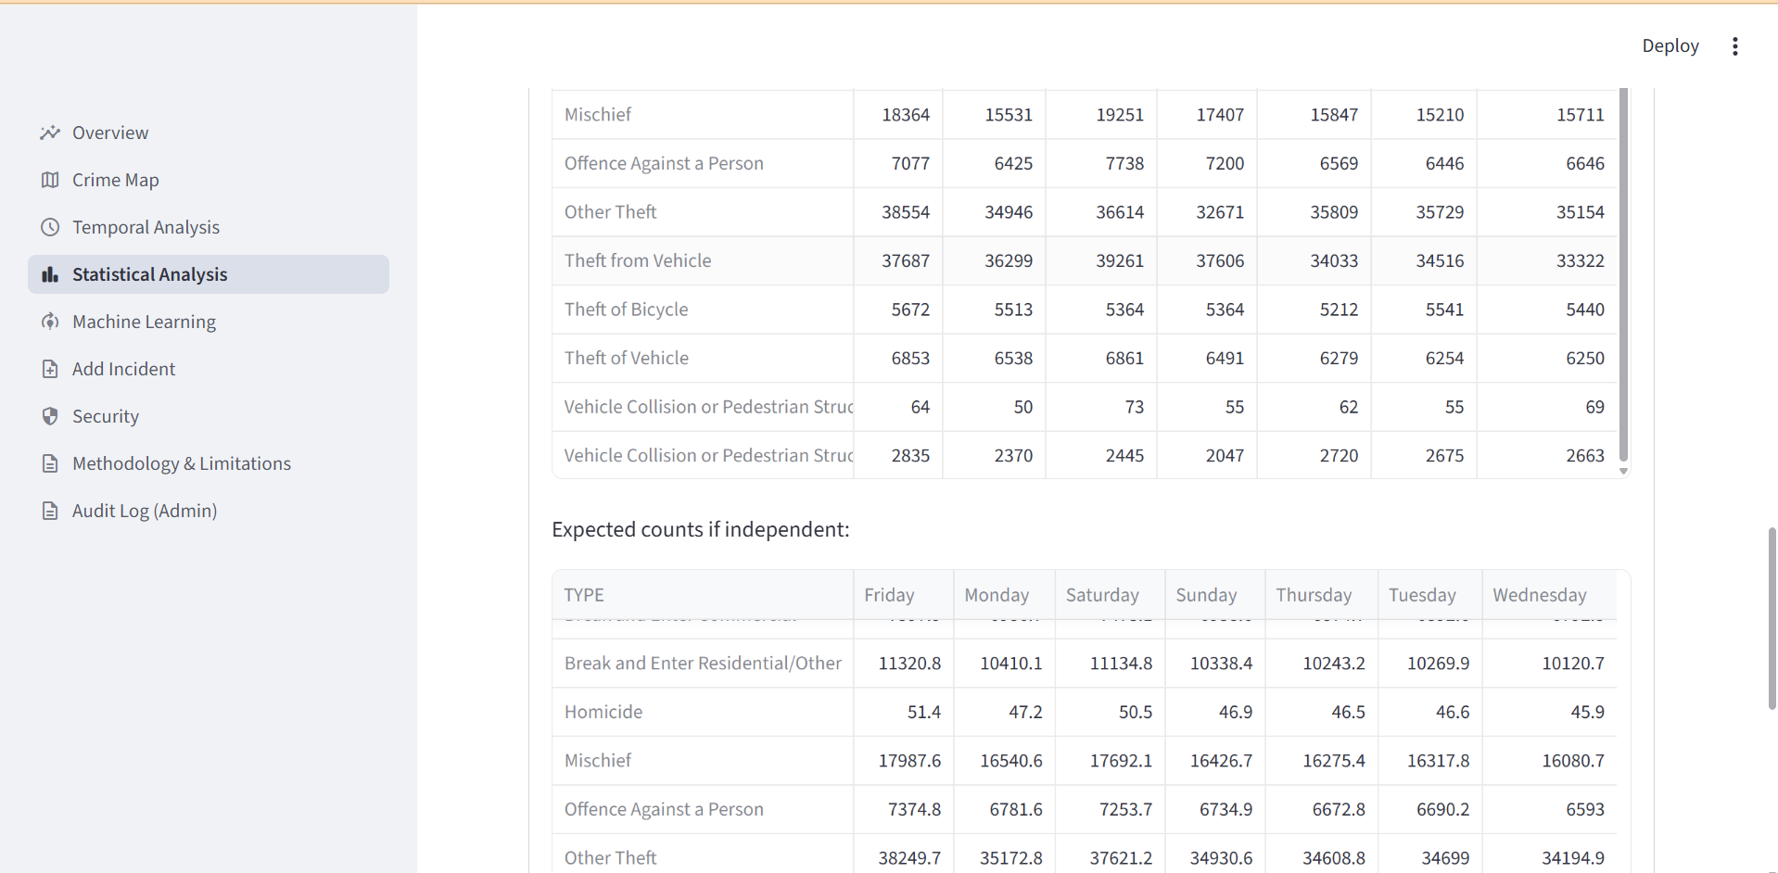
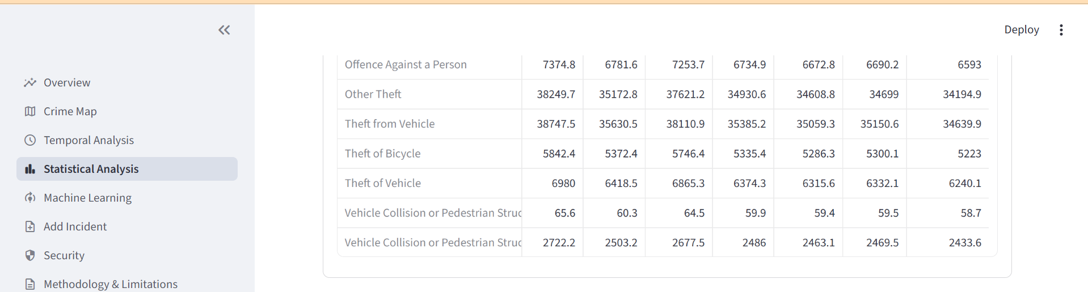
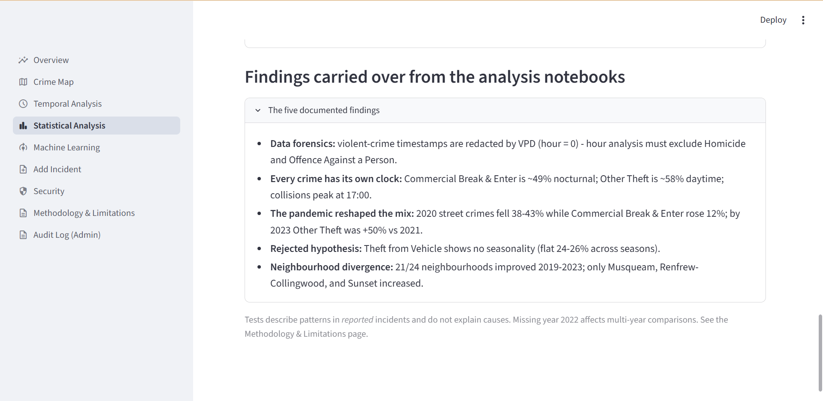

5.5 Feature 5: Crime Map with neighbourhood clustering
Individual contribution: Jaismine.
What it does: converts the data's UTM coordinates to latitude and longitude, aggregates incidents per neighbourhood (privacy-safe), groups neighbourhoods with similar crime mixes using k-means clustering, and shows them on an interactive Folium map on free ESRI tiles with hover popups and click-to-highlight. A plain-English guide and summary table help non-technical users.

5.6 Feature 6: Statistical Analysis (chi-square tests)
Individual contribution: Jaismine (page and stats module), with a datetime parsing fix identified together and fixed by Jaismine.
What it does: two chi-square tests - crime type x season and crime type x day of week - with observed/expected tables, p-values, and plain-English conclusions. Also a season-share heatmap. The page explains what the test means instead of only showing numbers.

5.7 Feature 7: Machine Learning forecast
Individual contribution: Jaismine.
What it does: pick a crime type and see the next 12 months predicted with a moving-average model, compared honestly against a "same as last year" baseline. The page shows MAE and RMSE of past predictions so users see how wrong the model can be. Plain-English explainers are included.

5.8 Feature 8: Security documentation (threat model and privacy review)
Individual contribution: Shashank.
What it does: threat model v0.4 with assets, threat actors, STRIDE analysis, OWASP Top 10 mapping, a controls table with implemented statuses, and a security testing plan. Privacy review v0.1 covers data inventory, privacy principles, credential handling, and location-data handling. The documents stay in sync with the code: when a control gets implemented, the status is updated.

6. AI Use Section

6.1 Table of AI tools and specific use
AI Tool Name | Version, Account Type | Specific feature for which the AI tool was used | Value Addition
opencode | v1.18.34, Zen account | Helped draft and debug Python for the data pipeline, validation module, SQLite store, Streamlit pages, and unit tests; suggested structures for the threat model and privacy documents; helped resolve the git merge between the two members' overlapping Add Incident work. | We reviewed every line of code, ran all tests ourselves, checked outputs against the real dataset, decided which controls belong in the prototype, fixed errors the AI missed, and wrote all documentation and work logs in our own words.
ChatGPT | GPT-5.6, basic account | Brainstorming research questions, explaining security concepts, and helping phrase plain-English explanations for charts. | The team picked the final topic and scope, made all research and design decisions, and simplified every explanation so it sounds like us, not like a textbook.

6.2 What value did we add over and above AI?
The AI gave us drafts and shortcuts, but the actual work and the final decisions are ours. We chose the dataset, decided how to handle duplicates and zero coordinates, picked the honest-baseline forecast over a fancy model, decided the three roles and their permissions, and chose which security controls to actually build. We ran every test, checked the numbers against the real data, demoed the app to find what felt confusing, and fixed bugs the AI never saw. Every work log entry and every summary in this report is written in our own words about work we actually did.

6.3 Appendix - AI prompt history
Date | AI Tool | Prompt / Request | How the output was used
Sep 2026 | ChatGPT | Develop a research project combining Data Analytics and Cybersecurity using Vancouver crime data | Brainstorming; the team selected and refined the final scope
Oct 9 | opencode | How can I download the VPD GeoDASH crime dataset for all neighbourhoods and years? | Wrote the download script and got the data
Oct 9 | opencode | What data quality checks should I run on the raw CSV? | Wrote the inspection script and documented the findings
Oct 9 | opencode | How do I organize a threat model using STRIDE and OWASP Top 10? | Used the structure to write the threat model v0.1
Oct 11 | opencode | How do I implement login attempt limiting and an audit log, and how should I test them? | Wrote the auth changes and tests; 20 tests passing at that time
Oct 15 | opencode | How should I validate form input for a crime-reporting app (allow-lists, date checks, XSS)? | Wrote validation.py and 18 tests
Oct 18 | opencode | How do I store user-entered records in SQLite with parameterized queries? | Built the SQLite store (db.py)
Oct 22 | opencode | How do I build a Streamlit form with dropdowns and show validation errors? | Rebuilt the Add Incident form
Oct 22 | ChatGPT | How can I explain a chi-square result to a non-technical reader? | Wrote plain-English explanations on the Statistical page
Oct 23 | ChatGPT | What is an honest way to show forecast error to users? | Designed the MAE/RMSE honest-baseline forecast page
Oct 24 | opencode | How do I test SQL injection safety in pytest? | Extended test_db.py with injection tests
Oct 25 | opencode | How do I merge two overlapping git branches and keep one shared module? | Resolved the merge; kept one shared db.py

7. Work Date / Hours Logs

7.1 Shashank Chaudhary (300392521)
Date | Number of Hours | Description of work done
Sep 18, 2026 | 1.5 | Initial research/project planning
Sep 22, 2026 | 2.5 | Cybersecurity research/threat modeling: identified potential security risks for the crime-data web application, including unauthorized access, SQL injection, XSS, password security, session security, and data exposure
Sep 26, 2026 | 2 | GitHub/repository work: accepted collaborator invitation, cloned the project repository, and set up the local project directory for development
Oct 9, 2026 | 1.5 | Project setup: created folder structure; added .gitignore; wrote scripts/00_download_data.py for reproducible data acquisition
Oct 9, 2026 | 1.5 | Data acquisition: downloaded VPD crime dataset from GeoDASH open data; wrote scripts/01_inspect_data.py; generated data quality summary (927,794 rows; 34,527 duplicates; missing 2022; 83K zero coordinates)
Oct 9, 2026 | 0.75 | Data cleaning: wrote scripts/02_clean_data.py (dedupe, categorical standardization, zero-coordinate flagging, datetime/day-of-week/season features); cleaned dataset to 893,267 rows with documented cleaning log
Oct 9, 2026 | 0.75 | Documentation: wrote docs/research/dataset_documentation.md covering source, schema, quality findings, and privacy notes
Oct 9, 2026 | 0.75 | Threat model: drafted docs/security/threat_model.md v0.1 - assets, threat actors, STRIDE analysis, OWASP Top 10 relevance, planned controls, and security testing plan
Oct 9, 2026 | 0.75 | Privacy review: drafted docs/security/privacy_and_data_protection.md v0.1
Oct 11, 2026 | 1.5 | Repo restructure: moved implementation code under the Implementation/ folder per the progress report template; fixed all path references; verified tests and app still run
Oct 11, 2026 | 1.5 | Security implementation: extended app/utils/auth.py with append-only audit logging and login attempt limiting (5 failures per 60s lockout)
Oct 11, 2026 | 1 | Security testing: wrote tests/test_security.py (6 tests); full test suite then 20 tests passing; updated threat model to v0.2
Oct 15, 2026 | 1.5 | Input validation module: wrote app/utils/validation.py - allow-lists for the 11 crime types and 24 neighbourhoods, date range checks, length limits, and HTML/script sanitization to prevent stored XSS
Oct 15, 2026 | 1.5 | Validation testing: wrote tests/test_validation.py (18 tests); full suite then 38 tests passing
Oct 15, 2026 | 0.75 | Threat model v0.3: marked the input validation/XSS control as implemented
Oct 15, 2026 | 1.5 | Audit Log page: built app/pages/9_audit_log.py - administrator-only page showing the append-only audit log
Oct 15, 2026 | 1 | Login hardening: wired audit logging and lockout enforcement into the Add Incident login flow
Oct 15, 2026 | 0.5 | App polish: removed roadmap/phase-date notes from app pages; updated Security page control statuses; installed scipy and re-verified the Statistical Analysis page
Oct 18, 2026 | 1.0 | Database: built the SQLite incident store (app/utils/db.py) with parameterized queries; user-entered records kept in a separate table tagged source='user'
Oct 18, 2026 | 1.0 | Validation: added hour-of-day check (0-23) to the validation module and wired it into the full-record validation
Oct 22, 2026 | 2.0 | Add Incident form: rebuilt the page with the full validated form; on submit the record is validated, saved to the SQLite DB, and written to the audit log; records table below the form (admins see all, others only their own); Overview page section for user-entered incidents
Oct 24, 2026 | 1.0 | Testing: extended tests/test_db.py (hour/role storage, per-user record filtering, count, SQL-injection-as-literal-text); merged with Jaismine's parallel Add Incident work into one shared db.py module; full suite now 73 tests passing
Oct 25, 2026 | 0.5 | Docs: threat model v0.4, Security page control statuses, README updates

7.2 Jaismine Kaur (300415820)
Date | Number of Hours | Description of work done
Sep 26, 2026 | 1.5 | Set up our shared project on GitHub: created the repository, invited Shashank as a collaborator, and made the first upload
Oct 9, 2026 | 1.0 | Read through the project to remind myself where we are, what the plan is, and what is due next
Oct 9, 2026 | 0.5 | Together with Shashank, created the project folders and the file that keeps large and private files out of GitHub
Oct 9, 2026 | 0.5 | Together with Shashank, downloaded the Vancouver crime data from the police open-data website and went through the quality report (928,362 rows, missing year 2022, 83K rows with no location)
Oct 9, 2026 | 0.25 | Helped write the document that explains our data - where it comes from, what each column means, and its known problems
Oct 9, 2026 | 0.25 | Read Shashank's first version of the security plan and gave feedback
Oct 9, 2026 | 0.25 | Together with Shashank, went through the data cleaning steps (928,362 down to 893,851 rows)
Oct 9, 2026 | 0.25 | Read the privacy notes document and checked it over
Oct 9, 2026 | 0.25 | Updated the README progress table and uploaded the work to GitHub
Oct 11, 2026 | 1.0 | Set up the coding environment on my own computer and installed all the needed tools
Oct 11, 2026 | 1.0 | Ran the whole data preparation process myself from start to finish: download, quality check, and cleaning
Oct 11, 2026 | 0.5 | Read the three data preparation scripts and their reports so I understand how each step works
Oct 11, 2026 | 0.5 | Read the data explanation and privacy documents
Oct 11, 2026 | 0.5 | Opened the app and explored it: the overview page, the time-patterns page, and the add-incident page with its three user roles
Oct 11, 2026 | 0.5 | Read through the app's structure: how the pages connect, the login system, and how data is loaded
Oct 11, 2026 | 0.5 | Read the automated tests and ran them (14 passing)
Oct 11, 2026 | 0.5 | Made a small app change: removed the course-code label from the sidebar and uploaded it
Oct 11, 2026 | 1.5 | Explored the data for patterns: when crimes happen during the day (and found that violent crimes have their exact time hidden on purpose), and how COVID changed the numbers
Oct 11, 2026 | 1.0 | Wrote a notebook that documents 5 findings with charts
Oct 11, 2026 | 1.0 | Read about ways to explore data and thought about how to remove repeated rows
Oct 12, 2026 | 1.0 | Cleaned up the notebook: better headings and a clearer layout
Oct 12, 2026 | 0.5 | Prepared Progress Report #1: the hours table, the summary, the list of uploaded work, and the AI-use section
Oct 16, 2026 | 1.5 | Built the statistics page: two connection tests (crime type vs season, crime type vs day of week) with easy-to-read results and tables
Oct 16, 2026 | 3.0 | Chased and fixed a bug where dates were saved in two different formats, which broke anything that used dates
Oct 22, 2026 | 1.0 | Picked the Add Incident feature to build completely - from the screen to the database and back - for the mid-course demo
Oct 22, 2026 | 1.5 | Built the Add Incident feature end to end: form with checks, safe database queries, each record stored with who added it and when, shown in the app
Oct 22, 2026 | 1.0 | Wrote tests for the database, including fake hacking inputs stored as plain text (51 tests passing)
Oct 22, 2026 | 1.5 | Combined my work with Shashank's overlapping changes (login lockout and the Audit Log page) and updated the Security page statuses
Oct 22, 2026 | 1.0 | Practiced the demo flow (login, roles, audit trail) and made a cheat sheet for the presentation
Oct 22, 2026 | 1.0 | Tested the Crime Map as if I were seeing it for the first time and listed what felt unclear
Oct 22, 2026 | 1.0 | Redesigned the map page for everyday users: a simple how-to guide, big-picture numbers, automatic neighbourhood summaries, and a full details table
Oct 22, 2026 | 1.5 | Fixed the map interactivity: switched to a map tool whose hover popups and click-to-highlight work reliably
Oct 22, 2026 | 0.5 | Fixed the broken map background by switching to a free street-map provider
Oct 22, 2026 | 1.0 | Fixed a crash that happened when a filter left no usable location data, and added a test (62 tests passing)
Oct 23, 2026 | 1.0 | Started planning the neighbourhood map feature: neighbourhood-level summaries instead of exact points to protect privacy
Oct 23, 2026 | 1.5 | Converted the data's map coordinates into latitude and longitude using standard formulas, and checked against known Vancouver places
Oct 23, 2026 | 1.0 | Planned the forecast feature: predict monthly crime counts and honestly show how wrong the guess has been
Oct 23, 2026 | 1.5 | Built the forecast feature: pick a crime type, see the next 12 months predicted, and see past accuracy compared with a same-as-last-year guess
Oct 23, 2026 | 0.5 | Wrote tests for the forecast math (7 new tests; 69 passing in total)
Oct 23, 2026 | 0.5 | Added a tech-stack section to the README and the Methodology page
Oct 23, 2026 | 0.5 | Updated the README progress table and folder-structure section
Oct 24, 2026 | 1.0 | Wrote the neighbourhood grouping step: counts and a middle-point location for each neighbourhood
Oct 24, 2026 | 1.0 | Added the grouping step: automatically put neighbourhoods with similar crime mixes together
Oct 25, 2026 | 1.5 | Built the Crime Map page in the app: filters, interactive map with circles sized by count and colored by pattern group, hover details, and the group summary table
Oct 25, 2026 | 1.0 | Wrote tests for the map math and grouping, and fixed a bug where neighbourhoods with missing names crashed the page (61 tests passing)
Oct 26, 2026 | 0.5 | Walked through the map page from top to bottom with the demo in mind and updated the demo cheat sheet

8. Closing and References

8.1 Acknowledgements
We thank our instructor, Padmapriya Arasanipalai Kandhadai, for the guidance on the project structure and for the feedback during the weekly check-ins. We also thank the Vancouver Police Department for publishing the crime data openly on GeoDASH.

8.2 References
[1] Vancouver Police Department. GeoDASH Open Data - Crime Incidents. https://geodash.vpd.ca/ (dataset downloaded Oct 2026).
[2] Vancouver Police Department. VPD OpenData Crime Incidents Description (PDF, included with the dataset download).
[3] OWASP Foundation. OWASP Top 10: 2021 - Web Application Security Risks. https://owasp.org/Top10/
[4] Microsoft. STRIDE threat modeling (Shostack, L.). Microsoft Security Documentation.
[5] Richardson, R., Schultz, J., & Crawford, K. (2019). Dirty Data, Bad Predictions: How Civil Rights Violations Impact Police Data, Predictive Policing Systems, and Justice. NYU Law Review, 94, 192-233.
[6] Streamlit Documentation. https://docs.streamlit.io/
[7] Python Software Foundation. sqlite3 - DB-API 2.0 interface for SQLite databases. https://docs.python.org/3/library/sqlite3.html
[8] Folium Documentation. https://python-visualization.github.io/folium/
[9] SciPy Documentation. scipy.stats.chi2_contingency. https://docs.scipy.org/

Grading Rubric (from the template)
Criteria | Grading
Report Adherence - Completed CHECKLIST given in Pg. 1; addresses all sections with clarity and details; changes to the original proposal clearly outlined with revised timelines and scope; each student's contribution clear in implementation details and work logs; good English and composition; verbal and visual information as appropriate | 4 points
Video Recording - clickable public link on the title page; single composite video of the product features; each student's contribution clearly demonstrated | 4 points
GitHub Repository CODE and installation instructions Check-In - evaluated individually for EACH STUDENT; README installation instructions updated; consistency of code check-in, complexity of code, technical merit of features | 7 points

