# Introduction

This is a .NET C# console application to define two-dimensional Shape objects. Each object has following characteristics.

* Name
* Area
* Perimeter

# Technologies used

Application is developed in Visual studio 2019, C# .NET 5.0 , unit tests etc

# Run

To run this project, set ‘consoleApp1’ as the start-up project and run (or select f5).

All outputs will be displayed into the console output.

# Summary

Application is developed with SOLID principles. Shape is an abstract base class, inheriting *IShape.cs*

We can create different classes of this base class, by inheriting the base class.

In this project, below classes are inheriting this base class. Application is open for modification. If you want to add more shapes, we can easily implement by adding this base class.

* Circle
* Triangle
* Quadrilateral (Since the properties are same, we can use this class for both Square and Rectangle)

Autofac is used for dependency injection.

Main application consists of below methods.

* Create different objects (like Circle, Triangle, Square, Rectangle etc)
* Program is designed to manually enter the input values

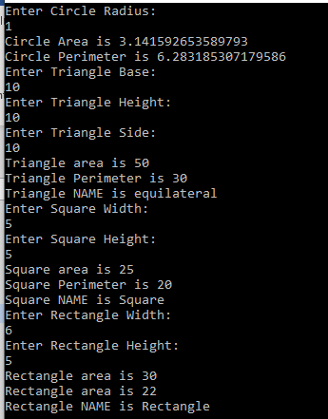

* Calculate Area and Perimeter
* Check the Names
* To track(in memory) the number of Shape objects created

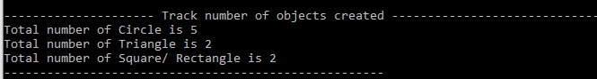

* To sort a collection of Shapes by Area or Perimeter.

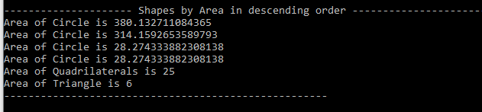

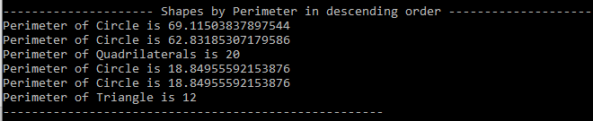

* To serialize/store shapes in various formats on disk. (You can specify the file download physical path location in app.config)
* Basic validations are in place to make sure that the given parameter is greater than 0.

# Output

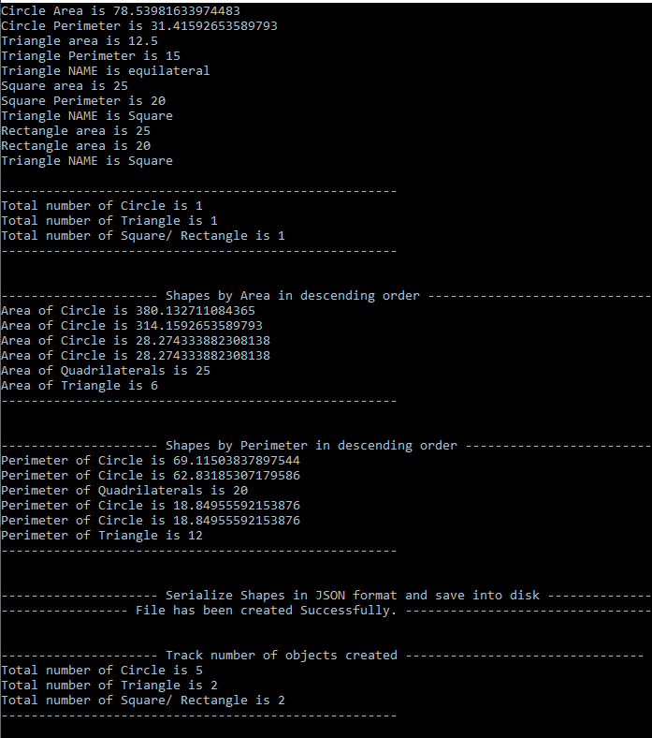

# Unit TEST

A unit test project also included in this solution. We can do the basic validations and

