**Ansible Playbook:**

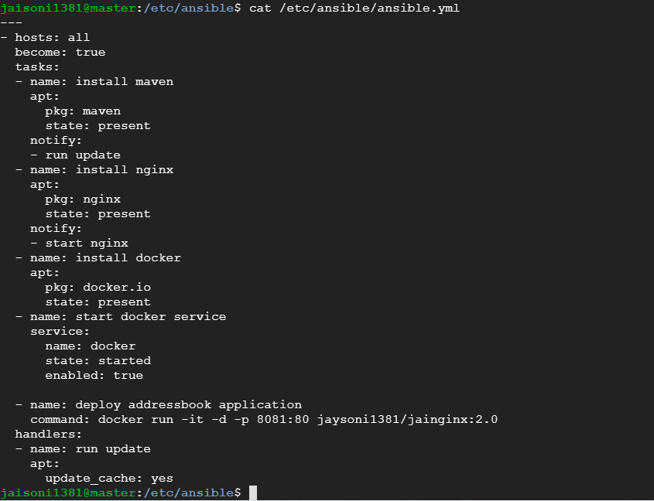

**Playbook Execution:**

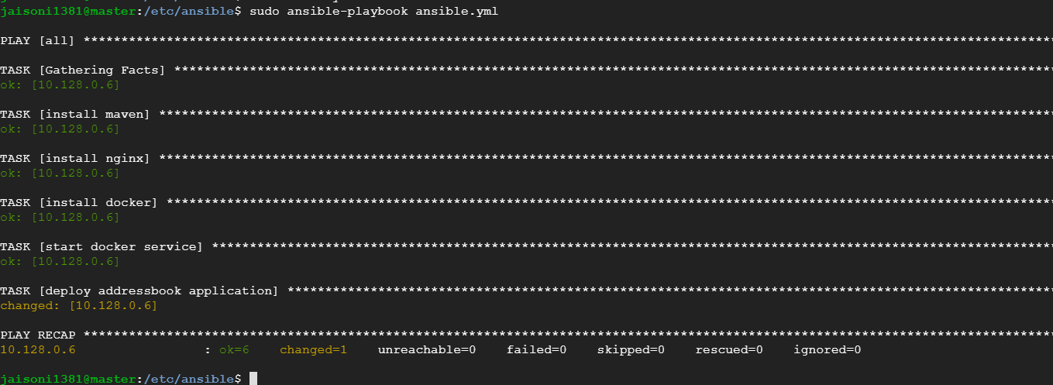

**Slave Node Docker process:**

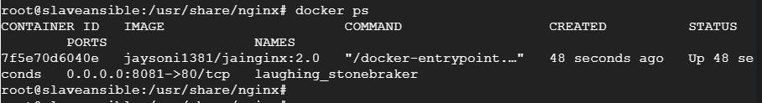

**Slave Node Evidence of (Maven, Java and Nginx):**

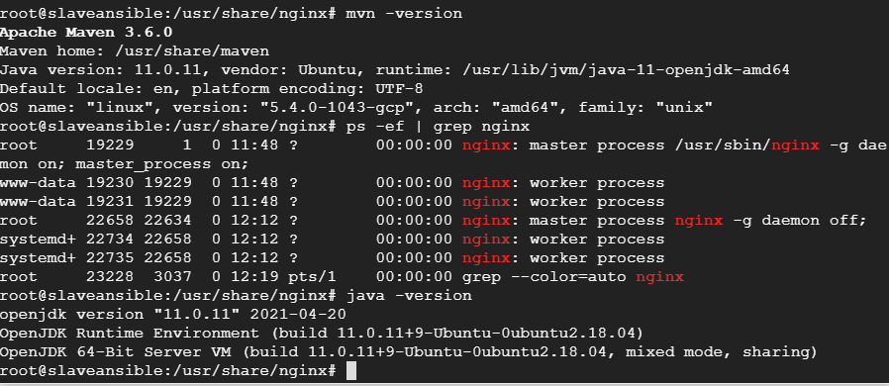

**Application Access:**

