**Docker File:**

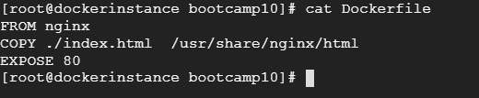

**Container status:**



**Running application:**

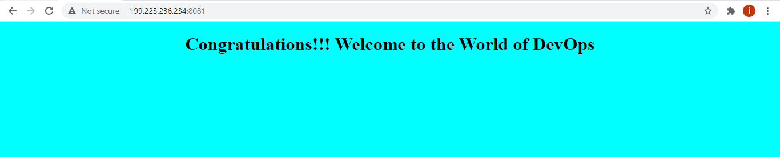

**DockerHub:**

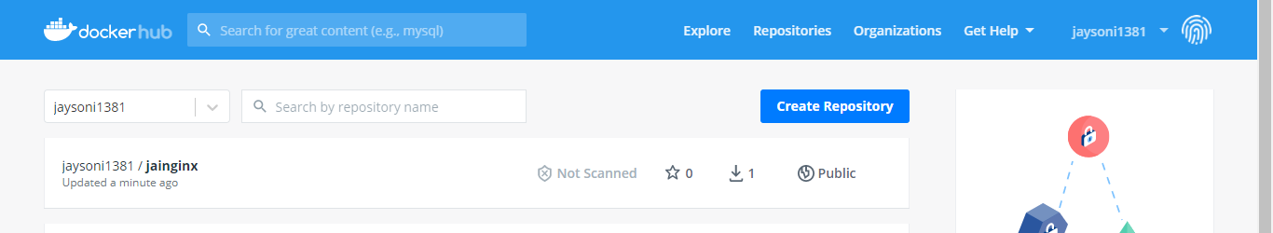

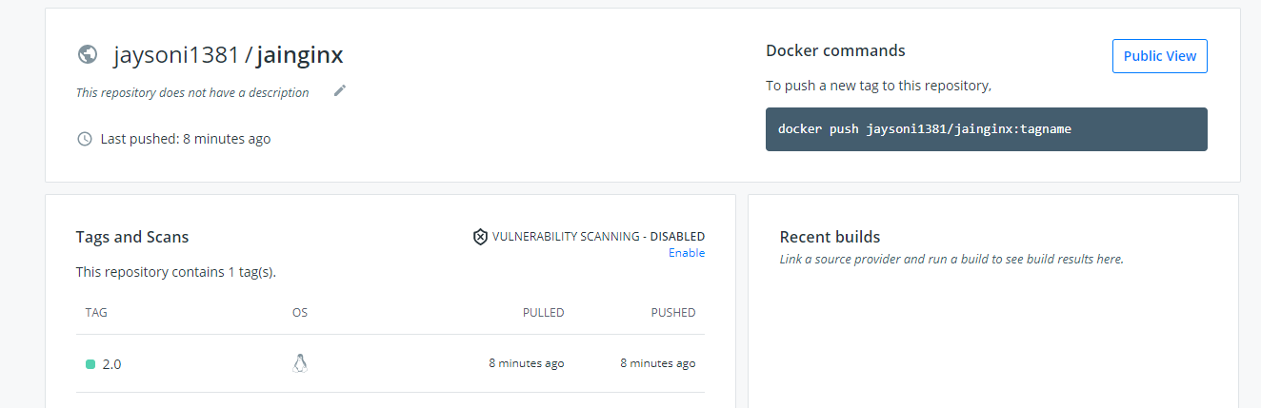

**Docker pull and running the image on remote:**

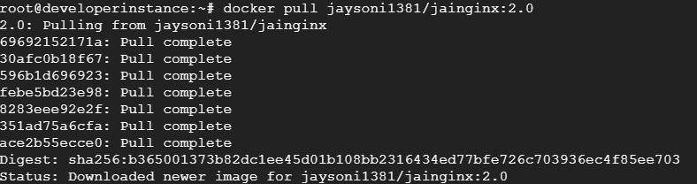

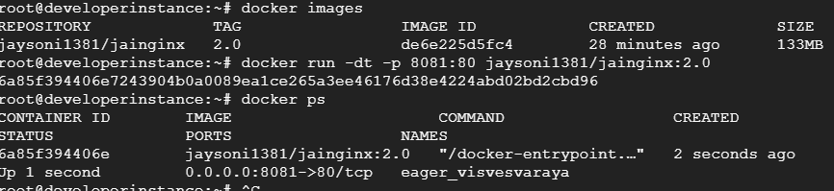

**Accessing the application from the URL:**

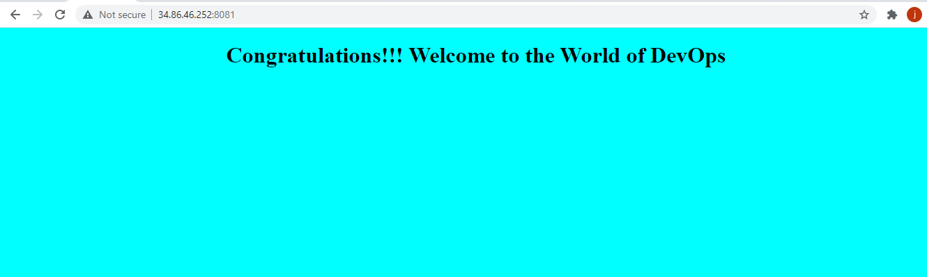

## Docker compose:

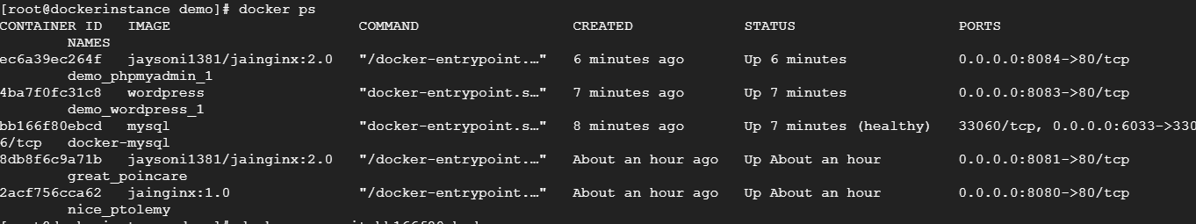

**Wordpress:**

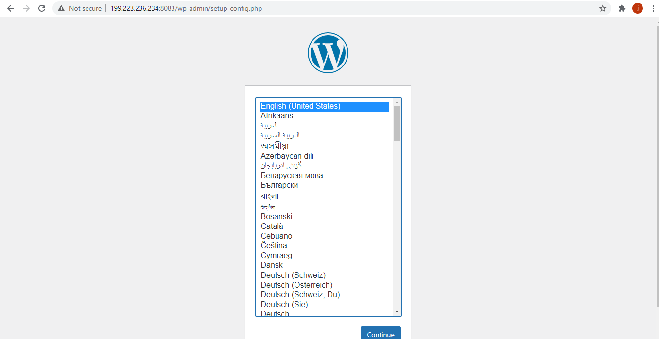

**Accessing our application:**

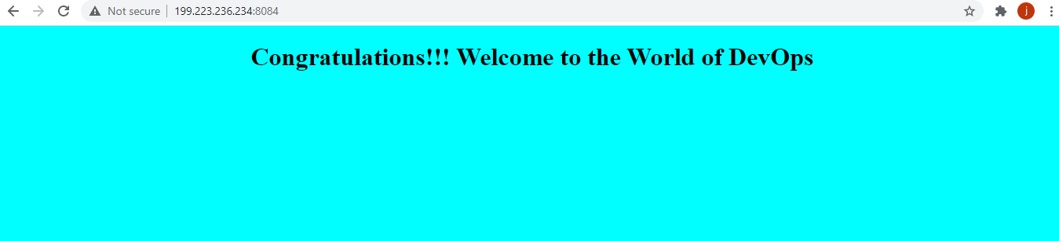

**MySql:**

