1. Created local git repository **developer A** and created 3 files (**demo1**, **demo2** , **demo3**).
2. Added those 3 files to staging area and also commit has been done.

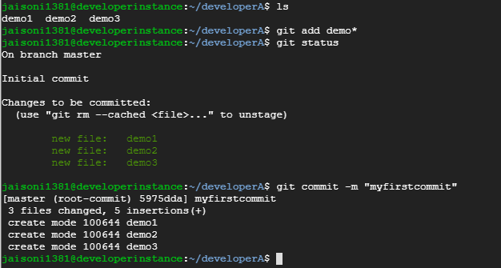

1. Created the remote repo and added the remote repo to the local repository:

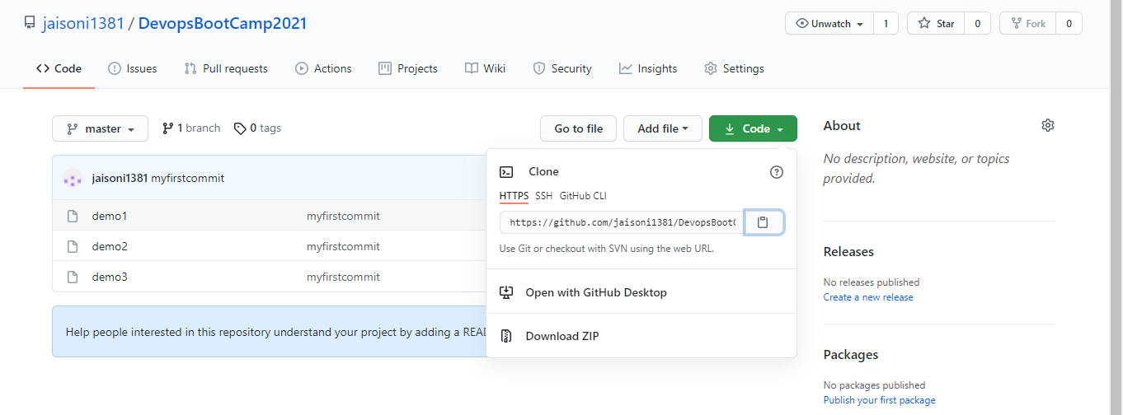

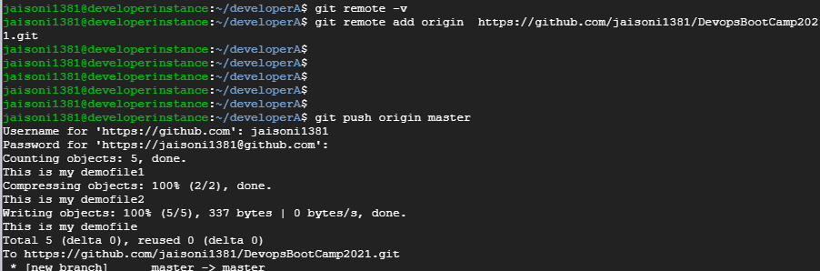

**Clone remote repo to developer B and make changes and sync to Developer A repo:**

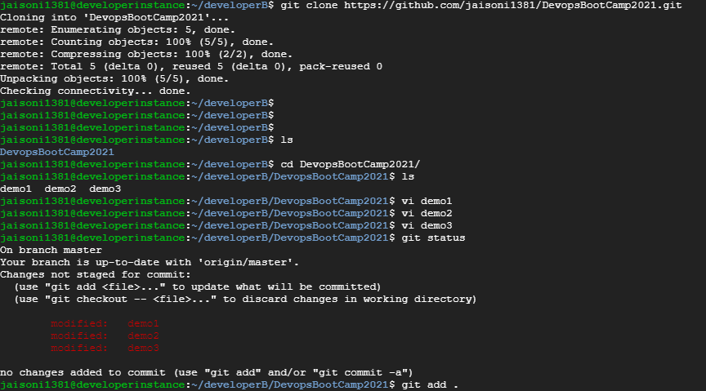



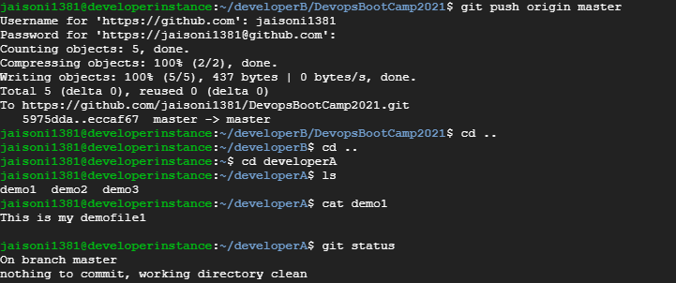

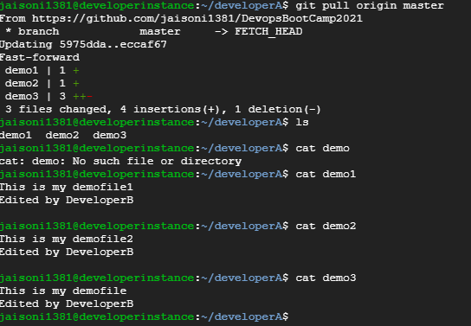

**Created Feature branch , made the changes and merged it.**

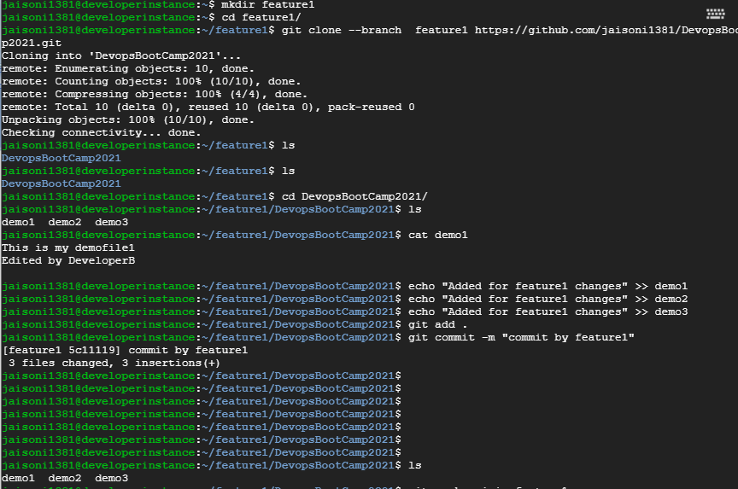

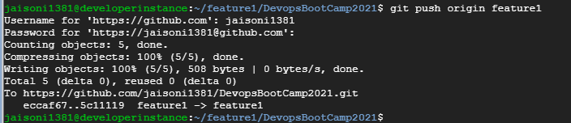

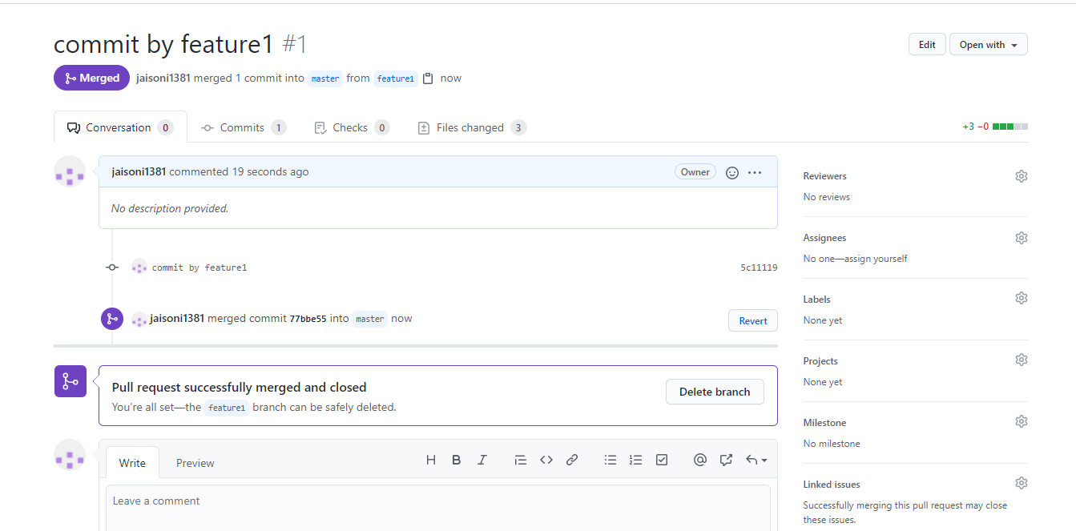

**Deleted the feature branch.**

