1. Write a query to get Profile ID, Full Name and Contact Number of the tenant who has stayed with us for the longest time period in the past
Query
select PR.profile_id,(PR.first_name +' '+ PR.last_name) as Name,PR.phone,DATEDIFF(DAY,TH.move_in_date,TH.move_out_date)as Number_of_Days_stayed
from Profiles PR
inner join
Tenancy_histories TH
on PR.profile_id=TH.profile_id
where DATEDIFF(DAY,TH.move_in_date,TH.move_out_date) = (select MAX( DATEDIFF(DAY,move_in_date,move_out_date)) from Tenancy_histories)
Output
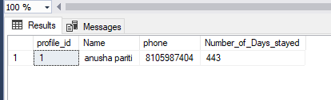
2. Write a query to get the Full name, email id, phone of tenants who are married and paying rent > 9000 using subqueries
Query
select (first_name+' '+last_name)as Name,email,phone as Contact_Number
from Profiles
where marital_status='Y' and profile_id in(select profile_id from Tenancy_histories where rent>9000)
Output
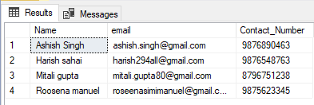
3.Write a query to display profile id, full name, phone, email id, city , house id, move_in_date , move_out date, rent, total number of referrals made, latest employer and the occupational category of all the tenants living in Bangalore or Pune in the time period of jan2015 to jan 2016 sorted by their rent in descending order
Query
select distinct(PR.profile_id),(PR.first_name+' '+PR.last_name) as Name,PR.phone,PR.email,PR.city,HS.house_id,TH.move_in_date,TH.move_out_date,TH.rent,ER.latest_employer,ER.occupational_catagory,(select count(ref_id) as Number_of_Referrels
from Referrals where referrer_id=PR.profile_id) as Number_of_referrals
from Profiles PR
inner join
Tenancy_histories TH
on
PR.profile_id=TH.profile_id
inner join

Employment_details ER
on PR.profile_id=ER.profile_id
inner join
Houses HS
on
TH.house_id=HS.house_id
inner join
Referrals RE
on
RE.referrer_id=PR.profile_id
where (PR.city='Bangalore' or PR.city='Pune') and (TH.move_in_date >= '2015-01-01' AND TH.move_out_date <= '2016-01-01') order by TH.rent desc
Output

4. Write a sql snippet to find the full_name, email_id, phone number and referral code of all the tenants who have referred more than once. Also find the total bonus amount they should receive given that the bonus gets calculated only for valid referrals.

Query
select RE.referrer_id,sum(RE.referrer_bonus_amount) as Bonus,(PR.first_name+' '+PR.last_name)as Name,PR.email,PR.phone
from Referrals RE
inner join Profiles PR
on
RE.referrer_id=PR.profile_id
where RE.referral_valid = 1
group by RE.referrer_id,PR.first_name,PR.last_name,PR.email,PR.phone
having count(RE.ref_id)>1
Output
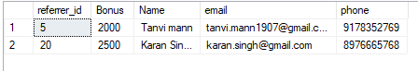

5. Write a query to find the rent generated from each city and also the total of all cities.
Query
select AD.city,SUM(TH.rent) as Total_Rent
from Addresses AD
inner join
Tenancy_histories TH
on AD.house_id = TH.house_id
group by AD.city
union all
select COALESCE(null,'Total of all Cities = ') ,sum(rent) from Tenancy_histories
Output
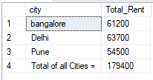
6. Create a view 'vw_tenant' find profile_id,rent,move_in_date,house_type,beds_vacant,description and city of tenants who shifted on/after 30th april 2015 and are living in houses having vacant beds and its address.
Query
create view vw_tenant
as
select PR.profile_id,TH.rent,AD.city,TH.move_in_date,HS.house_type,HS.beds_vacant,HS.furnishing_type,PR.phone,AD.description,AD.name as House_Name
from Profiles PR
inner join
Tenancy_histories TH
on
PR.profile_id=TH.profile_id
inner join
Houses HS
on
TH.house_id=HS.house_id
inner join Addresses AD
on HS.house_id=AD.house_id
where
TH.move_in_date>='2015-04-30' and HS.beds_vacant>0
Output
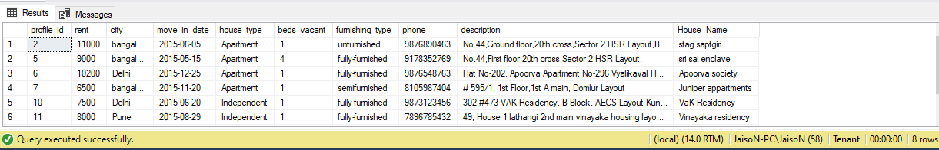

7. Write a code to extend the valid_till date for a month of tenants who have referred more than two times
Query
update Referrals
set
valid_till= DATEADD(MM,1,valid_till) where referrer_id in(select referrer_id from Referrals group by referrer_id having count(ref_id)>2)
Output
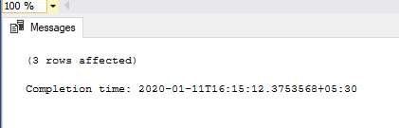

8. Write a query to get Profile ID, Full Name , Contact Number of the tenants along with a new column 'Customer Segment' wherein if the tenant pays rent greater than 10000, tenant falls in Grade A segment, if rent is between 7500 to 10000, tenant falls in Grade B else in Grade C
Query
select PR.profile_id,(PR.first_name+' '+PR.last_name) as Name, PR.phone as Contact_number,
IIF((TH.rent>10000), 'Grade A', IIF(TH.rent <= 10000 and TH.rent >= 7500, 'Grade B','Grade C'))as Customer_Segment
from Profiles PR
inner join
Tenancy_histories TH
on PR.profile_id = TH.profile_id
Output
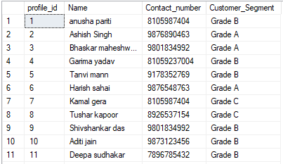
9. Write a query to get Fullname, Contact, City and House Details of the tenants who have not referred even once
Query
select PR.profile_id,(PR.first_name+' '+PR.last_name)as Name,PR.phone as Contact_number,PR.city,HS.*,AD.description,AD.name,AD.pincode
from Profiles PR
inner join
Tenancy_histories TH
on PR.profile_id=TH.profile_id
inner join
Houses HS
on TH.house_id = HS.house_id
inner join
Addresses AD
on HS.house_id=AD.house_id
where PR.profile_id not in(select referrer_id from Referrals)
OutPut
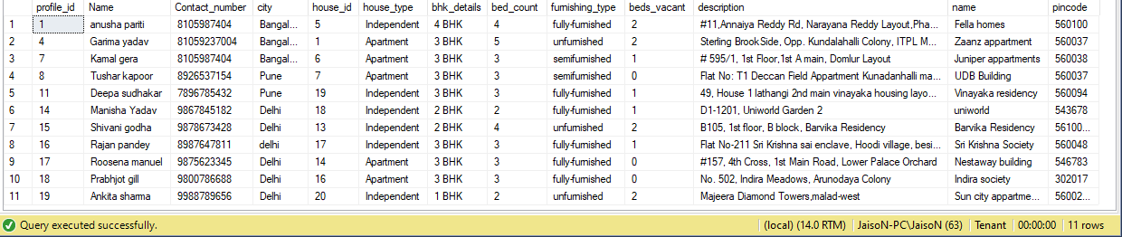
10. Write a query to get the house details of the house having highest occupancy
Query
select top (1) with ties AD.house_id, AD.name , HS.house_type, HS.bhk_details, HS.furnishing_type, (HS.bed_count - HS.Beds_vacant) AS Total_Occupancy
from Addresses AD
INNER JOIN Houses HS
ON
AD.house_id= HS.house_id
ORDER BY Total_Occupancy DESC
Output
