Explainable Decision Intelligence for Clinical Laboratory Operations: Predicting Turnaround-Time Breaches and Specimen Rejection for Cost-Aware Quality Management
Jaisritha Damavarapu

Abstract

Clinical and diagnostic laboratories operate under intensifying pressure to deliver fast, reliable results while controlling cost, yet the operational decisions that govern turnaround time (TAT) and specimen quality are still largely reactive and experience-driven. Prior machine-learning work predicts laboratory TAT accurately but stops at prediction, framing the problem as a clinical-efficiency task rather than a managerial decision problem. This study develops and validates an explainable decision-intelligence framework that couples predictive modeling with interpretability and an explicit cost-of-quality optimization, so that model outputs become governed, economically rational operating decisions. Using a reproducible, literature-calibrated dataset of 20,000 laboratory test orders, we benchmark logistic regression, random forest, and gradient boosting on two leakage-safe tasks, TAT-breach prediction and pre-analytical specimen rejection, under stratified cross-validation and a held-out test set. The best model attains a test ROC-AUC of 0.886 for TAT-breach prediction; rejection proves intrinsically harder (ROC-AUC 0.702), which is itself an actionable finding. SHAP attributions identify workload-at-arrival, analyzer utilization, request priority, night-shift operation, and transport time as the dominant, managerially-actionable drivers. Translating predictions into expedite-or-not decisions through a cost-sensitive threshold reduces expected operational cost by 35.9% relative to no intervention and by 23.7% relative to the best managerial heuristic, with the advantage widening to 50–78% as the stakes rise, as in time-critical donor-screening contexts. The framework offers laboratory and diagnostic-service managers a transparent, auditable bridge from prediction to decision, and contributes a replicable template for decision-intelligence research in regulated biomedical operations.

Jaisritha Damavarapu: Explainable Decision Intelligence for Clinical Laboratory Operations
Decision intelligence, explainable artificial intelligence, clinical laboratory operations, turnaround time, cost of quality, healthcare analytics, SHAP, digital transformation.

Introduction
The clinical laboratory is the quiet backbone of modern healthcare: an estimated majority of medical decisions depend on laboratory results, and the speed and reliability with which those results are produced shape patient flow, clinician scheduling, and the cost of care. Two operational indicators dominate how laboratories are judged. The first is turnaround time (TAT), the interval from order or collection to a reported result, which is the single most visible performance metric a laboratory reports to its clinical customers. The second is specimen quality, operationalized at the front door of the laboratory as the pre-analytical rejection of samples that are hemolyzed, clotted, mislabeled, or of insufficient volume. Both indicators carry direct economic weight: a breached TAT can extend an emergency-department stay or trigger duplicate testing, while a rejected specimen forces recollection, delays diagnosis, and consumes staff time.
These are, at root, management problems. Deciding when to expedite a sample, how to staff a shift, and where to intervene in the workflow are resource-allocation decisions made under uncertainty and cost constraints. Yet in most laboratories these decisions remain reactive, triggered after a delay has already occurred, and are rarely informed by predictive, auditable analytics. This gap is strategically important in exactly the settings where the stakes are highest. In time-critical donor screening for organ and tissue donation, for example, serological and nucleic-acid testing sits on the critical path to organ viability; a delayed or rejected specimen is not merely an efficiency loss but can foreclose a transplant. The same analytics that optimize routine laboratory throughput therefore carry disproportionate value where delay is catastrophic.
Machine learning has begun to enter this space, but narrowly. Existing studies demonstrate that TAT can be predicted from operational features with useful accuracy[1], [2], and that data-mining pipelines can monitor TAT and prompt targeted interventions[3], [4]. These contributions are valuable, but they share two limitations. First, they are framed as clinical-efficiency or laboratory-medicine problems and are published in that literature, leaving the managerial and strategic dimension, how a prediction becomes a cost-rational decision, largely unaddressed. Second, they stop at the predictive step: a probability is produced, but the decision rule that converts it into action, and the economic consequences of that rule, are not modeled.
This paper closes that gap by reframing laboratory operations as an explainable decision-intelligence problem. We make three contributions:
- A decision-intelligence framework, not merely a predictor. We couple predictive modeling with model-agnostic explainability (SHAP) and an explicit cost-of-quality optimization, so that predictions are translated into governed, economically rational operating decisions. This three-layer design is the central methodological contribution and the point of departure from prior TAT work.
- A rigorous, reproducible dual-task benchmark. We formulate two leakage-safe decision tasks, TAT-breach prediction and pre-analytical specimen rejection, and benchmark three model families under stratified cross-validation and a held-out test set, reporting discrimination, calibration, and decision-relevant metrics. The literature-calibrated data generator and all code are released, so every reported number is reproducible.
- An economic and managerial interpretation. We quantify the cost savings of model-guided intervention against managerial baselines, conduct a sensitivity analysis over the cost structure, and connect the results to concrete managerial levers and to high-stakes settings such as time-critical donor screening.
The remainder of the paper reviews related work (Section 2), formulates the problem and describes the data (Section 3), details the methodology (Section 4), presents predictive results (Section 5) and the explainability and decision analysis (Section 6), discusses implications and limitations (Sections 7–8), and concludes (Section 9).

Related Work

Machine learning for laboratory turnaround time
TAT prediction has attracted growing attention as laboratories digitize. A study on roughly ninety thousand clinical-chemistry samples from a European academic medical center showed that ensemble regressors could predict TAT from features such as request priority and the workload present at sample arrival, enabling earlier action on at-risk samples[1]. Random-forest models have been applied to anatomic-pathology TAT, a domain where processing is lengthy and variable[2]. Beyond point prediction, low-code data-mining pipelines have been used to monitor TAT over time and to trigger process interventions, with reported reductions in pre-analytical and analytical intervals[3]. Related work on pre-analytical TAT for microbiology has combined regression with clustering to attribute delay to specific workflow stages and ward contexts[4].
These studies establish that laboratory operational outcomes are learnable from routinely captured features. However, they are positioned within laboratory-medicine and clinical-efficiency framing, optimize predictive accuracy or monitoring, and do not model the downstream decision or its cost. The present work builds directly on their feature intuitions, workload, priority, shift, and specimen characteristics, while shifting the objective from prediction to cost-rational decision-making.

Pre-analytical quality and the total testing process
The pre-analytical phase is the dominant source of error in the total testing process, and specimen rejection is its most visible control point[5], [6]. Standards bodies specify acceptance and rejection criteria and collection-and-transport requirements[7]. Rejection is comparatively rare and heterogeneous in its causes, which, as our results confirm, makes it intrinsically harder to predict than TAT breach, an asymmetry with practical consequences for where predictive effort is best spent.

Cost of quality and decision support
The cost-of-quality tradition in operations management distinguishes prevention and appraisal costs from the internal and external failure costs they are meant to avert[8]. Framing laboratory intervention decisions in these terms converts a classification output into an economic optimization: the cost of expediting (an appraisal/prevention action) is weighed against the expected failure cost of an unmitigated breach. Decision-support and decision-intelligence systems have a long history in management research, but their application to laboratory operations with an explicit, explainable cost model is, to our knowledge, undeveloped. We position our contribution at this intersection.

Explainable AI in regulated settings
In regulated, safety-relevant domains, a prediction that cannot be explained is difficult to govern or to act upon. SHAP provides a theoretically grounded, model-agnostic attribution of a prediction to its input features[9], and is well suited to translating a risk score into a managerial cause (for example, attributing a flagged sample to excess workload-per-staff rather than to specimen type). Explainability is therefore not cosmetic here; it is what makes the decision layer auditable and actionable.

Problem Formulation and Data

Decision tasks
We study two binary decision problems defined at the moment a specimen is accessioned, so that every feature is available at decision time and no label leakage occurs:
- Task A: Specimen rejection. Will the specimen be rejected at accessioning for a pre-analytical quality failure?
- Task B: TAT breach. Among processed (non-rejected) specimens, will total turnaround time exceed the clinically defined threshold for the sample’s priority class?
Priority-specific TAT thresholds are set at 60, 100, and 150 minutes for STAT, urgent, and routine requests respectively, reflecting the common practice of tighter targets for higher-acuity requests.

Data and calibration
Sample-level laboratory operational data, timestamps, workload, and specimen quality, are not released publicly by laboratories or organ-procurement organizations, for patient-privacy and commercial reasons, and credentialed registries require data-use agreements that fall outside a short research cycle. We therefore generate a synthetic dataset of 20,000 test orders whose marginal distributions and effect sizes are calibrated to values reported in the peer-reviewed literature, and we release the generator so that all results are fully reproducible. The aim of calibration is not to reproduce any single real laboratory but to ensure that the relationships a model must learn resemble those observed in practice.
Calibration targets are drawn from the literature reviewed in Section 2: specimen rejection is concentrated in hemolysis-prone specimen types and high-workload, night-shift, and emergency contexts, at an overall rate (3.0%) within the realistic band for a mixed-acuity laboratory; TAT is right-skewed and driven primarily by the workload present at arrival, request priority, shift, analyzer utilization, and add-on or repeat testing. The resulting dataset exhibits a 3.0% rejection rate and, among processed samples, a 5.2% TAT-breach rate (STAT 18.5%, urgent 7.1%, routine 1.2%), yielding two realistic, class-imbalanced decision problems. Each record carries operational-context features (priority, laboratory section, specimen type, collection source, hour, shift, weekend), load features (pending-sample queue, staff on duty, workload-per-staff, analyzer utilization, add-on and repeat flags), and pre-analytical quality signals (hemolysis index, transport time, label completeness, volume adequacy).

Methodology

Models and preprocessing
We benchmark three model families spanning the interpretability–flexibility spectrum: ℓ₂-regularized logistic regression (LR), random forest (RF), and gradient-boosted trees (XGBoost)[10], [11]. Categorical features are one-hot encoded; numeric features are standardized for LR. Class imbalance is addressed with balanced class weighting for LR and RF and with a scale-positive-weight adjustment for XGBoost. All pipelines are implemented in scikit-learn and XGBoost[12].

Validation protocol
For each task the data are split into a 75% training set and a 25% stratified held-out test set. On the training set we estimate generalization with stratified five-fold cross-validation, reporting the mean and standard deviation of ROC-AUC, average precision (PR-AUC), and the Brier score. Final performance is reported on the untouched test set. We emphasize three complementary metrics because they answer different questions: ROC-AUC measures ranking discrimination, PR-AUC is informative under class imbalance, and the Brier score measures probability calibration, which matters directly for the cost-threshold decision that follows.

Explainability
For the best-performing TAT-breach model we compute SHAP values on the test set[9], summarizing global importance as the mean absolute SHAP value per feature. This attributes the model’s risk scores to specific operational drivers, each of which maps to a managerial lever.

Cost-of-quality decision layer
The decision is whether to intervene, to flag and expedite a sample, given its predicted breach probability p̂ and a decision threshold t: intervene if p̂ ≥ t. Let C_{I} be the marginal cost of intervening on one sample (staff time to flag and expedite) and C_{B} the expected downstream cost of one unmitigated breach (extended length of stay, repeat orders, clinician follow-up). Assuming intervention mitigates a true breach, the expected total cost at threshold t over N samples is
$$C\left(t\right)=C_{I}\left(TP\left(t\right)+FP\left(t\right)\right)+C_{B} FN\left(t\right),$$
where TP, FP, and FN are the counts of true positives, false positives, and false negatives induced by t. The cost-optimal operating point is
$$t^{⋆}=\underset{t∈\left(0,1\right)}{argmin}C\left(t\right).$$
Because t* is obtained by directly minimizing the empirical cost in Equation (1) over the observed probabilities, the procedure is robust to imperfect probability calibration: it finds the best operating point for whatever scores the model produces.
We compare the model-guided policy against three managerial baselines: (i) treat none (no intervention), (ii) treat all (expedite every sample), and (iii) a priority-only rule (expedite STAT requests only), the heuristic a laboratory would most plausibly use without analytics. Illustrative unit costs (C_{I} = $15, C_{B} = $120) are used for the main comparison, and a sensitivity analysis varies the cost ratio C_{B}/C_{I} from 2 to 50 to represent settings from routine testing to time-critical donor screening.

Predictive Results
Table I reports predictive performance for both tasks. For TAT-breach prediction, all three models discriminate well; logistic regression attains the highest test ROC-AUC (0.886) and PR-AUC (0.433), with cross-validation tightly concentrated (0.894 ± 0.008), indicating stable generalization. Figure 1 shows the corresponding ROC and precision–recall curves. The strong ROC-AUC alongside a far lower PR-AUC is the expected signature of an imbalanced problem and underscores why average precision, not accuracy, is the appropriate discrimination metric here.
A nuance with direct operational relevance appears in the calibration column: although logistic regression ranks best by discrimination, the tree ensembles are better calibrated (Brier 0.070–0.072 versus 0.125). Where a laboratory intends to act on raw probabilities rather than on a tuned threshold, the better-calibrated model may be preferable; where, as in our decision layer, an empirical cost-optimal threshold is selected, discrimination is the binding consideration and the robustness noted after Equation (2) applies.
Specimen rejection is substantially harder to predict (best test ROC-AUC 0.702). This is not a modeling deficiency but a property of the phenomenon: rejection is rare and its causes are heterogeneous and partly stochastic. The practical implication is managerial. Predictive effort and automation are better concentrated on TAT management, while rejection is better addressed through upstream process controls at collection and transport.
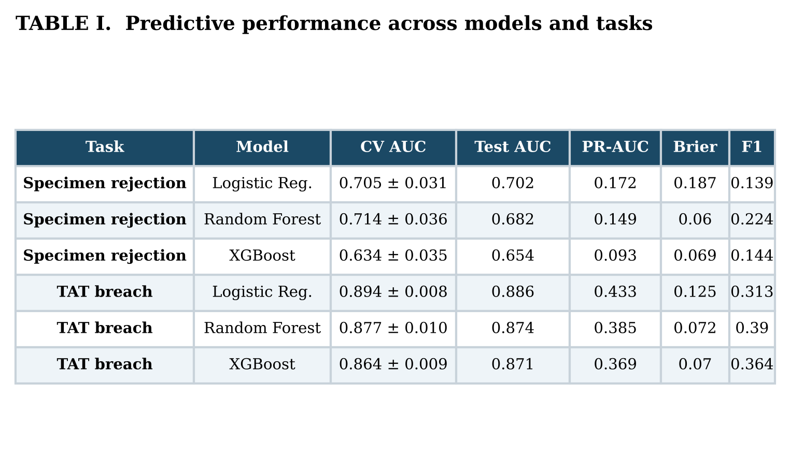
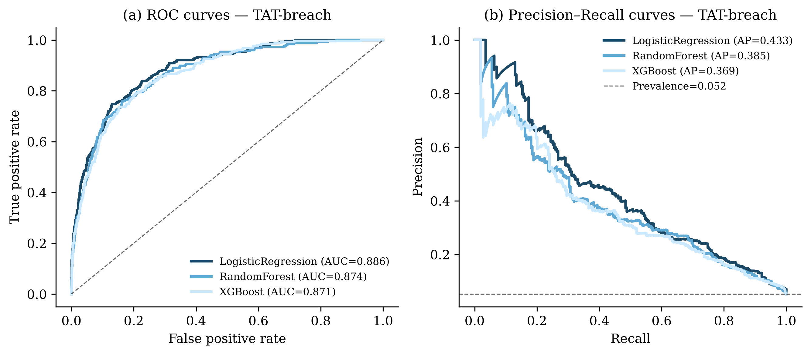
Predictive performance on the held-out test set for the TAT-breach task. (a) ROC curves and (b) precision–recall curves for the three models; the dashed line in (b) marks the positive-class prevalence.

Explainability and Decision Analysis
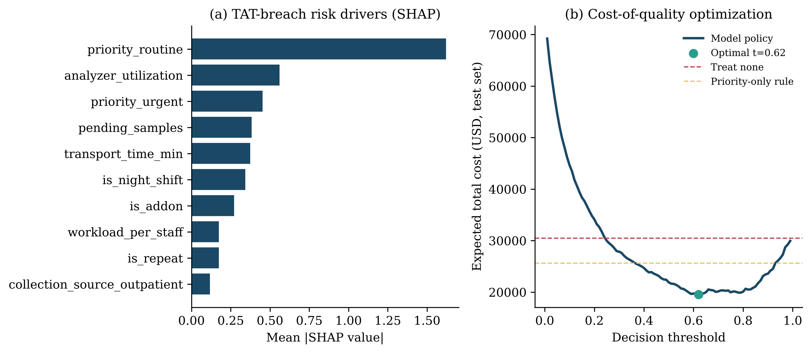
Decision-intelligence layer for the TAT-breach task. (a) Global SHAP importance of the risk drivers (mean absolute SHAP value); the leading drivers after request priority are operational variables a manager can influence. (b) Expected total operational cost as a function of the decision threshold; the convex curve attains its minimum at the cost-optimal threshold (t* = 0.62, marked), lying below both the treat-none and priority-only baselines.

What drives a breach
Figure 2(a) ranks the global SHAP importance of the TAT-breach drivers. Request priority is dominant, unsurprising given priority-specific thresholds, but the next tier is composed almost entirely of operational variables that management can influence: analyzer utilization, the pending-sample queue at arrival, transport time, night-shift operation, add-on testing, and workload-per-staff. This is the actionable core of the result: the model does not merely flag risk, it attributes risk to levers a laboratory manager controls through staffing, shift design, analyzer capacity planning, and transport logistics.

From prediction to cost-rational decision
Figure 2(b) plots expected total cost against the decision threshold. The curve is convex with a clear minimum at t* = 0.62, and over a wide band of thresholds the model-guided policy lies below both the treat-none and priority-only baselines. Table II quantifies the comparison on the held-out test set. Doing nothing incurs the full failure cost; expediting everything is worst of all, more than doubling cost; the priority-only heuristic helps modestly (16.0% below treat-none). The model-guided policy at its cost-optimal threshold reduces expected cost by 35.9% relative to treat-none and by 23.7% relative to the best managerial baseline, the economically meaningful comparison, since no competent manager does nothing.
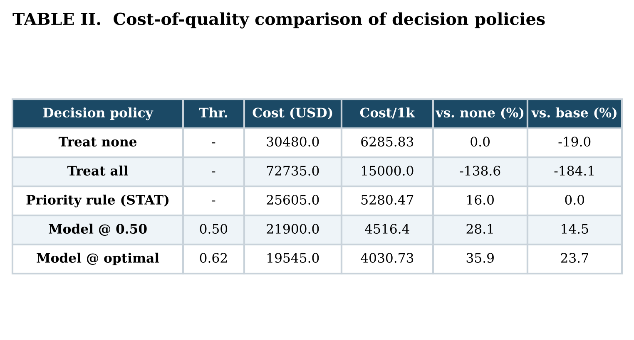

When the stakes rise: sensitivity
The value of the framework grows with the cost of failure. As the ratio C_{B}/C_{I} increases from 2 to 50, the cost-optimal threshold falls, the system intervenes more aggressively, and savings relative to doing nothing rise from 6.1% to 77.9%. This is precisely the regime of time-critical donor screening, where a delayed result can forfeit organ viability and the effective C_{B} is very large. The same analytics that yield modest savings in routine chemistry become decisive in high-stakes biomedical operations, which is where we argue the approach has the greatest strategic value.

Discussion
The central message is that the managerial payoff lies not in prediction alone but in the disciplined translation of prediction into a cost-rational, explainable decision. Three implications follow for practice. First, the dominant, controllable drivers of TAT breach are operational: workload, analyzer utilization, shift, and transport, so the most effective interventions are managerial (dynamic staffing, capacity planning, transport scheduling) rather than purely technical. Second, the asymmetry between the two tasks is itself a decision: because rejection resists prediction while TAT breach does not, scarce analytics and automation capacity should be directed at TAT management and at upstream process control for specimen quality. Third, the sensitivity analysis gives managers a principled way to set the operating point according to the stakes of their setting, rather than defaulting to an arbitrary threshold.
For diagnostic enterprises and organ-procurement organizations pursuing digital transformation, the framework offers a template that is transparent enough to govern and auditable enough to defend, properties that matter in regulated environments where an unexplained model is difficult to adopt. It also formalizes, in the open literature, a class of operational analytics that large testing networks often develop privately, lowering the barrier for smaller laboratories to adopt evidence-based decision support.

Limitations
This study has clear limitations. The dataset is synthetic and literature-calibrated; although this makes the work fully reproducible and avoids privacy constraints, the absolute performance and cost figures should be read as illustrative of the methodology rather than as estimates for any specific laboratory. The cost model is deliberately simple: linear unit costs and an assumption that intervention mitigates a true breach, and real settings involve partial mitigation, capacity constraints on how many samples can be expedited, and non-linear failure costs. Prospective validation on de-identified operational data under an appropriate data-use agreement is the essential next step, together with extension of the cost layer to capacitated and dynamic intervention policies.

Conclusion
We presented an explainable decision-intelligence framework for clinical laboratory operations that moves beyond turnaround-time prediction to cost-rational, auditable decision-making. On a reproducible, literature-calibrated benchmark, the approach predicts TAT breach with strong discrimination, attributes risk to managerially-actionable drivers through SHAP, and converts predictions into expedite decisions that cut expected operational cost by up to 35.9% against doing nothing and 23.7% against the best managerial heuristic, with the advantage widening sharply as the stakes rise toward time-critical donor screening. By uniting prediction, explanation, and economic optimization, the framework offers laboratory and diagnostic-service leaders a practical bridge from analytics to governed decisions, and a replicable template for decision-intelligence research in regulated biomedical operations.

Reproducibility
The data generator, experiment pipeline, explainability and cost-analysis code, and all figures and tables are available at https://github.com/jaisrithad/clinical-lab-decision-intelligence. All results are reproducible from a fixed random seed.

Declaration of Competing Interest
The author declares that she has no known competing financial interests or personal relationships that could have appeared to influence the work reported in this paper.

Funding
This research did not receive any specific grant from funding agencies in the public, commercial, or not-for-profit sectors.

Data Availability
All data used in this study are synthetic and generated by the released code; no human-subjects, patient, or donor data were used. The data generator and the generated dataset are available in the public repository linked above, enabling full reproduction of every reported result.

Ethics Statement
This study did not involve human participants, animals, or identifiable personal data. No ethical approval was therefore required.

Declaration of Generative AI and AI-Assisted Technologies
During the preparation of this work, the author used generative AI and AI-assisted tools to support drafting, code development, and language editing. After using these tools, the author reviewed and edited the content as needed and takes full responsibility for the content of the publication.
Reference:
E. R. Tsai, D. Demirtas, N. Hoogendijk, A. N. Tintu, and R. J. Boucherie, “Turnaround time prediction for clinical chemistry samples using machine learning,” Clinical Chemistry and Laboratory Medicine, vol. 60, no. 12, pp. 1902–1910, 2022.
W. Kinnares, “Predicting anatomic pathology turnaround time using machine learning models,” Journal of the Thai Medical Informatics Association, vol. 12, no. 1, pp. 49–58, 2026.
Y. Goren and D. I. Topcu, “Application of data mining for monitoring turnaround time in clinical laboratories: a workflow-based model using Orange visual programming,” International Journal of Medical Biochemistry, vol. 9, no. 3, pp. 162–169, 2026.
S. Lv, H. Ye, Y. Li, and J. Zhang, “Applying a logistic regression–clustering joint model to analyze the causes of prolonged pre-analytic turnaround time for urine culture testing in hospital wards,” Frontiers in Digital Health, vol. 7, 2025.
M. Plebani, “The detection and prevention of errors in laboratory medicine,” Annals of Clinical Biochemistry, vol. 47, no. 2, pp. 101–110, 2010.
R. Hawkins, “Managing the pre- and post-analytical phases of the total testing process,” Annals of Laboratory Medicine, vol. 32, no. 1, pp. 5–16, 2012.
Clinical and Laboratory Standards Institute, Collection, Transport, and Processing of Specimens for Clinical Testing, CLSI guideline GP41, CLSI, 2021.
P. B. Crosby, Quality is Free: The Art of Making Quality Certain. New York, NY, USA: McGraw-Hill, 1979.
S. M. Lundberg and S.-I. Lee, “A unified approach to interpreting model predictions,” in Advances in Neural Information Processing Systems (NeurIPS), 2017, pp. 4765–4774.
L. Breiman, “Random forests,” Machine Learning, vol. 45, no. 1, pp. 5–32, 2001.
T. Chen and C. Guestrin, “XGBoost: a scalable tree boosting system,” in Proc. 22nd ACM SIGKDD Int. Conf. Knowledge Discovery and Data Mining, 2016, pp. 785–794.
F. Pedregosa et al., “Scikit-learn: machine learning in Python,” Journal of Machine Learning Research, vol. 12, pp. 2825–2830, 2011.

J. Damavarapu is with the Doctor of Business Administration program (Emphasis: AI and Digital Transformation Strategy/Health Management Innovation), Midwest University, USA, and is a practicing laboratory technologist. E-mail: djaisritha@gmail.com.
Reproducible code and data generator: https://github.com/jaisrithad/clinical-lab-decision-intelligence.

